VIETNAM GENERAL CONFEDERATION OF LABOR

**TON DUC THANG UNIVERSITY**

**FACULTY OF INFORMATION TECHNOLOGY**



**NGUYỄN TRẦN HOÀNG NHÂN – 523H0164**

**BÀI TẬP LỚN HỆ CƠ SỞ DỮ LIỆU  
2024 - 2025**

**HỆ CƠ SỞ DỮ LIỆU**

**HO CHI MINH CITY, 2024**

VIETNAM GENERAL CONFEDERATION OF LABOR

**TON DUC THANG UNIVERSITY**

**FACULTY OF INFORMATION TECHNOLOGY**



**NGUYỄN TRẦN HOÀNG NHÂN – 523H0164**

**BÀI TẬP LỚN CƠ SỞ DỮ LIỆU**

**HỆ CƠ SỞ DỮ LIỆU**

Advised by

**Dr. HUỲNH THỊ THU THỦY**

**HO CHI MINH CITY, 2024**

**TABLE OF CONTENT**

LIST OF FIGURES ii

CHAPTER 1. METHODOLOGY OF SOLVING TASKS 1

1.1 Declaration: 1

1.2 Task 1a: 1

1.3 Task 1b: 2

1.4 Task 1c: 2

1.5 Task 1d: 2

1.6 Task 1e: 3

1.7 Task 1f: 3

1.8 Task 1g: 4

1.9 Task 1h: 4

CHAPTER 2. SOURCE CODES AND OUTPUTS 6

2.1 Declaration: 6

2.2 Task 1a: 7

2.3 Task 1b: 8

2.4 Task 1c: 9

2.5 Task 1d: 10

2.6 Task 1e: 10

2.7 Task 1f: 10

2.8 Task 1g: 11

2.9 Task 1h: 11

# LIST OF FIGURES

Figure 1: Import numpy library, declare matrix A, matrix B and matrix C. 6

Figure 2: Print matrix A, matrix B and matrix C 6

Figure 3: Matrix A 7

Figure 4: Matrix B 7

Figure 5: Matrix C 7

Figure 6: Implement task 1a 8

Figure 7: Answer of task 1a 8

Figure 8: Implement task 1b 8

Figure 9: Answer of task 1b 9

Figure 10: Implement task 1c 9

Figure 11: Answer of task 1c 10

Figure 12: Implement task 1d 10

Figure 13: Answer of task 1d 10

Figure 14: Implement task 1e 10

Figure 15: Answer of task 1e 10

Figure 16: Implement task 1f 11

Figure 17: Answer of task 1f 11

Figure 18: Implement task 1g 11

Figure 19: Answer of task 1g 11

Figure 20: Implement task 1h 12

Figure 21: Answer of task 1h 12

# METHODOLOGY OF SOLVING TASKS

## Declaration:

* The numpy library is imported and aliased as np.
* The sympy library is imported and aliased as sp.
* Three matrices (A, B, and C) are defined using the np.random.randint function from the numpy library.
* The rows and cols variables define the number of rows and columns for each matrix, respectively.
* The np.random.randint function generates a random integer matrix with values between low (inclusive) and high (exclusive). In this case, low is set to 1 and high is set to rows * cols + 1 to ensure values within a reasonable range for the matrix size. Size is a tuple specifying the shape of the matrix (number of rows, number of columns).

## Task 1a:

Calculate: $A+A^{T}+CB+B^{T}C^{T}$.

* Performs the core calculations and stores the result in a variable named result. It combines four elements:
* a_matrix + a_matrix.T: This is the addition operation between the matrix a_matrix and its transpose a_matrix.T. The transpose of a matrix is computed using the .T method in NumPy.
* np.matmul(c_matrix, b_matrix): This is the matrix multiplication operation between c_matrix and b_matrix using the np.matmul() function in NumPy.
* np.matmul(b_matrix.T, c_matrix.T): Similarly, this is the matrix multiplication operation between the transpose of b_matrix and the transpose of c_matrix.
* print(result): After the computations, the result is stored in the variable result, and then printed to the screen using the print statement.

## Task 1b:

Calculate $\frac{A}{10}+{\left(\frac{A}{11}\right)}^{2}+{\left(\frac{A}{12}\right)}^{3}+…+{\left(\frac{A}{17}\right)}^{8}+{\left(\frac{A}{18}\right)}^{9}+{\left(\frac{A}{19}\right)}^{10}$

* result = 0: Initializes the variable result to 0.
* for i in range(10): This is a loop that iterates i from 0 to 9 (inclusive). It will repeat the subsequent code block 10 times.
* result += np.linalg.matrix_power(a_matrix / (10 + i), i + 1):
* np.linalg.matrix_power(a_matrix / (10 + i), i + 1): This calculates the matrix power of the expression (a_matrix / (10 + i)) raised to the power of (i + 1). np.linalg.matrix_power() function computes the matrix power of a given matrix.
* result += ...: This adds the result of the matrix power calculation to the result variable. It's equivalent to result = result + ....
* print(result): Prints out the final result after the loop completes.

## Task 1c:

Save odd rows of the matrix $A$ into a new matrix, and print the resultant matrix to the screen.

* odd_row = [value for index, value in enumerate(a_matrix) if index % 2 == 0]: This line creates a list comprehension that iterates over the rows of the matrix a_matrix and selects only the rows whose index is odd (i.e., index % 2 == 0). It extracts the values of these rows and stores them in the list odd_row.
* result_matrix = np.array(odd_row): Converts the list odd_row into a NumPy array and assigns it to the variable result_matrix. This creates a new matrix containing only the odd-indexed rows from the original matrix a_matrix.
* print(result_matrix): Prints out the resulting matrix result_matrix.

## Task 1d:

Save odd integer numbers in the matrix $A$ into a new vector, and print the resultant vector to the screen.

* mask = a_matrix % 2 != 0: This line creates a boolean mask by applying the condition a_matrix % 2 != 0. This condition checks each element of the matrix a_matrix to see if it's odd (i.e., not divisible by 2). If an element satisfies this condition, the corresponding entry in the mask will be True; otherwise, it will be False.
* result_matrix = a_matrix[mask]: This line uses the boolean mask to select the elements from the matrix a_matrix where the mask is True. In other words, it filters out the elements of a_matrix that are odd according to the condition specified by the mask.
* print(result_matrix): Prints out the resulting matrix result_matrix.

## Task 1e:

Save prime numbers in the matrix $A$ into a new vector, and print the resultant vector to the screen.

* prime_numbers = np.array([num for row in a_matrix for num in row if sp.isprime(num)]): This line creates a NumPy array prime_numbers containing prime numbers extracted from the matrix a_matrix. It uses a list comprehension to iterate over each element (num) in each row (row) of a_matrix. The condition if sp.isprime(num) checks if num is a prime number using the sp.isprime() function from the SymPy library.
* print(prime_numbers): Prints out the resulting array prime_numbers containing prime numbers extracted from a_matrix.

## Task 1f:

Given a matrix $D=CB$, reverse elements in the odd rows of the matrix $D$, and print the resultant matrix to the screen.

* d_matrix = np.matmul(c_matrix, b_matrix): This line computes the matrix product of c_matrix and b_matrix using the np.matmul() function in NumPy and assigns the result to the variable d_matrix.
* for i in range(len(d_matrix)): This line initiates a loop that iterates over the indices of the rows in d_matrix.
* if i % 2 == 0: Inside the loop, this line checks if the index i is even.
* d_matrix[i] = np.flip(d_matrix[i]): If the index i is even, this line flips the elements of the row i in the matrix d_matrix using the np.flip() function. Flipping the row means reversing the order of its elements.
* print(d_matrix): Finally, the resulting matrix d_matrix, after every other row has been flipped, is printed.

## Task 1g:

Regarding the matrix $A$, find the rows which have maximum count of prime numbers, and print the rows to the screen.

* max_prime_count = max(sum(sp.isprime(num) for num in row) for row in a_matrix): This line calculates the maximum count of prime numbers in any row of the matrix a_matrix. It uses a generator expression within the max() function to iterate over each row of a_matrix, calculate the sum of prime numbers in that row, and then find the maximum of these sums.
* rows_with_max_primes = [row for row in a_matrix if sum(sp.isprime(num) for num in row) == max_prime_count]: This line creates a list rows_with_max_primes containing the rows of a_matrix that have the maximum count of prime numbers. It uses a list comprehension to iterate over each row of a_matrix, and selects only those rows whose sum of prime numbers equals max_prime_count.
* for row in rows_with_max_primes: This initiates a loop that iterates over each row in rows_with_max_primes.
* print(row): Inside the loop, this line prints out each row that has the maximum count of prime numbers.

## Task 1h:

Regarding the matrix $A$, find the rows which have the longest contiguous odd numbers sequence, and print the rows to the screen.

* def longest_odd_sequence(lst): This line defines a nested function named longest_odd_sequence(lst). This function calculates the length of the longest sequence of consecutive odd numbers in a given list lst. It iterates through the elements of the list, updating current_length if the element is odd and resetting it to 0 if the element is even. It returns the max_length found.
* max_odd_sequence_lengths = [longest_odd_sequence(row) for row in a_matrix]: This line creates a list max_odd_sequence_lengths containing the lengths of the longest sequences of consecutive odd numbers in each row of the matrix a_matrix. It uses a list comprehension to iterate over each row of a_matrix and apply the longest_odd_sequence() function to it.
* max_length = max(max_odd_sequence_lengths): This line calculates the maximum length of consecutive odd numbers among all rows of the matrix a_matrix.
* rows_with_max_length = [row for row, length in zip(a_matrix, max_odd_sequence_lengths) if length == max_length]: This line creates a list rows_with_max_length containing the row(s) of a_matrix that have the maximum length of consecutive odd numbers. It uses a list comprehension and the zip() function to iterate over pairs of rows and their corresponding lengths, and selects only those rows whose length matches max_length.
* for row in rows_with_max_length: This initiates a loop that iterates over each row in rows_with_max_length.
* print(row): Inside the loop, this line prints out each row that has the maximum length of consecutive odd numbers.

# SOURCE CODES AND OUTPUTS

## Declaration:

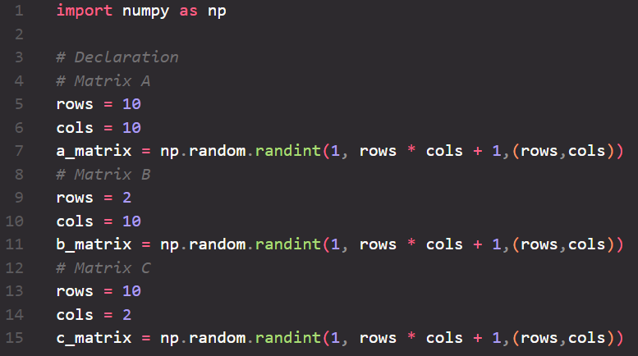

Figure 1: Import numpy library, declare matrix A, matrix B and matrix C.

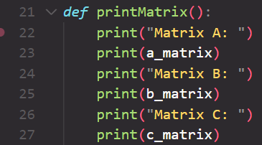

Figure 2: Print matrix A, matrix B and matrix C

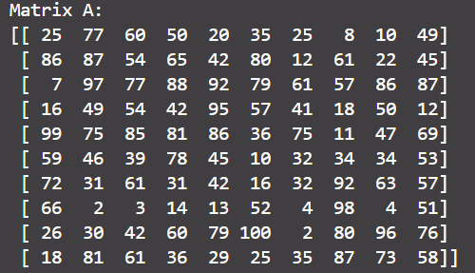

Figure 3: Matrix A

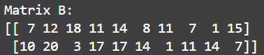

Figure 4: Matrix B

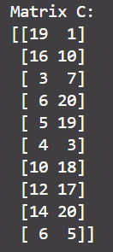

Figure 5: Matrix C

## Task 1a:



Figure 6: Implement task 1a

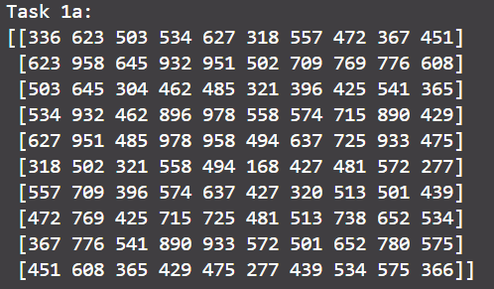

Figure 7: Answer of task 1a

## Task 1b:

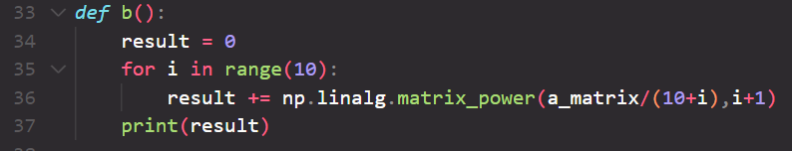

Figure 8: Implement task 1b

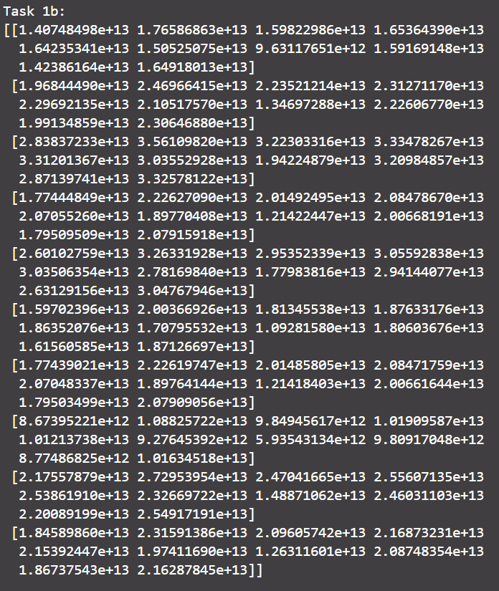

Figure 9: Answer of task 1b

## Task 1c:

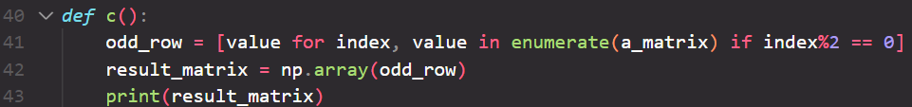

Figure 10: Implement task 1c

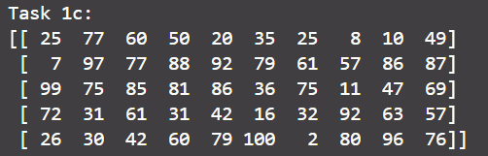

Figure 11: Answer of task 1c

## Task 1d:

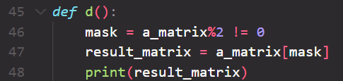

Figure 12: Implement task 1d

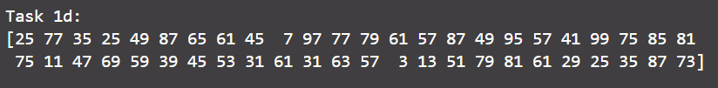

Figure 13: Answer of task 1d

## Task 1e:



Figure 14: Implement task 1e



Figure 15: Answer of task 1e

## Task 1f:

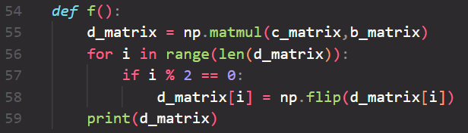

Figure 16: Implement task 1f

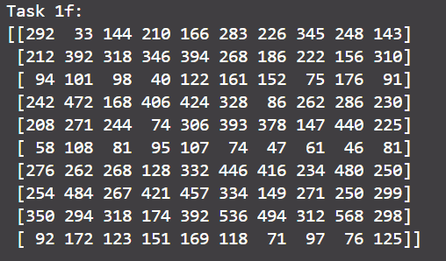

Figure 17: Answer of task 1f

## Task 1g:

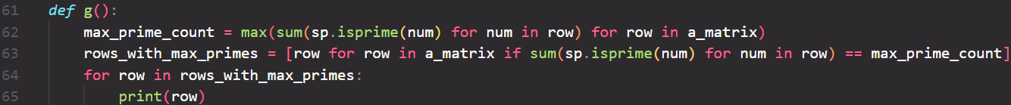

Figure 18: Implement task 1g



Figure 19: Answer of task 1g

## Task 1h:

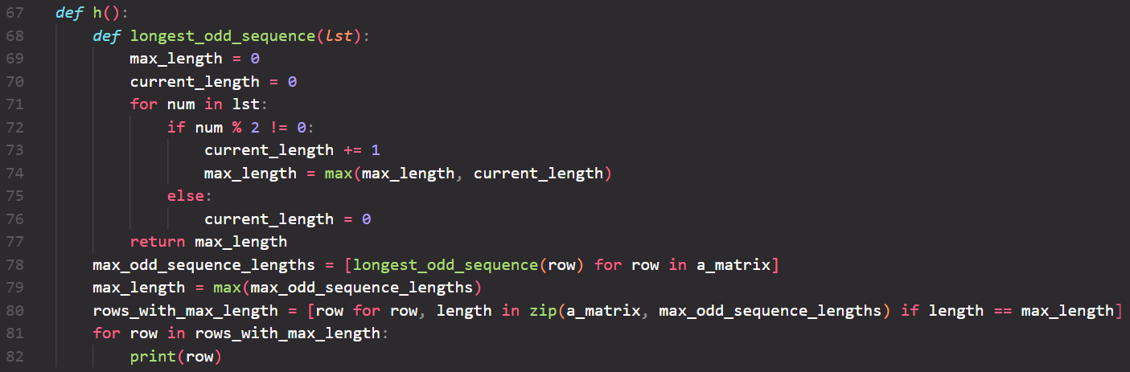

Figure 20: Implement task 1h



Figure 21: Answer of task 1h