PII Redaction Tool (Redactly)
Approach Overview
Redactly is an AI-assisted PII redaction platform that detects, reviews, and safely replaces sensitive information in PDF and DOCX files while preserving the original formatting. It combines multiple detection techniques instead of relying on a single model, improving both precision and recall.

Solution Workflow
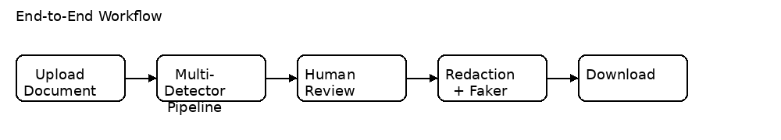
1. User uploads a PDF or DOCX.
2. Text, layout, and embedded images are extracted.
3. Multiple detectors (Regex, spaCy, Microsoft Presidio, heuristics, labeled-field detector, OCR) identify PII.
4. Results are merged and confidence-scored.
5. Users review detections before redaction.
6. Faker generates realistic replacement values.
7. The document is rewritten while preserving layout.
8. The user downloads the redacted document together with an audit log and replacement map.

System Architecture
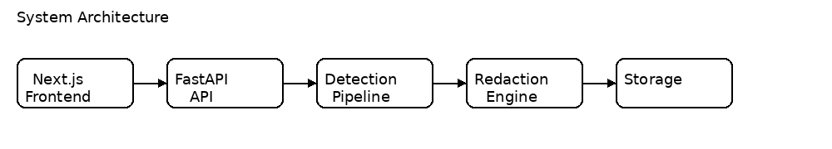
Frontend: Next.js + TypeScript workspace for upload, review, preview, and analytics.
Backend: FastAPI REST APIs orchestrate detection, replacement, and redaction.
Detection Layer: Regex, spaCy NER, Microsoft Presidio, heuristic rules, and OCR.
Replacement Engine: Faker creates deterministic realistic replacements.
Storage: SQLite/PostgreSQL stores jobs, policies, and audit information.

PDF Redaction
PyMuPDF extracts text spans with bounding boxes. After detection, accepted entities are mapped back to their exact page coordinates. True PDF redaction annotations are applied, permanently removing the original text from the PDF content stream. Replacement values are drawn into the same position to preserve layout.

DOCX Redaction
python-docx edits text at the run level, allowing replacements without changing fonts, bold, italics, colors, or paragraph formatting. Embedded images are OCR processed and sensitive regions are masked.

Technology Stack
Layer | Technology | Reason
NER | spaCy | Fast local named-entity recognition
PII Detection | Microsoft Presidio | PII recognizers with confidence scores
Pattern Matching | Regex | High precision for structured PII
OCR | Tesseract | Offline image text extraction
PDF | PyMuPDF | True redaction support
Backend | FastAPI | Fast async APIs
Frontend | Next.js | Modern UI
Fake Data | Faker | Realistic replacements

Key Advantages
- Multi-detector architecture improves detection accuracy.
- Human review minimizes false positives.
- Format-preserving redaction keeps documents readable.
- Offline processing protects sensitive data.
- Complete audit trail ensures transparency.

