**Name :Anal Ashok Gore**

**Roll no:17**

**Term paper**

**Subject: SAS programming langauge**

* [**Introduction**](https://www.edureka.co/blog/sas-programming/#FundamentalsOfSASProgramming)
* **Why we use SAS**
* [**Fundamentals Of SAS Programming**](https://www.edureka.co/blog/sas-programming/#FundamentalsOfSASProgramming)
* [**SAS Code Structure**](https://www.edureka.co/blog/sas-programming/#SASCodeStructure)
* [**Informat And Format In SAS**](https://www.edureka.co/blog/sas-programming/#InformatsAndFormatsInSAS)
* [**SAS Loops**](https://www.edureka.co/blog/sas-programming/#SASLoops)
* [**Basic Statistical Procedures Using SAS**](https://www.edureka.co/blog/sas-programming/#BasicStatisticalProceduresUsingSAS)

**Introduction of SAS**

**SAS** stands for **Statistical Analysis Software**. It was created in the year 1960 by the SAS Institute. From 1st January 1960, SAS was used for data management, business intelligence, Predictive Analysis, Descriptive and Prescriptive Analysis etc. Since then, many new statistical procedures and components were introduced in the software.

With the introduction of JMP (Jump) for statistics SAS took advantage of the **Graphical user Interface** which was introduced by the Macintosh. Jump is basically used for the applications like Six Sigma, designs, quality control and engineering and scientific analysis.

SAS is platform independent which means you can run SAS on any operating system either Linux or Windows. SAS is driven by SAS programmers who use several sequences of operations on the SAS datasets to make proper reports for data analysis.

Over the years SAS has added numerous solutions to its product portfolio. It has solution for Data Governance, Data Quality, Big Data Analytics, Text Mining, Fraud management, Health science etc. We can safely assume SAS has a solution for every business domain.

**Why we use SAS**

SAS is basically worked on large datasets. With the help of SAS software you can perform various operations on the data like −

* Data Management
* Statistical Analysis
* Report formation with perfect graphics
* Business Planning
* Operations Research and project Management
* Quality Improvement
* Application Development
* Data extraction
* Data transformation
* Data updation and modification
* **Fundamentals Of SAS Programming**

**SAS Windows**

Large organisations and training institutes prefer using SAS Windows. SAS Windows has a lot of utilities that help reduce the time required to write codes.

The following image shows the different parts of SAS Windows.

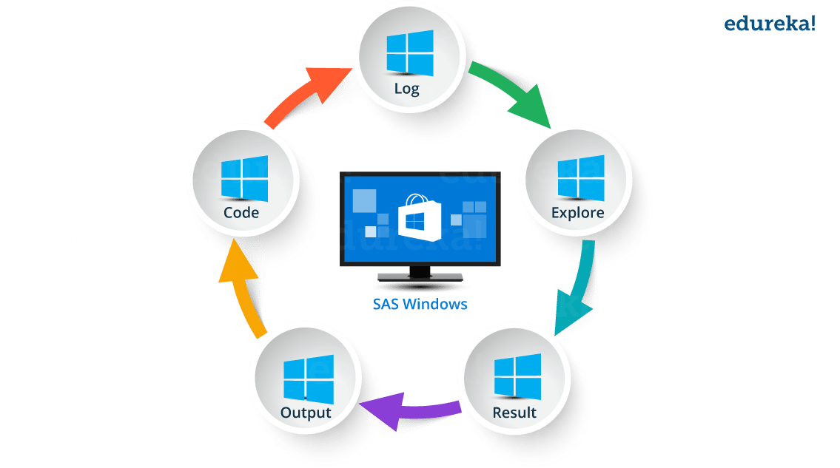

* **Log Window**: It is an execution window. Here, you can check the execution of your program. It also displays errors, warnings and notes.
* **Code Window**: This window is also known as editor window. Consider it as a blank paper or a notepad, where you can write your SAS code.
* **Output Window**: As the name suggests, this window displays the output of the program/ code which you write in the editor.
* **Result Window**: It is an index that list all the outputs of programs that are run in one session. Since it holds the results of a particular session, if you close the software and restart it, the result window will be empty.
* **Explore Window**: It holds the list of all the libraries in the system. You can also browse the system supported files here.

**SAS Data Sets**

SAS data sets are called as data files. Data files constitute of rows and columns. Rows hold observations and columns hold Variable names.

**SAS Variables**

SAS has two types of variables:

* **Numeric variables**:This is the default variable type. These variables are used in mathematical expressions.
* **Character variables**:Character variables are used for values that are not.used in expressionThey are treated as text or strings. A variable becomes a character variable by adding a ‘$’ sign at the end of the variable name.

**SAS Libraries**

SAS library is a collection of SAS files that are stored in the same folder or directory on your computer.

* **Temporary Library**: In this library, the data set gets deleted when the SAS session ends.
* **Permanent Library**: Data sets are saved permanently. Hence, they are available across sessions.

Users can also create or define a new library known as user defined libraries by using the keyword **LIBNAME**. These are also permanent libraries.

## ****SAS Programming: SAS Code Structure****

SAS programming is based on two building blocks:

* **DATA Step**: The DATA step creates a SAS data set and then passes the data onto a PROC step
* **PROC Step**: The PROC step processes the data

 A SAS program should follow below mentioned rules:

* Almost every code will begin with either DATA or a PROC Step
* Every line of SAS code ends with a semi colon
* A SAS code ends with RUN or QUIT keyword
* SAS codes are not case sensitive
* You can write a code across different lines or you can write multiple statements in one line

Now that we have seen a few basic terminologies, let us get started with SAS programming with this basic code:

|  |  |
| --- | --- |
| 1  2  3  4  5  6  7  8  9  10 | DATA Employee_Info;  input Emp_ID Emp_Name$ Emp_Vertical$;  datalines;  101 Mak SQL  102 Rama SAS  103 Priya Java  104 Karthik Excel  105 Mandeep SAS  ;  Run; |

## ****Informats And Formats In SAS****

It is important that you understand this topic well if you want to be good at SAS programming. If you can recall, I mentioned earlier that SAS has two standard variable types:

* Numeric
* Character

When SAS comes across non standard variables, SAS will throw an error or you won’t get the desired output. To overcome this problem, SAS uses Informats and Formats.

## ****Informat****

Informat are typically used to read or input data from external files or flat files (like text files or sequential files). The informat instructs SAS on how to read data into SAS variables.

SAS has three types of Informat :

* Character Informat: $INFORMATw
* Numeric Informat: INFORMATw.d
* Date/ Time Informat: INFORMATw

## ****Format****

 Defining a format for a variable is how you tell SAS to display the values in the variable.

Formats are grouped into the same three classes as informats (character, numeric, and date-time) and also always contain a dot.

The general form of a format statement is:

* FORMAT variable-name FORMAT-NAME.;

## ****SAS Loops****

While doing SAS programming, we may encounter situations where we repeatedly need to execute a block of code several number of times. It is inconvenient to write the same set of statements again and again. This is where loops come into picture. In SAS, the Do statement is used to implement loops. It is also known as the Do Loop. The image below shows the general form of the Do loop statements in SAS.

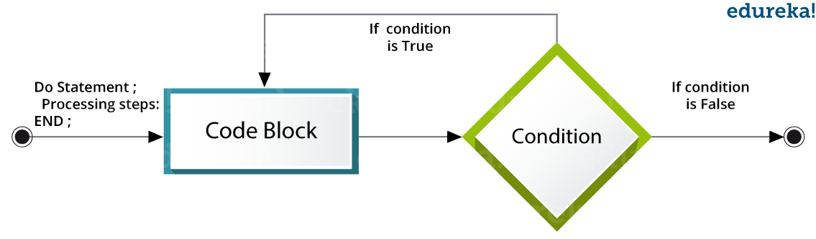Following are the  types of DO loops in SAS:

* **Index**: The loop continues from the start value till the stop value of the index variable.
* **While**: The loop continues as long as the **While** condition becomes false.
* **Until**: The loop continues till the **Until** condition becomes True.