**Name :Anal Ashok Gore**

**Roll no:17**

**Term paper**

**Subject: SAS programming langauge**

* [**Introduction**](https://www.edureka.co/blog/sas-programming/#FundamentalsOfSASProgramming)
* **Why we use SAS**
* **History of SAS**
* [**Fundamentals Of SAS Programming**](https://www.edureka.co/blog/sas-programming/#FundamentalsOfSASProgramming)
* [**SAS Code Structure**](https://www.edureka.co/blog/sas-programming/#SASCodeStructure)
* [**Informat And Format In SAS**](https://www.edureka.co/blog/sas-programming/#InformatsAndFormatsInSAS)
* [**SAS Loops**](https://www.edureka.co/blog/sas-programming/#SASLoops)
* [**Basic Statistical Procedures Using SAS**](https://www.edureka.co/blog/sas-programming/#BasicStatisticalProceduresUsingSAS)

**Introduction of SAS**

**SAS** stands for **Statistical Analysis Software**. It was created in the year 1960 by the SAS Institute. From 1st January 1960, SAS was used for data management, business intelligence, Predictive Analysis, Descriptive and Prescriptive Analysis etc. Since then, many new statistical procedures and components were introduced in the software.

With the introduction of JMP (Jump) for statistics SAS took advantage of the **Graphical user Interface** which was introduced by the Macintosh. Jump is basically used for the applications like Six Sigma, designs, quality control and engineering and scientific analysis.

SAS is platform independent which means you can run SAS on any operating system either Linux or Windows. SAS is driven by SAS programmers who use several sequences of operations on the SAS datasets to make proper reports for data analysis.

Over the years SAS has added numerous solutions to its product portfolio. It has solution for Data Governance, Data Quality, Big Data Analytics, Text Mining, Fraud management, Health science etc. We can safely assume SAS has a solution for every business domain.

## What is SAS?

**SAS** is a command-driven statistical software suite widely used for statistical data analysis and visualization. SAS full form is Statistical Analysis Software. It allows you to use qualitative techniques and processes which help you to enhance employee productivity and business profits. SAS is also used for advanced analytics like business intelligence, crime investigation, and predictive analysis. SAS is pronounced as “SaaS.”

In SAS, data is extracted & categorized which helps you to identify and analyze data patterns. It is a software suite which allows you to perform advanced analysis, Business Intelligence, Predictive Analysis, data management to operate effectively in the competitive & changing business conditions. Moreover, SAS is platform independent which means you can run SAS on any operating system either Linux or Windows.

Compared to other [BI tools](https://www.guru99.com/business-intelligence-tools.html), SAS provides extensive support to programmatically transform and analyze data, apart from using the drag and drop interface. This provides very granular control over data manipulation and analyzes which is its USP.

**Why we use SAS**

SAS is an integrated software suite for advanced analytics, business intelligence, data management, and predictive analytics. You can use SAS software through both a graphical interface and the SAS programming language, or Base SAS.

With SAS software, you can complete these tasks:

* access data in almost any format, including SAS tables, Microsoft Excel tables, and database files.
* manage and manipulate your existing data to get the data that you need. For example, you can subset your data, combine it with other data, and create new columns.
* analyze your data using statistical techniques ranging from descriptive measures like correlations to logistic regression and mixed models to sophisticated methods such as modern model selection and Bayesian hierarchical models.
* present the results of your analyses in a meaningful report that you can share with others. The reports that you create can be saved in a wide variety of formats, including HTML, PDF, and RTF.

## SAS history

* SAS was developed by Jim Goodnight and John Shall in 1970 at N.C. University
* Initially, it was developed for Agricultural Research.
* Later, it expanded to a gamut of tools to include Predictive Analytics, Data Management, BI among others.
* Today 98 of world’s top companies in fortune 400 uses SAS data analytical tool for [Data analysis.](https://www.guru99.com/what-is-data-analysis.html)

**How to work SAS?**

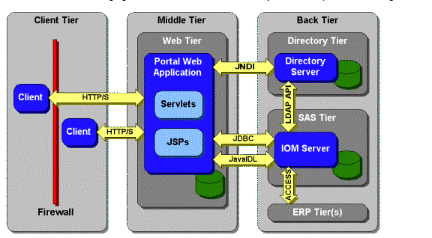

Architecture of SAS

SAS architecture is divided mainly of three parts:

* Client Tier
* Middle Tier
* Back tier

### Client tier:

Client tier is where the application is installed on a machine, where the user is sitting. It consists of the components which are used to view the portal and its content. It also includes a standard web browser that is used to interact with the portal over standard HTTP or HTTPS protocol. It also helps you to make the SAS web application firewall friendly.

### Middle tier:

The middle tier offers a centralized access point for enterprise information. All access to content is processed by components operating of this tier. The separation of the business logic with display logic helps you to leverage the logic of the middle tier. Moreover, centralized points of access make it easier to enforce security rules, administer the portal and manage code changes.

The middle tier hosts the following functions:

**SAS Information Delivery Portal Web Application:**It is the collection of JSP, Java servlets, JavaBeans, and other classes and resources. These components help you to access information stored in the enterprise directory to create a customizable interface for the user.

**Servlet Engine:**The servlet engine is also called a servlet container. It is responsible for managing the SAS Information Delivery Portal Web Application. The servlet engine offers a run time environment. It provides concurrency, deployment, lifecycle management, etc.

**Web server:**Web server offers service for the servlet engine which can be used to host website. This should be accessed using the portal.

### Back Tier:

The back tier is an area where the data and computation servers run which may contain business objects. It is an enterprise directory server. The enterprise directory server maintains metadata about content which is located throughout the enterprise.

## SAS Program Structure

The below diagram shows the steps to be written in the given sequence to create a SAS Program.

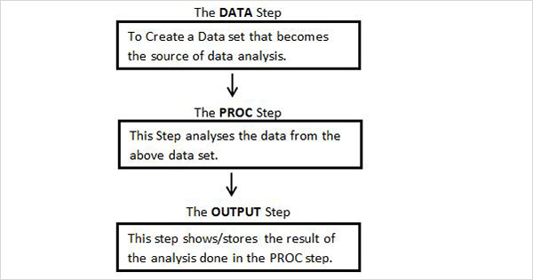

Every SAS program must have all these steps to complete reading the input data, analysing the data and giving the output of the analysis. Also the **RUN** statement at the end of each step is required to complete the execution of that step.

Now that we have seen a few basic terminologies, let us get started with SAS programming with this basic code:

|  |  |
| --- | --- |
| 1  2  3  4  5  6  7  8  9  10 | DATA Employee_Info;  input Emp_ID Emp_Name$ Emp_Vertical$;  datalines;  101 Mak SQL  102 Rama SAS  103 Priya Java  104 Karthik Excel  105 Mandeep SAS  ;  Run; |