Dune

Josue

5/3/2022

knitr::opts_chunk$set(echo = TRUE)

library(vegan)

## Loading required package: permute

## Loading required package: lattice

## This is vegan 2.6-2

library(ggplot2)  
library(ggvegan)  
library(ape)  
library(dplyr)

##   
## Attaching package: 'dplyr'

## The following objects are masked from 'package:stats':  
##   
## filter, lag

## The following objects are masked from 'package:base':  
##   
## intersect, setdiff, setequal, union

library(ggpubr)

##   
## Attaching package: 'ggpubr'

## The following object is masked from 'package:ape':  
##   
## rotate

data("dune")  
head(dune)

## Achimill Agrostol Airaprae Alopgeni Anthodor Bellpere Bromhord Chenalbu  
## 1 1 0 0 0 0 0 0 0  
## 2 3 0 0 2 0 3 4 0  
## 3 0 4 0 7 0 2 0 0  
## 4 0 8 0 2 0 2 3 0  
## 5 2 0 0 0 4 2 2 0  
## 6 2 0 0 0 3 0 0 0  
## Cirsarve Comapalu Eleopalu Elymrepe Empenigr Hyporadi Juncarti Juncbufo  
## 1 0 0 0 4 0 0 0 0  
## 2 0 0 0 4 0 0 0 0  
## 3 0 0 0 4 0 0 0 0  
## 4 2 0 0 4 0 0 0 0  
## 5 0 0 0 4 0 0 0 0  
## 6 0 0 0 0 0 0 0 0  
## Lolipere Planlanc Poaprat Poatriv Ranuflam Rumeacet Sagiproc Salirepe  
## 1 7 0 4 2 0 0 0 0  
## 2 5 0 4 7 0 0 0 0  
## 3 6 0 5 6 0 0 0 0  
## 4 5 0 4 5 0 0 5 0  
## 5 2 5 2 6 0 5 0 0  
## 6 6 5 3 4 0 6 0 0  
## Scorautu Trifprat Trifrepe Vicilath Bracruta Callcusp  
## 1 0 0 0 0 0 0  
## 2 5 0 5 0 0 0  
## 3 2 0 2 0 2 0  
## 4 2 0 1 0 2 0  
## 5 3 2 2 0 2 0  
## 6 3 5 5 0 6 0

data("dune.env")  
head(dune.env)

## A1 Moisture Management Use Manure  
## 1 2.8 1 SF Haypastu 4  
## 2 3.5 1 BF Haypastu 2  
## 3 4.3 2 SF Haypastu 4  
## 4 4.2 2 SF Haypastu 4  
## 5 6.3 1 HF Hayfield 2  
## 6 4.3 1 HF Haypastu 2

?metaMDS  
dune %>%  
metaMDS(trace = F) %>% ordiplot(type = "n") %>%  
text("sites")

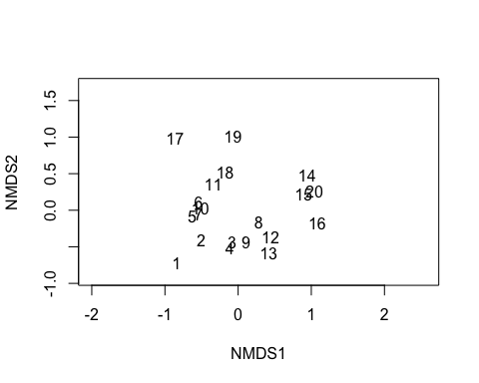

PCA<- rda(dune,scale=F)  
PCA

## Call: rda(X = dune, scale = F)  
##   
## Inertia Rank  
## Total 84.12   
## Unconstrained 84.12 19  
## Inertia is variance   
##   
## Eigenvalues for unconstrained axes:  
## PC1 PC2 PC3 PC4 PC5 PC6 PC7 PC8   
## 24.795 18.147 7.629 7.153 5.695 4.333 3.199 2.782   
## (Showing 8 of 19 unconstrained eigenvalues)

barplot(as.vector(PCA$CA$eig)/sum(PCA$CA$eig))

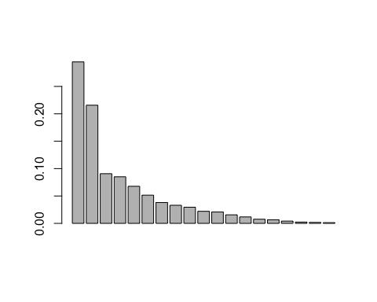

Por el primer y segundo componente se tiene una varianza de

sum((as.vector(PCA$CA$eig)/sum(PCA$CA$eig))[1:2])

## [1] 0.510462

Mientras que por los primeros tres ejes se tiene

sum((as.vector(PCA$CA$eig)/sum(PCA$CA$eig))[1:3])

## [1] 0.6011515

plot(PCA)

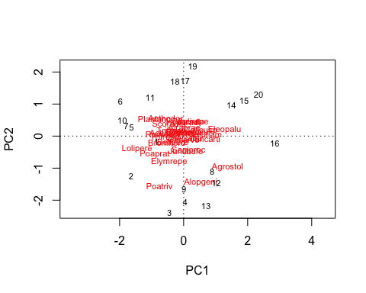

plot(PCA, display = "sites", type = "p")

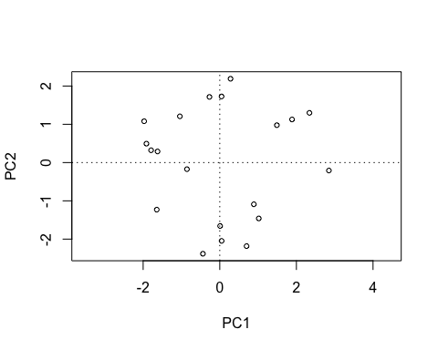

plot(PCA, display = "species", type = "t")

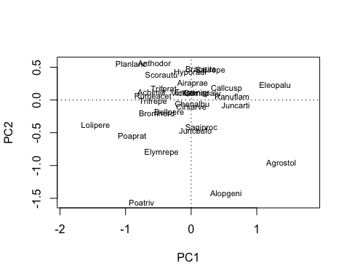

biplot(PCA, choices = c(1,2), type = c("t", "p"), xlim = c(-2,2))

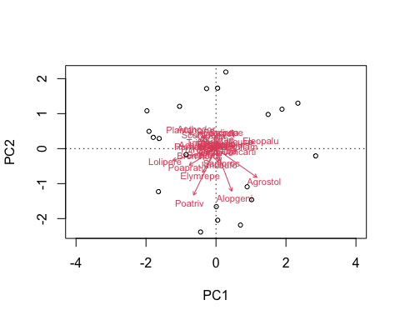

biplot(PCA, choices = c(1,3), type = c("t","p"), xlim = c(-5,5))

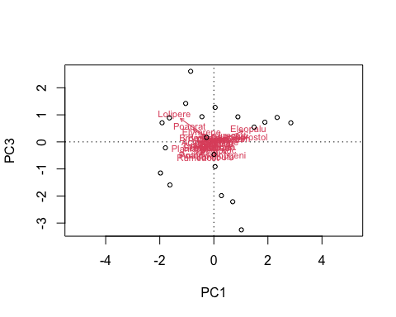

#PCOA

dist <- vegdist(dune, method = "bray")  
PCOA <- pcoa(dist)  
barplot(PCOA$values$Relative_eig[1:10])

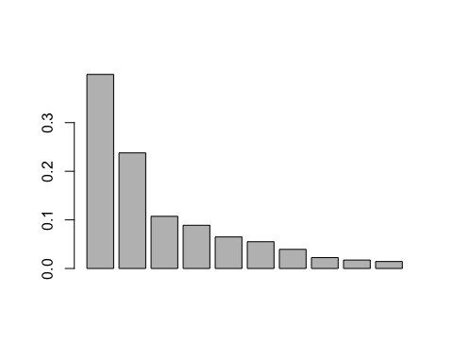

?pcoa  
PCOA <- pcoa(dist, correction = "cailliez")  
biplot.pcoa(PCOA)

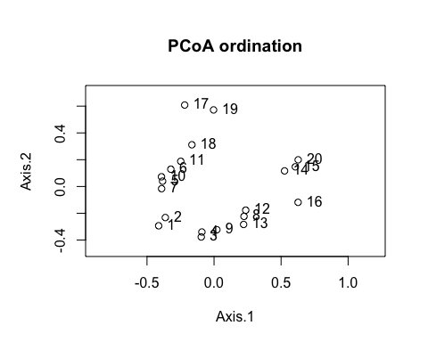

biplot.pcoa(PCOA, dune)

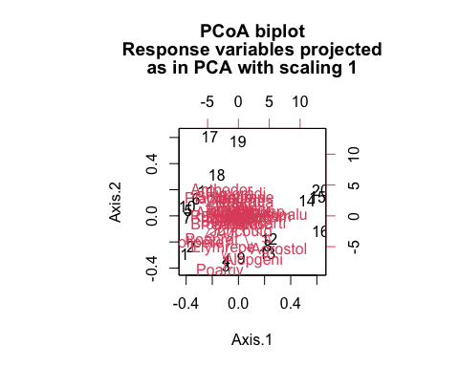

plot(PCA)



#NMDS

dune.hel<- decostand(dune, method = "hellinger")  
nmds1<-metaMDS(dune.hel, autotransform = F)

## Run 0 stress 0.1021819   
## Run 1 stress 0.1021819   
## ... New best solution  
## ... Procrustes: rmse 3.18578e-06 max resid 7.09992e-06   
## ... Similar to previous best  
## Run 2 stress 0.1021819   
## ... Procrustes: rmse 4.444189e-06 max resid 1.020585e-05   
## ... Similar to previous best  
## Run 3 stress 0.19097   
## Run 4 stress 0.1021819   
## ... Procrustes: rmse 2.054029e-06 max resid 5.672041e-06   
## ... Similar to previous best  
## Run 5 stress 0.1021819   
## ... New best solution  
## ... Procrustes: rmse 8.379303e-07 max resid 2.411528e-06   
## ... Similar to previous best  
## Run 6 stress 0.1749763   
## Run 7 stress 0.1040366   
## Run 8 stress 0.1021819   
## ... Procrustes: rmse 3.698664e-06 max resid 1.330545e-05   
## ... Similar to previous best  
## Run 9 stress 0.1021819   
## ... Procrustes: rmse 2.565204e-06 max resid 5.888279e-06   
## ... Similar to previous best  
## Run 10 stress 0.1021819   
## ... Procrustes: rmse 1.622171e-06 max resid 3.690979e-06   
## ... Similar to previous best  
## Run 11 stress 0.1021819   
## ... Procrustes: rmse 4.54461e-06 max resid 9.805909e-06   
## ... Similar to previous best  
## Run 12 stress 0.1021819   
## ... Procrustes: rmse 3.544142e-06 max resid 1.256446e-05   
## ... Similar to previous best  
## Run 13 stress 0.1021819   
## ... Procrustes: rmse 3.87965e-06 max resid 1.291929e-05   
## ... Similar to previous best  
## Run 14 stress 0.1021819   
## ... Procrustes: rmse 3.305051e-06 max resid 1.112526e-05   
## ... Similar to previous best  
## Run 15 stress 0.1021819   
## ... Procrustes: rmse 2.666148e-06 max resid 6.01445e-06   
## ... Similar to previous best  
## Run 16 stress 0.1040366   
## Run 17 stress 0.1021819   
## ... Procrustes: rmse 1.079193e-06 max resid 2.206314e-06   
## ... Similar to previous best  
## Run 18 stress 0.1021819   
## ... Procrustes: rmse 2.202241e-06 max resid 6.837418e-06   
## ... Similar to previous best  
## Run 19 stress 0.1021819   
## ... Procrustes: rmse 2.292363e-06 max resid 7.416387e-06   
## ... Similar to previous best  
## Run 20 stress 0.1021819   
## ... Procrustes: rmse 2.711459e-06 max resid 6.28814e-06   
## ... Similar to previous best  
## *** Solution reached

#definimos el scree  
NMDS.scree <- function(x) {   
plot(rep(1, 10), replicate(10, metaMDS(x, autotransform = F, k = 1)$stress) , xlim = c(1, 10),ylim = c(0, 0.30), xlab = "# de Dimensiones", ylab = "Tensi on", main = "NMDS")  
for (i in 1:10) {  
points(rep(i + 1,10),replicate(10, metaMDS(x, autotransform = F, k = i +  
1)$stress)) }  
}  
  
#se aplica a dist de dune  
  
NMDS.scree(dune.hel)

## Run 0 stress 0.288725   
## Run 1 stress 0.5053728   
## Run 2 stress 0.5426904   
## Run 3 stress 0.3745441   
## Run 4 stress 0.5407171   
## Run 5 stress 0.5005635   
## Run 6 stress 0.489074   
## Run 7 stress 0.5383521   
## Run 8 stress 0.5403209   
## Run 9 stress 0.2862979   
## ... New best solution  
## ... Procrustes: rmse 0.03101157 max resid 0.1227797   
## Run 10 stress 0.5169142   
## Run 11 stress 0.5182766   
## Run 12 stress 0.2825868   
## ... New best solution  
## ... Procrustes: rmse 0.02680935 max resid 0.06658005   
## Run 13 stress 0.4381755   
## Run 14 stress 0.5267018   
## Run 15 stress 0.5445638   
## Run 16 stress 0.5279126   
## Run 17 stress 0.5460547   
## Run 18 stress 0.5273343   
## Run 19 stress 0.5376299   
## Run 20 stress 0.4166208   
## *** No convergence -- monoMDS stopping criteria:  
## 20: scale factor of the gradient < sfgrmin  
## Run 0 stress 0.288725   
## Run 1 stress 0.2801262   
## ... New best solution  
## ... Procrustes: rmse 0.07319551 max resid 0.2893327   
## Run 2 stress 0.387535   
## Run 3 stress 0.5311646   
## Run 4 stress 0.5330478   
## Run 5 stress 0.5220894   
## Run 6 stress 0.4989462   
## Run 7 stress 0.5156829   
## Run 8 stress 0.5191171   
## Run 9 stress 0.4885658   
## Run 10 stress 0.517987   
## Run 11 stress 0.2824782   
## Run 12 stress 0.3824685   
## Run 13 stress 0.5278174   
## Run 14 stress 0.5304486   
## Run 15 stress 0.5381837   
## Run 16 stress 0.5434972   
## Run 17 stress 0.5189445   
## Run 18 stress 0.2863168   
## Run 19 stress 0.5457741   
## Run 20 stress 0.5141467   
## *** No convergence -- monoMDS stopping criteria:  
## 20: scale factor of the gradient < sfgrmin  
## Run 0 stress 0.288725   
## Run 1 stress 0.4760791   
## Run 2 stress 0.5448079   
## Run 3 stress 0.5174595   
## Run 4 stress 0.5448168   
## Run 5 stress 0.526922   
## Run 6 stress 0.5422622   
## Run 7 stress 0.4512106   
## Run 8 stress 0.5180697   
## Run 9 stress 0.5276672   
## Run 10 stress 0.5469156   
## Run 11 stress 0.460638   
## Run 12 stress 0.4953496   
## Run 13 stress 0.3403137   
## Run 14 stress 0.5448168   
## Run 15 stress 0.5284565   
## Run 16 stress 0.5297774   
## Run 17 stress 0.2862979   
## ... New best solution  
## ... Procrustes: rmse 0.03101161 max resid 0.1227796   
## Run 18 stress 0.2734747   
## ... New best solution  
## ... Procrustes: rmse 0.1254284 max resid 0.4586686   
## Run 19 stress 0.5282534   
## Run 20 stress 0.279579   
## *** No convergence -- monoMDS stopping criteria:  
## 20: scale factor of the gradient < sfgrmin  
## Run 0 stress 0.288725   
## Run 1 stress 0.5019542   
## Run 2 stress 0.4489564   
## Run 3 stress 0.4509908   
## Run 4 stress 0.3626259   
## Run 5 stress 0.5443642   
## Run 6 stress 0.5327282   
## Run 7 stress 0.5460153   
## Run 8 stress 0.4223101   
## Run 9 stress 0.5312559   
## Run 10 stress 0.5444031   
## Run 11 stress 0.4984182   
## Run 12 stress 0.5476855   
## Run 13 stress 0.5181071   
## Run 14 stress 0.5237328   
## Run 15 stress 0.5386747   
## Run 16 stress 0.5206523   
## Run 17 stress 0.3167922   
## Run 18 stress 0.5375253   
## Run 19 stress 0.5357588   
## Run 20 stress 0.5088326   
## *** No convergence -- monoMDS stopping criteria:  
## 20: scale factor of the gradient < sfgrmin  
## Run 0 stress 0.288725   
## Run 1 stress 0.2867177   
## ... New best solution  
## ... Procrustes: rmse 0.03097215 max resid 0.1219817   
## Run 2 stress 0.4310078   
## Run 3 stress 0.2801405   
## ... New best solution  
## ... Procrustes: rmse 0.09889369 max resid 0.4018259   
## Run 4 stress 0.5088156   
## Run 5 stress 0.2798201   
## ... New best solution  
## ... Procrustes: rmse 0.07747919 max resid 0.269224   
## Run 6 stress 0.5308362   
## Run 7 stress 0.3879429   
## Run 8 stress 0.5225611   
## Run 9 stress 0.5437067   
## Run 10 stress 0.5196284   
## Run 11 stress 0.2848388   
## Run 12 stress 0.496478   
## Run 13 stress 0.437859   
## Run 14 stress 0.2773374   
## ... New best solution  
## ... Procrustes: rmse 0.06379259 max resid 0.2471943   
## Run 15 stress 0.535264   
## Run 16 stress 0.3885606   
## Run 17 stress 0.4861358   
## Run 18 stress 0.5107636   
## Run 19 stress 0.4789996   
## Run 20 stress 0.5470823   
## *** No convergence -- monoMDS stopping criteria:  
## 20: scale factor of the gradient < sfgrmin  
## Run 0 stress 0.288725   
## Run 1 stress 0.528676   
## Run 2 stress 0.4974031   
## Run 3 stress 0.4239342   
## Run 4 stress 0.5411361   
## Run 5 stress 0.341176   
## Run 6 stress 0.5463022   
## Run 7 stress 0.4651725   
## Run 8 stress 0.2923813   
## Run 9 stress 0.2807251   
## ... New best solution  
## ... Procrustes: rmse 0.03055905 max resid 0.06733824   
## Run 10 stress 0.5438291   
## Run 11 stress 0.504704   
## Run 12 stress 0.5449244   
## Run 13 stress 0.5304203   
## Run 14 stress 0.524264   
## Run 15 stress 0.453141   
## Run 16 stress 0.5383383   
## Run 17 stress 0.4559952   
## Run 18 stress 0.4276031   
## Run 19 stress 0.464169   
## Run 20 stress 0.2796416   
## ... New best solution  
## ... Procrustes: rmse 0.1029173 max resid 0.2889339   
## *** No convergence -- monoMDS stopping criteria:  
## 20: scale factor of the gradient < sfgrmin  
## Run 0 stress 0.288725   
## Run 1 stress 0.5375748   
## Run 2 stress 0.5436032   
## Run 3 stress 0.3139384   
## Run 4 stress 0.5137416   
## Run 5 stress 0.52641   
## Run 6 stress 0.5344845   
## Run 7 stress 0.5102837   
## Run 8 stress 0.545969   
## Run 9 stress 0.4843564   
## Run 10 stress 0.5069989   
## Run 11 stress 0.5355328   
## Run 12 stress 0.4168433   
## Run 13 stress 0.4638014   
## Run 14 stress 0.520834   
## Run 15 stress 0.5167056   
## Run 16 stress 0.3059092   
## Run 17 stress 0.5455876   
## Run 18 stress 0.5091544   
## Run 19 stress 0.5086155   
## Run 20 stress 0.5198263   
## *** No convergence -- monoMDS stopping criteria:  
## 1: stress ratio > sratmax  
## 19: scale factor of the gradient < sfgrmin  
## Run 0 stress 0.288725   
## Run 1 stress 0.278082   
## ... New best solution  
## ... Procrustes: rmse 0.02945049 max resid 0.06711587   
## Run 2 stress 0.5439866   
## Run 3 stress 0.2918392   
## Run 4 stress 0.5390643   
## Run 5 stress 0.4186445   
## Run 6 stress 0.4864006   
## Run 7 stress 0.48608   
## Run 8 stress 0.4769009   
## Run 9 stress 0.5054984   
## Run 10 stress 0.4238526   
## Run 11 stress 0.5093343   
## Run 12 stress 0.5438787   
## Run 13 stress 0.2816526   
## Run 14 stress 0.2792937   
## Run 15 stress 0.5385264   
## Run 16 stress 0.4976997   
## Run 17 stress 0.5477226   
## Run 18 stress 0.4957859   
## Run 19 stress 0.5094758   
## Run 20 stress 0.2860968   
## *** No convergence -- monoMDS stopping criteria:  
## 20: scale factor of the gradient < sfgrmin  
## Run 0 stress 0.288725   
## Run 1 stress 0.279579   
## ... New best solution  
## ... Procrustes: rmse 0.1203359 max resid 0.3401408   
## Run 2 stress 0.518796   
## Run 3 stress 0.5179113   
## Run 4 stress 0.4919307   
## Run 5 stress 0.4864778   
## Run 6 stress 0.5291427   
## Run 7 stress 0.5424185   
## Run 8 stress 0.529314   
## Run 9 stress 0.4700499   
## Run 10 stress 0.4052964   
## Run 11 stress 0.3156744   
## Run 12 stress 0.5152418   
## Run 13 stress 0.5382127   
## Run 14 stress 0.2796832   
## ... Procrustes: rmse 0.002267474 max resid 0.006171804   
## ... Similar to previous best  
## Run 15 stress 0.5456151   
## Run 16 stress 0.4598029   
## Run 17 stress 0.3589485   
## Run 18 stress 0.5275238   
## Run 19 stress 0.5445643   
## Run 20 stress 0.5276147   
## *** Solution reached  
## Run 0 stress 0.288725   
## Run 1 stress 0.5415714   
## Run 2 stress 0.5324373   
## Run 3 stress 0.5391084   
## Run 4 stress 0.4901797   
## Run 5 stress 0.4833058   
## Run 6 stress 0.5392122   
## Run 7 stress 0.5470013   
## Run 8 stress 0.4465404   
## Run 9 stress 0.5363653   
## Run 10 stress 0.4992699   
## Run 11 stress 0.5446842   
## Run 12 stress 0.4492398   
## Run 13 stress 0.5279429   
## Run 14 stress 0.5295035   
## Run 15 stress 0.2819425   
## ... New best solution  
## ... Procrustes: rmse 0.1165138 max resid 0.3454997   
## Run 16 stress 0.5476854   
## Run 17 stress 0.5411757   
## Run 18 stress 0.5008024   
## Run 19 stress 0.430756   
## Run 20 stress 0.547563   
## *** No convergence -- monoMDS stopping criteria:  
## 20: scale factor of the gradient < sfgrmin

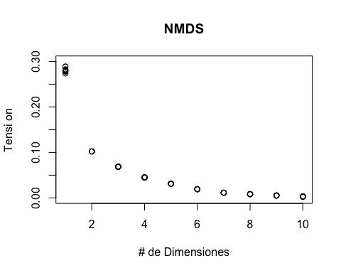

ordiplot(nmds1)

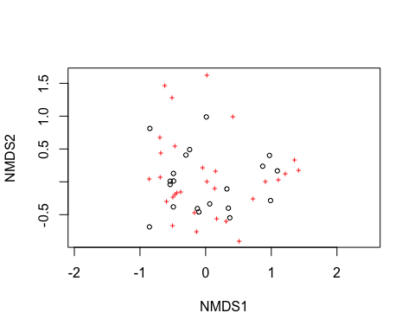

ordiplot(nmds1, type = "t")

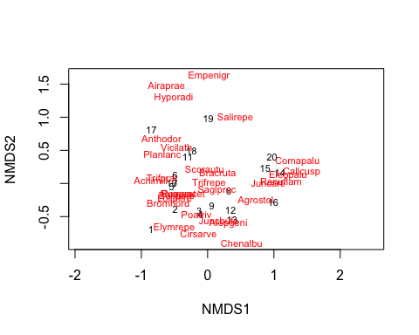

#Use ggvegan autoplot

autoplot(nmds1)

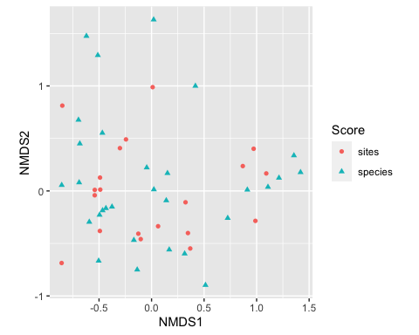

head(nmds1$species)

## MDS1 MDS2  
## Achimill -0.8551869 0.05547484  
## Agrostol 0.7248935 -0.25861998  
## Airaprae -0.6200470 1.47510010  
## Alopgeni 0.3149612 -0.59765288  
## Anthodor -0.6955888 0.67649318  
## Bellpere -0.4661807 -0.18587584

fort<- fortify(nmds1)  
head(fort)

## Score Label NMDS1 NMDS2  
## 1 sites 1 -0.8560238 -0.6865337  
## 2 sites 2 -0.4921154 -0.3812939  
## 3 sites 3 -0.1258358 -0.4072723  
## 4 sites 4 -0.1031720 -0.4589160  
## 5 sites 5 -0.5409651 -0.0414489  
## 6 sites 6 -0.4905997 0.1271422

ggplot()+  
 geom_point(data = subset(fort, Score=='sites'),  
 mapping = aes(x= NMDS1, y= NMDS2),  
 colour= "black", alpha=0.5)+  
 geom_segment(data = subset(fort, Score=='species'),  
 mapping = aes(x=0, y=0, xend=NMDS1, yend=NMDS2),  
 arrow = arrow(length = unit(0.015,"npc"),  
 type = "closed"),  
 colour="darkgray",  
 size=0.8)+  
 geom_text(data = subset(fort, Score=='species'),  
 mapping = aes(label= Label, x= NMDS1*1.1, y=NMDS2 * 1.1))+  
 geom_abline(intercept = 0, slope = 0, linetype="dashed", size=0.8, colour="gray")+  
 geom_vline(aes(xintercept=0), linetype="dashed", size=0.8, colour="gray")+  
 theme(panel.grid.major = element_blank(),  
 panel.grid.minor = element_blank(),  
 panel.background = element_blank(),  
 axis.line = element_line(colour = "black"))

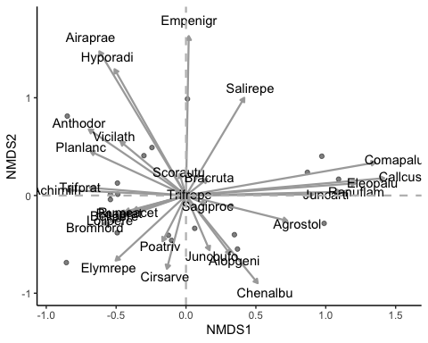

Bien preciosa la imagen, pero mejor las separamos

p1<- ggplot()+  
 geom_point(data = subset(fort, Score=='sites'),  
 mapping = aes(x= NMDS1, y= NMDS2),  
 colour= "black", alpha=0.5)+  
 geom_segment(data = subset(fort, Score=='species'),  
 mapping = aes(x=0, y=0, xend=NMDS1, yend=NMDS2),  
 arrow = arrow(length = unit(0.015,"npc"),  
 type = "closed"),  
 colour="darkgray",  
 size=0,  
 alpha=0)+  
 geom_text(data = subset(fort, Score=='species'),  
 mapping = aes(label= Label, x= NMDS1*1.1, y=NMDS2 * 1.1))+  
 geom_abline(intercept = 0, slope = 0, linetype="dashed", size=0.8, colour="gray")+  
 geom_vline(aes(xintercept=0), linetype="dashed", size=0.8, colour="gray")+  
 theme(panel.grid.major = element_blank(),  
 panel.grid.minor = element_blank(),  
 panel.background = element_blank(),  
 axis.line = element_line(colour = "black"))  
p1

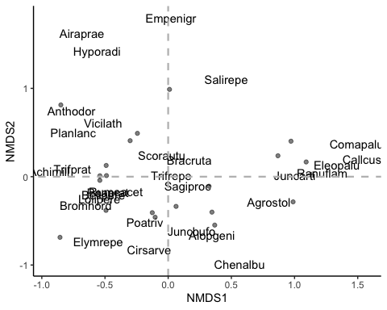

p2<- ggplot()+  
 geom_point(data = subset(fort, Score=='sites'),  
 mapping = aes(x= NMDS1, y= NMDS2),  
 colour= "black", alpha=0)+  
 geom_segment(data = subset(fort, Score=='species'),  
 mapping = aes(x=0, y=0, xend=NMDS1, yend=NMDS2),  
 arrow = arrow(length = unit(0.015,"npc"),  
 type = "closed"),  
 colour="darkgray",  
 size=0.8)+  
 geom_text(data = subset(fort, Score=='species'),  
 mapping = aes(label= Label, x= NMDS1*1.1, y=NMDS2 * 1.1))+  
 geom_abline(intercept = 0, slope = 0, linetype="dashed", size=0.8, colour="gray")+  
 geom_vline(aes(xintercept=0), linetype="dashed", size=0.8, colour="gray")+  
 theme(panel.grid.major = element_blank(),  
 panel.grid.minor = element_blank(),  
 panel.background = element_blank(),  
 axis.line = element_line(colour = "black"))  
p2

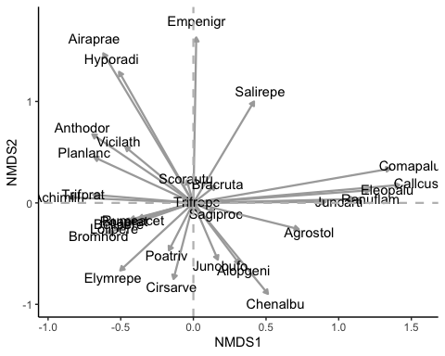

library(ggpubr)  
ggarrange(p1, p2, ncol=1)

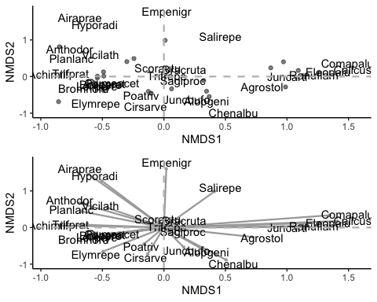

summary(dune.env)

## A1 Moisture Management Use Manure  
## Min. : 2.800 1:7 BF:3 Hayfield:7 0:6   
## 1st Qu.: 3.500 2:4 HF:5 Haypastu:8 1:3   
## Median : 4.200 4:2 NM:6 Pasture :5 2:4   
## Mean : 4.850 5:7 SF:6 3:4   
## 3rd Qu.: 5.725 4:3   
## Max. :11.500

hay cinco variables en dune.env, se hará análisis de la composicion de la comunidad de dune con los valores de Management y use (solo por escoger un par)

adonis(dune~Management, data=dune.env)

## 'adonis' will be deprecated: use 'adonis2' instead

## $aov.tab  
## Permutation: free  
## Number of permutations: 999  
##   
## Terms added sequentially (first to last)  
##   
## Df SumsOfSqs MeanSqs F.Model R2 Pr(>F)   
## Management 3 1.4686 0.48953 2.7672 0.34161 0.002 **  
## Residuals 16 2.8304 0.17690 0.65839   
## Total 19 4.2990 1.00000   
## ---  
## Signif. codes: 0 '***' 0.001 '**' 0.01 '*' 0.05 '.' 0.1 ' ' 1  
##   
## $call  
## adonis(formula = dune ~ Management, data = dune.env)  
##   
## $coefficients  
## Achimill Agrostol Airaprae Alopgeni Anthodor Bellpere  
## (Intercept) 1.0083333 2.0583333 0.2083333 1.6500000 1.1166667 0.7666667  
## Management1 1.3250000 -2.0583333 -0.2083333 -0.9833333 0.2166667 0.9000000  
## Management2 0.1916667 -0.6583333 -0.2083333 -0.0500000 0.6833333 -0.3666667  
## Management3 -0.6750000 0.1083333 0.6250000 -1.6500000 0.2166667 -0.4333333  
  
##   
## $model.matrix  
## (Intercept) Management1 Management2 Management3  
## 1 1 -1 -1 -1  
## 2 1 1 0 0  
## 3 1 -1 -1 -1  
## 4 1 -1 -1 -1  
## 5 1 0 1 0  
## 6 1 0 1 0  
## 7 1 0 1 0  
## 8 1 0 1 0  
## 9 1 0 1 0  
## 10 1 1 0 0  
## 11 1 1 0 0  
## 12 1 -1 -1 -1  
## 13 1 -1 -1 -1  
## 14 1 0 0 1  
## 15 1 0 0 1  
## 16 1 -1 -1 -1  
## 17 1 0 0 1  
## 18 1 0 0 1  
## 19 1 0 0 1  
## 20 1 0 0 1  
##   
## $terms  
## dune ~ Management  
## attr(,"variables")  
## list(dune, Management)  
## attr(,"factors")  
## Management  
## dune 0  
## Management 1  
## attr(,"term.labels")  
## [1] "Management"  
## attr(,"order")  
## [1] 1  
## attr(,"intercept")  
## [1] 1  
## attr(,"response")  
## [1] 1  
## attr(,".Environment")  
## <environment: R_GlobalEnv>  
##   
## attr(,"class")  
## [1] "adonis"

Parece que la variable Management explica la variabilidad de los datos, luego mirandola en gráficas…

p3<- ggplot()+  
 geom_point(data = subset(fort, Score=='sites'),  
 mapping = aes(x=NMDS1, y= NMDS2, colour=dune.env$Management), alpha=0.5)+  
 geom_segment(data = subset(fort, Score=='species'),  
 mapping = aes(x=0, y=0, xend=NMDS1, yend=NMDS2),  
 arrow = arrow(length = unit(0.015,"npc"),  
 type = "closed"),  
 colour="darkgray",  
 size=0,  
 alpha=0)+  
 geom_text(data = subset(fort, Score=='species'),  
 mapping = aes(label= Label, x= NMDS1*1.1, y=NMDS2 * 1.1), alpha=0)+  
 geom_abline(intercept = 0, slope = 0, linetype="dashed", size=0.8, colour="gray")+  
 geom_vline(aes(xintercept=0), linetype="dashed", size=0.8, colour="gray")+  
 theme(panel.grid.major = element_blank(),  
 panel.grid.minor = element_blank(),  
 panel.background = element_blank(),  
 axis.line = element_line(colour = "black"),  
 legend.position = c(0.8,0.2))+  
 scale_color_discrete("Management")  
 p3

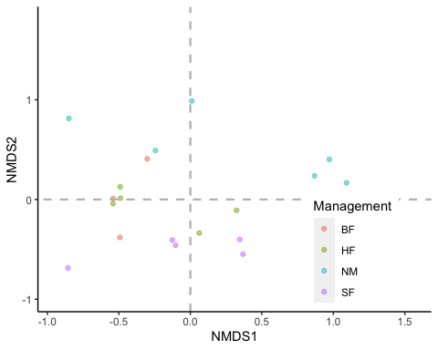

ggarrange(p3, p2, ncol = 1)

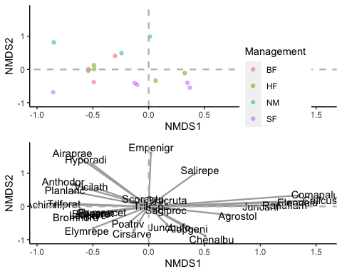

ef <- envfit(dune~Management, dune.env)  
ef

##   
## ***FACTORS:  
##   
## Centroids:  
## Achimill Agrostol  
## ManagementBF 2.3333 0.0000  
## ManagementHF 1.2000 1.4000  
## ManagementNM 0.3333 2.1667  
## ManagementSF 0.1667 4.6667  
##   
## Goodness of fit:  
## r2 Pr(>r)   
## Management 0.3916 0.029 *  
## ---  
## Signif. codes: 0 '***' 0.001 '**' 0.01 '*' 0.05 '.' 0.1 ' ' 1  
## Permutation: free  
## Number of permutations: 999

plot(nmds1, type = "t", display = "sites")

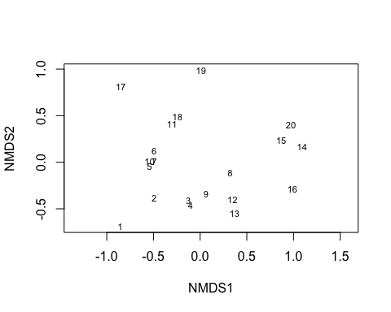

dist<- vegdist(dune, method = "bray")  
NMDS.scree <- function(x){  
plot(rep(1, 10), replicate(10, metaMDS(x, autotransform = F, k = 1)$stress) , xlim = c(1, 10),ylim = c(0, 0.30), xlab = "# de Dimensiones", ylab = "Tensi on", main = "NMDS")  
for (i in 1:10) {  
points(rep(i + 1,10),replicate(10, metaMDS(x, autotransform = F, k = i +  
1)$stress)) }  
}  
NMDS.scree(dist)

## Run 0 stress 0.2938407   
## Run 1 stress 0.4025874   
## Run 2 stress 0.5470017   
## Run 3 stress 0.4600292   
## Run 4 stress 0.5373628   
## Run 5 stress 0.5466492   
## Run 6 stress 0.5435962   
## Run 7 stress 0.3509287   
## Run 8 stress 0.3048664   
## Run 9 stress 0.4492265   
## Run 10 stress 0.5225517   
## Run 11 stress 0.2867573   
## ... New best solution  
## ... Procrustes: rmse 0.07622751 max resid 0.2770865   
## Run 12 stress 0.5460845   
## Run 13 stress 0.5368757   
## Run 14 stress 0.5110222   
## Run 15 stress 0.520062   
## Run 16 stress 0.5300691   
## Run 17 stress 0.5034551   
## Run 18 stress 0.5130705   
## Run 19 stress 0.5169513   
## Run 20 stress 0.5074115   
## *** No convergence -- monoMDS stopping criteria:  
## 20: scale factor of the gradient < sfgrmin  
## Run 0 stress 0.2938407   
## Run 1 stress 0.5024298   
## Run 2 stress 0.2850372   
## ... New best solution  
## ... Procrustes: rmse 0.06734495 max resid 0.2690499   
## Run 3 stress 0.5246805   
## Run 4 stress 0.5263482   
## Run 5 stress 0.5278921   
## Run 6 stress 0.518854   
## Run 7 stress 0.5234812   
## Run 8 stress 0.4842145   
## Run 9 stress 0.5464947   
## Run 10 stress 0.4964807   
## Run 11 stress 0.5243441   
## Run 12 stress 0.499327   
## Run 13 stress 0.4304216   
## Run 14 stress 0.3705398   
## Run 15 stress 0.5312219   
## Run 16 stress 0.2965468   
## Run 17 stress 0.5081163   
## Run 18 stress 0.536443   
## Run 19 stress 0.5022339   
## Run 20 stress 0.4616036   
## *** No convergence -- monoMDS stopping criteria:  
## 20: scale factor of the gradient < sfgrmin  
## Run 0 stress 0.2938407   
## Run 1 stress 0.4922223   
## Run 2 stress 0.5378201   
## Run 3 stress 0.5461177   
## Run 4 stress 0.2876251   
## ... New best solution  
## ... Procrustes: rmse 0.06674441 max resid 0.2678954   
## Run 5 stress 0.5319195   
## Run 6 stress 0.5333835   
## Run 7 stress 0.5406552   
## Run 8 stress 0.4641049   
## Run 9 stress 0.3730075   
## Run 10 stress 0.5202829   
## Run 11 stress 0.3530994   
## Run 12 stress 0.5439807   
## Run 13 stress 0.5398738   
## Run 14 stress 0.4350717   
## Run 15 stress 0.5127701   
## Run 16 stress 0.5195721   
## Run 17 stress 0.5148891   
## Run 18 stress 0.424589   
## Run 19 stress 0.5454508   
## Run 20 stress 0.5304541   
## *** No convergence -- monoMDS stopping criteria:  
## 20: scale factor of the gradient < sfgrmin  
## Run 0 stress 0.2938407   
## Run 1 stress 0.4409915   
## Run 2 stress 0.5112527   
## Run 3 stress 0.5449241   
## Run 4 stress 0.5016825   
## Run 5 stress 0.5280206   
## Run 6 stress 0.3004491   
## Run 7 stress 0.5388935   
## Run 8 stress 0.4995866   
## Run 9 stress 0.5405962   
## Run 10 stress 0.4701103   
## Run 11 stress 0.5165538   
## Run 12 stress 0.470313   
## Run 13 stress 0.5267728   
## Run 14 stress 0.5061077   
## Run 15 stress 0.4024942   
## Run 16 stress 0.5339035   
## Run 17 stress 0.4134881   
## Run 18 stress 0.5421617   
## Run 19 stress 0.5195591   
## Run 20 stress 0.5298581   
## *** No convergence -- monoMDS stopping criteria:  
## 20: scale factor of the gradient < sfgrmin  
## Run 0 stress 0.2938407   
## Run 1 stress 0.2771668   
## ... New best solution  
## ... Procrustes: rmse 0.1058146 max resid 0.3248548   
## Run 2 stress 0.4590853   
## Run 3 stress 0.5418536   
## Run 4 stress 0.5099428   
## Run 5 stress 0.5042216   
## Run 6 stress 0.5412669   
## Run 7 stress 0.5447697   
## Run 8 stress 0.5339513   
## Run 9 stress 0.5276736   
## Run 10 stress 0.5049034   
## Run 11 stress 0.2871863   
## Run 12 stress 0.5437495   
## Run 13 stress 0.5368704   
## Run 14 stress 0.452855   
## Run 15 stress 0.5330238   
## Run 16 stress 0.5426366   
## Run 17 stress 0.5468712   
## Run 18 stress 0.5332171   
## Run 19 stress 0.5144826   
## Run 20 stress 0.3736156   
## *** No convergence -- monoMDS stopping criteria:  
## 20: scale factor of the gradient < sfgrmin  
## Run 0 stress 0.2938407   
## Run 1 stress 0.4578099   
## Run 2 stress 0.5268123   
## Run 3 stress 0.5372604   
## Run 4 stress 0.5337244   
## Run 5 stress 0.5159585   
## Run 6 stress 0.4697486   
## Run 7 stress 0.4860655   
## Run 8 stress 0.4719845   
## Run 9 stress 0.4919862   
## Run 10 stress 0.5222301   
## Run 11 stress 0.5081787   
## Run 12 stress 0.5465094   
## Run 13 stress 0.5039866   
## Run 14 stress 0.435342   
## Run 15 stress 0.2861583   
## ... New best solution  
## ... Procrustes: rmse 0.07262532 max resid 0.2714592   
## Run 16 stress 0.387561   
## Run 17 stress 0.2852687   
## ... New best solution  
## ... Procrustes: rmse 0.01285604 max resid 0.03403732   
## Run 18 stress 0.33282   
## Run 19 stress 0.5459808   
## Run 20 stress 0.3991999   
## *** No convergence -- monoMDS stopping criteria:  
## 20: scale factor of the gradient < sfgrmin  
## Run 0 stress 0.2938407   
## Run 1 stress 0.5400158   
## Run 2 stress 0.5311931   
## Run 3 stress 0.5307949   
## Run 4 stress 0.5439706   
## Run 5 stress 0.4981306   
## Run 6 stress 0.5463258   
## Run 7 stress 0.5390881   
## Run 8 stress 0.5467224   
## Run 9 stress 0.5442281   
## Run 10 stress 0.5407837   
## Run 11 stress 0.5347893   
## Run 12 stress 0.457998   
## Run 13 stress 0.4263574   
## Run 14 stress 0.5315353   
## Run 15 stress 0.2980102   
## Run 16 stress 0.5157518   
## Run 17 stress 0.5477226   
## Run 18 stress 0.5343574   
## Run 19 stress 0.5435451   
## Run 20 stress 0.5035776   
## *** No convergence -- monoMDS stopping criteria:  
## 20: scale factor of the gradient < sfgrmin  
## Run 0 stress 0.2938407   
## Run 1 stress 0.5445416   
## Run 2 stress 0.3851485   
## Run 3 stress 0.5456255   
## Run 4 stress 0.533938   
## Run 5 stress 0.4626337   
## Run 6 stress 0.5128785   
## Run 7 stress 0.5472165   
## Run 8 stress 0.2926193   
## ... New best solution  
## ... Procrustes: rmse 0.03172713 max resid 0.1134179   
## Run 9 stress 0.5256666   
## Run 10 stress 0.4094202   
## Run 11 stress 0.5028548   
## Run 12 stress 0.5127819   
## Run 13 stress 0.5121656   
## Run 14 stress 0.4947021   
## Run 15 stress 0.5411517   
## Run 16 stress 0.5417701   
## Run 17 stress 0.5229463   
## Run 18 stress 0.5304237   
## Run 19 stress 0.5163832   
## Run 20 stress 0.5204037   
## *** No convergence -- monoMDS stopping criteria:  
## 20: scale factor of the gradient < sfgrmin  
## Run 0 stress 0.2938407   
## Run 1 stress 0.4398692   
## Run 2 stress 0.5437366   
## Run 3 stress 0.5327331   
## Run 4 stress 0.4680706   
## Run 5 stress 0.4957387   
## Run 6 stress 0.382833   
## Run 7 stress 0.4980813   
## Run 8 stress 0.5454142   
## Run 9 stress 0.4864843   
## Run 10 stress 0.5444432   
## Run 11 stress 0.5186201   
## Run 12 stress 0.5445798   
## Run 13 stress 0.5019101   
## Run 14 stress 0.5214256   
## Run 15 stress 0.5398759   
## Run 16 stress 0.5302487   
## Run 17 stress 0.5206445   
## Run 18 stress 0.2932994   
## ... New best solution  
## ... Procrustes: rmse 0.0402369 max resid 0.1627709   
## Run 19 stress 0.544997   
## Run 20 stress 0.4960667   
## *** No convergence -- monoMDS stopping criteria:  
## 20: scale factor of the gradient < sfgrmin  
## Run 0 stress 0.2938407   
## Run 1 stress 0.5169117   
## Run 2 stress 0.5132037   
## Run 3 stress 0.5288466   
## Run 4 stress 0.3667858   
## Run 5 stress 0.44054   
## Run 6 stress 0.4940321   
## Run 7 stress 0.4314195   
## Run 8 stress 0.5290224   
## Run 9 stress 0.4835889   
## Run 10 stress 0.450282   
## Run 11 stress 0.4958278   
## Run 12 stress 0.5229686   
## Run 13 stress 0.5249566   
## Run 14 stress 0.5295772   
## Run 15 stress 0.4619061   
## Run 16 stress 0.5127023   
## Run 17 stress 0.5347559   
## Run 18 stress 0.5442697   
## Run 19 stress 0.4766994   
## Run 20 stress 0.4333491   
## *** No convergence -- monoMDS stopping criteria:  
## 20: scale factor of the gradient < sfgrmin

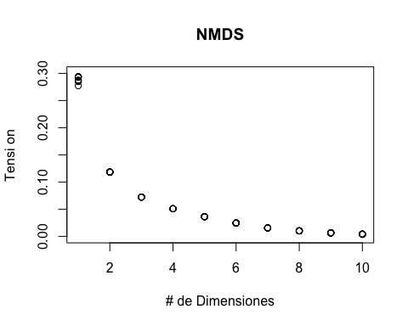

Aqui vuelvo a intentar de la forma en como lo vimos en la clase

NMDSA <- metaMDS(dune, k=2, trymax = 100, trace = F, autotransform = F, distance = "bray")  
NMDSA

##   
## Call:  
## metaMDS(comm = dune, distance = "bray", k = 2, trymax = 100, autotransform = F, trace = F)   
##   
## global Multidimensional Scaling using monoMDS  
##   
## Data: dune   
## Distance: bray   
##   
## Dimensions: 2   
## Stress: 0.1183186   
## Stress type 1, weak ties  
## Two convergent solutions found after 20 tries  
## Scaling: centring, PC rotation, halfchange scaling   
## Species: expanded scores based on 'dune'

plot.new()  
plot(NMDSA, display = "sites", type = "n")  
points(NMDSA, display = "sites", col = "red", cex = 1.25)

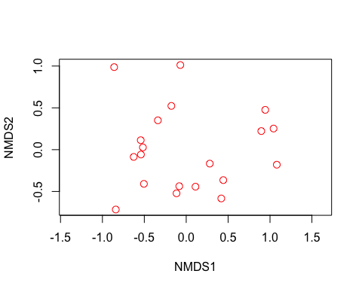

ordiplot(NMDSA, type = "n")  
orditorp(NMDSA, display = "species", col = "red", air = 0.01)   
orditorp(NMDSA, display = "sites", cex = 1.1, air = 0.01)

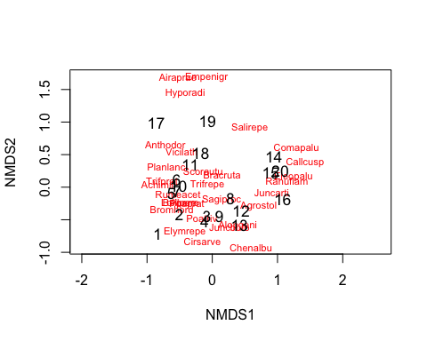

##Interpretación

data("dune.env")  
ef <- envfit(NMDSA, dune.env)   
ef

##   
## ***VECTORS  
##   
## NMDS1 NMDS2 r2 Pr(>r)   
## A1 0.96474 0.26322 0.3649 0.018 *  
## ---  
## Signif. codes: 0 '***' 0.001 '**' 0.01 '*' 0.05 '.' 0.1 ' ' 1  
## Permutation: free  
## Number of permutations: 999  
##   
## ***FACTORS:  
##   
## Centroids:  
## NMDS1 NMDS2  
## Moisture1 -0.5101 -0.0403  
## Moisture2 -0.3938 0.0139  
## Moisture4 0.2765 -0.4033  
## Moisture5 0.6561 0.1476  
## ManagementBF -0.4534 -0.0102  
## ManagementHF -0.2636 -0.1282  
## ManagementNM 0.2958 0.5790  
## ManagementSF 0.1506 -0.4670  
## UseHayfield -0.1568 0.3248  
## UseHaypastu -0.0412 -0.3370  
## UsePasture 0.2854 0.0844  
## Manure0 0.2958 0.5790  
## Manure1 -0.2482 -0.0215  
## Manure2 -0.3079 -0.1866  
## Manure3 0.3101 -0.2470  
## Manure4 -0.3463 -0.5583  
##   
## Goodness of fit:  
## r2 Pr(>r)   
## Moisture 0.5014 0.001 ***  
## Management 0.4134 0.004 **   
## Use 0.1871 0.128   
## Manure 0.4247 0.029 *   
## ---  
## Signif. codes: 0 '***' 0.001 '**' 0.01 '*' 0.05 '.' 0.1 ' ' 1  
## Permutation: free  
## Number of permutations: 999

plot(NMDSA, type = "t", display = "sites")   
plot(ef, p.max = 0.05)

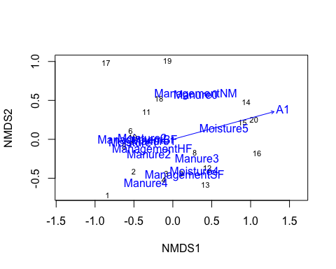

group = c(rep(“Group1”, 12), rep(“Group2”, 12))

colors = c(rep(“red”, 12), rep(“blue”, 12))

ordiplot (NMDSA, display = 'si', type = 'n')  
points (NMDSA, col = dune.env$Management)

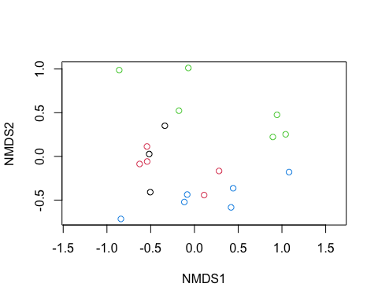

Otra ves no pude avanzar de esta parte, lo intenté de varias maneras pero me di por vencido… hay una tesis que se tiene que escribir… en vacaciones lo revisaré porque me interesa muchisimo este análisis