|  |  |
| --- | --- |
| **Cairo University**  **Faculty of Engineering**  **Electronics & Comm. Dept.** | **Fourth Year 2020 / 2021**  **Electronics ELC401A** |



**CMOS Operational Amplifier Design**

|  |  |  |
| --- | --- | --- |
| **الرقم** | **السكشن** | **الأسم** |
| **55** | **2** | **عبدالرحمن ايمن محمود** |
| **60** | **2** | **عبدالرحمن عبدالعظيم عبدالرحمن** |
| **60** | **3** | **محمد محمود جابر** |
| **51** | **4** | **هشام محمد عبدالله نجيب حسن** |

# Problem Definition: Folded-Cascode Operational Amplifier for Buffer Use

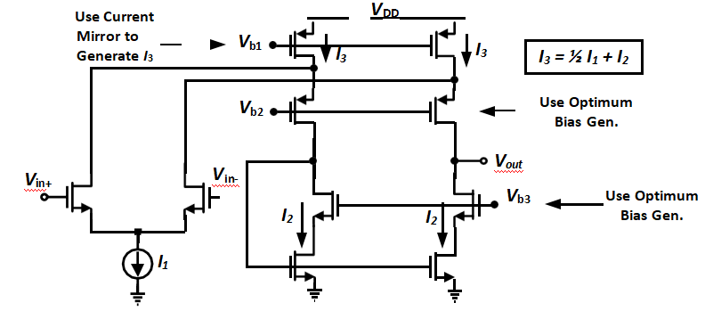

## 1.1. Specifications🡺Problem Analysis

You are required to design the single-ended single-stage op-amp shown such that:

* + *V*DD = 3.3V🡺🡺Tsmc130nm Nmos3v/Pmos3v of Vth=650mv
  + *V*inCM = VDD / 2 = 1.65 V VDS1 , VDS2 is fixed at a certain value
  + *A*DC > 55 dB (DC differential gain)🡺🡺Vds=Veff+100mV
  + GBW > 100 MHz for a load of 2pF🡺Inv. Prob.🡺 Tunable Range for Bias of I1

– Slew Rate > 100 V/𝜇𝑠𝑒𝑐 🡺🡺Small Signal Analysis

* + Output Swing > 1.5Vpp 🡺🡺 Large Signal Analysis
  + Input referred thermal noise density < 10𝑛𝑉/√𝐻𝑧
  + PM > 60 degrees🡺🡺Inversely Proportional with GBW🡺 Tunable Range for Bias of I1
  + Minimize power consumption🡺🡺Vb Power Consumption

## 1.2. Large Signal Analysis

**Specs & Givens**:

* O/P Swing = 1.5Vpp
* Vth n,p~= 650 mV
* VDS=Vov+100mV
* VDD=3.3 V

**Solution:**

* Step1: Determine Overdrive Voltage:

* Step2: Determine Vb1 from overdrive voltage and VDS=Vov+100mV
* Step3: Determine Vb2 from Vb1, overdrive voltage and VDS=Vov+100mV
* Step4: Determine bias voltage for M0

805mV< Vg of M0 < 850mV

will occur so it is better to choose in between like 830mV

## 1.3. Small Signal Analysis

* Model Parameter Extraction neglecting short channel effects
  + Kn: 16 uA/V2
  + Vthn: 0.62
  + Kp: 6 uA/V2
  + Vthp: 0.63
  + L=1um
* Extracting Small Signal Parameters:
  + Slewrate > 100V/usec===>gm1,2=1.294mA/V
  + Bandwidth > 100MHz===> gm3,4=gm5,6=1.294mA/V

|  |  |  |  |  |  |  |  |
| --- | --- | --- | --- | --- | --- | --- | --- |
| M# | Vg | W/L | Type | M# | Vg | W/L | Type |
| 0 | 830mV | 80.25 | NMOS | 5,6 | 1.26V | 39.75 | NMOS |
| 1,2 | 1.65(given) | 68.1 | NMOS | 7,8 | 1.85V | 39.75*2 | PMOS |
| 3,4 | Vout | 39.75 | NMOS | 9,10 | 2.25V | 39.75*2 | PMOS |

# 2. Simulations

### 2.1. Simulate the circuit (inside opamp)

#### 2.1.1. Print all transistor operating point information (DC)

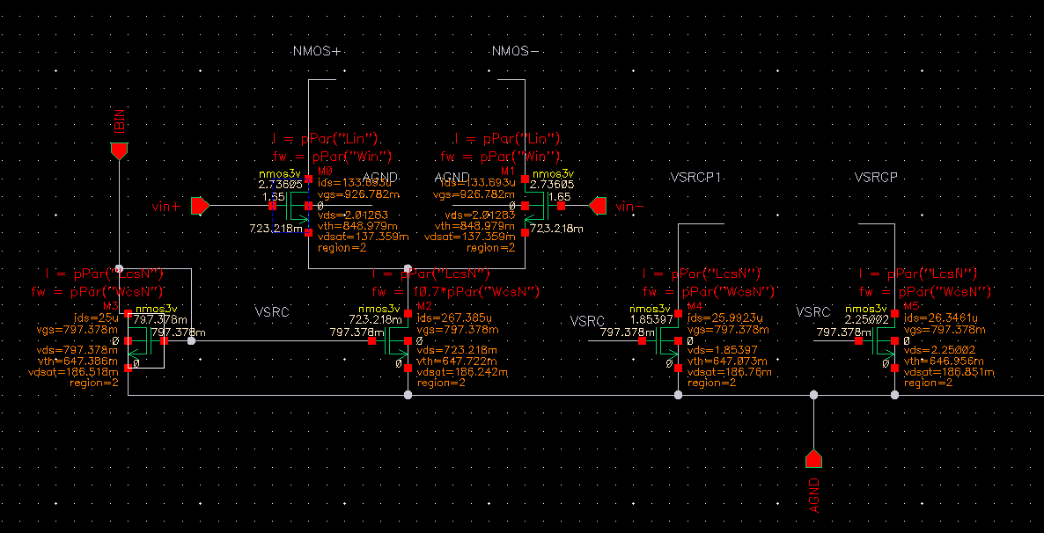

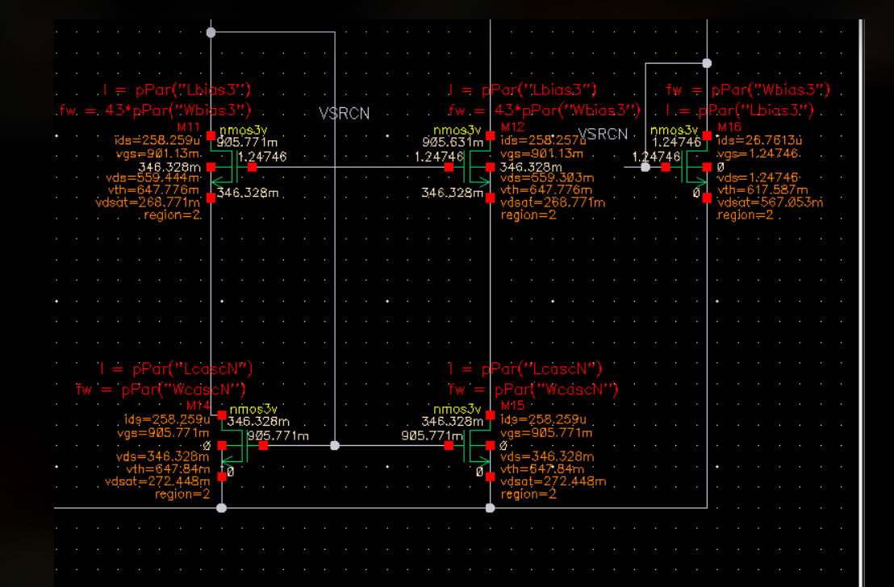

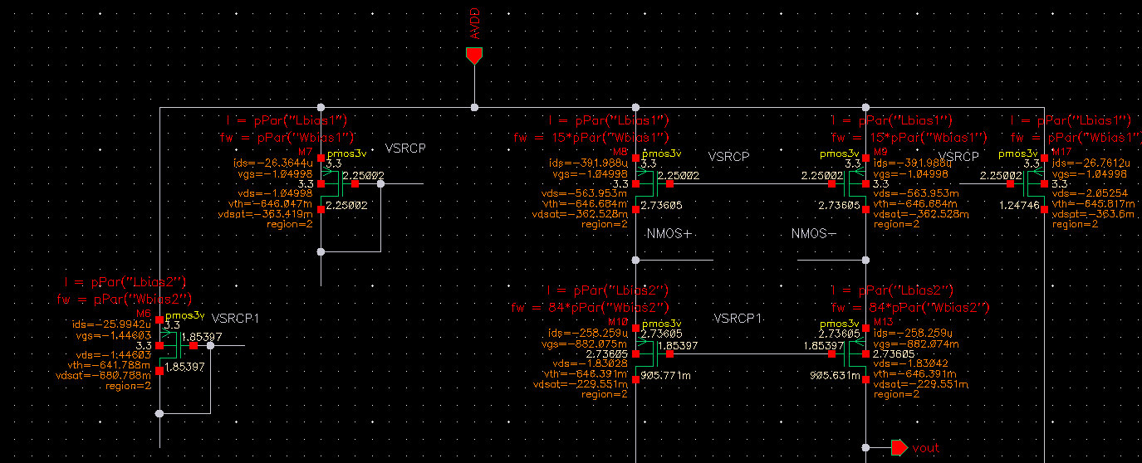

#### 

#### 2.1.2. Plot the gain and phase versus frequency (AC). Show open-loop gain and PM

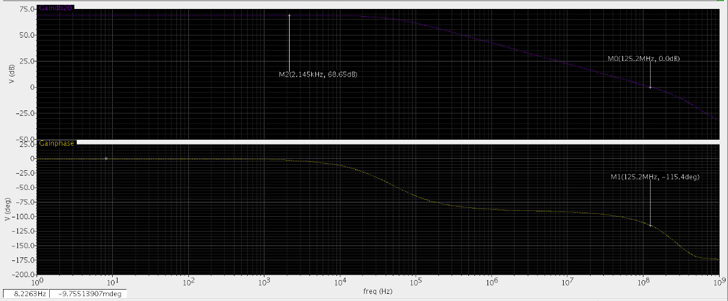

**Comments:**

Gain-Bandwidth product is about 125MHz>100MHz and Phase margin=180-115=65>60 degrees and

DC-Gain=68.65dB>50dB

#### 2.1.3. Plot the common-mode rejection ratio (CMRR)

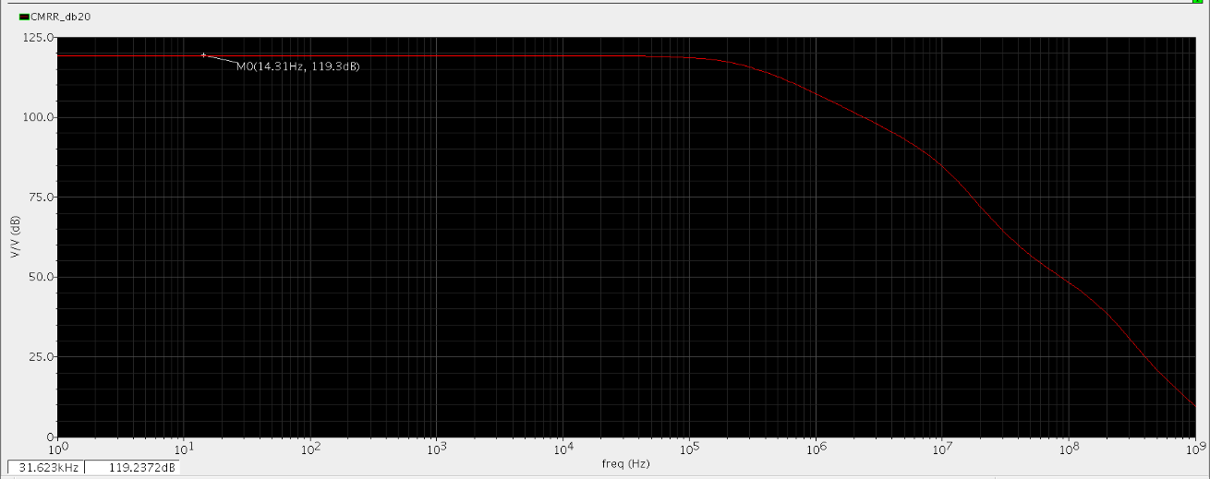

**Comments:**

Common Mode Rejection Ratio is about 113 dB which is very high and make opamp act with very good

efficiency in rejecting noise

#### 2.1.4. Plot the power supply rejection ratio (PSRR)

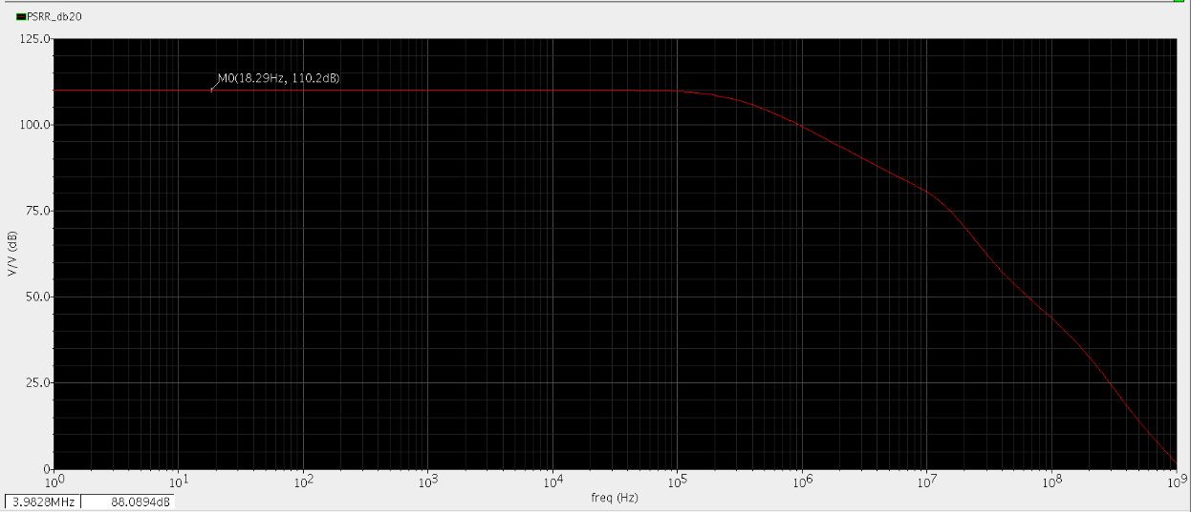

**Comments:**

Power supply rejection ratio is very high about 110 dB which means the high capability of this opamp to reject supply voltage variations

### 

### 

### 2.2. Place the op-amp in a unity feedback (**Buffer**) configuration:

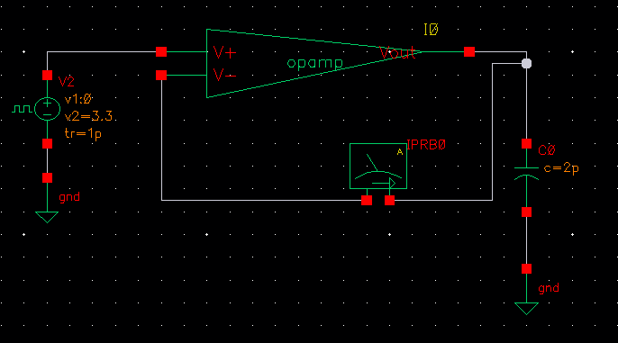

#### 2.2.1. Plot STB gain and phase versus frequency (AC) and calculate open-loop gain and PM

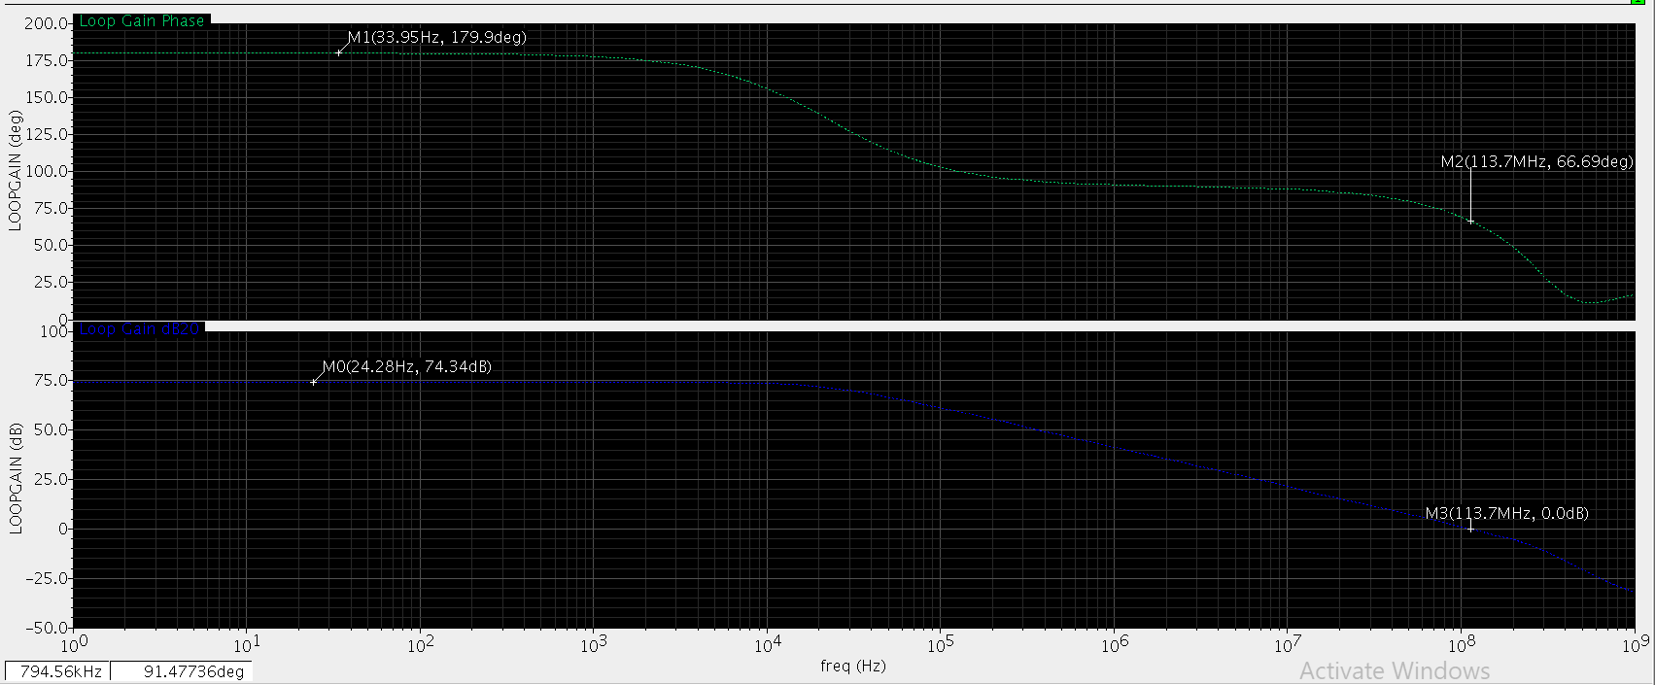

**Comments:**

Gain-Bandwidth product is 113.7 MHz and DC-gain=74.35dB

#### 2.2.2. What is the difference between those results and previous open-loop AC results?Using Probe sees another capacitance when measuring at input port of the opamp

#### 

#### 

#### 2.2.3. Plot the DC-gain versus *V*out (report when DC-gain drops by 10dB to verify specifications)

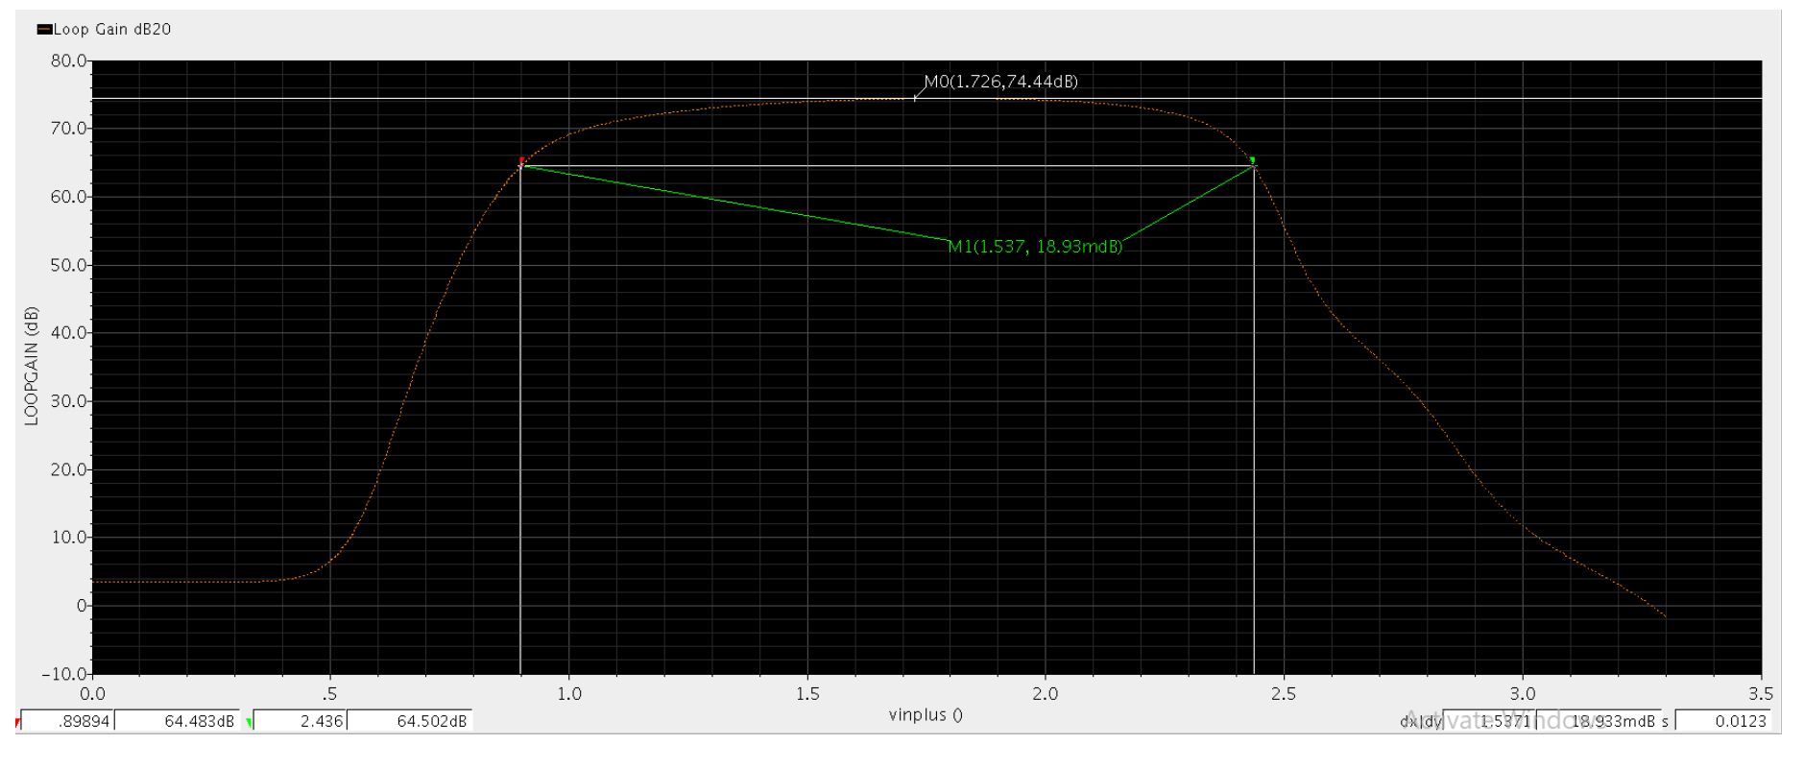

**Comments:**

Output Swing is of value = 1.54Vpp > 1.5Vpp

#### 2.2.4. Plot the closed-loop (CL) frequency response. What is ACL and BWCL (comment)?

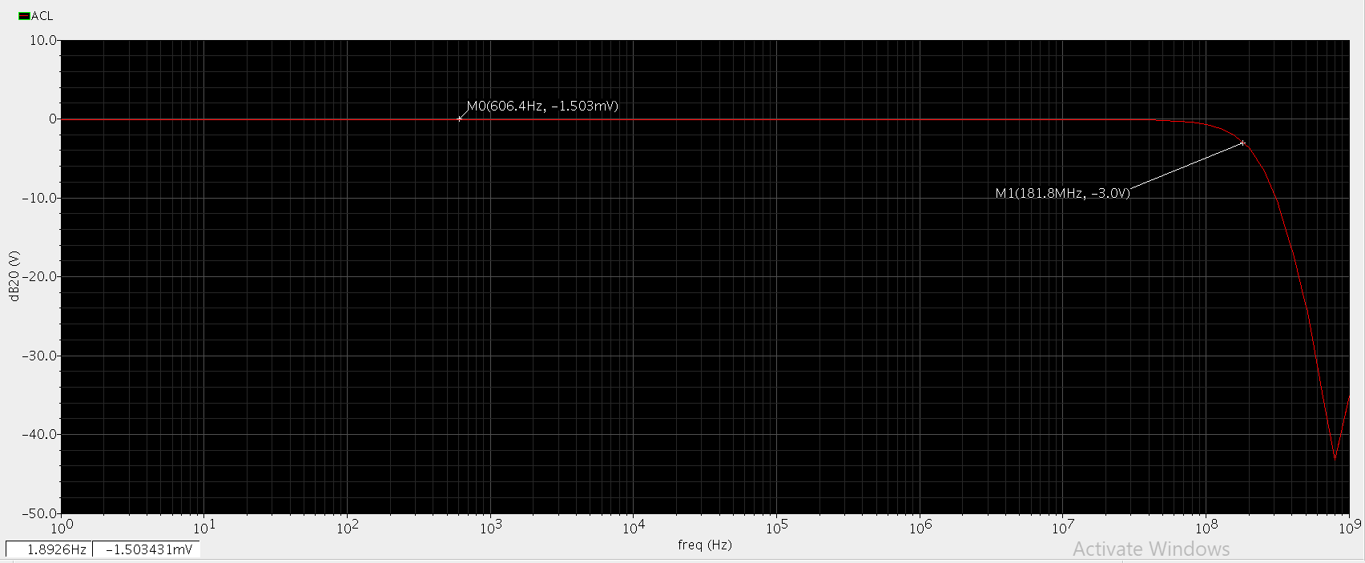

**Comment:**

Bandwidth is extended to 181.8 MHz and DC gain remains -1.503 mdb (Buffer since it ‘s very near to 0)

#### 2.2.5. Simulate input-referred noise and tabulate top 4 contributors @10MHz (comment).

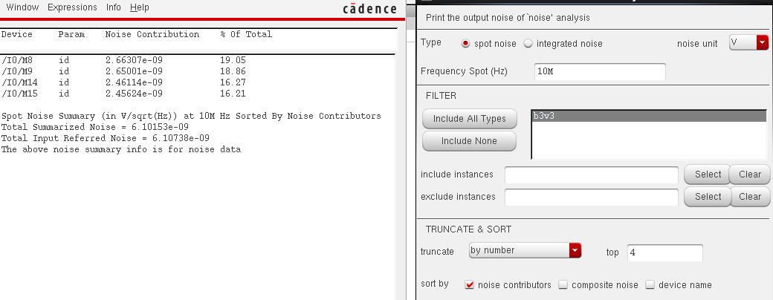

**Comments:**

Total input referred noise is of value 6.1 nV/ sqrt(Hz) < 10nV/sqrt(Hz)

#### 

#### 

#### 2.2.6. Simulate the slew rate and verify the specifications.

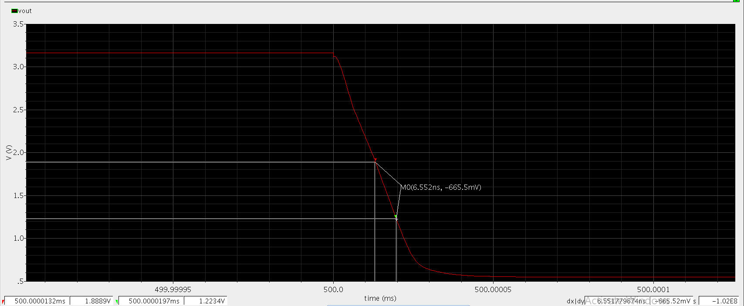

**Comments:**

Slew rate is 102v/usec. > 100v/usec.

#### 2.2.7. Apply a sine input signal of 1Vpp @10MHz and plot Vout (add proper input DC value). Plot DFT (in dB) and calculate harmonic distortion HD2, HD3, and THD (comment).

**-plot Vout vs time:**

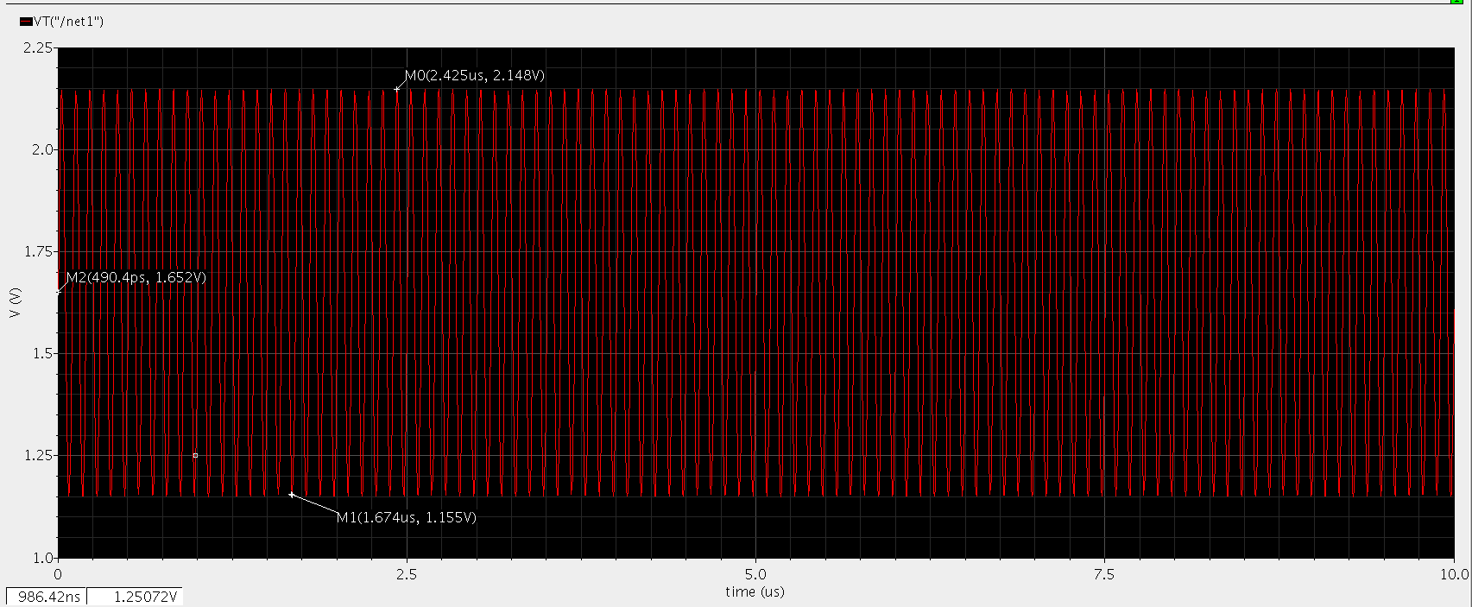

**-plot DFT of Vout (db20) vs frequency :**

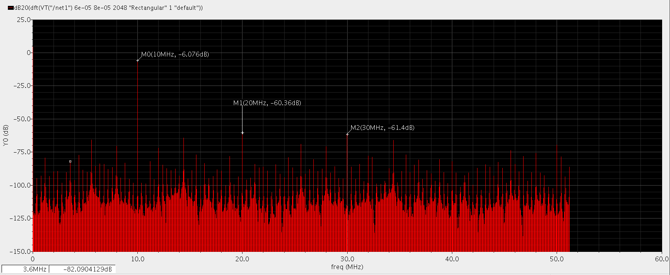

Comment:

AT 10 MHZ, The harmonic distortion=-6 db is clearly high since the source is excited at 10 MHz.

,.

-**-calculating THD :**

**We will use the calculator in cadence to calculator THD :**



**Comment:**

since THD is calculated as percentage,so THD =372E-3 % ,which means the harmonic distortion is very small nearly negligible.

#### 2.2.8. Plot Vout for a small step input of 100mV (add proper input DC value). Calculate the fractional gain error (FGE) and 1% settling time (compare with hand analysis).

**-plot Vout vs time(100mv):**

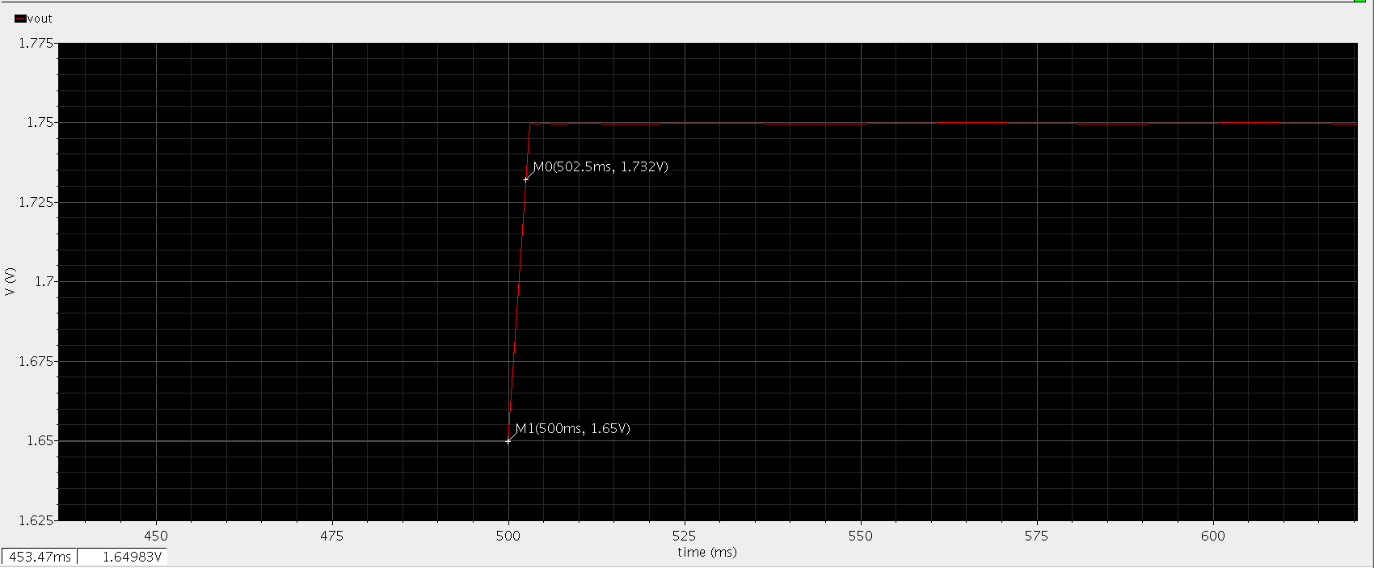

Comment:

-from the previous :Ts=502.5-500=2.5msec.

-To calculate it analytically:, since GBW=2*pi*181.8 MHz as it ‘s shown in ClosedLoop frequency response so Ts=3.5 ns.

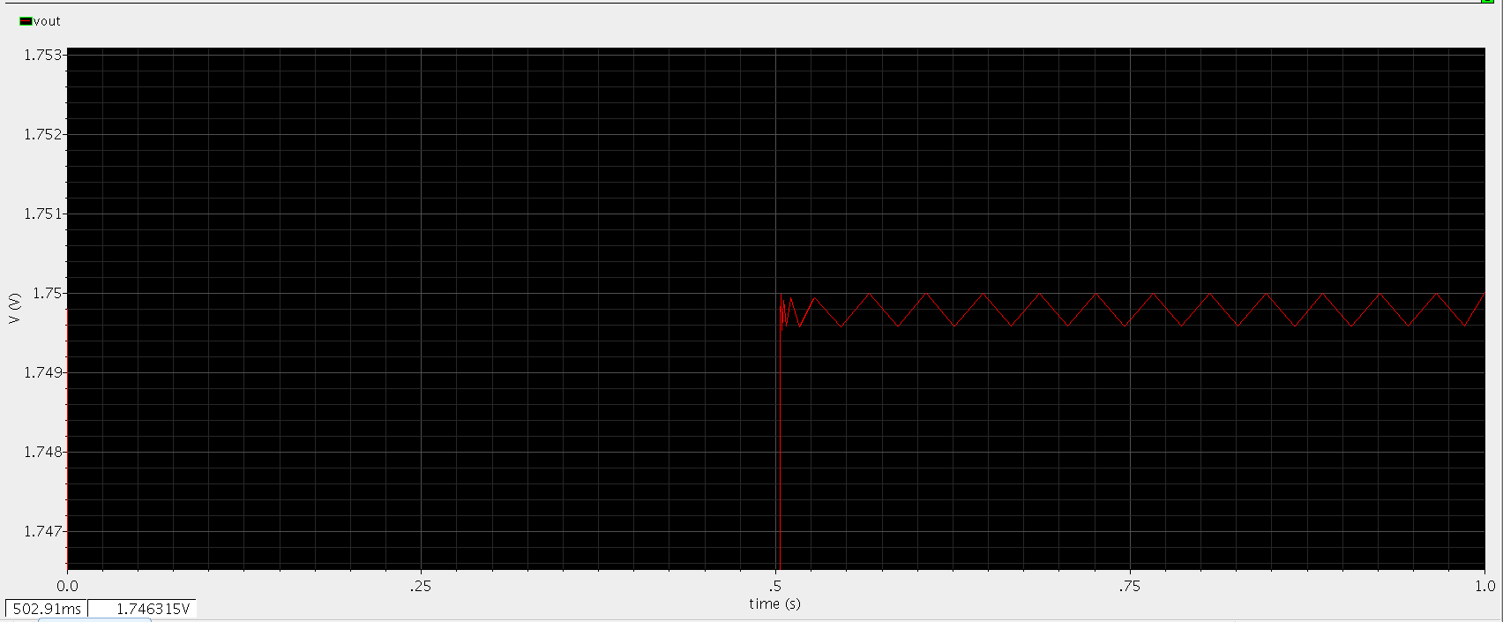

**Comment:**

We can note that the analytical value is very different to the practical value and that’s because PM is not very big nearly 66 deg. and that causes ringing as shown in the previous figure , so this suggests that the system is not underdamped and that’s why this equation doesn’t hold.

-Calculating FGE:

from the closed loop frequency response

so

Analytically: , since loop gain in buffer=74.34 db, so FGE=192E-6.

So as shown the two values practical and analytical are comparable.