

Analog IC Design Intern Application

Lab#1: SPICE

Prepared by:

Hisham Elreedy

Reasons For Sending After OverDue and not being accepted:

1. I understood the problem Correctly after searching it was easier than I expected
2. I would like to know a feedback on my work because I may did something wrong again because I learn by this way if I didn’t try I won’t learn then I won’t be able to join ADT team
3. The question in interview was so easy but I didn’t answer because I worried you ask a harder question about analog design not control theory, like what I thought about the assignment
4. I studied control theory last year and we built analog low freq. filters based on mathematical modeling approaches which we learned while studying control theory course

1. I didn’t remember all of this as it was long time ago and this year of study we were focusing on electromagnetics theory and microwave-antenna design approaches. But I revised all of them and solved interview problem, where my GP focuses on Control theory approach but not in direct way like using pre-standard libraries in our work for mathematical modeling for Neural Networks like pytorch.

# Requirement 1: SPICE subcircuit that describes an op-amp with an open-loop gain of 1e4 and a UGF of 10MHz.

1. **Circuit Diagram:**

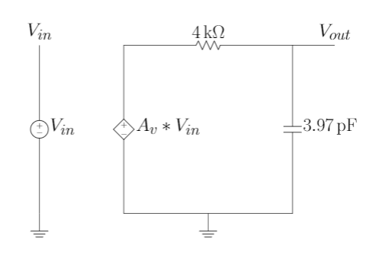

## Equations:

$$F_{Hz}=\frac{1}{2πRC}$$

$$∵F_{Hz}=10MHz$$

$$choose R=4KΩ$$

$$∴C=3.97pF$$

## Spice Netlist Code:

*-----------------------------------------------

*Requirement 1

*-----------------------------------------------

.subckt nonidealopamp plus minus out

E1 mid gnd plus minus 1e4 * **linear-dependent** voltage source to model opamp

R1 mid out 4k * R1

C1 out gnd 3.97pf *C1

.ENDS nonidealopamp

# Requirement 2: Use the previous sub circuit to write a netlist of a non-inverting amplifier. The feedback resistance is 9kOhm and the other resistance is 1kOhm. Use a 1V DC input. Use comments generously to describe every line of the netlist. Run transfer function (TF)analysis. Report a snapshot of the SPICE output file. Justify the output.

## Block and Circuit Diagram

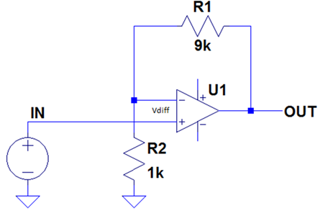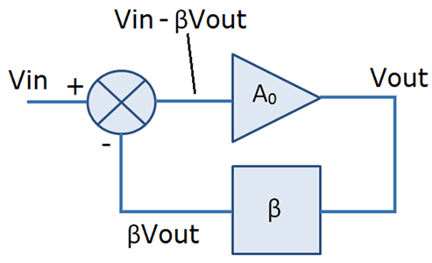

## Spice Netlist Code

## Xop1 plus minus out nonidealopamp

## R2 gnd minus 1k

## R1 minus out 9k

## Vin plus gnd 1V

## .tf V(out) Vin

## .probe

## 2.2. Simulation

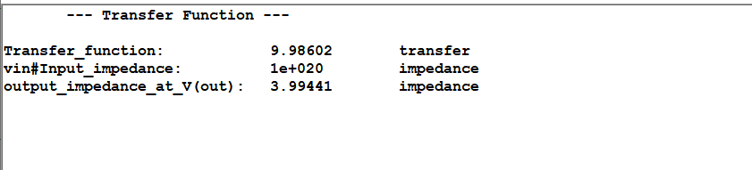

## 2.3. Analysis Equations

$$V^{-}=V_{out}*\frac{R_{2}}{R_{1}+R_{2}}\left(from circuit\right)=V_{out}*β (from block diagram)$$

$$β=\frac{R_{2}}{R_{1}+R_{2}}=\frac{1}{10}=0.1$$

$$V^{+}=V_{in} (in block and cct diagram)$$

$$TF\left(s\right)=\frac{V_{out}}{V_{in}}\left(S\right)=\frac{\frac{A_{o}}{1+sCR}}{1+\frac{A_{o}β}{1+sCR}}=\frac{A_{o}}{{1+sCR+A}_{o}β}≅\frac{1}{β}=\frac{R_{1}+R_{2}}{R_{2}}=1+\frac{R_{1}}{R_{2}}=10$$

The gain become independent of frequency which means GBW is infinite

# Requirement3: Change the input to be a sine wave with 1V amplitude and 1kHz frequency. Run transient analysis for two complete periods. Use a time step = period/50. Report results (Vsig and Vout vs time). Clearly annotate the peak value of Vsig and Vout in the figure

## Spice Netlist Code:

Xop1 plus minus out nonidealopamp

R2 gnd minus 1k

R1 minus out 9k

Vin plus gnd SIN 0 1V 1k

.tran 200us 1ms

## Simulation

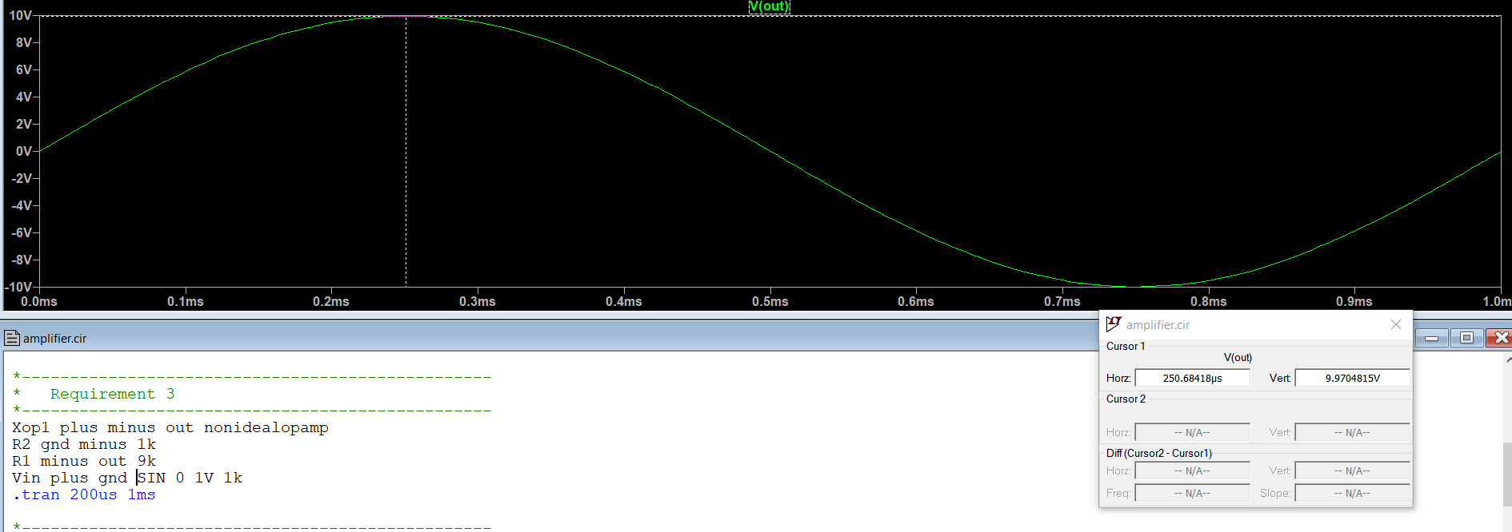

## Analysis Equation

$$V_{out}=V_{in}*T.F=10*1V≅10V$$

# Requirement 4: How much is the voltage gain? Compare the voltage gain acquired from hand analysis, TF analysis, and TRAN analysis in a table. Comment.

|  |  |  |  |
| --- | --- | --- | --- |
|  | Hand Analysis | TF Analysis | TRAN Analysis |
| Voltage Gain | $$@s=0\left(DC\right)$$ $tf=\frac{A_{o}}{{1+A}_{o}β}=\frac{{10}^{4}}{1+{10}^{4}*\frac{1}{10}}=$ 9.99 | 9.986 | 9.97 |

Comment:

This proves that TF analysis is more accurate than Tran. analysis

# Requirement 5: Report the waveform of the differential input of the op-amp. Clearly annotate the peak value in the figure. What is the amplitude of this signal? Why (explain with hand-analysis)?

## Simulation

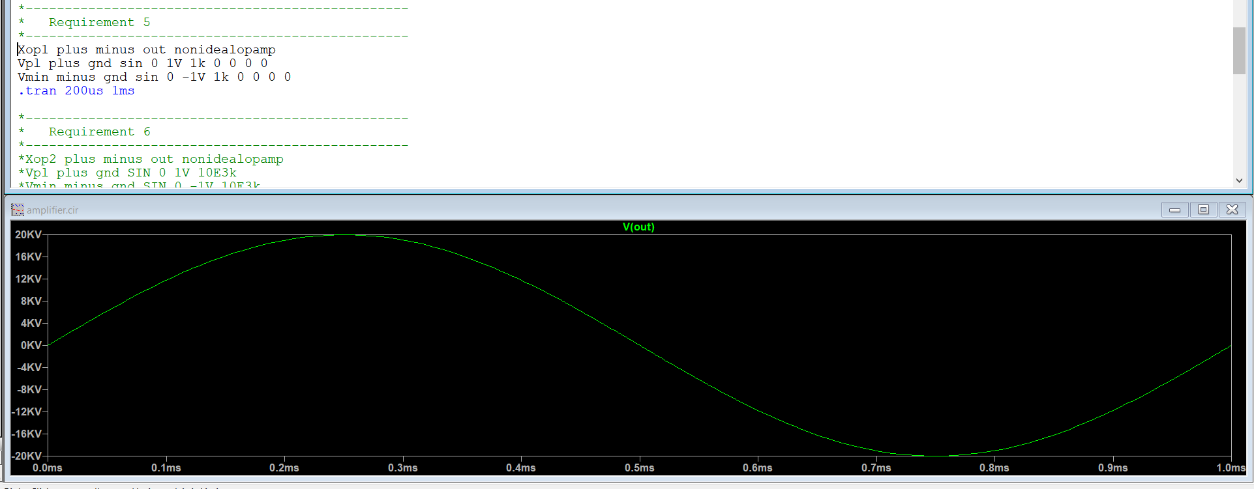

## Analysis Equation

$$V_{out}=A_{v}*\left(V^{+}-V^{-}\right)=20kV$$

$$@ω≪\frac{1}{RC} ,\frac{V_{out}}{V_{in}}\left(jω\right)=\frac{A_{o}}{1+jωCR}==>LPF≅A_{o}$$

## Spice Netlist Code

## Xop2 plus minus out nonidealopamp

## Vplus plus gnd SIN 0 1V 1k

## Vminus minus gnd SIN 0 -1V 1k

## R1 out gnd 1

## .tran 200us 1ms

# Requirement 6: Repeat the previous step but with input frequency equal to the UGF. What is the amplitude of this signal? Why (explain with hand-analysis)?

$$@ω≫\frac{1}{RC} ,\frac{V_{out}}{V_{in}}\left(jω\right)=\frac{A_{o}}{1+jωCR}==>integrator(\frac{1}{jω})≅\frac{A_{o}}{jωCR}$$

Input frequency equal to UGF means that roots is at the edge of stability which means at the oscillatory frequency

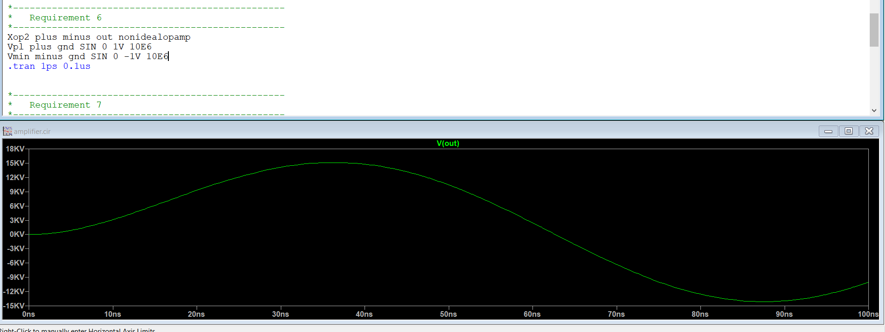

# Requirement 7: Run AC analysis to plot the frequency response of the previous non-inverting amplifier (use an AC source). Use parametric sweep for the feedback resistance with two values (9k and 4k). Report the gain in dB vs frequency (log-log scale). Clearly annotate the DC gain, the 3dB high cutoff frequency, and the GBW (UGF) in the figure

## Simulation

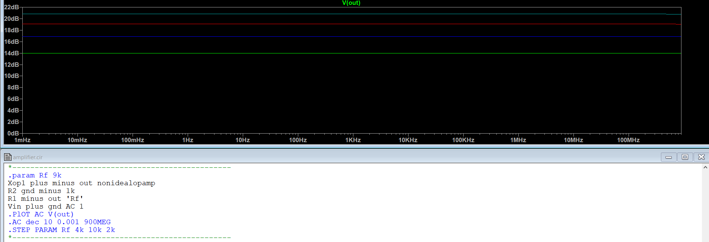

## Analysis

|  |  |  |
| --- | --- | --- |
| Rf | Gain(v/v) | Gain in dB |
| 4k | 5 | 13.979 |
| 6k | 7 | 16.9 |
| 8k | 9 | 19.085 |
| 10k | 11 | 20.827 |

## 3dB cutoff @ inf. And GBW is infinite because open loop gain is approx. infinite

$$TF\left(s\right)=\frac{V_{out}}{V_{in}}\left(S\right)=\frac{\frac{A_{o}}{1+sCR}}{1+\frac{A_{o}β}{1+sCR}}=\frac{A_{o}}{{1+sCR+A}_{o}β}≅\frac{1}{β}=\frac{R_{1}+R_{2}}{R_{2}}=1+\frac{R_{1}}{R_{2}}=10$$

The gain become independent of frequency which means GBW is infinite

## Spice Netlist Code

*.param Rf 9k

*Xop1 plus minus out nonidealopamp

*R2 gnd minus 1k

*R1 minus out 'Rf'

*Vin plus gnd AC 1

*.PlOT AC V(out)

*.AC dec 10 0.001 900MEG

*.STEP PARAM Rf 4k 10k 2k

# Requirement 8: If you increase the input amplitude in AC analysis and transient analysis, do you expect to see clipping in the output? Why?

No, because we are using a ideal linear dependent source which means it never saturates that’s why we can’t see clipping in the output

# Requirement 9: Compare the DC gain, the 3dB high cutoff frequency, and the GBW (UGF) from hand analysis and AC analysis in a table. Comment.

|  |  |  |
| --- | --- | --- |
|  | Hand Analysis | AC Analysis |
| DC Gain | 80dB | 80dB |
| 3dB high cutoff frequency | 10MHz | 10MHz |
| GBW(UGF) | 10MHz | 10MHz |

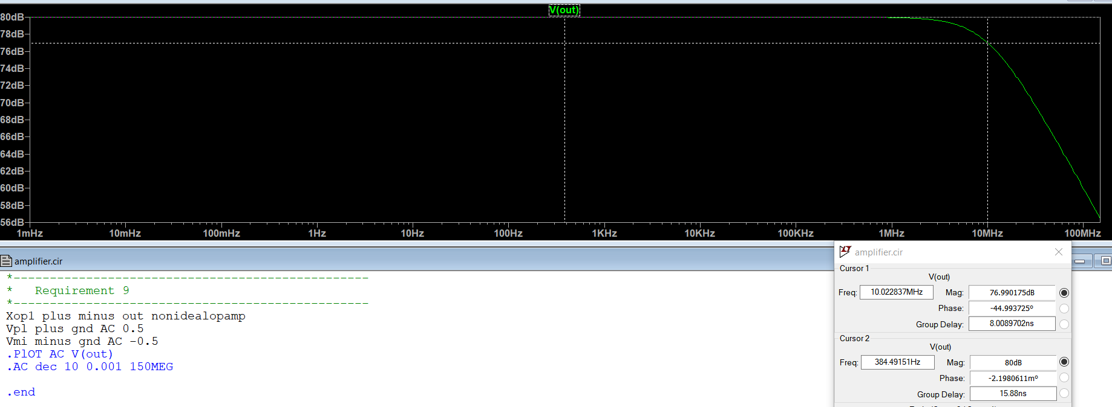

# Interview Problem: Bode plot of closed loop response and pz map

case of using inverting amplifier

Our Case but with a small finite gain 10:

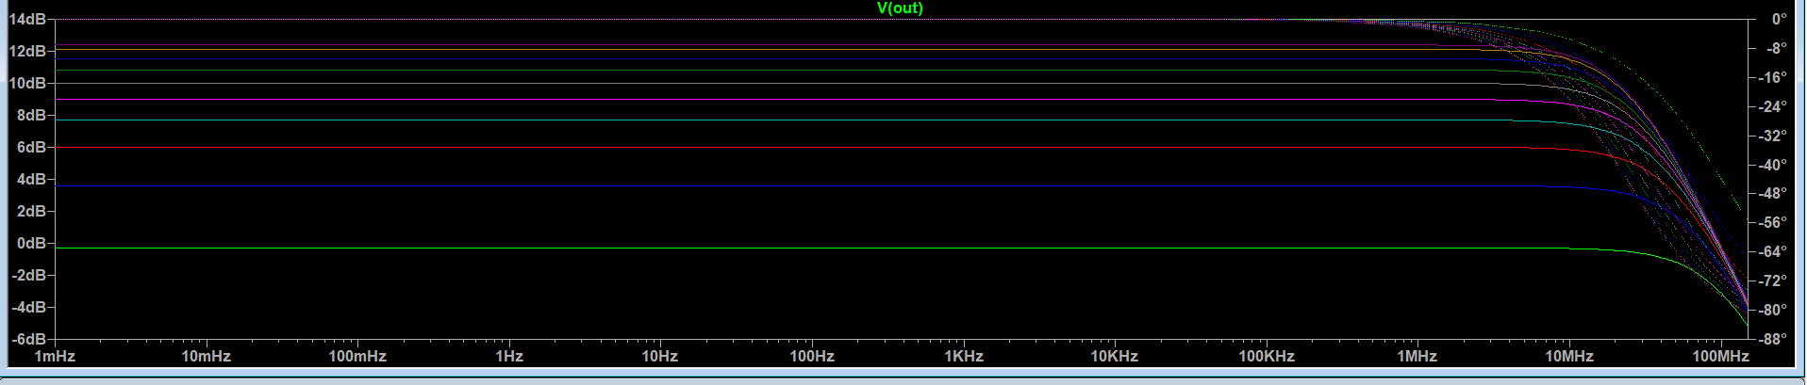

And ofcourse by this intuition poles of closed on pz map will move till certain limit