

Software Engineering Intern Application

Task#1: Function Plotter

Prepared by:

Hisham Elreedy

# Designing Program:

A simple interface developed using pyside2 and py-qt5 which takes inputs from users from text boxes and displays output by pressing simple push button called “plot”,there is also a toolbox above the plot window to help navigating it and save it in a file.

Where I enabled user to enter different types of equations and support “+,-,*,/,^,sin,cos”.

you can run the program simply by calling “python main.py”

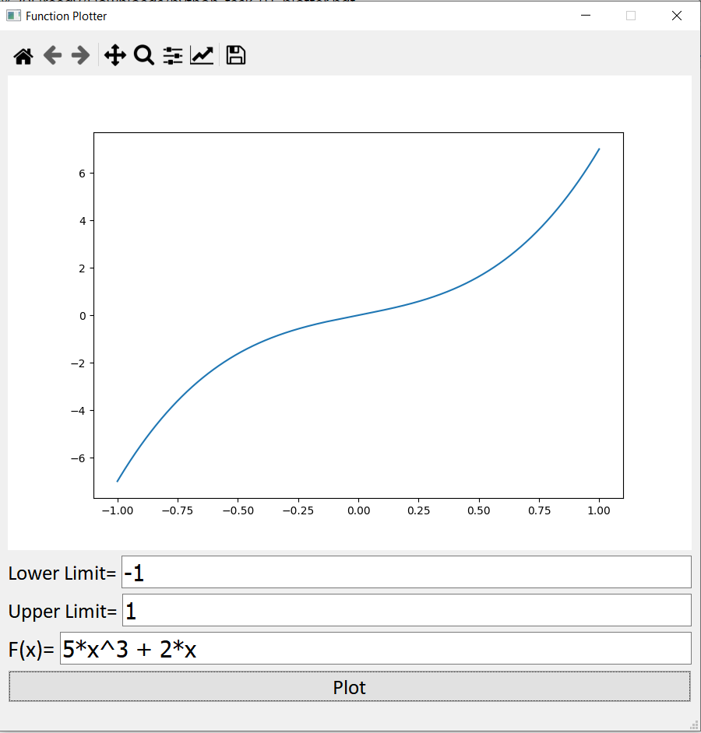

# Validating Program

Program print statements when user enters any invalid input in text boxes where it also tells user exactly which one the inputs whether it is lower or upper limit or equation is written in correctly

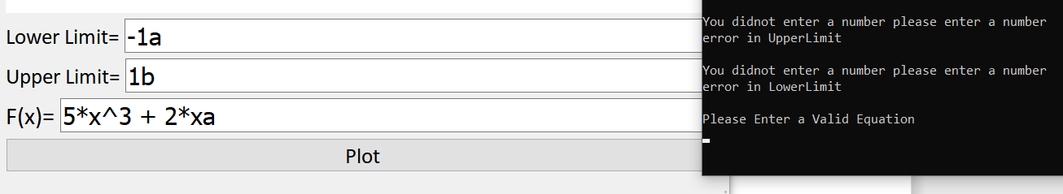

# Testing Program

Pytest is used to verify the operation of back-end modules using several test cases and doing assertion error in case of predicted output is not equal to

actual output.

Pytest-qt is used to verify the operation of front-end modules by using a qt-bot that uses gui in automated way and performs the operations done by normal user and use pytest-plt to verify that plots displayed to user by checking if it matches the baseline-images that we already saved before for checking