PLL Project

EECE Department

2020/2021

Submitted to Eng. **Bassem Abdel-Aziz**

Submitted by:

|  |  |  |
| --- | --- | --- |
| Name | section | BN |
| Abdel-Rahman Abdel-Azeem | 2 | 60 |
| Mohamed Mahmoud Gaber | 3 | 60 |
| Abdel-Rahman Ayman Mahmoud | 2 | 55 |
| Hisham Mohamed Abdullah | 4 | 51 |

**Table of figures:**

2……………………………………………..………………………………………………….. Figure 1: Input & Output part7

2……………………………………………..………………………………………………….. Figure 2: LPF output

3……………………………………………..………………………………………………….. Figure 3: Input & Output part8

3……………………………………………..………………………………………………….. Figure 4: LPF output

4……………………………………………..………………………………………………….. Figure 5: Input & Output part9

4……………………………………………..………………………………………………….. Figure 6: LPF output

5……………………………………………..………………………………………………….. Figure 7: ripples of part 9

6……………………………………………..………………………………………………….. Figure 8: Input & Output part10

6……………………………………………..………………………………………………….. Figure 9: LPF output

7……………………………………………..…………………………………………………. Figure 10: Input & Output part11

7……………………………………………..………………………………………………….. Figure 11: LPF output

Simulation:

7-

Sinusoidal input with Frequency= ${10}^{6}+{10}^{4}$ Hz, initial phase= 0

VCO frequency = ${10}^{6}$ Hz, Kvco = ${10}^{5}$ Hz/v and BW= ${10}^{6}$

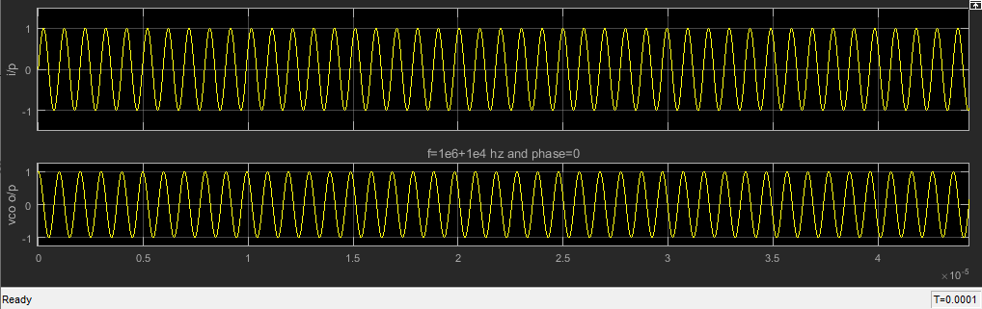

Figure 1: Input & Output part7

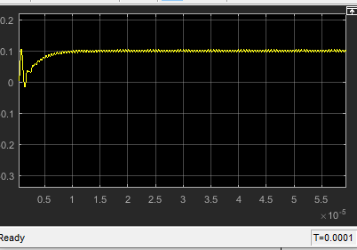

Figure 2: LPF output

8- Frequency = ${10}^{6}-{10}^{4}$ Hz

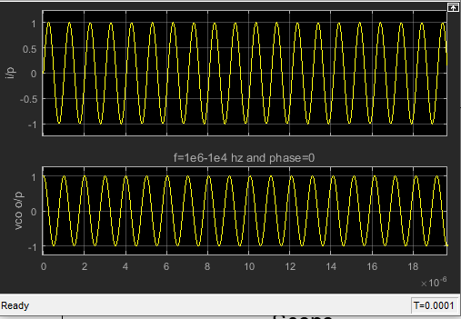

Figure 3: Input & Output part8

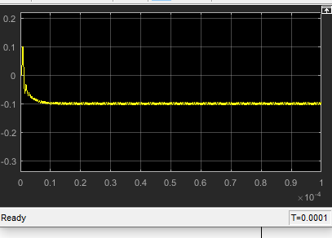

Figure 4: LPF output part 8

9 – Kvco =2 ${10}^{5}$* Hz/v

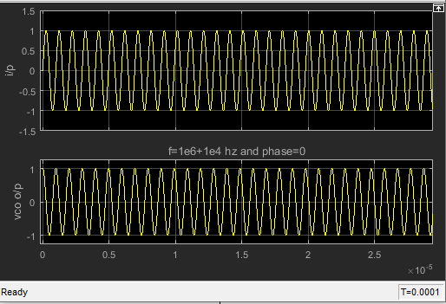

Figure 5: Input & Output part 9

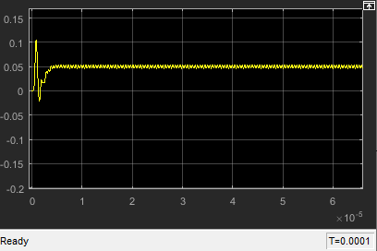

Figure 6: LPF output part 9

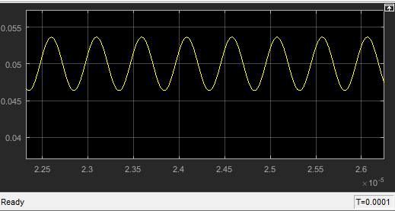

Figure 7 : ripples of part 9

Comments on 7-9:

Φe = $\frac{wout-Wo}{kpd*Kvco}$ ∆∅ = $2 *\frac{π}{T}$ ∗ ∆𝑡

VCout = Kpd* Φe

Wout= Wo+ Kvco*VCout

* The behavior of the Filter in 7,8&9 🡪 it will settle at 0.1, -0.1 and 0.05 volts with some ripples.
* phase

Φe )7 = $\frac{π}{2}$ + ΔΦ

Φe )8 = $\frac{π}{2}$- ΔΦ

Φe )9 = $\frac{π}{2}$ + ΔΦ/2

* increasing VCO gain will decrease SS value of filter as the filter will need less voltage to achieve required F lock

10- BW= ${10}^{5}$ Hz

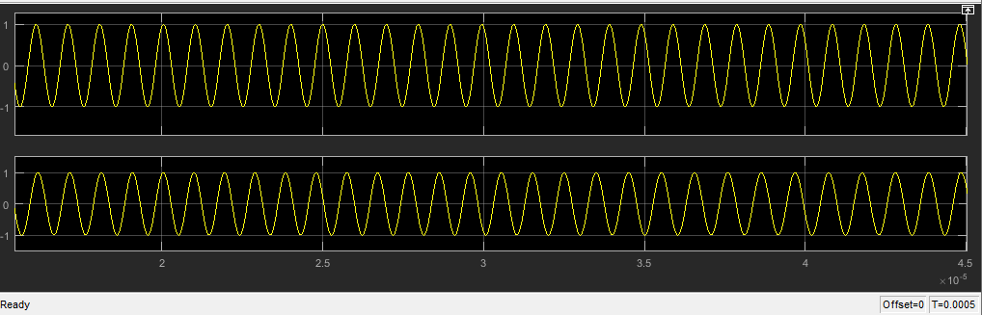

Figure 8: Input & Output part10

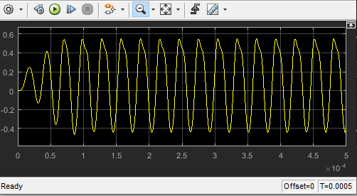

Figure 9: LPF output part 10

Comments:

* output doesn’t lock to the input.
* ζ $=\frac{1}{ϵwn}=\frac{2}{Wlpf}$ if $Wlpf$ decreases 🡪 ζ increases, speed decreases 🡪 stability decreases.
* Vcout is critically stable
* Φe will be changed In a specific range.

11- frequency = ${10}^{6}+{10}^{5}$ HZ

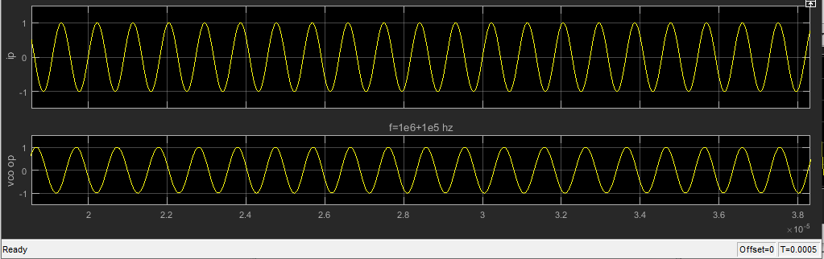

Figure 10: Input & Output part11

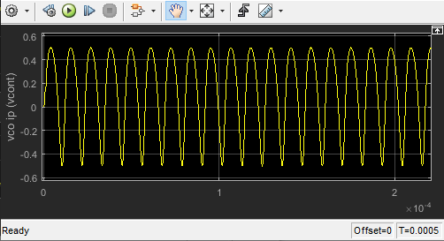

Figure 11: LPF output part11

Comments:

* Win= ( ${10}^{6}+{10}^{5})*2π$ rad/s , the O/p of the filter will be oscillated without ripples at low time because of low frequency of Vcout.
* And this oscillates because the increase of ΔW 🡪 increase ΔVcout & ΔW > Wlpf