EduConnect: Using Digital Access and Data-Driven Mentorship to Bridge Educational Disparities in Rural Students.

A
Web Systems
and
Technologies 2
Presented to the Faculty of
Mindoro State University Bongabong Campus
Labasan, Bongabong
Oriental Mindoro

In Partial Fulfillment
of the Requirements for the Degree
Bachelor of Science in Information Technology

by:

John Emmanuel Reyes
Kian Alvin Gonzales
Rogelyn Coniate

December 02, 2025

TABLE OF CONTENTS

Chapter I – Introduction
Project Context ……………………………………………………………………………………………………….1-2
Objectives of the Study………………………………………………………………………………………….3
General Objective…………………………………………………………………………………………………….3
Specific Objectives …………………………………………………………………………………………….3
Scope and Limitations………………………………………………………………………………………….4-5
Significance of the Study……………………………………………………………………………….5-6
Definition of Terms………………………………………………………………………………………….7-8-9
Chapter II – Requirements Specification
Hardware Requirements………………………………………………………………………………………….10
Software Requirements ………………………………………………………………………………….11-13
Functional Requirements……………………………………………………………………………….13-14
Non-Functional Requirements…………………………………………………………………….14-15
Chapter III – Design and Development Methodologies
Development Methodologies………………………………………………………………………….16-17
Database Schema…………………………………………………………………………………………………….17-18
System Architecture………………………………………………………………………………………….18-19

Data Flow Diagram (DFD) Level 0………………………………………………………….19-20
UML Use-Case Diagram…………………………………………………………………………………………….21
Chapter IV – Development, Testing, and Evaluation Result
Presentation of the System Output…………………………………………………….22-25
Chapter V – Conclusion and Recommendation
Conclusion……………………………………………………………………………………………………………….26-27
Recommendation………………………………………………………………………………………………….27
Appendix
References…………………………………………………………………………………………………………..28
Pictures During Development, Testing & Evaluation…….29
Approved Letter……………………………………………………………………………………………..30

CHAPTER I
INTRODUCTION
Project Context
Education plays a vital role in personal and community development. However, in many rural areas such as Gloria, Oriental Mindoro, students continue to face serious challenges in keeping up with their studies. These challenges include limited internet connectivity, lack of digital devices, and minimal access to academic guidance. As a result, learning gaps persist between rural students and those in urban or more developed areas. Although technology is increasingly used in education, many rural learners still cannot fully benefit from it. Unstable or expensive internet connections prevent students from accessing online learning platforms, digital resources, and virtual consultations with teachers or mentors. In addition, the absence of consistent academic support makes it difficult fo to stay motivated, monitor their progress, and receive proper guidance, which can negatively affect their academic performance. To help address these problems, the proponents developed EduConnect: Using Digital Access and Data-Driven Mentorship to Bridge Educational Disparities in Rural Students. EduConnect is a web-based system with offline features designed to support rural students by improving access to learning resources and mentorship opportunities. The system connects students with teachers, professionals, and volunteer mentors through chat, video calls, and offline messaging. It also offers a digital library and a learning materials. One of the key features of EduConnect is its offline accessibility. Students can download selected learning content and access it even without an internet connection. This feature is especially beneficial for learners in Gloria, Oriental Mindoro who experience unstable or limited network signals. Once the device reconnects to the internet, the system automatically updates student progress, messages, and activities. Through the combination of online connectivity and offline access, EduConnect aims to reduce educational disparities in rural communities. By providing continuous learning support and mentorship despite connectivity limitations, the system helps students remain engaged in their studies, receive guidance, and gain fair access to educational opportunities. EduConnect seeks to empower rural students to overcome learning challenges and achieve their academic goals.

Objectives
The general objectives of this study EduConnect: Using Digital Access and Data-Driven Mentorship to Bridge Educational Disparities in Rural Students aims to develop a web-based system called EduConnect that uses digital access and data-driven mentorship to support rural students in Gloria, Oriental Mindoro, and help lessen the educational gaps they experience.
Specifically aims to;
1. To create an online platform where students can sign up, log in, and access learning support with ease.
2. To connect students with mentors such as teachers, tutors, and professionals through messaging or video calls.
3. To offer a digital library that contains learning materials, study guides, and helpful resources for students.
4. To design a simple and accessible interface that works well even for students with limited internet access.
5. To give rural students equal learning opportunities by giving them access to quality mentorship and academic support.
6. To analyze user data to understand common problems and improve the mentorship system over time.

Scope and Limitation of the Study
This study focuses on developing and evaluating EduConnect, a web-based system with offline capabilities designed to support rural students in Gloria, Oriental Mindoro through digital access and data-driven mentorship. The system includes features such as user registration and login, student and mentor profiles, messaging and video call options for mentoring sessions, a digital library of learning materials, and progress-tracking tools that provide personalized recommendations. EduConnect also allows students to download selected learning resources for offline use, enabling them to continue studying even without an internet connection. The study covers how students and mentors use both the online and offline features of the platform, how mentorship sessions are conducted, and how the system helps improve access to educational support in rural settings. Testing and data gathering will involve selected students, teachers, and volunteer mentors within Gloria.

However, the study still has several limitations. While offline access is available for downloaded learning materials, features such as messaging, video calls, real-time updates, and data synchronization require an internet connection. The availability of mentors depends on the number of active volunteers, which may affect response time and the frequency of mentorship sessions. The system can only track progress based on activities completed within the platform and updates this information once the device reconnects to the internet; it does not measure long-term academic performance outside the system. The research is limited to participants from Gloria, Oriental Mindoro, so findings may not fully represent other rural communities. Additionally, performance issues may occur on devices with limited storage, very slow internet, or outdated hardware, which can affect the offline downloading process and overall user experience.

Significance of the Study
This study is significant as it addresses the educational challenges faced by students in Gloria, Oriental Mindoro, particularly limited internet connectivity, lack of digital learning resources, and insufficient academic mentorship, which contribute to educational disparities between rural and more developed areas. Through the development of EduConnect, the study aims to provide a digital platform that supports learning and mentorship for students in the locality.

Students in Gloria, Oriental Mindoro will benefit from EduConnect as it offers access to learning materials and academic guidance regardless of location. The system enables students to connect with mentors and access a digital library, allowing them to continue learning even in areas with unstable or limited internet access.

Mentors, including teachers, tutors, and professionals, will benefit from the platform as it provides an organized and accessible medium for delivering academic guidance. EduConnect allows mentors to extend their support beyond traditional classroom settings and assist students in rural communities.

Educational institutions in Gloria, Oriental Mindoro may benefit from this study as EduConnect can serve as a supplementary tool for academic support. The system may help schools improve access to learning resources and promote inclusive education for rural students.

Future researchers and system developers may use this study as a reference in developing similar digital learning andmentorship platforms for rural communities. The design and findings of this study may contribute to future improvements in educational technology.

Definition of Terms
The following are the terms used in the study. These are operationally defined for better understanding of the readers.

EduConnect. The proposed web-based learning and mentorship system with offline features designed to support rural students by providing access to educational materials, mentorship, and progress monitoring.

Digital Access. The ability of students to use digital devices, educational platforms, and learning resources, whether online or offline, through the EduConnect system.

Academic Mentorship. Refers to the guidance and support provided by teachers, professionals, or volunteer mentors to help students improve their academic performance and learning skills through the EduConnect system.

Data-Driven Mentorship. The practice of using student learning data, progress records, and activity history to guide mentors in giving personalized and timely academic assistance.

Educational Disparities. The differences in learning opportunities, access to resources, and academic support between rural students and students in more developed areas.

Internet Connectivity. The availability and reliability of an internet connection that allows users to access online features, communicate with mentors, and synchronize data within the system.

Offline Learning. A feature of the system that allows students to access downloaded learning materials, messages, and activities without an active internet connection.

Progress Monitoring. The process of tracking and recording students’ learning activities, completed tasks, and academic development within the EduConnect platform.

Rural Students. Learners residing in rural communities who experience limited access to digital technology, internet connectivity, and academic guidance.

Web-Based System. An application that runs on a web browser and can be accessed using smartphones, tablets, or computers.

CHAPTER II
REQUIREMENT SPECIFICATION
Hardware and Software Requirements
Hardware Requirements
Hardware | Description
Web Server / Cloud Hosting | Required to host the EduConnect platform, database, offline content syncing API, and user authentication services. A basic server with at least 2 vCPUs, 4 GB RAM, and 50 GB SSD storage is adequate for initial deployment.
Client Device (Android Smartphone / Laptop / Desktop) | Used by students and mentors to access the system. Must support modern browsers. Minimum recommended: Android 8+, 2GB RAM, or Windows 10 laptop/desktop with 4GB RAM.
Backup Storage Device (External Hard Drive or Cloud Backup) | Used for storing server backups, database snapshots, and offline learning content packages.
Camera and Microphone (Optional) | Needed for users who participate in video-call mentoring sessions. Most smartphones already include these features.
Power Supply / Charging Devices | Essential for ensuring uninterrupted device usage, especially in rural areas with unstable electricity. Power banks or UPS systems are recommended.
Software Requirements
Software | Description
Operating System (Ubuntu Server / Windows Server) | Used on the server to host the application. Ubuntu Server is recommended for reliability, security, and compatibility with web technologies.
Web Browser (Chrome, Firefox, Edge, Safari) | Used by students and mentors to access the EduConnect platform. Supports HTML, CSS, JavaScript, and offline storage APIs.
Web Development Stack (Laravel) | Core technologies used in building the EduConnect interface, backend, and offline features.
Database Management System (MySQL) | Stores user accounts, progress data, learning materials, system logs, and downloaded content.
Web Server Software (Apache) | Handles system requests and runs the EduConnect backend.
Version Control (Git / GitHub) | Used by developers for tracking changes, collaborating, and updating the system.
Offline Storage API / PWA Service Worker | Enables offline downloading and caching of learning materials for students with weak internet.
Video Conferencing API | Allows mentors and students to conduct live video mentoring sessions.
Development Tools (VS Code, XAMPP/Laragon for local testing) | Used during the coding, debugging, and local deployment of the system.
Security Tools (SSL Certificate, HTTPS, Encryption Libraries) | Protects user data during login, file transfers, and database transactions.

Functional Requirements
The functional requirements describe the specific actions and behaviors that the system must perform to achieve its intended purpose.
Requirement ID | Functional Requirements
Req_001 | The system must allow students, mentors, and teachers to create an account and securely log in.
Req_002 | The students must be able to download lessons, modules, or videos so they can study even without an internet connection.
Req_003 | The system must automatically upload progress, messages, and new data to the server.
Req_004 | The system must match students with volunteer mentors based on interests, grade level, or subject needs.
Req_005 | The users must be able to send messages, ask questions, and receive guidance from mentors through chat.
Req_006 | The system must allow mentors or teachers to upload learning materials, activities, and videos for students.
Req_007 | The system must track activities completed by students and display their progress.
Req_008 | The users must receive alerts about new uploaded materials, mentor feedback, or reminders.
Req_009 | The students and mentors must be able to update their basic information and preferences.
Req_010 | The admins must be able to manage accounts, review mentors, check system logs, and monitor platform activity.

Non-Functional Requirements
The non-functional requirements describe the quality attributes, performance expectations, and system constraints that ensure the system’s reliability and usability.
Requirement ID | Non-Functional Requirements
Req_001 | The system should be easy to navigate, with simple menus and clear instructions suitable for rural students.
Req_002 | The app should load pages quickly and handle multiple users without lag.
Req_003 | The user data must be protected through encrypted login and secure storage.
Req_004 | The system should work consistently even with unstable internet, especially through its offline features.
Req_005 | The system should work on most Android devices commonly used in rural communities.
Req_006 | The platform should support growing numbers of students, mentors, and uploaded resources.
Req_007 | The system should be easy for developers to update, fix, and improve.
Req_008 | The system should automatically back up user data and restore it if technical issues occur.
Req_009 | The system must be accessible at least 95% of the time, except during scheduled maintenance.
Req_010 | Only authorized users should access personal information, following data protection guidelines.

CHAPTER III
DESIGN AND DEVELOPMENT METHODOLOGIES

Development Methodology
The development of EduConnect: Using Digital Access and Data-Driven Mentorship to Bridge Educational Disparities in Rural Students followed the Agile Development Methodology. This approach was chosen to allow flexibility, continuous improvement, and user-focused development throughout the project.
AGILE METHODOLOGY
PLANNING PHASE
DESIGN PHASE

DEVELOPMENT PHASE
TESTING PHASE

DEPLOYMENT PHASE
MAINTENANCE AND IMPROVEMENT

CONTINUOUS FEEDBACK & CYCLE

Figure 1. Agile Methodologies
The Agile Development Model is an iterative approach that divides the system development process into small cycles to allow continuous improvement. It starts with planning and analysis to identify system requirements, followed by design and development in manageable phases. Each developed feature is tested before deployment to ensure quality and functionality. Feedback gathered during maintenance and user interaction is used to refine and improve the system, allowing it to remain flexible, user-focused, and responsive to the needs of the community throughout the development process.

Database Schema
This database schema represents of how information is stored in a learning platform. It has a User table for basic details like name, email, and password. From there, users can have roles such as Student or Admin, which have extra details like grade level or position. The Learning Material table stores lessons or files, and other tables like Progress and Offline Download track how much a user has completed and what they downloaded. There’s also a Message table for sending messages and a Notification table for alerts. The System Log table records actions for security and tracking. Finally, the Mentor and Mentorship Match tables help connect mentors with users. All these tables are linked together so the system can manage users, lessons, progress, communication, and mentorship in one organized structure.
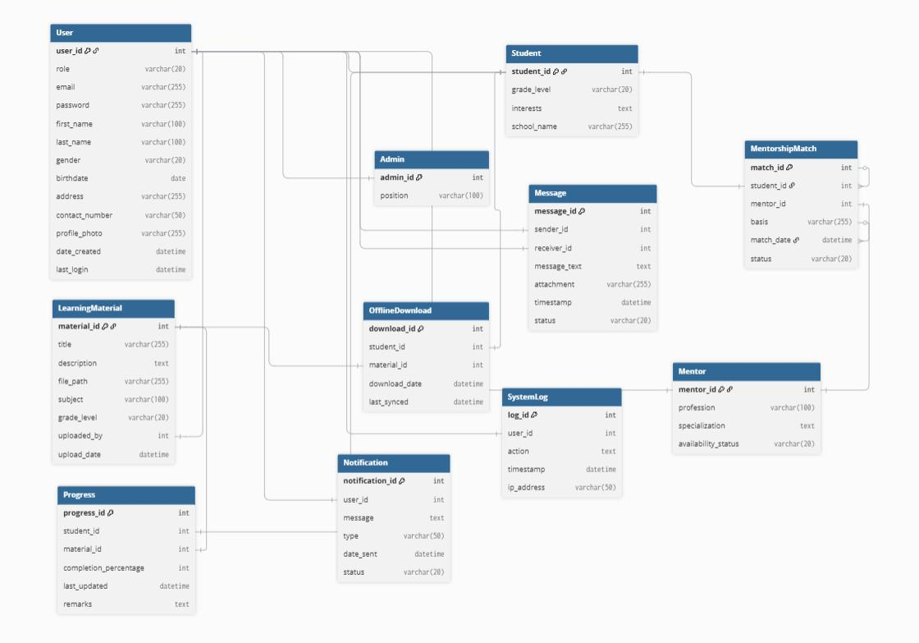

Figure 1. Database Design
The Entity-Relationship Diagram (ERD) illustrates the core data structure of the EduConnect System. It presents the main entities such as Students, Mentors, Administrators, Learning Materials, and Messages, along with their relationships. The diagram defines how data is stored, connected, and managed within the system, ensuring organized handling of user information, mentorship communication, and educational resources to effectively support learning and academic guidance for rural students.

Architectural Diagram/Block Diagram
The Architectural Diagram for EduConnect illustrates a 3-Tier Web Application Architecture that supports secure access, efficient data management, and reliable mentorship services.
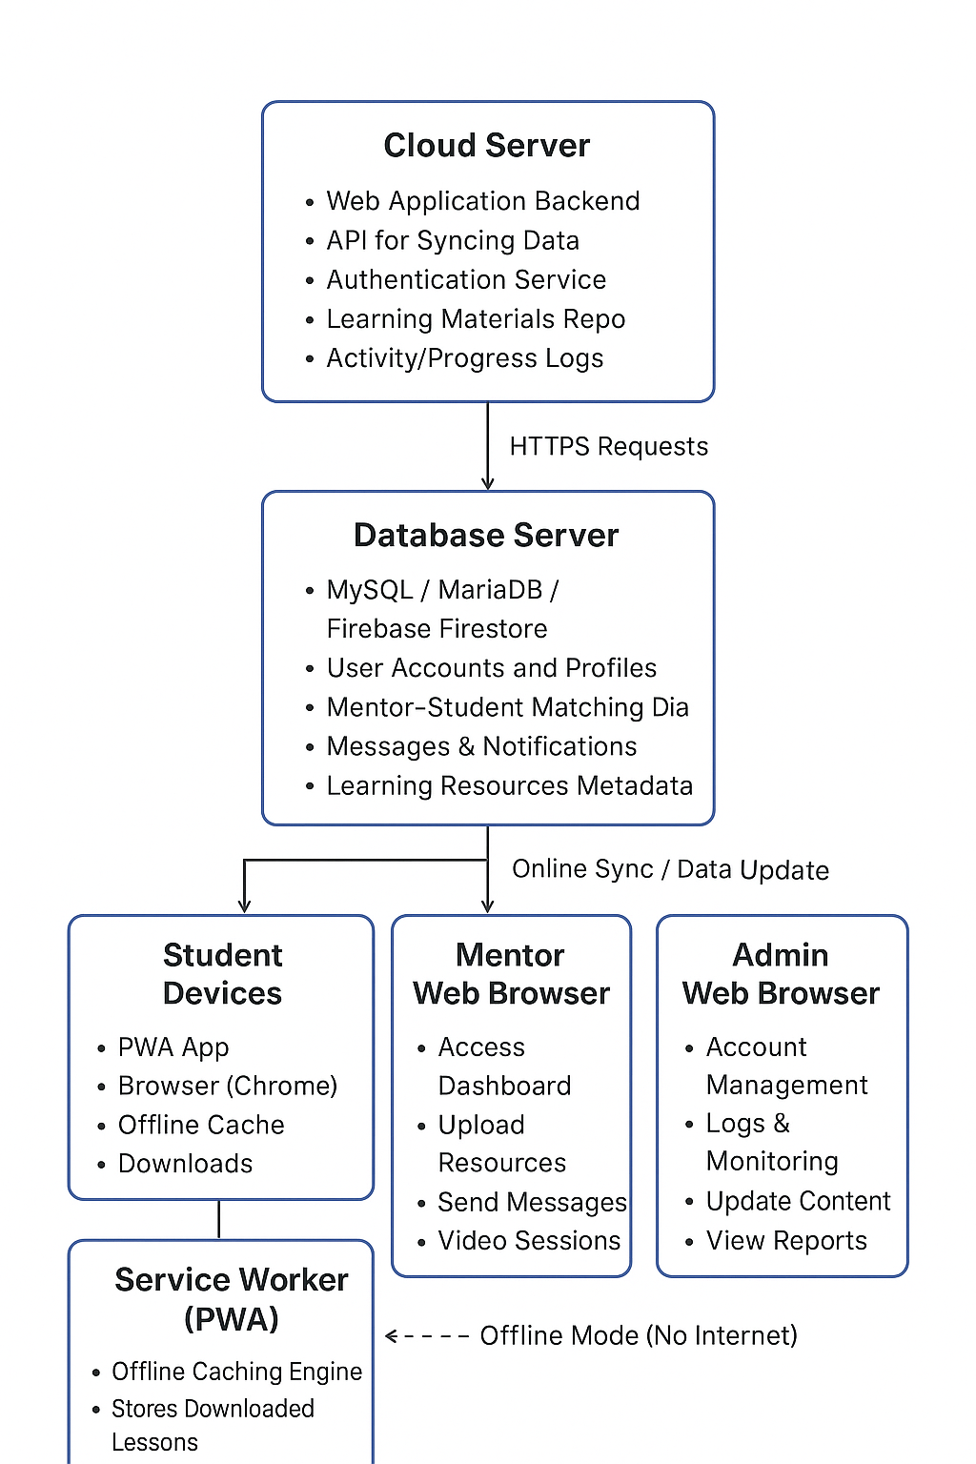
Figure 2: Architectural Diagram
The EduConnect system follows a three-tier architecture to ensure organized, secure, and reliable delivery of learning and mentorship services. The Presentation Tier allows students, mentors, and administrators to access the system through web browsers and a progressive web application (PWA), providing both online and offline access to learning resources. The Application Tier, hosted on a cloud server, serves as the core of the system by managing user authentication, mentorship communication, data synchronization, and system logic. The Data Tier consists of a database server that securely stores user accounts, learning materials, messages, notifications, and activity records. Data flows efficiently between these layers, where user requests are processed by the application server, stored or retrieved from the database, and returned to the user interface, ensuring smooth and continuous system operation even with limited internet connectivity.

(DFD) Data Flow Diagram Level 0
Mentor
Student

Login Credentials, Mentorship Responses,
Learning Requests, Messages, Feedback, Learning
Progress Data. Recommendations.
EduConnect: Using Digital Access and Data-Driven Mentorship to Bridge Educational Disparities in Rural Students.

Learning Materials (Online/ Student Profiles Offline), Mentor Reports, Consultation Notifications, Progress Requests Progress Updates.
User Management Data,
Content Updates, System
System Logs
System Administrator

Figure 3: DFD Level 0

The DFD Level 0 shows EduConnect as a centralized system that interacts with students, mentors, and system administrators. Students use the system to access learning materials and academic guidance, mentors provide support using data-driven insights, and administrators manage system operations. This context diagram highlights how EduConnect facilitates digital access and mentorship to help bridge educational disparities among rural students.
UML Use-Case Diagram
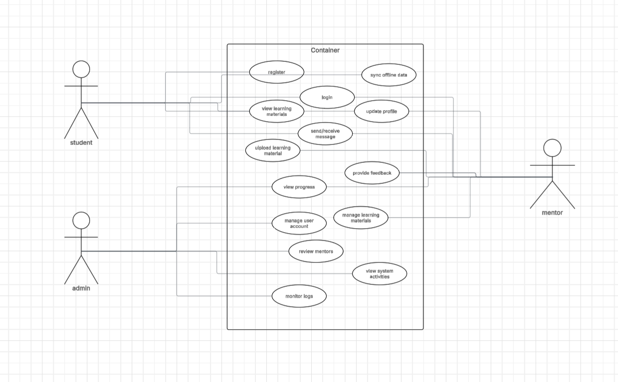
Figure 4: UML Use-case Diagram
The UML Use-Case Diagram illustrates the functional interactions among the three primary actors of the EduConnect system: the Student, Mentor, and Admin. Each actor performs specific system operations represented by use cases within the main system container. Students can register, log in, update their profiles, view and download learning materials, send and receive messages, view their progress, and synchronize offline data. Mentors are able to upload learning materials, communicate with students, provide feedback, update their profiles, and monitor student progress. Meanwhile, the Admin manages user accounts, learning materials, system activities, mentor reviews, and system logs. The diagram provides a comprehensive overview of how each actor interacts with the system’s core features, emphasizing the flow of user actions and the system's role in supporting learning, mentorship, and administrative oversight.

Chapter IV
Development, Testing, and Evaluation Result

The EduConnect System includes simple interface pages for online learning and mentorship. The Home Page introduces the platform and provides login access, while the Student Dashboard displays enrolled courses and quick links to assignments, video calls, and progress. Each Course Page allows students to view lessons, download materials, submit activities, and join mentoring sessions. The Video Call Interface supports real-time communication between students and mentors for interactive learning support.
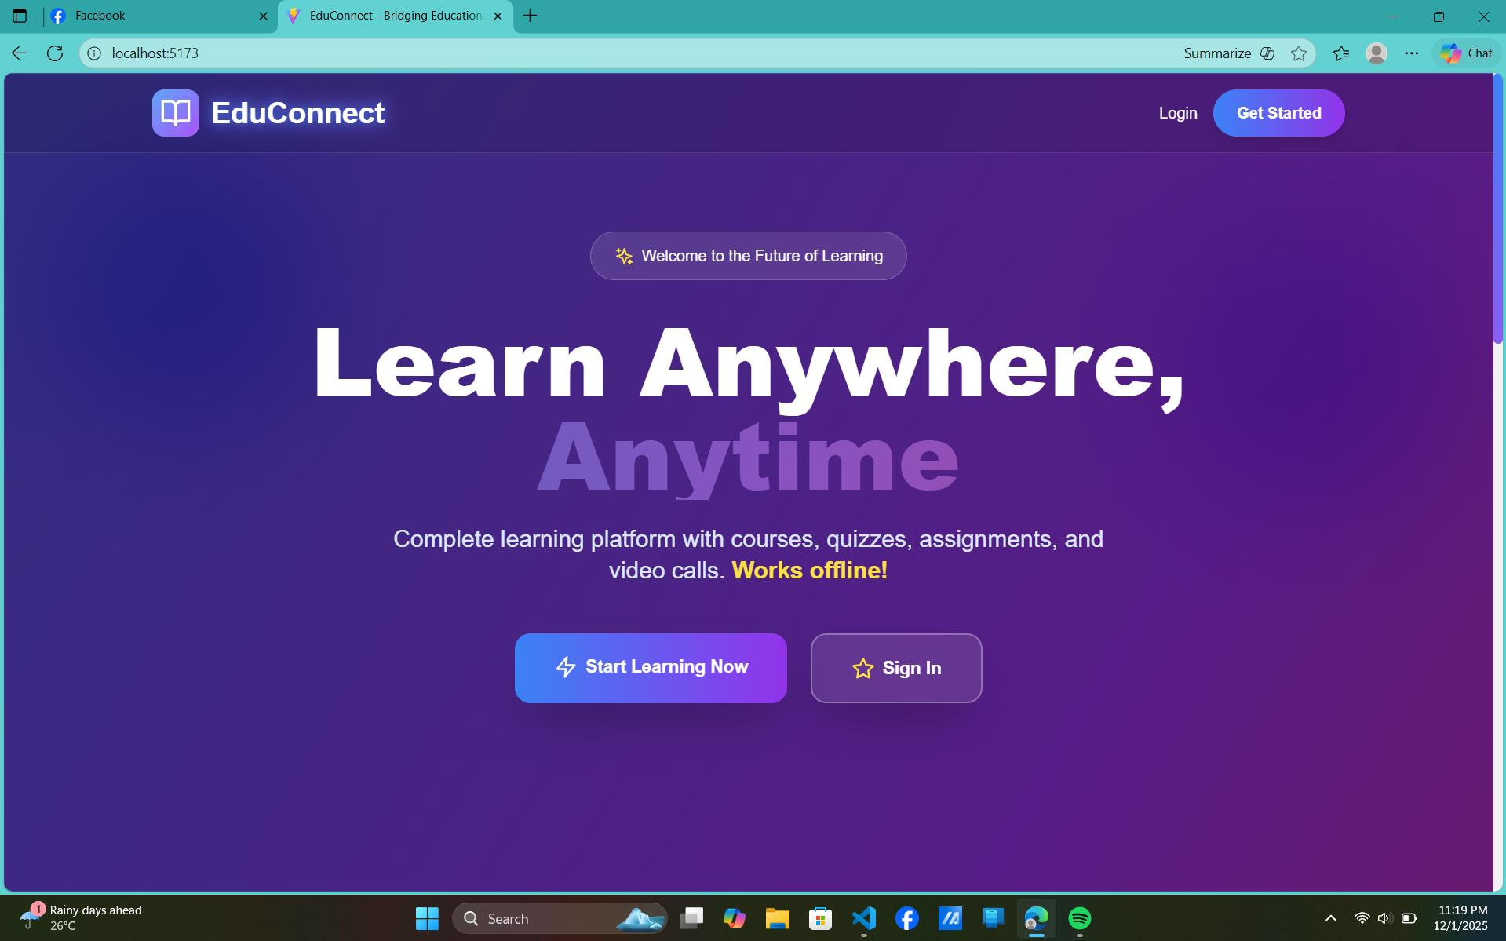
Picture 1: Welcome Page
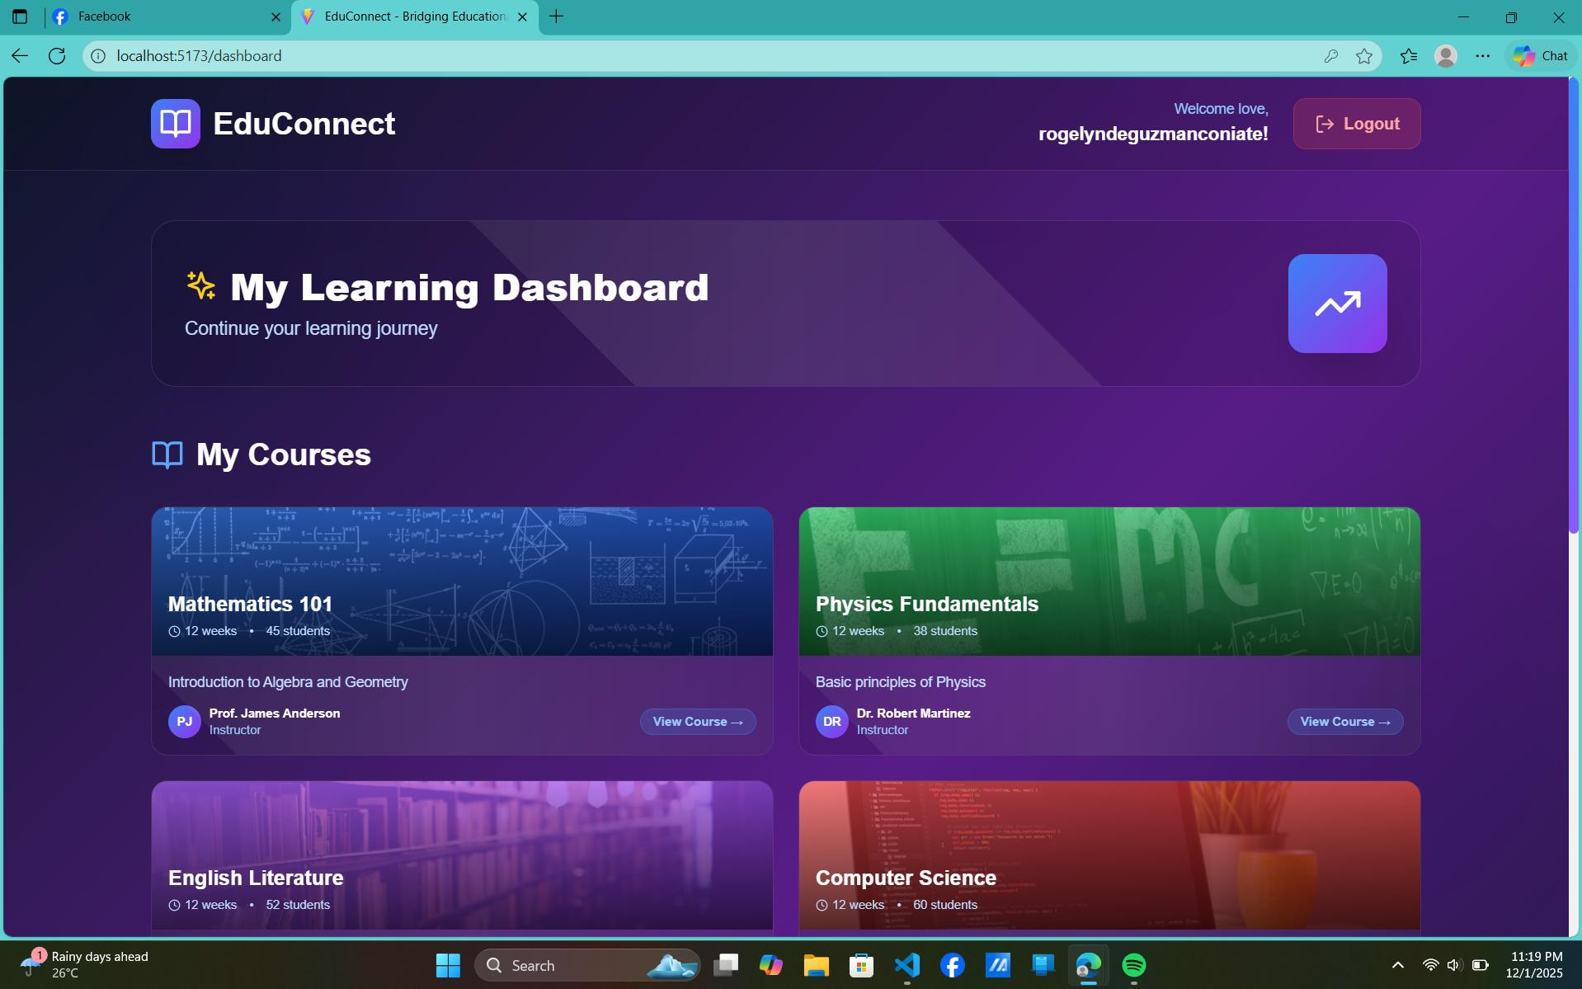
The Welcome Page of EduConnect introduces the platform as a flexible and accessible learning system, highlighted by the message “Learn Anywhere, Anytime.” It presents key features such as courses, quizzes, assignments, video calls, and offline access for students with limited internet connectivity. The page provides clear navigation options like Login, Get Started, and Start Learning Now, guiding users toward immediate use of the platform while reflecting EduConnect’s goal of supporting continuous learning for rural students.

Picture 2. Dashboard

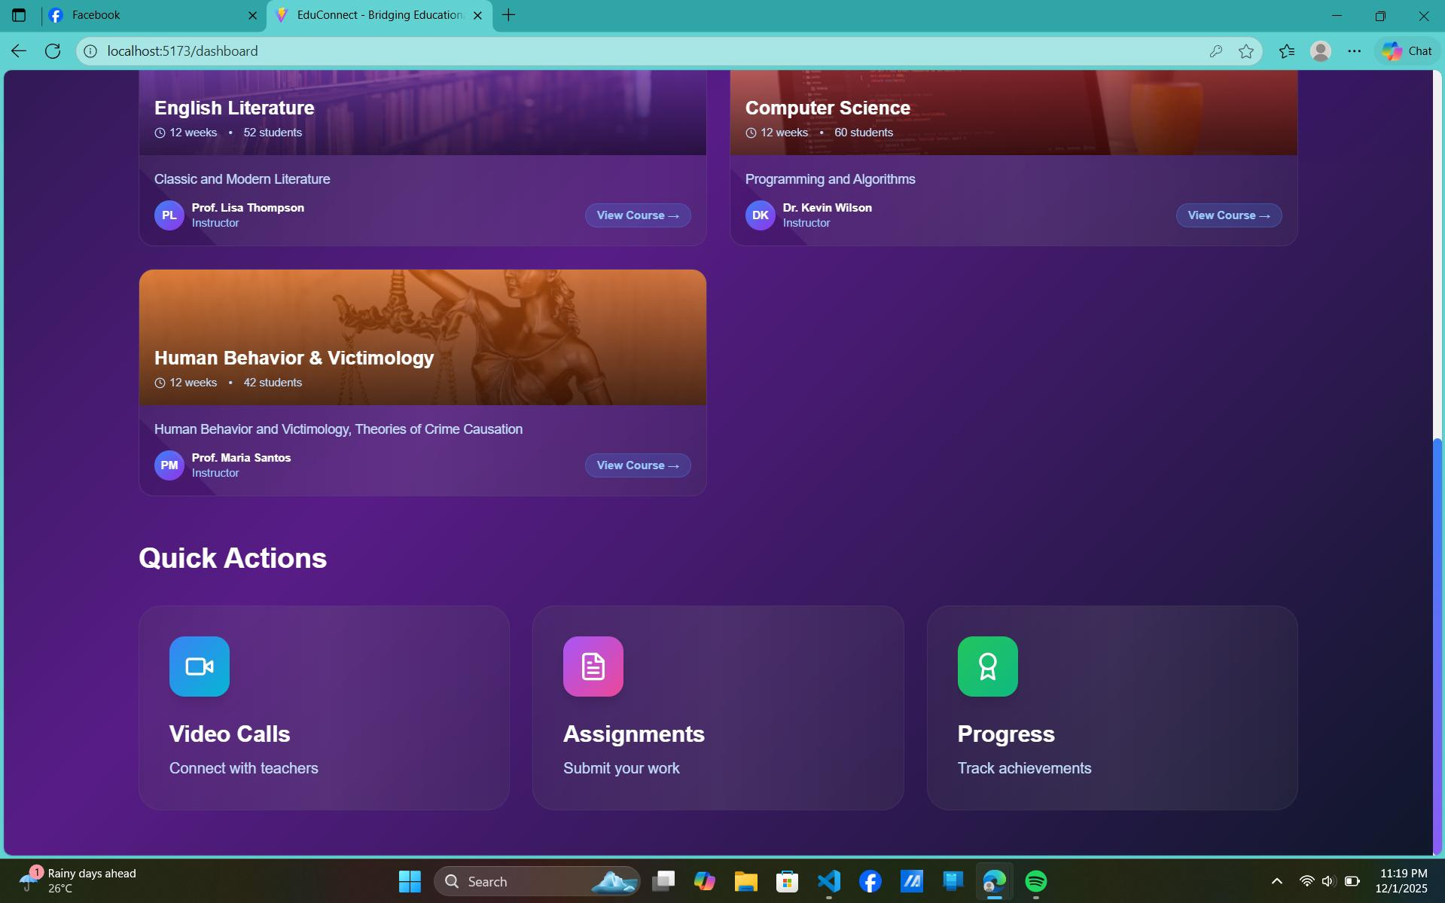
The dashboard is the main page for students after logging in to EduConnect, showing their learning progress and enrolled courses. At the top, it greets the user and provides a Logout button. The section titled My Learning Dashboard encourages continuing the learning journey. Below that, the My Courses area displays subjects like Mathematics 101, Physics Fundamentals, English Literature, and Computer Science, each with details such as modules, number of students, and a View Course button for easy access. This simple layout helps students quickly navigate their courses and manage their studies.

Picture 3.Quick Actions
The Quick Actions section provides easy access to the most important features of EduConnect, allowing students to perform tasks quickly without navigating through multiple menus. It includes three main options: Video Calls, which lets students connect with mentors or teachers for real-time guidance; Assignments, where students can submit their work and manage tasks; and Progress, which helps track achievements and monitor learning performance. This section is designed for convenience, ensuring that essential tools for communication, coursework, and progress tracking are always just one click away.

Chapter V
Conclusion and Recommendation
Conclusion
This project successfully developed EduConnect, a digital learning platform created to help students in rural areas, especially in Gloria, Oriental Mindoro. The system was designed to make learning easier by providing access to study materials, mentorship, and learning support even in areas with limited or unstable internet connection.

Through EduConnect, students can view lessons, submit activities, and communicate with mentors using simple and easy-to-use features. The inclusion of offline access helps ensure that students can continue learning anytime, even without internet. Testing results showed that the system works as intended and is helpful for supporting students’ learning needs.

The EduConnect shows that technology can be used as a practical solution to support education in rural communities. By providing flexible learning access and guidance, the system helps students stay engaged in their studies and work toward their academic goals.

Recommendation

References
Davis, C., Krupa, J. (2025). Access, Education, and Connectivity: Closing the Fourth Industrial Revolution Gap in Rural Regions. Science Journal of Education, 13(2), 62-68. https://doi.org/10.11648/j.sjedu.20251302.12

Ashfaq Ahmed. (2024). The Digital Divide: Access to Technology in Rural vs. Urban Areas. Review Journal of Social Psychology & Social Works, 1(2), 61–73. https://doi.org/10.71145/rjsp.v1i2.18

Rye, S.A. Exploring the gap of the digital divide. GeoJournal 71, 171–184 (2008). https://doi.org/10.1007/s10708-008-9154-8

Block, J. (2010). Distance Education and the Digital Divide: An Academic Perspective. Online Journal of Distance Learning Administration, 13(1),. Retrieved December 1, 2025 from https://www.learntechlib.org/p/76539/.

Picture During Development, Testing & Evaluation

