EduConnect: Using Digital Access and Data-Driven Mentorship to Bridge Educational Disparities in Rural Students.

A
Web Systems
and
Technologies 2
Presented to the Faculty of
Mindoro State University Bongabong Campus
Labasan, Bongabong
Oriental Mindoro

In Partial Fulfillment
of the Requirements for the Degree
Bachelor of Science in Information Technology

by:

John Emmanuel Reyes
Kian Alvin Gonzales
Rogelyn Coniate

November 24, 2025

TABLE OF CONTENTS

LIST OF FIGURES

LIST OF TABLES

LIST OF APPENDICES

CHAPTER I
INTRODUCTION
Project Context
Education plays a vital role in personal and community development. However, in many rural areas such as Gloria, Oriental Mindoro, students continue to face serious challenges in keeping up with their studies. These challenges include limited internet connectivity, lack of digital devices, and minimal access to academic guidance. As a result, learning gaps persist between rural students and those in urban or more developed areas. Although technology is increasingly used in education, many rural learners still cannot fully benefit from it. Unstable or expensive internet connections prevent students from accessing online learning platforms, digital resources, and virtual consultations with teachers or mentors. In addition, the absence of consistent academic support makes it difficult for students to stay motivated, monitor their progress, and receive proper guidance, which can negatively affect their academic performance. To help address these problems, the proponents developed EduConnect: Using Digital Access and Data-Driven Mentorship to Bridge Educational Disparities in Rural Students. EduConnect is a web-based system with offline features designed to support rural students by improving access to learning resources and mentorship opportunities. The system connects students with teachers, professionals, and volunteer mentors through chat, video calls, and offline messaging. It also offers a digital library and a learning materials. One of the key features of EduConnect is its offline accessibility. Students can download selected learning content and access it even without an internet connection. This feature is especially beneficial for learners in Gloria, Oriental Mindoro who experience unstable or limited network signals. Once the device reconnects to the internet, the system automatically updates student progress, messages, and activities. Through the combination of online connectivity and offline access, EduConnect aims to reduce educational disparities in rural communities. By providing continuous learning support and mentorship despite connectivity limitations, the system helps students remain engaged in their studies, receive guidance, and gain fair access to educational opportunities. EduConnect seeks to empower rural students to overcome learning challenges and achieve their academic goals.

Objectives
The general objectives of this study EduConnect: Using Digital Access and Data-Driven Mentorship to Bridge Educational Disparities in Rural Students aims to develop a web-based system called EduConnect that uses digital access and data-driven mentorship to support rural students in Gloria, Oriental Mindoro, and help lessen the educational gaps they experience.
Specifically aims to;
1. To create an online platform where students can sign up, log in, and access learning support with ease.
2. To connect students with mentors such as teachers, tutors, and professionals through messaging or video calls.
3. To offer a digital library that contains learning materials, study guides, and helpful resources for students.
4. To design a simple and accessible interface that works well even for students with limited internet access.
5. To give rural students equal learning opportunities by giving them access to quality mentorship and academic support.
6. To analyze user data to understand common problems and improve the mentorship system over time.

Scope and Limitation of the Study
This study focuses on developing and evaluating EduConnect, a web-based system with offline capabilities designed to support rural students in Gloria, Oriental Mindoro through digital access and data-driven mentorship. The system includes features such as user registration and login, student and mentor profiles, messaging and video call options for mentoring sessions, a digital library of learning materials, and progress-tracking tools that provide personalized recommendations. EduConnect also allows students to download selected learning resources for offline use, enabling them to continue studying even without an internet connection. The study covers how students and mentors use both the online and offline features of the platform, how mentorship sessions are conducted, and how the system helps improve access to educational support in rural settings. Testing and data gathering will involve selected students, teachers, and volunteer mentors within Gloria.

However, the study still has several limitations. While offline access is available for downloaded learning materials, features such as messaging, video calls, real-time updates, and data synchronization require an internet connection. The availability of mentors depends on the number of active volunteers, which may affect response time and the frequency of mentorship sessions. The system can only track progress based on activities completed within the platform and updates this information once the device reconnects to the internet; it does not measure long-term academic performance outside the system. The research is limited to participants from Gloria, Oriental Mindoro, so findings may not fully represent other rural communities. Additionally, performance issues may occur on devices with limited storage, very slow internet, or outdated hardware, which can affect the offline downloading process and overall user experience.

Significance of the Study
This study is significant as it addresses the educational challenges faced by students in Gloria, Oriental Mindoro, particularly limited internet connectivity, lack of digital learning resources, and insufficient academic mentorship, which contribute to educational disparities between rural and more developed areas. Through the development of EduConnect, the study aims to provide a digital platform that supports learning and mentorship for students in the locality.

Students in Gloria, Oriental Mindoro will benefit from EduConnect as it offers access to learning materials and academic guidance regardless of location. The system enables students to connect with mentors and access a digital library, allowing them to continue learning even in areas with unstable or limited internet access.

Mentors, including teachers, tutors, and professionals, will benefit from the platform as it provides an organized and accessible medium for delivering academic guidance. EduConnect allows mentors to extend their support beyond traditional classroom settings and assist students in rural communities.

Educational institutions in Gloria, Oriental Mindoro may benefit from this study as EduConnect can serve as a supplementary tool for academic support. The system may help schools improve access to learning resources and promote inclusive education for rural students.

Future researchers and system developers may use this study as a reference in developing similar digital learning andmentorship platforms for rural communities. The design and findings of this study may contribute to future improvements in educational technology.

Definition of Terms
The following are the terms used in the study. These are operationally defined for better understanding of the readers.

EduConnect. The proposed web-based learning and mentorship system with offline features designed to support rural students by providing access to educational materials, mentorship, and progress monitoring.

Digital Access. The ability of students to use digital devices, educational platforms, and learning resources, whether online or offline, through the EduConnect system.

Academic Mentorship. Refers to the guidance and support provided by teachers, professionals, or volunteer mentors to help students improve their academic performance and learning skills through the EduConnect system.

Data-Driven Mentorship. The practice of using student learning data, progress records, and activity history to guide mentors in giving personalized and timely academic assistance.

Educational Disparities. The differences in learning opportunities, access to resources, and academic support between rural students and students in more developed areas.

Internet Connectivity. The availability and reliability of an internet connection that allows users to access online features, communicate with mentors, and synchronize data within the system.

Offline Learning. A feature of the system that allows students to access downloaded learning materials, messages, and activities without an active internet connection.
Progress Monitoring. The process of tracking and recording students’ learning activities, completed tasks, and academic development within the EduConnect platform.
Rural Students. Learners residing in rural communities who experience limited access to digital technology, internet connectivity, and academic guidance.
Web-Based System. An application that runs on a web browser and can be accessed using smartphones, tablets, or computers.

CHAPTER II
REQUIREMENT SPECIFICATION
Hardware and Software Requirements
Hardware Requirements
Hardware | Description
Web Server / Cloud Hosting | Required to host the EduConnect platform, database, offline content syncing API, and user authentication services. A basic server with at least 2 vCPUs, 4 GB RAM, and 50 GB SSD storage is adequate for initial deployment.
Client Device (Android Smartphone / Laptop / Desktop) | Used by students and mentors to access the system. Must support modern browsers. Minimum recommended: Android 8+, 2GB RAM, or Windows 10 laptop/desktop with 4GB RAM.
Backup Storage Device (External Hard Drive or Cloud Backup) | Used for storing server backups, database snapshots, and offline learning content packages.
Camera and Microphone (Optional) | Needed for users who participate in video-call mentoring sessions. Most smartphones already include these features.
Power Supply / Charging Devices | Essential for ensuring uninterrupted device usage, especially in rural areas with unstable electricity. Power banks or UPS systems are recommended.
Software Requirements
Software | Description
Operating System (Ubuntu Server / Windows Server) | Used on the server to host the application. Ubuntu Server is recommended for reliability, security, and compatibility with web technologies.
Web Browser (Chrome, Firefox, Edge, Safari) | Used by students and mentors to access the EduConnect platform. Supports HTML, CSS, JavaScript, and offline storage APIs.
Web Development Stack (Laravel) | Core technologies used in building the EduConnect interface, backend, and offline features.
Database Management System (MySQL) | Stores user accounts, progress data, learning materials, system logs, and downloaded content.
Web Server Software (Apache) | Handles system requests and runs the EduConnect backend.
Version Control (Git / GitHub) | Used by developers for tracking changes, collaborating, and updating the system.
Offline Storage API / PWA Service Worker | Enables offline downloading and caching of learning materials for students with weak internet.
Video Conferencing API | Allows mentors and students to conduct live video mentoring sessions.
Development Tools (VS Code, XAMPP/Laragon for local testing) | Used during the coding, debugging, and local deployment of the system.
Security Tools (SSL Certificate, HTTPS, Encryption Libraries) | Protects user data during login, file transfers, and database transactions.

Functional Requirements
The functional requirements describe the specific actions and behaviors that the system must perform to achieve its intended purpose.
Requirement ID | Functional Requirements
Req_001 | The system must allow students, mentors, and teachers to create an account and securely log in.
Req_002 | The students must be able to download lessons, modules, or videos so they can study even without an internet connection.
Req_003 | The system must automatically upload progress, messages, and new data to the server.
Req_004 | The system must match students with volunteer mentors based on interests, grade level, or subject needs.
Req_005 | The users must be able to send messages, ask questions, and receive guidance from mentors through chat.
Req_006 | The system must allow mentors or teachers to upload learning materials, activities, and videos for students.
Req_007 | The system must track activities completed by students and display their progress.
Req_008 | The users must receive alerts about new uploaded materials, mentor feedback, or reminders.
Req_009 | The students and mentors must be able to update their basic information and preferences.
Req_010 | The admins must be able to manage accounts, review mentors, check system logs, and monitor platform activity.

Non-Functional Requirements
The non-functional requirements describe the quality attributes, performance expectations, and system constraints that ensure the system’s reliability and usability.
Requirement ID | Non-Functional Requirements
Req_001 | The system should be easy to navigate, with simple menus and clear instructions suitable for rural students.
Req_002 | The app should load pages quickly and handle multiple users without lag.
Req_003 | The user data must be protected through encrypted login and secure storage.
Req_004 | The system should work consistently even with unstable internet, especially through its offline features.
Req_005 | The system should work on most Android devices commonly used in rural communities.
Req_006 | The platform should support growing numbers of students, mentors, and uploaded resources.
Req_007 | The system should be easy for developers to update, fix, and improve.
Req_008 | The system should automatically back up user data and restore it if technical issues occur.
Req_009 | The system must be accessible at least 95% of the time, except during scheduled maintenance.
Req_010 | Only authorized users should access personal information, following data protection guidelines.

CHAPTER III
DESIGN AND DEVELOPMENT METHODOLOGIES

Development Methodology

Database Schema

Figure 1. Database Design
Architectural Diagram/Block Diagram
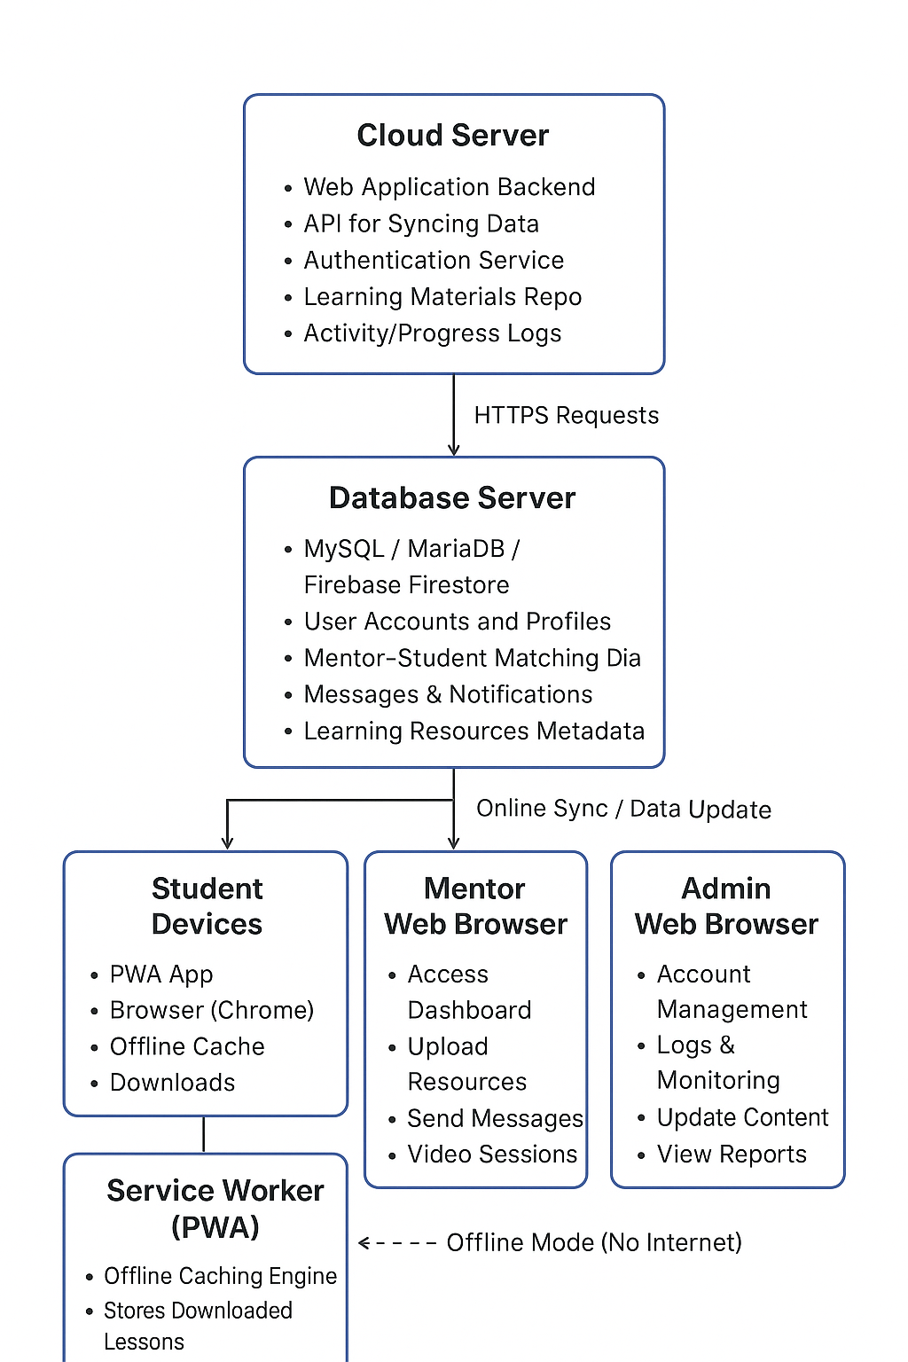
Figure 2: Architectural Diagram
(DFD) Data Flow Diagram Level 0
Mentor
Student

Login Credentials, Mentorship Responses,
Learning Requests, Messages, Feedback, Learning
Progress Data. Recommendations.
EduConnect: Using Digital Access and Data-Driven Mentorship to Bridge Educational Disparities in Rural Students.

Learning Materials (Online/ Student Profiles Offline), Mentor Reports, Consultation Notifications, Progress Requests Progress Updates.
User Management Data,
Content Updates, System
System Logs
System Administrator

Figure 3: DFD Level 0

The DFD Level 0 shows EduConnect as a centralized system that interacts with students, mentors, and system administrators. Students use the system to access learning materials and academic guidance, mentors provide support using data-driven insights, and administrators manage system operations. This context diagram highlights how EduConnect facilitates digital access and mentorship to help bridge educational disparities among rural students.
UML Use-Case Diagram

Figure 4: UML Use-case Diagram
Development Methodologies

Chapter IV
Development, Testing, and Evaluation Result
Presentation of the System Output
Picture 1: Welcome Page

Chapter V
Conclusion and Recommendation
Conclusion
Recommendation
References
Picture During Development, Testing & Evaluation
Approved Letter

APPENDICES

APPENDIX A
PICTURE OF INTERVIEW WITH BUSINESS OWNER

