#include<iostream>

#include <stdio.h>

#include<iomanip>

#define Number 5

using namespace std;

int main()

{

int n;

int daoda[Number],fuwu[Number],i;

cout<<"请?依°¨¤次ä?输º?入¨?各¡Â个?进?程¨¬的Ì?到Ì?达ä?时º¡À间?并¡é以°?空?格?间?隔?:";

for(i=0;i<Number;i++)

{

cin>>daoda[i];

}

cout<<"请?依°¨¤次ä?输º?入¨?各¡Â个?进?程¨¬的Ì?服¤t务?时º¡À间?，ê?并¡é以°?空?格?间?隔?:";

for(i=0;i<Number;i++)

{

cin>>fuwu[i];

}

cout<<"请?输º?入¨?n=1选?择?FCFS或¨°者?n=2选?择?SJF或¨°者?n=3同ª?时º¡À调Ì¡Â用®?FCFS和¨ªSJF,n=";

cin>>n;

while(n<1||n>3){

cout<<"输º?入¨?的Ì?n有®D误¨®，ê?请?重?新?输º?入¨?n，ê?n=";

cin>>n;

}

struct statedd //声¦¨´明¡Â结¨¢构1

{

bool doneF,doneS;

int daoda,fuwu;

float wancheng,zhouzhuan,daiquan,wan,zhou,dai;

};

statedd process[Number];//声¦¨´明¡Â结¨¢构1变À?量¢?，ê?这a里¤?为a数ºy组Á¨¦

int timeflyF=0,timeflyS=0;//定¡§义°?两¢?个?类¤¨¤似?于®¨²秒?表À¨ª的Ì?变À?量¢?

int j,k,l,nextproF,nextproS;

// 获?取¨?数ºy据Y

for(i=0;i<Number;i++)

{

process[i].doneF = false;

process[i].doneS = false;

process[i].wancheng = 0;

process[i].zhouzhuan = 0;

process[i].daiquan = 0;

process[i].wan = 0;

process[i].zhou = 0;

process[i].dai =0;

process[i].daoda = daoda[i];

process[i].fuwu = fuwu[i];

}

// 获?取¨?最Á?先¨¨到Ì?达ä?的Ì?进?程¨¬下?标À¨ºfirst

int first=0;

l=first;

for(i=1;i<Number;i++)

{

if(daoda[first]>daoda[i])

first=i;

}

process[first].doneF=true;

process[first].doneS=true;

process[first].wancheng = process[first].fuwu + process[first].daoda;

process[first].wan = process[first].fuwu + process[first].daoda;

timeflyF += process[first].daoda+process[first].fuwu;

timeflyS += process[first].daoda+process[first].fuwu;

// 接¨®下?去¨£¤到Ì?达ä?的Ì?进?程¨¬

//*************************************************************

// fcfs ********************************************************

for(j=1;j<Number;j++)

{

nextproF = Number+1;

for(k =0 ; k<Number; k++ )

{

if( !process[k].doneF )

{

if( process[k].daoda <= timeflyF ) // 到Ì?达ä?

{

if( nextproF ==Number+1)

nextproF = k;

else

{

if( process[nextproF].daoda > process[k].daoda )

nextproF = k; //获?取¨?到Ì?达ä?时º¡À刻¨¬最Á?先¨¨的Ì?进?程¨¬

}//else

}//if2

}//if1

}//for

// 处ä|理¤¨ª

process[nextproF].wancheng = process[nextproF].fuwu + timeflyF;

timeflyF += process[nextproF].fuwu;

process[nextproF].doneF=true;

} // circle2

// SJF **********************************************

for(j=1;j<Number;j++)

{

nextproS = Number+1;

for(k=0 ; k<Number; k++ )

{

if(!process[k].doneS)

{

if( process[k].daoda <= timeflyS ) // 到Ì?达ä?

{

if( nextproS ==Number+1 )

nextproS = k;

else

{

if( process[nextproS].fuwu > process[k].fuwu )

nextproS = k; //获?取¨?服¤t务?时º¡À间?最Á?小?的Ì?进?程¨¬

}//else

}//if2

}//if1

}//for

// 处ä|理¤¨ª

process[nextproS].wan = process[nextproS].fuwu + timeflyS;

timeflyS += process[nextproS].fuwu;

process[nextproS].doneS=true;

} // circle2

//****************************************************************

float Fz=0,Fdq=0,Sz=0,Sdq=0;//

for(i=0;i<Number;i++)

{ //----------------------------------------------------

process[i].zhouzhuan=process[i].wancheng-process[i].daoda;

Fz += process[i].zhouzhuan;

process[i].daiquan=process[i].zhouzhuan/process[i].fuwu;

Fdq += process[i].daiquan;

//----------------------------------------------------

process[i].zhou=process[i].wan-process[i].daoda;

Sz += process[i].zhou;

process[i].dai=process[i].zhou/process[i].fuwu;

Sdq += process[i].dai;

}

//=========================输º?出?==================================

//-------------------------------------------------------------------

if(n==1||n==3){

cout<<"\t"<<endl;

cout<<"FCFS:"<<endl;

for(i=0;i<Number;i++)

{

if(i<1)

{

cout<<"时º¡À刻¨¬"<<l<<":进?程¨¬"<<i+1<<"在¨²运?行D"<<endl;

}

else

{

cout<<"时º¡À刻¨¬"<<process[i-1].wancheng<<":进?程¨¬"<<i+1<<"在¨²运?行D"<<endl;

}

}

cout<<setw(10)<<"进?程¨¬ID"<<" ";

cout<<setw(10)<<"完ª¨º成¨¦时º¡À间?"<<" ";

cout<<setw(10)<<"周¨¹转Áa时º¡À间?"<<" ";

cout<<setw(10)<<"带ä?权¨¡§周¨¹转Áa时º¡À间?"<<" "<<endl;

for(i=0;i<Number;i++)

{

cout<<setw(10)<<i+1<<" ";

cout<<setw(10)<<setiosflags(ios::fixed)<<setprecision(2)<<process[i].wancheng<<" ";

cout<<setw(10)<<setiosflags(ios::fixed)<<setprecision(2)<<process[i].zhouzhuan<<" ";

cout<<setw(10)<<setiosflags(ios::fixed)<<setprecision(2)<<process[i].daiquan<<" "<<endl;

}

cout<<"平?均¨´周¨¹转Áa时º¡À间?为a：êo "<<setiosflags(ios::fixed)<<setprecision(2)<<Fz/Number<<endl;

cout<<"平?均¨´带ä?权¨¡§周¨¹转Áa时º¡À间?为a：êo"<<setiosflags(ios::fixed)<<setprecision(2)<<Fdq/Number<<endl;

}

//-------------------------------------------------------------------

if(n==2||n==3){

cout<<"\t"<<endl;

cout<<"SJF:"<<endl;

for(i=0;i<Number;i++)

{

if(i<1)

{

cout<<"时º¡À刻¨¬"<<l<<":进?程¨¬"<<i+1<<"在¨²运?行D"<<endl;

}

else

{

cout<<"时º¡À刻¨¬"<<process[i-1].wan<<":进?程¨¬"<<i+1<<"在¨²运?行D"<<endl;

}

}

cout<<setw(10)<<"进?程¨¬ID"<<" ";

cout<<setw(10)<<"完ª¨º成¨¦时º¡À间?"<<" ";

cout<<setw(10)<<"周¨¹转Áa时º¡À间?"<<" ";

cout<<setw(10)<<"带ä?权¨¡§周¨¹转Áa时º¡À间?"<<" "<<endl;

for(i=0;i<Number;i++)

{

cout<<setw(10)<<i+1<<" ";

cout<<setw(10)<<setiosflags(ios::fixed)<<setprecision(2)<<process[i].wan<<" ";

cout<<setw(10)<<setiosflags(ios::fixed)<<setprecision(2)<<process[i].zhou<<" ";

cout<<setw(10)<<setiosflags(ios::fixed)<<setprecision(2)<<process[i].dai<<" "<<endl;

}

cout<<"平?均¨´周¨¹转Áa时º¡À间?为a：êo "<<setiosflags(ios::fixed)<<setprecision(2)<<Sz/Number<<endl;

cout<<"平?均¨´带ä?权¨¡§周¨¹转Áa时º¡À间?为a：êo"<<setiosflags(ios::fixed)<<setprecision(2)<<Sdq/Number<<endl;

cout<<"\t"<<endl;

}

cin>>i;

return 0;

}

**实例截图：**

五个进程，到达时间分别为0,1,3,4,6

服务时间分别为5,7,3,8,2

设置选择量n，

当n=1时，选择FCFS

当n=2时，选择SJF

当n=3时，同时分别调用FCFS和SJF

n不为1或2或3时提示错误，重新输入n；

1-FCFS 算法

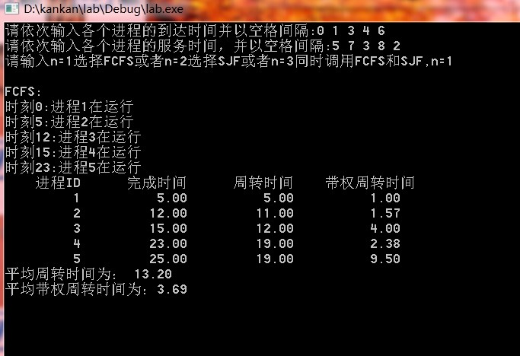

2-SJF算法

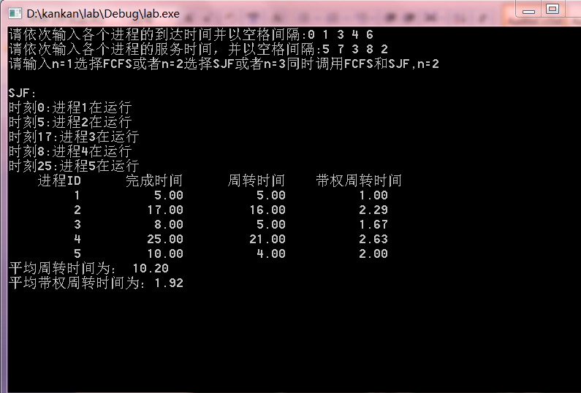

3同时调用FCFS和SJF

