**Super Store Product Analysis (2022-2025)**

Analyzing the products offered by Super Store from 2022 – 2025.

By AL

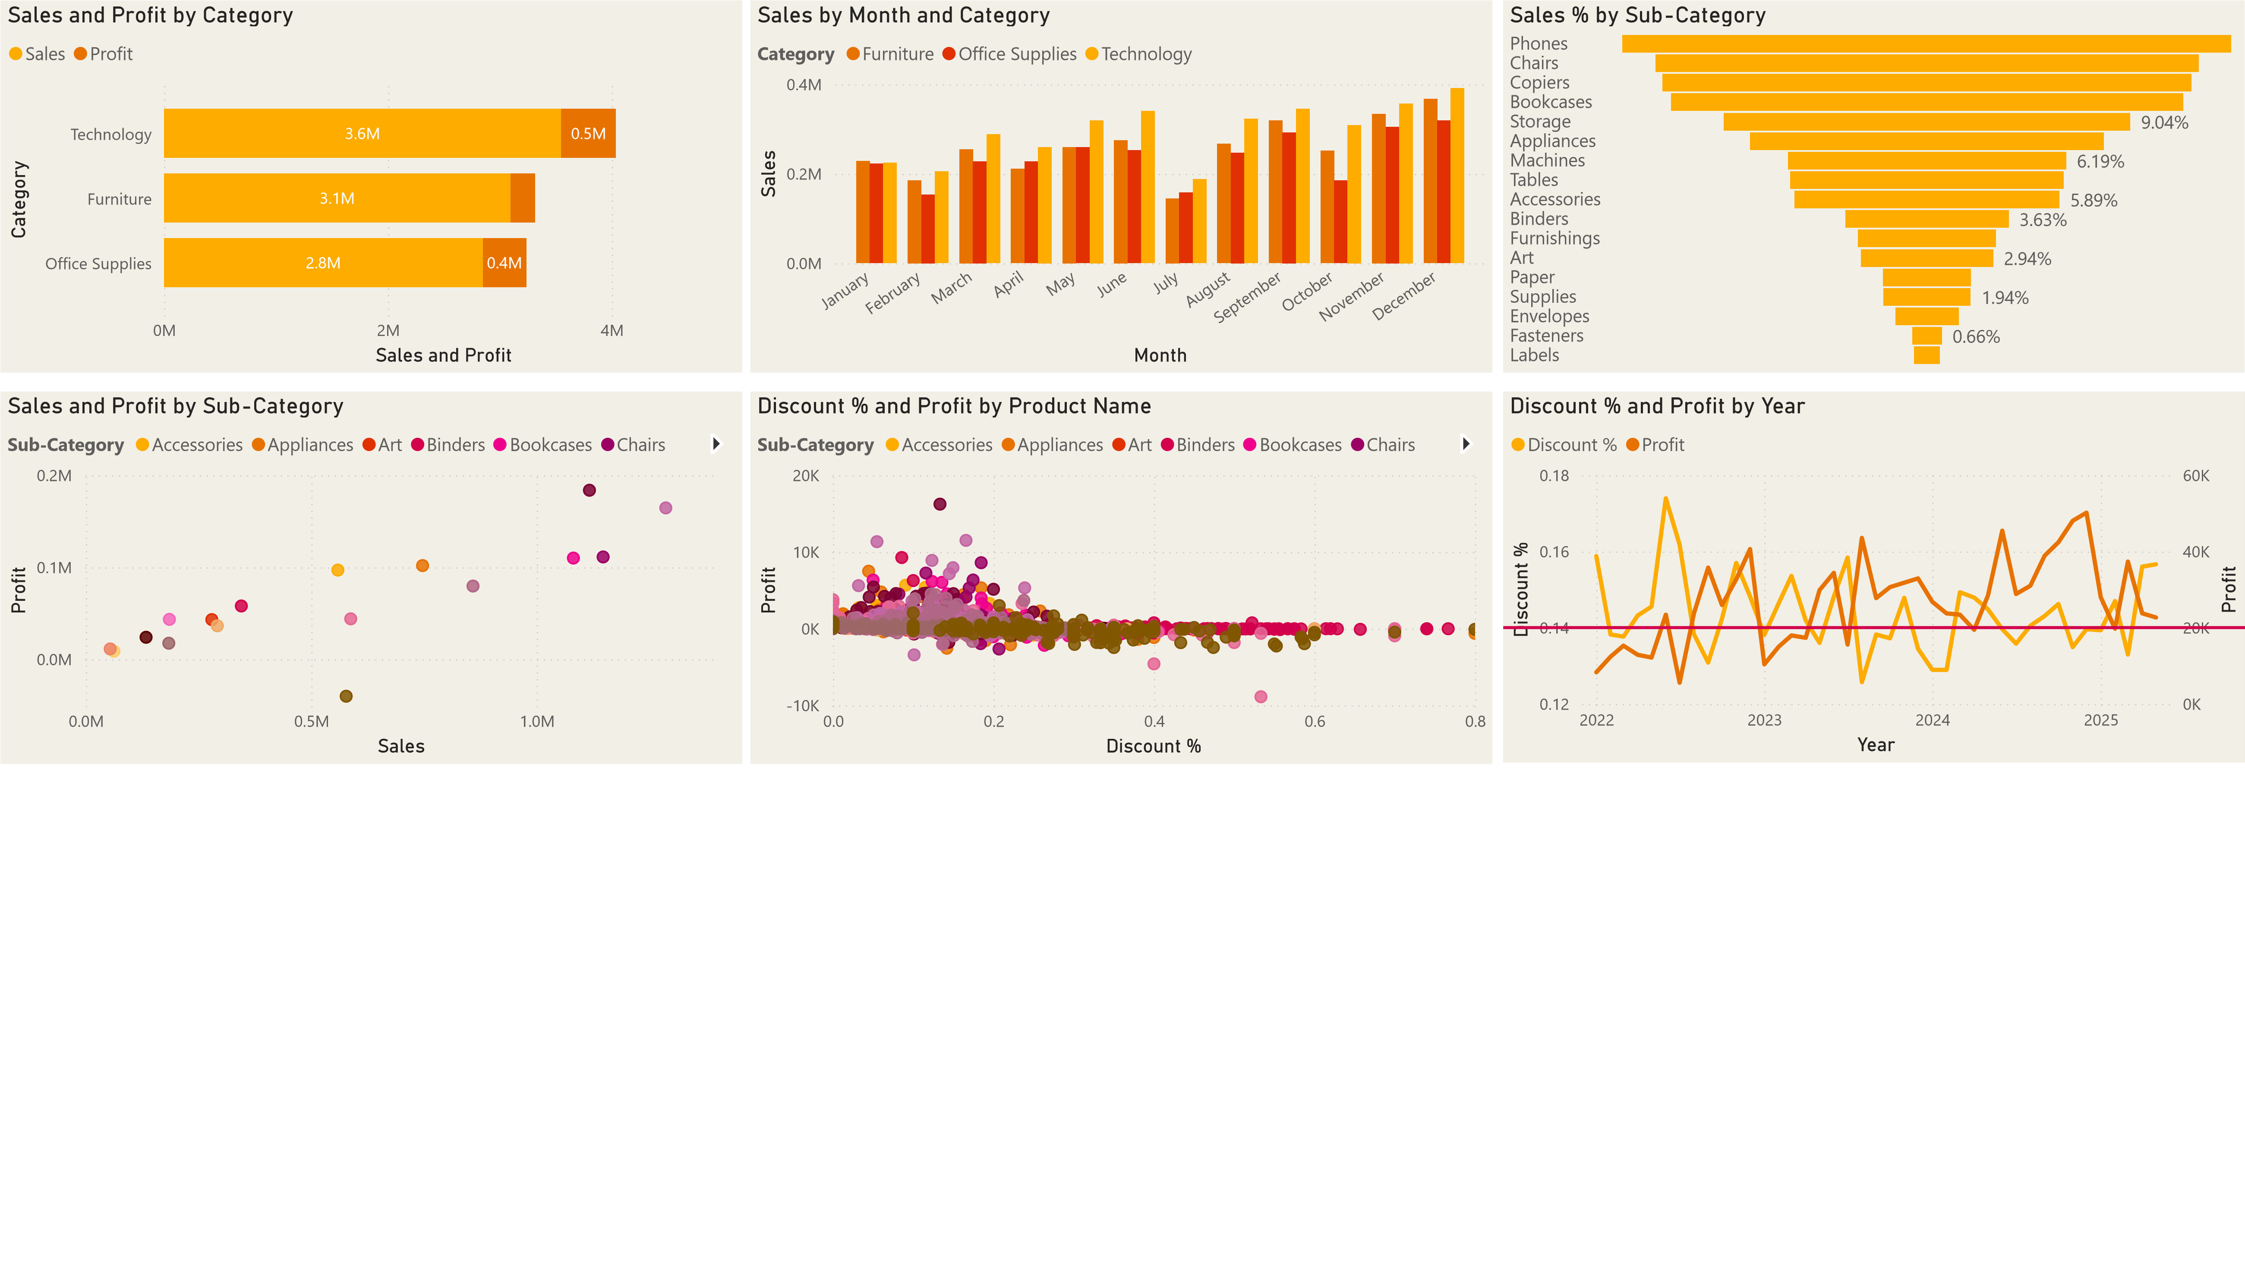

**Super Store Product Metrics:**

* **Sales** – Sales from products offered across all regions
* **Category** – Products and the Sub Category of products
* **Discount** – Impact of discounts on products

**Summary of insights:**

**Sales**:

* The Technology products offered are bringing in the most sales and profit, 3.6M in sales with .5M in profits. This is followed by Office Supplies with 2.8M in sales with .4M in profits and Furniture products with 3.1M in sales with .2M in profits.
* These trends hold true throughout every month of the year but there is a noticeably drop off in sales and profit across the board for the month of July while the months of November and December remain the strongest for sales.

**Category**:

* Phone sales are the best-selling product offered, making up 13.9% of total sales with 9.4% average profit per sale.
* Tables are the only unprofitable sub category that is offered, producing .3M in losses despite .5M in total sales.

**Discount**:

* Products with high discounts (40-60%) are netting losses, discounted items over 14% become unprofitable.
* Several heavily discounted products (e.g., Acco Hole Reinforcements, SanDisk Message Books) show negative profits, suggesting over-discounting is hurting revenue.

**Recommendations:**

* Re-evaluate discounting above 14%, as it often results in steep losses, most profitable range is 5%-10%.
* Analyze discount effectiveness, are deep discounts actually boosting sales, or just reducing profitability?
* Prioritize high-profit products, promote items that sell well without excessive discounting.
* Refine pricing strategy for Tables, high sales but low revenue indicate the need for price adjustments.

**Final Insights:**

* Deeply discounted items are not profitable or driving positive revenue growth.
* The Technology Category is the primary category driving revenue growth; the Furniture category needs re-evaluation.