**Super Store Segment Analysis (2022-2025)**

Analyzing the Segment trends by Super Store from 2022 – 2025.

By AL

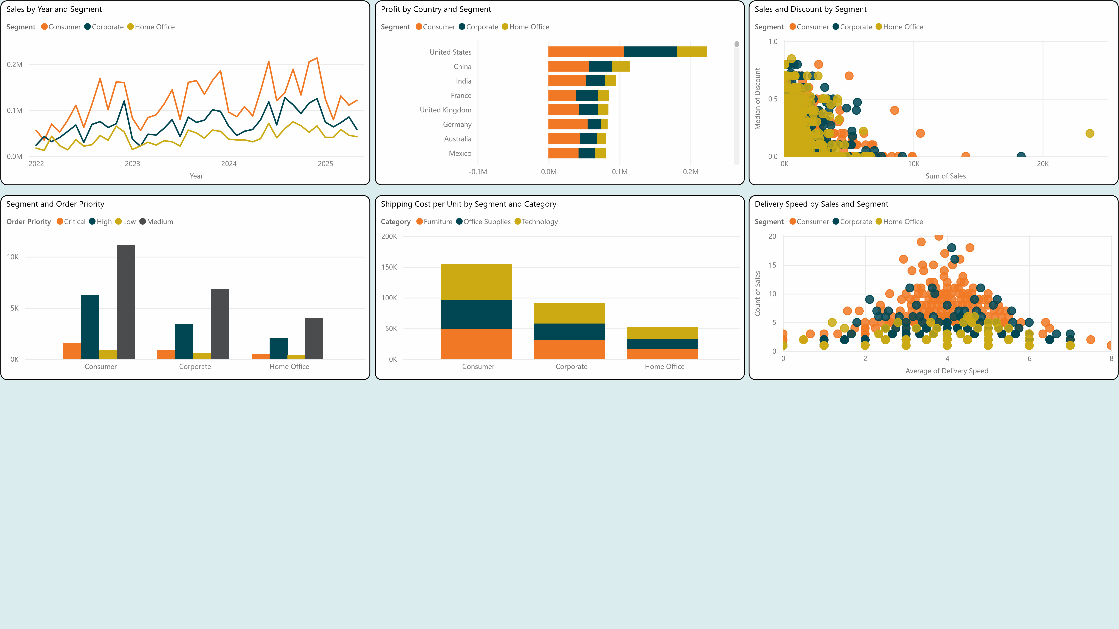

**Super Store Segment Metrics:**

* **Sales** – Sales by all Segments
* **Segments** – Consumer, Corporate, Home Office
* **Order Priority** – Critical, High, Medium, Low

**Summary of insights:**

**Sales**:

* Overall, Consumer sales dominate, while Corporate customers maintain consistent spending, and Home Office purchases remain moderate and varied.
* Discounts show minimal effects on the total sales across all segments but Home orders remain on the low end.

**Segments**:

* Consumer Customers are the primary segment driving growth, placing $5M in orders netting $.7M in profits. Consumer customers place the highest number of orders for phones totaling over $.8M in sales.
* Corporate Customers are the second placed segment driving growth, placing $3M in orders netting $.3M in profits. Corporate customers tend to place orders in the furniture category placing over $1M worth of orders since 2022.
* Home Office Customers are the third placed segment driving growth, currently sales have remained flat. Placing $1.6M in orders netting $.2M in profits. The main category orders are placed for remains Office-Supplies, totaling $.5M.

**Order Priority**:

* Critical Priority Orders mostly placed by consumer customers, often for technology and office supplies, suggesting time-sensitive personal or small business needs.
* High Priority Orders frequently placed by corporate and home office customers, often for office supplies and furniture, indicating urgent business needs.
* Medium Priority Orders spread across all segments, showing a balance between planned purchases and moderate urgency. This priority constitutes 60% of all orders and is favored by across all segments.
* Low Priority Orders are negligibly only constituting 5% of total orders across all three segments, indicating customers place orders more so out of necessity.

**Recommendations:**

* Consumer customers drive the highest total revenue, optimizing bulk pricing and prioritizing shipping efficiency would be beneficial.
* Home Office customers show moderate profitability, targeted discounts or product bundling could enhance their engagement.
* Deep discounts for products are affecting profitability, discounts above 10% need to be reviewed.

**Final Insights:**

* Optimizing bulk pricing and fast shipping could further enhance consumer revenue, while targeted discounts and bundling may increase engagement among home office buyers. Additionally, reviewing deep discounts exceeding 10% can help protect profitability
* Critical priority orders are largely placed by consumer customers for technology and office supplies, while high-priority purchases come from corporate and home office customers needing furniture and office essentials. Medium-priority orders represent 60% of transactions, balancing planned purchases with moderate urgency, and low-priority orders remain minimal at 5%, indicating necessity-driven buying behavior.