**Super Store Shipping Analysis (2022-2025)**

Analyzing the Shipping Mode trends offered by Super Store from 2022 – 2025.

By AL

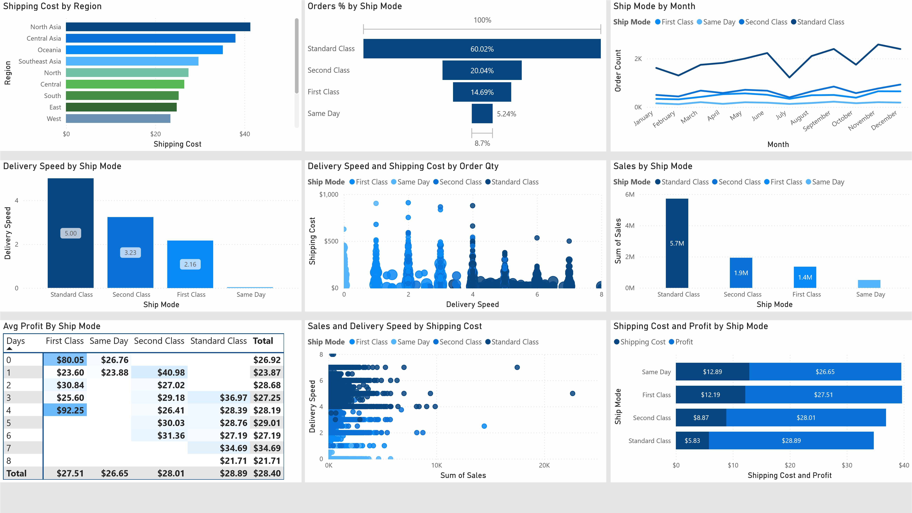

**Super Store Ship Mode Metrics:**

* **Sales** – Sales from all Ship Modes offered
* **Shipping** Costs – Cost of Shipping to Global Regions
* **Modes** – Same Day, First Class, Second Class, Standard Class
* **Regions** – North Asia, Central Asia, Oceania, South East Asia, North America, South America, Central America

**Summary of insights:**

**Sales**:

* First, Second and Same Day shipping options constitute 3.5 million in sales over the past three years but is eclipsed by Standard Class with 5.7 million in sales shipped via this option.

**Shipping** **Costs**:

* Standard Class shipping option continues to be the most profitable method of shipping with the average orders netting $28.89. This is followed by Second Class at $28.01, First Class at $27.51, and Same Day at $26.65.
* Shipping costs decline as the shipping length of time increases. The decrease is significant with Standard Shipping costs dropping over 50% when compared to Same Day shipping.

**Modes**:

* Clientele routinely prefer using the Standard Class offered when making purchases. This trend is valid throughout the year and the Standard Class shipping option offered has continued to grow positively year over year.
* The average shipping time per class is as follows; Standard Class at 5 days, Second Class at 3.5 days, First Class at 2.16 days and Same Day Class at 18 Hours per delivery.

**Regions**:

* The regions with the highest shipping costs continue to be in Asia. Shipping costs range from $25 to $40 on average with prices dropping by 10% plus when orders are placed out of Asia.

**Recommendations:**

* Prioritize same-day shipping for high-value orders only. Lowest profit margin per shipping method.
* Consider combining First and Second-Class options into one category. First Class profits are lower on average compared to Second Class and there is little difference in shipping times.
* Introduce customer-based shipping incentives for summer months (free expedited shipping for top buyers) to try and boost sales during down moths.
* Reassess shipping costs in low-margin orders.

**Final Insights:**

* High-value orders benefit more from faster shipping, but efficiency depends on cost structure.
* Same day shipping remains flat and needs overhaul to justify program.