**Profit Forecasting Model**

Profit Forcasting Model based on the sales data of Super Store from 2022 – 2025.

By AL

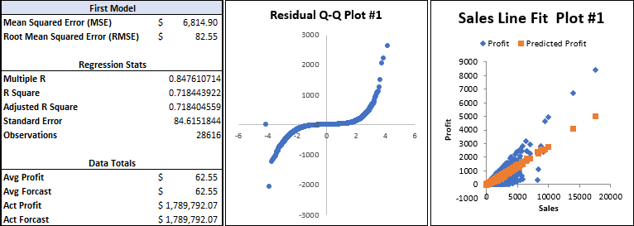

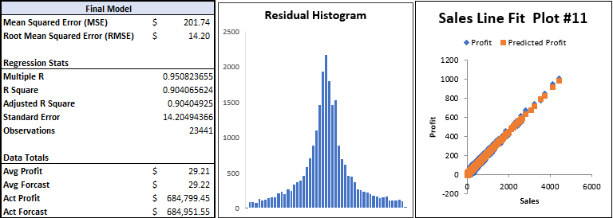

**Summary**

This report analyzes the relationship between profit and key business variables using linear regression models. The objective is to identify significant predictors that influence profit and refine the model for higher accuracy. This model was built and refined using Excel.

**Methodology**

A total of 11 iterations of this model was built using business data, incorporating variables such as Sales, Quantity, Discount, and Shipping Cost to assess their impact on Profit. The final model optimizes prediction accuracy by refining the variable selection.

**Enhancing the Accuracy of the Model**

To improve the precision of the Profit Prediction Model, several refinements were made based on residual analysis.

* A Q-Q plot revealed slight waviness, indicating mild departures from normality. To ensure residuals followed a normal distribution, transformations were made and data with high variance was removed.
* Initially, the model included multiple predictors, such as Sales, Quantity, Discount, and Shipping Cost. After assessing multicollinearity and significance levels, Shipping Cost was removed.

**Results & Comparison**

Initial Model

* R-Squared: 71.8% (indicating strong but improvable fit)
* Significant Predictors: Sales, Quantity, Discount, and Shipping Cost
* Discount had the largest negative impact (-98.54 coefficient), showing that higher discounts significantly reduce profit.
* Sales had a strong positive impact (0.292), reinforcing its importance.

**Final Model**

* -R-Squared:90.4% (stronger predictive power)
* -Significant Predictors: Sales, Quantity, Discount (Shipping Cost removed).
  + Sales remains a key positive predictor (0.223).
  + Quantity has shifted to a positive effect (0.708), suggesting that bulk orders drive profit.
  + Discount’s negative impact is reduced (-30.56), meaning the revised model better accounts for how discounts affect profit.

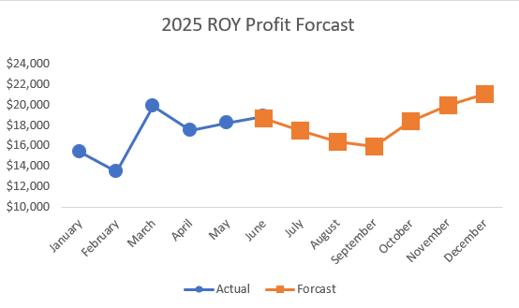

**Conclusion**

This refined regression model successfully captures profit determinants with greater precision. Future enhancements may include testing non-linear relationships or adding interaction terms for deeper insights.