

Data Technician

Name: Alaa Mostafa
Course Date: 16/12/24
Table of contents
Day 1: Task 1 2
Day 2: Task 1 2
Day 2: Task 2 3
Day 2: Task 3 4
Day 3: Task 1 4
Day 3: Task 2 5
Dataset: 5
Step 1: Create a Pivot Table 5
Step 2: Use the SWITCH Function 5
Submission: 6
Day 3: Task 3 6
Day 4: Task 1 7
Course Notes 9
Additional Information 10

Day 1: Task 1

Please complete the below boxes on commons laws and regulations that must be followed when working with customers data, use the below bulleted list to support your answers.

- What is it
- Why is it important
- Provide a real-world example of how you can follow it
- How does it impact working with data
- What could happen if you breached it

Data Protection Act | The Data Protection Act 2018 governs personal data processing in the UK, protecting privacy and defining duties.  It protects peoples personal information in the UK.  You can follow it by not divulging personal information of co-workers to people outside of the organisation. Or co workers that have no business requirement to know.  It means that providing the business keeps upto date info you have error free protected data that can’t be accessed without authority.  Liable to be fined and also dismissed from job.
GDPR | The GDPR, in effect since May 25, 2018, sets strict global standards for data privacy, empowering individuals to control their personal information.  Keeps the data protected and confidential  Maintaining employee data concerning race for example.  It means that the data is critical information that cant be divulged to unauthorised parties.  You could be fined and dismissed from work.
Freedom of Information Act | The Freedom of Information Act 2000 grants public access to information held by UK public authorities.  Important because it gives anyone the access to legitimate maintained information.  Company accounts and corporation tax  Correct legitimate data that has been assessed before accessible to those observing.  You could be prosecuted by the company that you are watching
Computer Misuse Act | The Computer Misuse Act 1990 sets legal boundaries to prevent unauthorized access to computer systems, protecting users and organizations from cybercrime.  Help users to feel safe that they will be protected and that if anything happens to them there is every chance that they will receive what has been taken.  Use devices like encryptions on important documents.  In terms of working with data it means that sensitive information can be protected in both professional and domestic surroundings.  If breached you could be dismissed and fined or imprisoned.

Day 2: Task 1

Please research and complete the following tasks within the retail-sales_dataset.xlsx document, paste a print screen into the provided boxes below:

- In the sheet ‘retail_sales_dataset’ add all available data between columns A –J into a ‘table’
- Using the ‘sort’ function, sort ‘Age’ to ‘largest to smallest’
- Using the ‘SUM’ function, show me the commission total in cell ‘L10’
- Using the ‘AVERAGE’ function, show me the average commission in cell ‘L11’

Print screen 1 | 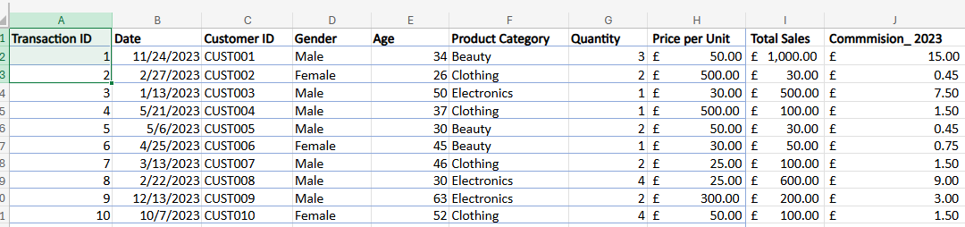
Print screen 2 | 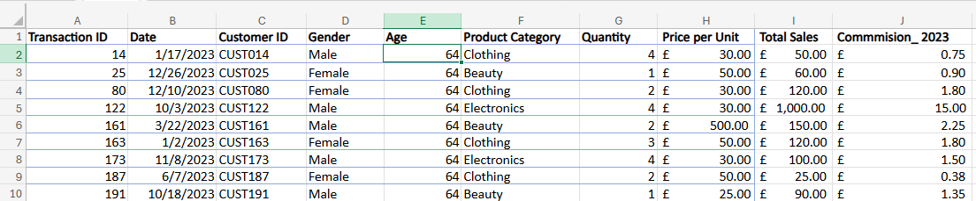
Print screen 3
Print screen 4

Day 2: Task 2

Please research and complete the following tasks within the retail-sales_dataset.xlsx document, paste print screens into the provided box below:



Print screen 1 | 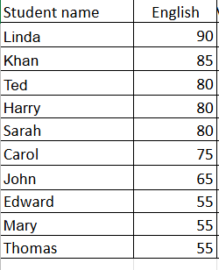  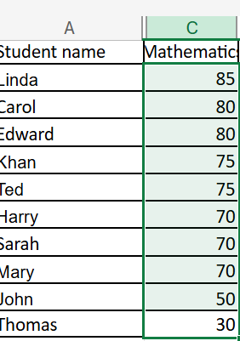  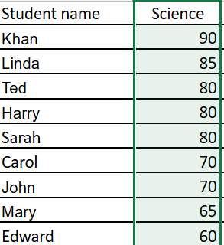  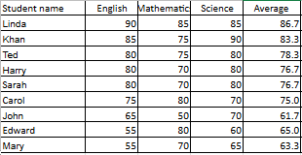  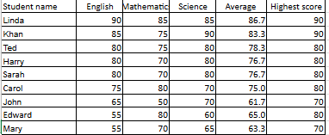  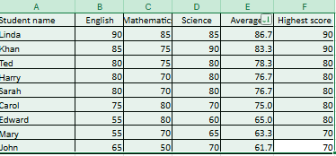  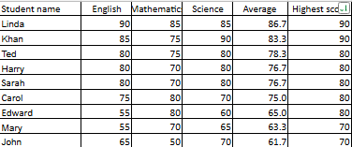  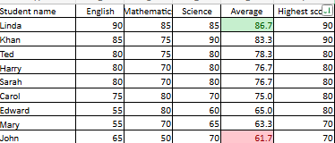

Day 2: Task 3

Using the skills developed today, have some fun with the data set you have imported. Paste your work below and enjoy!

Data taken from the retail_ sales_datasheet.
Pivot table 1

Print screen 1
  Date | Gender | Product Category | Sum of Age | (Concatenate) Merging Gender with Sum Age | Vlookup Males and Females with a sum age equal to 40
  1/1/2023 | Female | Clothing | 40 | Female 40 | 34
   | Female Total |  | 40 | Female Total 40 | 34
   | Male | Beauty | 46 | Male 46 | 46
   |  | Clothing | 41 | 41 | 41
   | Male Total |  | 87 | Male Total 87 | 49
  1/1/2023 Total |  |  | 127 | 127 | 97
  1/2/2023 | Female | Beauty | 19 | Female 19 | 19

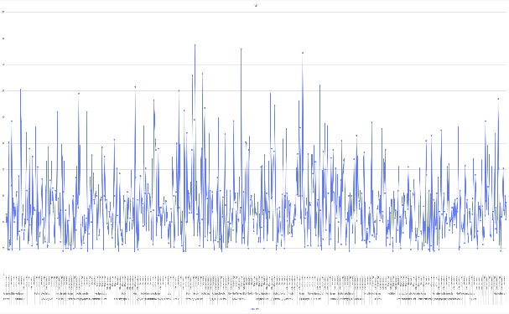
Figure 1 line graph for pivot table 1

Pivot Table 2
Product Category | Sum of Total Sales
Beauty | £143,515.00
Clothing | £155,580.00
Electronics | £156,905.00
Grand Total | £456,000.00

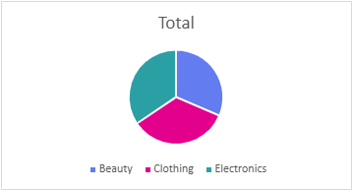
Figure 2 Pie Chart for Pivot table 2

Day 3: Task 1

Please download the dataset ‘Day_3_Task_1_Bike_Sales_Pivot_Lab.xlsx’ and the lab instructions.

Do not worry if you do not complete the lab, just working with data and playing with the pivot table will be good experience.

Please paste your final pivot table below and complete the reflection questions:

Print screen1
  Row Labels | Australia | Canada | France | Germany | United States | United Kingdom | United States | United States | Grand Total
  Youth (<25) | 11 | 0 | 10 | 0 | 0 | 6 | 0 | 0 | 27
  F | 9 | 0 | 6 | 0 | 0 | 1 | 0 | 0 | 16
  M | 2 | 0 | 4 | 0 | 0 | 5 | 0 | 0 | 11
  Young Adults (25-34) | 20 | 11 | 10 | 0 | 0 | 4 | 16 | 0 | 61
  F | 17 | 6 | 1 | 0 | 0 | 3 | 10 | 0 | 37
  M | 3 | 5 | 9 | 0 | 0 | 1 | 6 | 0 | 24
  Adults (35-64) | 32 | 0 | 0 | 13 | 2 | 4 | 47 | 1 | 99
  F | 17 | 0 | 0 | 8 | 2 | 1 | 27 | 0 | 55
  M | 15 | 0 | 0 | 5 | 0 | 3 | 20 | 1 | 44
  Grand Total | 63 | 11 | 20 | 13 | 2 | 14 | 63 | 1 | 187
In which markets does Germany have customers? | Germany’s customers are found in the young adults category aged between 35-64.
What country has sales in all markets? | Australia.
What are the most profitable markets by country, age group, and gender? | Youth <25 females is Australia, Youth <25 males Is the U.K.  Young Adults ( 25-34 ) Female is Australia, Male is France.  Adult (35-64) Female United States, Male United States.
Any other findings? | United states appear 3 times in the table with different figures.

Day 3: Task 2

The dataset below tracks the sales performance of different products in various counties in England. Please paste the dataset into a blank Excel workbook. Your task is to:
- Create a Pivot Table to summarise the data by county and product.
- Use the SWITCH function to categorise products based on their sales volume.

Dataset:
County | Product | Sales Volume
Yorkshire | Laptops | 500
Yorkshire | Smartphones | 200
Cornwall | Laptops | 700
Cornwall | Printers | 400
Lancashire | Smartphones | 150
Lancashire | Laptops | 600
Essex | Printers | 800
Essex | Smartphones | 300
Durham | Laptops | 250
Durham | Printers | 300
Greater Manchester | Smartphones | 600
Greater Manchester | Laptops | 400

Step 1: Create a Pivot Table
- Select the dataset (columns A to C).
- Insert a Pivot Table to summarise the data by County in the rows and Products in the columns. Use Sales Volume as the value to be summarised.

Step 2: Use the SWITCH Function
In a new column next to your data, use the SWITCH function to categorise products based on Sales Volume as follows:
  - For sales greater than 600: "High"
  - For sales between 300 and 600: "Medium"
  - For sales less than 300: "Low"
SWITCH Function Example:
=SWITCH(TRUE, C2 > 600, "High", C2 >= 300, "Medium", "Low")
- Apply this formula to each row, and check if the products are categorised correctly.

Submission:
- A completed Pivot Table summarising sales by county and product.
- A new column in the dataset categorising products by sales volume using the SWITCH function.
  - Please paste your completed work below

Print screen 1 | Pivot Table  A Dataset featuring a switch function
  “Sum of Sales by county and product “ | Product
  County | Laptops | Printers | Smartphones | Grand Total
  Cornwall | 700 | 400 |  | 1100
  Durham | 250 | 300 |  | 550
  Essex |  | 800 | 300 | 1100
  Greater Manchester | 400 |  | 600 | 1000
  Lancashire | 600 |  | 150 | 750
  Yorkshire | 500 |  | 200 | 700
  Grand Total | 2450 | 1500 | 1250 | 5200
  County | Product | Sales Volume | Switch
  Yorkshire | Laptops | 500 | Medium
  Yorkshire | Smartphones | 200 | Low
  Cornwall | Laptops | 700 | High
  Cornwall | Printers | 400 | Medium
  Lancashire | Smartphones | 150 | Low
  Lancashire | Laptops | 600 | Medium
  Essex | Printers | 800 | High
  Essex | Smartphones | 300 | Medium
  Durham | Laptops | 250 | Low
  Durham | Printers | 300 | Medium
  Greater Manchester | Smartphones | 600 | Medium
  Greater Manchester | Laptops | 400 | Medium

Day 3: Task 3

Please download the dataset ‘Day_3_Task_3_Bike_Sales_Visualisations_Lab.xlsx’ and the the lab instructions. Do not worry if you do not complete the lab, just working with data and playing with the charts will be good experience.

Please paste your results below:

Print screen 1 | Revenue and Profit by Year  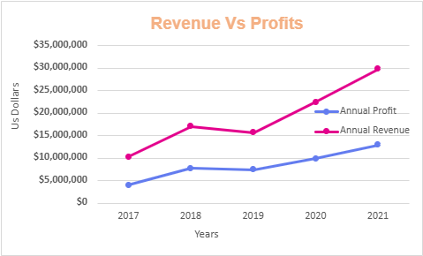  Product Revenue by Country  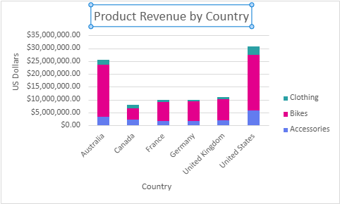  Revenue by Age Group  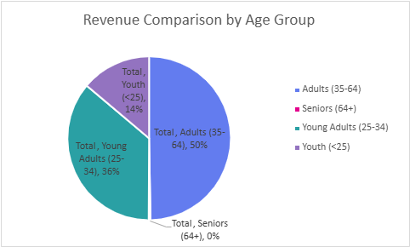
  Year | Annual Profit | Annual Revenue
  2017 | 4065680 | 10289670
  2018 | 7747551 | 17028380
  2019 | 7417353 | 15705990
  2020 | 9909624 | 22405052
  2021 | 12986202 | 29747226
  Grand Total | 42126410 | 95176318
  Sum of Revenue | Product_Category
  Country | Accessories | Bikes | Clothing | Grand Total
  Australia | 3284787 | 20231486 | 1911313 | 25427586
  Canada | 2305298 | 4317696 | 1391542 | 8014536
  France | 1627689 | 7378349 | 841175 | 9847213
  Germany | 1724549 | 7544500 | 713154 | 9982203
  United Kingdom | 1951000 | 8184668 | 954338 | 11090006
  United States | 5819323 | 21551497 | 3443954 | 30814774
  Grand Total | 16712646 | 69208196 | 9255476 | 95176318
  Age_Group | Sum of Revenue
  Adults (35-64) | 47323876
  Seniors (64+) | 339700
  Young Adults (25-34) | 34310905
  Youth (<25) | 13201837
  Grand Total | 95176318

Day 4: Task 1

You have been asked to deliver your analysis findings to the board of directors, with your analysis you have identified that customers are leaving your company at the 12-month point, this is typically when they receive their renewal price.

Conduct research and complete the below questions:

How would you prepare for the delivery? | To create the analysis I would have to first propose a statement that my research is based on this would be like a null hypothesis. So for example I would have to create a statement like “ the majority of customers leave the company after 12 months “ So I would need to take a parent population sample from data over a range so this could be over say a 3 year period.
What tools would you use for the delivery? | I would need to take reports surmising this information soi that would be things like a pivot table, comparison charts and graphs, something like excel as well. I could also need company accounts to create meaningful information to prove my hypothesis. And to show how far the data is a realisation of the standard deviation. To work effectively quickly you would need to create visualisations of the following formulas “ SUMIF, COUNT, COUTIFS, AVERAGE, IF, as well as chart to visualise trends and distributions.
What is prospecting and why would you complete this before your delivery? | Prospecting data refers to information collected about potential customers that helps businesses identify and target leads effectively, enhancing sales and marketing efforts. This is completed before delivery to make a valid assessment on how feasible the study/analysis would be. Also whether it would be possible to prove the null hypothesis.
Tell me best practices for public speaking and providing updates to senior leaders | There are various methods of developing skills for public speaking :  Practicing in front of a mirror,  Recording your presentation to perfect what is said during the presentation.  Drinking water at intervals to prevent dry mouth and the accidental reaction of not speaking when you need to.  Focus on the back of the room where you are speaking to eliminate fear of nerves,  When looking up always focus on the audience members lips not their eyes.  When providing updates to senior leaders the following should be considered:  Try to include then participants, try to make the information accessible to the understanding of the senior partners , they may have little or no knowledge of what you’re talking about. Ask questions to see if they did understand what you have been talking about. Also be concise and use little of no jargon.
What will you show the board in your delivery? | Promote how insight leads knowledge of data and how decisions can be easily made as a result.  Use visual representations of how the data has and can show trends, and business needs.  Look at showing them any immediate issues that need to change for the better of the company. This includes structure and development.
How will you articulate the changes that are needed? | I would articulate the changes with minimal jargon, use easy to understand English to create a good rapport and immediate relationship so that they feel at ease asking questions, or the need to clarify points that they may not understand.
Provide a list of online resources and videos that will support your preparation for public speaking | Ted  Microsoft Powerpoint  Chat GBT  Microsoft Pilot
Evaluate tools that provide visualisation.  Tell me what they are.  Tell me what you would choose when delivering your presentation and why | PowerPoint – useful to present easy to understand or simplified training information, a good way to present an over view of a project quickly to build knowledge,  Reports are a detailed method of explaining all the findings both short comings and developments.  Pivot tables and graphs can show and explain this point is a succinct way.  This is generally really important. Hence the use of simple formulas like IF COUNT AVERAGE SUM VLOOKUP,  I would choose to use a digital survey to find out what recipients knew before the presentation as well as after to assess the effectiveness of the presentation.  I would use a slide show using power point  I would engage with attendees to help them to understand that the knowledge they are obtaining can be easy to understand.  I would use pivot tables, tables and charts and graphs to visualise findings and trends helping to make the explanations easier to present.

Course Notes

It is recommended to take notes from the course, use the space below to do so, or use the revision guide shared with the class:

Additional Information

We have included a range of additional links to further resources and information that you may find useful, these can be found within your revision guide.

END OF WORKBOOK

Please check through your work thoroughly before submitting and update the table of contents if required.

Please send your completed work booklet to your trainer.

