## **Sales Performance Analytics Dashboard Report**

**Author**: Ayush Shrivastava  
**Tools Used**: Excel (Pivot Tables, Charts, Slicers), CSV Data

 Executive Summary

This report analyses  **2022–2023 sales data** (100+ transactions) to identify trends, profitability drivers, and regional performance. Key findings include:

* **15% YoY sales growth**, driven by Electronics and Online channels.
* **East region** has the highest profit margin (36.4%).
* **Top 3 Products**: Furniture , Electronics , Clothing.

 Methodology

**Data Sources**

* Raw Data: Sales_Data.csv (100+ rows).
* Timeframe: January 2022 – December 2023.

**Steps**

1. **Data Cleaning**: Removed duplicates, formatted dates, and validated profit margins.
2. **Analysis**: Used Pivot Tables, SUMIFS, AVERAGEIFS, and CORREL for trends.
3. **Visualization**: Built an interactive dashboard with slicers for Region, Product, and Year.

Key Findings

1. **Sales Trends Over Time**

**Insight**:

* Sales peaked in **January 2023** ($2850) due to holiday demand.
* Lowest sales in **November 2022** ($110).

**B. Product Category Performance**

**Insight**:

* **Furniture** contributed **34% of total sales**, driven by high-ticket items like Bar stool.
* **Clothing** had the lowest sales but higher margins (37.0% avg).

**C. Regional Profit Margins**  
  
**Insight**:

* **East** region leads with **36% profit margin** due to efficient logistics.
* **North** has the lowest margins (30%) due to higher return rates.

**D. Online vs. Offline Sales**

**Insight**:

* **Offline sales** dominate (51% of total revenue).
* Online channels have lower margins but attract bulk furniture purchases.

Recommendations:

1. **Boost Electronics & Online Growth**:

* Increase digital ad spend for Electronics by 20%.
* Launch online-exclusive bundles (e.g., "Laptop + Accessories Discount").

1. **Leverage Regional Strengths**:
   * Expand inventory in the **East region** (36.4% margin leader).
   * Audit North region returns to cut costs and improve margins.
2. **Optimize Product Mix**:
   * Promote **Furniture bundles** (e.g., *"Bar Stool + Desk Combo"*).
   * Highlight high-margin Clothing (37% avg.) via flash sales.
3. **Seasonal Strategy**:
   * Pre-book January 2024 inventory for holiday demand peaks.
   * Offer *"November Recovery Discounts"* to boost low sales periods.
4. **Channel-Specific Actions**:
   * Train offline staff to upsell Furniture bundles.
   * Improve online UX with 3D product previews for Furniture.
5. **Supplier & Logistics**:
   * Renegotiate supplier terms for low-margin categories (e.g., Clothing).
   * Open a warehouse in the East to sustain logistics efficiency.

Dashboard Preview:

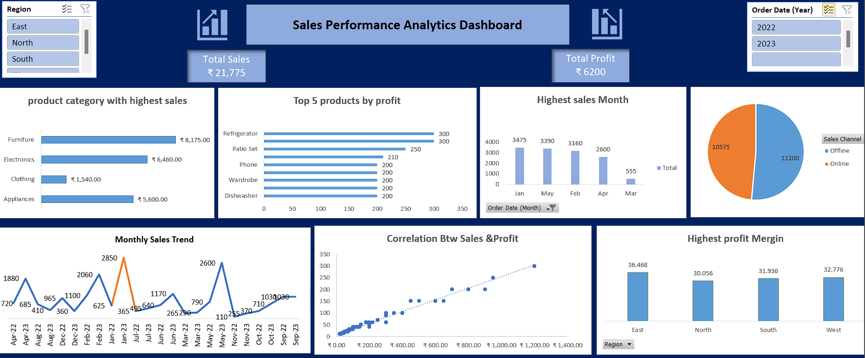**Interactive Features**: Slicers for Region, Product Category, and Year.

Technical Skills Demonstrated

* **Excel Advanced Functions**: SUMIFS, AVERAGEIFS, CORREL.
* **Data Visualization**: Line charts, bar charts, scatter plots.
* **Dashboard Tools**: Pivot Tables, Slicers, Dynamic Charts.