**Introduction**

**Application Gateway Configuration**

You will create all of the resources needed to load balance the VMSS traffic using an Application Gateway in this Lab Step. As Microsoft explains, an Application Gateway can be described by five configuration settings:

1. **Backend server pool**: The list of IP addresses of the backend servers. The IP addresses listed should either belong to the virtual network, but in a different subnet for the application gateway, or should be a public IP/VIP.
2. **Backend server pool settings**: Every pool has settings like port, protocol, and cookie-based affinity. These settings are tied to a pool and are applied to all servers within the pool.
3. **Frontend port**: This port is the public port that is opened on the application gateway. Traffic hits this port, and then gets redirected to one of the backend servers.
4. **Listener**: The listener has a frontend port, a protocol (HTTP or HTTPS), and the SSL certificate name (if configuring SSL offload).
5. **Rule**: The rule binds the listener and the backend server pool and defines which backend server pool the traffic should be directed to when it hits a particular listener. The rule can be either basic (round-robin) or path-based

When you first create an Application Gateway it includes an empty default backend pool for you to add addresses to. An Application Gateway must always have at least one backend pool.

**Requirements**

Assume that you have the following requirement for this Lab:

1. The web application must be accessible via the internet.
2. The web application uses HTTP and must be accessible on port 80.
3. The load balancing should not use sticky sessions/cookie-based affinity to promote equal load distribution to web application servers. (The web application is stateless meaning there is no benefit to sticky sessions.)
4. There is no need for a web application firewall (WAF).

**Solution to Implement**

The following bullets help explain the resources that need to be created to meet the requirements in the instructions of this Lab Step:

* The web application uses HTTP making Application Gateway preferred over Azure Load Balancers
* A public IP address is required for the Application Gateway's frontend to be accessible via the internet
* The VMSS instances do not have public IP addresses. This means that the Application Gateway must be in the same virtual network as the VMSS to reach it. However, the Application Gateway must be in a different subnet than the VMSS. Application Gateways always need to be in a subnet of their own.
* The requirements related to listener settings, such as listening on port 80, and backend pool settings, such as disabling cookie-based affinity, can be satisfied by setting appropriate options when creating the Application Gateway
* Because no WAF is required, the Application Gateway can be a standard small type to minimize costs. Medium size or greater is required for WAF types.

**Instructions**

1. Create a subnet in the app virtual network:

[**Copy code**](https://cloudacademy.com/lab/application-load-balancing-azure-application-gateways/creating-application-gateway-load-balance-vmss-traffic/?context_id=1332&context_resource=lp)

az network vnet subnet create --resource-group $resource_group --vnet-name app \

--name app-gw --address-prefix 10.0.100.0/24

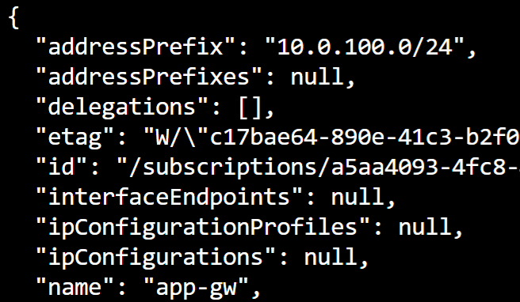

The output displays the JSON specification of the subnet. The address prefix is chosen to not overlap with the web subnet (10.0.0.0/24).

2. Create a public IP address for the Application Gateway frontend:

[**Copy code**](https://cloudacademy.com/lab/application-load-balancing-azure-application-gateways/creating-application-gateway-load-balance-vmss-traffic/?context_id=1332&context_resource=lp)

az network public-ip create --resource-group $resource_group --name app-gw-ip \

--allocation-method Dynamic

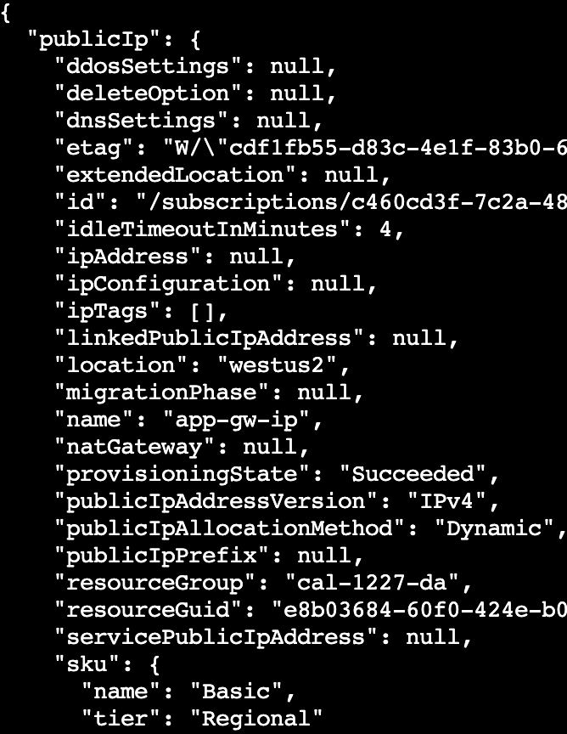

The dynamic allocation method means that an IP address will be assigned when the public IP is associated with a resource. Static allocation can be used to reserve an address that won't change when it is not associated with a resource, for a cost. Currently the public IP is not associated so the **ipAddress** is **null**.

3. Read through the available configuration options for creating an Application Gateway and consider what options are needed to meet the requirements, pressing *spacebar* to advance the output:

[**Copy code**](https://cloudacademy.com/lab/application-load-balancing-azure-application-gateways/creating-application-gateway-load-balance-vmss-traffic/?context_id=1332&context_resource=lp)

az network application-gateway create -h

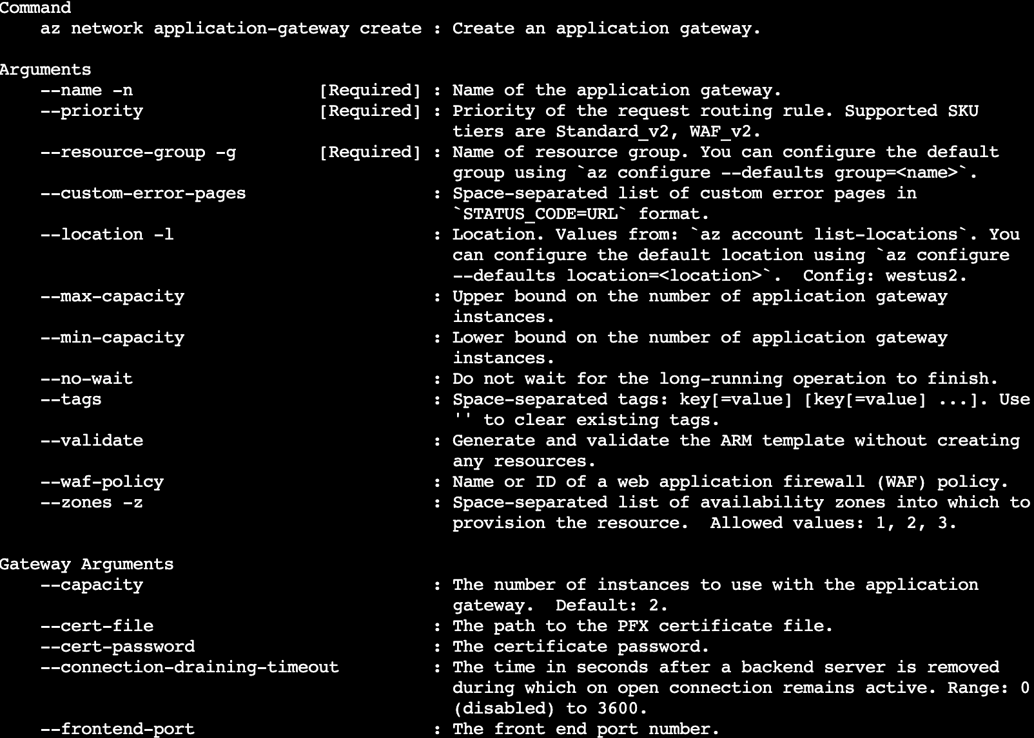

The **--cert-file**and **--cert-password**options can be used to configure SSL offloading. In the description for the **--sku** option, there are **Standard** and **WAF** SKUs:



The v2 tiers support availability zones. Availability zones are a good idea for production, along with a **--capacity** of at least two to ensure a failure of one Application Gateway instance can be tolerated. For this Lab, a single small instance is sufficient.

4. Create an Application Gateway the satisfies the requirements:

[**Copy code**](https://cloudacademy.com/lab/application-load-balancing-azure-application-gateways/creating-application-gateway-load-balance-vmss-traffic/?context_id=1332&context_resource=lp)

az network application-gateway create --resource-group $resource_group --vnet-name app --subnet app-gw \

                                      --name app-gw --capacity 1 --frontend-port 80 \

                                      --http-settings-cookie-based-affinity Disabled \

                                      --http-settings-port 80 --http-settings-protocol Http \

                                      --public-ip-address app-gw-ip --sku Standard_Small \

                                      --priority 100

The http-settings-port is the port that the Application Gateway uses to communicate with the backend pool. It also automatically sends probes on that port to monitor the health of backend pool instances, removing any that don't provide a healthy response to the probe.

Note that the --servers option is not used. Although you could specify a list of IP addresses it is better to separately configure the VMSS so that when the VMSS scales up or down, the Application Gateway will automatically be updated to include/exclude added/removed VMSS instances. You will do this in the next Lab Step.

The command takes around 17 minutes to complete. Please wait until this is completed to be able to pass the check and proceed with the next lab step.

**Summary**

In this Lab Step, you created several resources necessary to create an Application Gateway. The Application Gateway takes a long time to create, but once it is finished the Lab environment will resemble the following diagram:

