**Introduction**

**Application Gateway Background**

Azure Application Gateways are HTTP/HTTPS load balancing solutions, compared to Azure Load Balancers which are TCP/UDP load balancing solutions. Similar to Azure Load Balancers, Application Gateways can be configured with internet-facing IP addresses or with internal load balancer endpoints making them inaccessible via the internet. Application Gateways are ideal when you require:

* Web-based traffic in any of HTTP, HTTPS, or WebSocket protocols
* TLS/SSL offloading to improve utilization of backend by offloading encrypt/decrypt operations to the load balancer
* Built-in web application firewall (requires medium Application Gateway type or larger)
* Cookie affinity for sticky sessions

Azure application gateways can be configured using a variety of backends including plain VMs, Azure Web Apps, Azure Kubernetes Service (AKS), and Virtual Machine Scale Sets (VMSS).

**Lab Scenario**

In this Lab, you will use the Azure CLI to configure an application gateway to load balance traffic to a VMSS that you will deploy a web application to. VMSSs are sets of identically configured virtual machines (VM) referred to as instances in the VMSS. VMSSs can automatically scale the number of instances based on a variety of metrics. Instances are distributed across availability zones to provide fault tolerance in case of a major failure of a zone within a region. The Cloud Academy Lab environment includes several resources that you will need to learn about before configuring the Application Gateway. That is the purpose of the following instructions in this Lab Step. Although the Lab emphasizes the Azure CLI, feel free to explore the resources in the Portal whenever you like.

**Instructions**

1. List the virtual networks in the environment:

[**Copy code**](https://cloudacademy.com/lab/application-load-balancing-azure-application-gateways/understanding-azure-application-gateways-and-lab-scenario/?context_id=1332&context_resource=lp)

# Set default location to WestUS2 where Lab resources are located

az configure --defaults location=westus2

az network vnet list --output table



There is a single virtual network named **app** that hosts web application resources. There is a single subnet that you will inspect next.

2. List the subnet in the app virtual network:

[**Copy code**](https://cloudacademy.com/lab/application-load-balancing-azure-application-gateways/understanding-azure-application-gateways-and-lab-scenario/?context_id=1332&context_resource=lp)

resource_group=$(az group list --query [].name --output tsv)

az network vnet subnet list --resource-group $resource_group --vnet-name app --output table

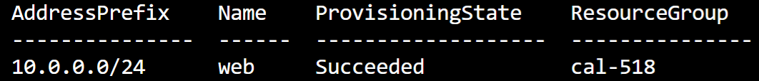

The **web** contains the VMSS that will host the web application.

3. Query the subnet's network security group (NSG) ID:

[**Copy code**](https://cloudacademy.com/lab/application-load-balancing-azure-application-gateways/understanding-azure-application-gateways-and-lab-scenario/?context_id=1332&context_resource=lp)

az network vnet subnet list --resource-group $resource_group --vnet-name app --query [].networkSecurityGroup.id --output tsv

alt

The output will confirms that an NSG is associated with the subnet and that the NSG is named **website-vmssnsg**.

4. List the rules in the website-vmssnsg NSG:

[**Copy code**](https://cloudacademy.com/lab/application-load-balancing-azure-application-gateways/understanding-azure-application-gateways-and-lab-scenario/?context_id=1332&context_resource=lp)

az network nsg rule list --resource-group $resource_group --nsg-name website-vmssnsg --output jsonc

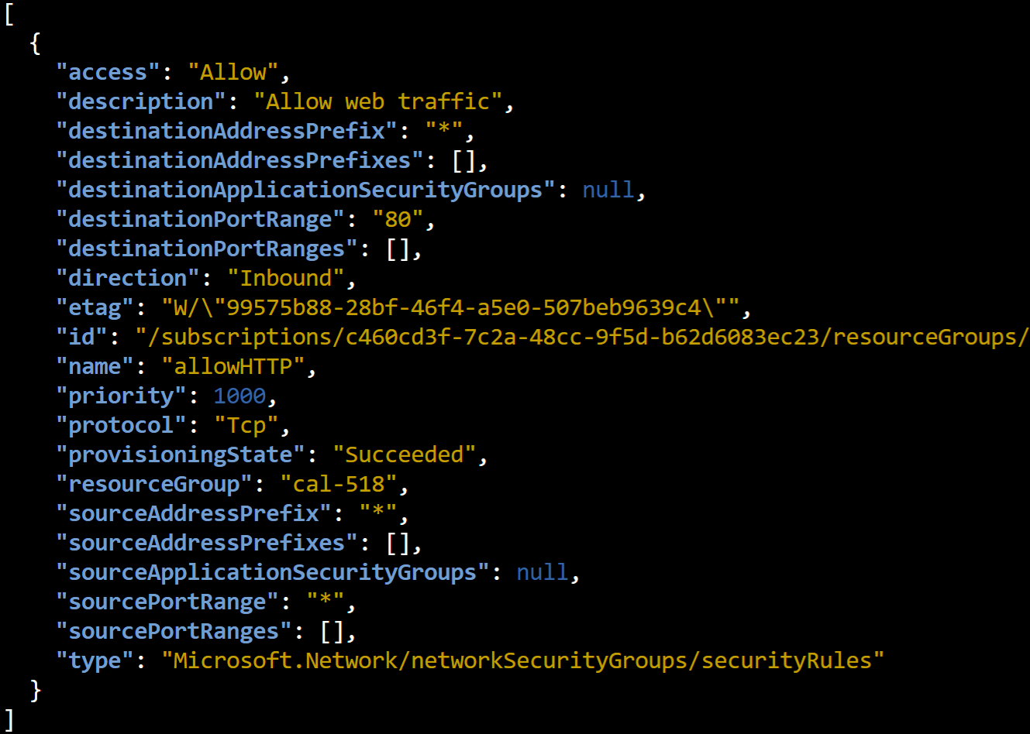

The NSG has a single (non-default) rule that allows HTTP (**Tcp** destination port **80**).

4. Page through the output of the VMSS by pressing *spacebar* after entering:

[**Copy code**](https://cloudacademy.com/lab/application-load-balancing-azure-application-gateways/understanding-azure-application-gateways-and-lab-scenario/?context_id=1332&context_resource=lp)

az vmss list --output jsonc | more

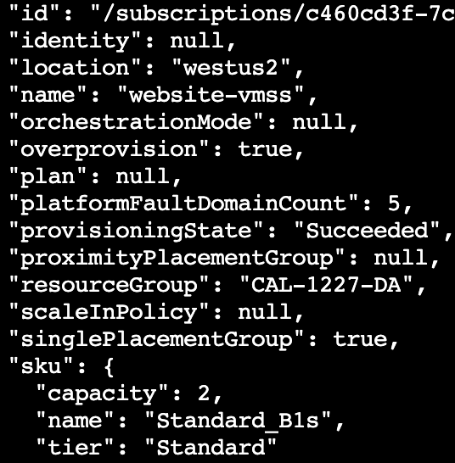

The **website-vmss** has a **capacity**of **2** meaning that two VM instances are in the VMSS. Other properties to note are:

* **"publicIpAddressConfiguration": null**(meaning the instances cannot be reached via the internet)
* **"networkSecurityGroup": null** (meaning there is no additional NSG besides the one associated with the subnet)
* **"offer": "CentOS"** (meaning instances are running the CentOS distribution of Linux)
* **"zones": ["1", "2"]** (meaning the instances are spread across two availability zones in the region)

The instances are not currently running any web application. You will deploy one later.

**Summary**

In this Lab Step, you understood the challenges that an Application Gateway can solve. You also inspected the Lab environment to see the resources that were created when you started the Lab. The Lab environment resembles the following diagram:

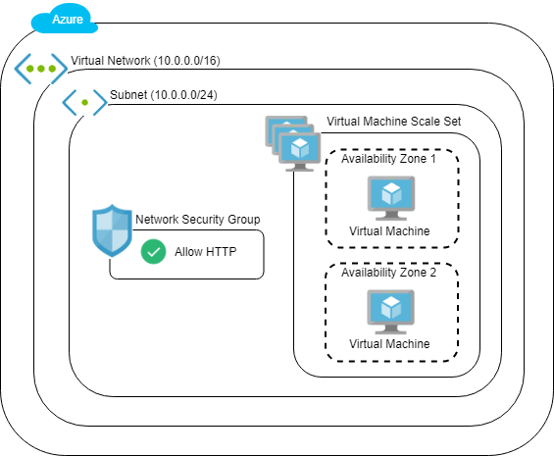

You will configure an Application Gateway to load balance application traffic destined for the VMSS.