**Introduction**

The Application Gateway currently has an empty backend pool. To access the web application through the Application Gateway you need to configure the VMSS to be in the backend pool. You will do that in this Lab Step. The configuration change actually needs to take place on the VMSS rather than the Application Gateway. This makes sense considering the VMSS knows when it scales up or down and can keep the backend pool up to date.

*Note*: You should wait until the Application Gateway has finished creating before moving on to the instructions of this Lab Step. You can wait until the Application Gateway provisioning completes by issuing

[**Copy code**](https://cloudacademy.com/lab/application-load-balancing-azure-application-gateways/configuring-vmss-application-gateway-backend-pool/?context_id=1332&context_resource=lp)

az network application-gateway wait --resource-group $resource_group --name app-gw --created

alt

The command prompt will be returned to you when the provisioning completes. While you wait, it is a good opportunity to explore the metrics and settings of the VMSS and the Application Gateway in the Azure Portal.

**Instructions**

1. Inspect the network interface configuration of the VMSS:

[**Copy code**](https://cloudacademy.com/lab/application-load-balancing-azure-application-gateways/configuring-vmss-application-gateway-backend-pool/?context_id=1332&context_resource=lp)

az configure --defaults location=westus2

resource_group=$(az group list --query [].name --output tsv)

az vmss show --resource-group $resource_group --name website-vmss \

--query virtualMachineProfile.networkProfile.networkInterfaceConfigurations

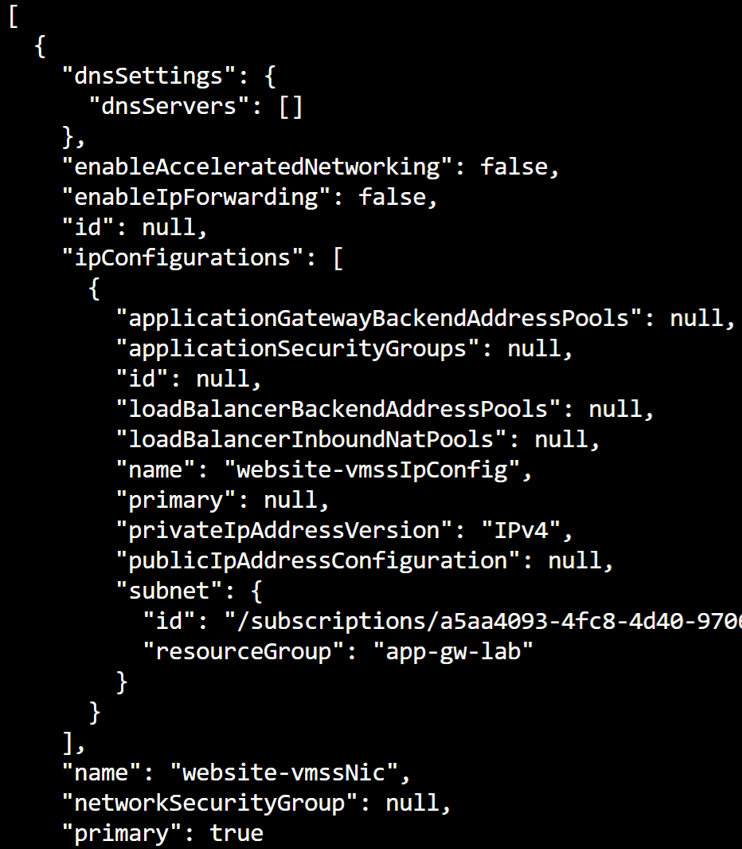

The main properties to note are **applicationGatewayBackendAddressPools** and **loadBalancerBackendAddressPools** which are used to configure the VMSS in a backend pool for an Application Gateway or an Azure Load Balancer, respectively. As the property names suggest, there can be more than one of each type of backend pool. Because of this, the [property values are lists](https://docs.microsoft.com/en-us/azure/templates/microsoft.compute/virtualmachinescalesets#virtualmachinescalesetipconfigurationproperties-object). The elements in the lists are objects containing the ID of the backend pool.

2. Review the properties of the Application Gateway focusing on relevant backend address pool values:

[**Copy code**](https://cloudacademy.com/lab/application-load-balancing-azure-application-gateways/configuring-vmss-application-gateway-backend-pool/?context_id=1332&context_resource=lp)

az network application-gateway show --resource-group $resource_group --name app-gw | more

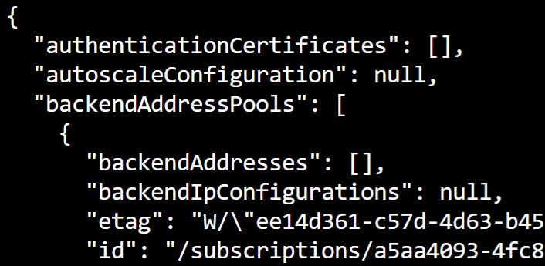

The **backendAddressPools**[0].**id** is what you need to configure the VMSS backend pool.

3. Extract the backend pool ID and store it in a variable:

[**Copy code**](https://cloudacademy.com/lab/application-load-balancing-azure-application-gateways/configuring-vmss-application-gateway-backend-pool/?context_id=1332&context_resource=lp)

backend_pool_id=$(az network application-gateway show --resource-group $resource_group --name app-gw --query backendAddressPools[0].id)

Now that you have the ID, it's a good time to review the different options available for updating with the Azure CLI. With the Azure CLI, when you need to update a property you can use the --set option with the following pattern --set property=value. The value can be an entire list when the property is a list type. For changes involving lists, you can also use --add and --remove to modify the list elements. If the elements are JSON objects, you specify the JSON string as the parameter to the --add or --remove option. In the case of updating the VMSS backend pool property, you could use either set or add because there is no risk of overwriting other pools when the value is currently null.

4. Update the VMSS backend pool configuration to reference the Application Gateway's default backend pool by ID:

[**Copy code**](https://cloudacademy.com/lab/application-load-balancing-azure-application-gateways/configuring-vmss-application-gateway-backend-pool/?context_id=1332&context_resource=lp)

az vmss update --resource-group $resource_group --name website-vmss \

--add virtualMachineProfile.networkProfile.networkInterfaceConfigurations[0].ipConfigurations[0].applicationGatewayBackendAddressPools "{'id':$backend_pool_id}"

The command uses --add to add an element to the (empty) list. The element is a JSON object with only an id property. The pattern for --add and --remove updates is --add/--remove property value.

The command outputs the latest JSON specification for the VMSS. You can verify that the **applicationGatewayBackendAddressPools**field is a list with the object you just added.

*Note*: This command may take 5 or more minutes to output.

5. Get the public IP address associated with the Application Gateway frontend:

[**Copy code**](https://cloudacademy.com/lab/application-load-balancing-azure-application-gateways/configuring-vmss-application-gateway-backend-pool/?context_id=1332&context_resource=lp)

az network public-ip show --resource-group $resource_group --name app-gw-ip --query ipAddress --output tsv

The output is the IP address.

6. Open a new web browser tab and navigate to the IP address:

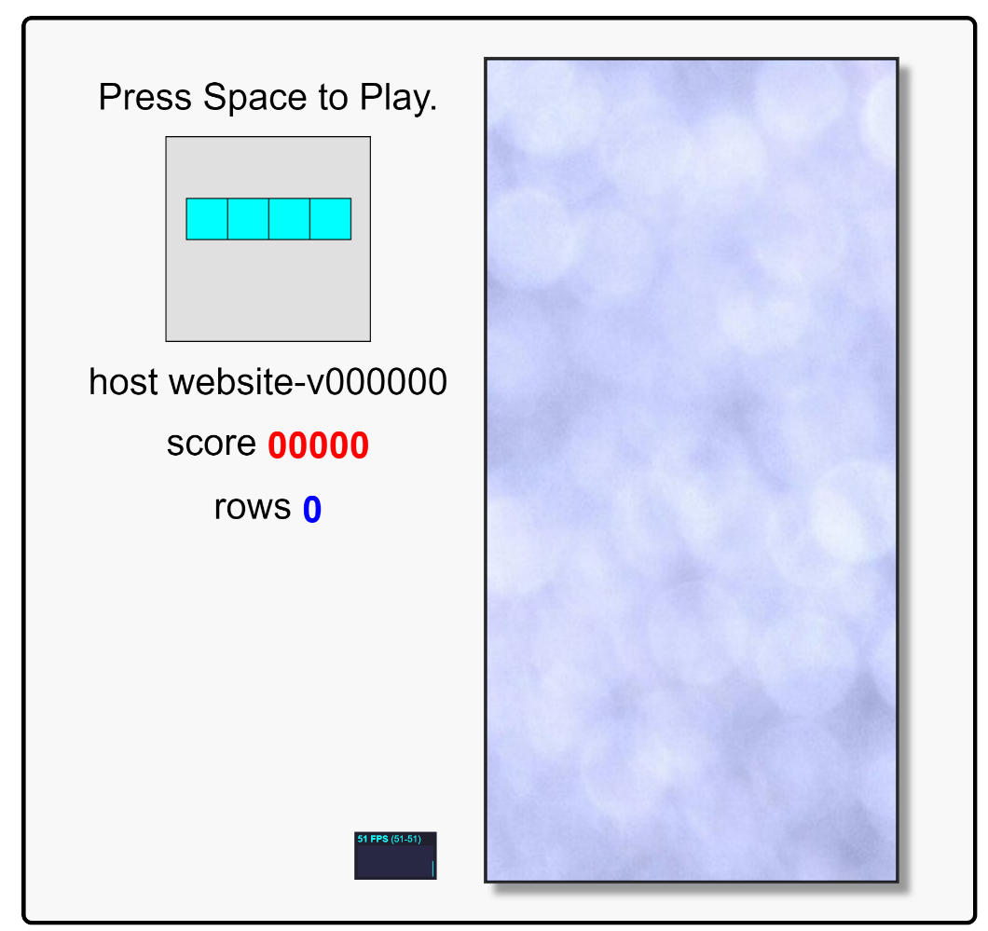

The web application is displayed. Press the spacebar if you'd like to test it out. The **host** line gives the name of the VMSS instance that is serving your HTTP request. In the image above the hostname is **website-v000000**.

7. Refresh your browser until you see the **host website-v** line change:

alt

This confirms that the Application Gateway is load balancing traffic to the VMSS instances that are serving the web application.

*Note*: Your browser may cache the application for short periods causing the same host to appear. If you don't observe a change in the **host** after refreshing several times, you can try a different browser or private/incognito mode of your browser and refresh with a few seconds delay between refreshes.

**Summary**

In this Lab Step, you configured the Application Gateway backend pool property of the VMSS to refer to the Application Gateway's default backend pool. This completed the requirements to enable the Application Gateway to load balance application traffic served by the VMSS. The Lab environment now resembles the following:

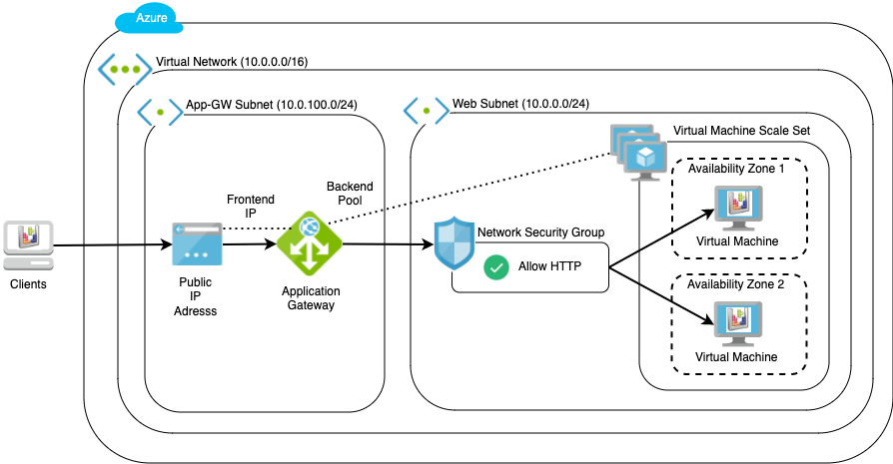

*Note*: It is possible to create a VMSS and Application Gateway in a single step. However, it is instructive to configure the backend pool after the VMSS is created to understand more about how it works and how to use the Azure CLI.