**Introduction**

The VMSS is not running any web application yet. In this Lab Step, you will deploy a web application by running a custom script on the VMSS instances using a VMSS extension. Extensions are small applications that automate tasks on running instances. You will use a custom script extension that allows you to run an arbitrary script on the VMSS instances. The script you will use will install Docker and deploy an application that is packaged in a Docker image.

**Instructions**

1. Run a custom script that deploys a web application on the VMSS instances using an extension:

[**Copy code**](https://cloudacademy.com/lab/application-load-balancing-azure-application-gateways/using-vmss-extension-deploy-web-application-vmss/?context_id=1332&context_resource=lp)

az vmss extension set --vmss-name website-vmss --name customScript --resource-group $resource_group --version 2.0 --publisher Microsoft.azure.extensions --settings '{"fileUris": ["https://raw.githubusercontent.com/cloudacademy/azure-lab-provisioners/master/app-gw/deploy.sh"], "commandToExecute": "./deploy.sh"}'

Once the command finishes in a few minutes, it outputs the JSON specification of the VMSS. It includes the extension in the **virtualMachineProfile**.**extensionProfile** property:

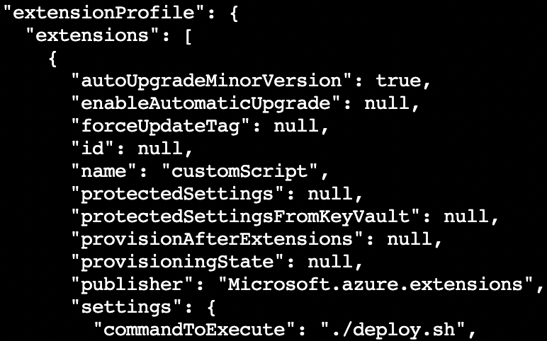

The deploy script started a web application on the instances on port 80. The content of the script is below:

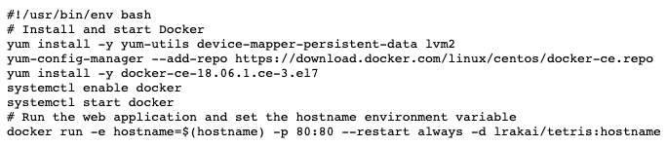

You don't need to understand the details. Just know that Docker is being installed and a web application is being run using the docker run command on the last line.

**Summary**

In this Lab Step, you used a VMSS extension to deploy a web application to the instances. The Lab environment currently resembles the following diagram:

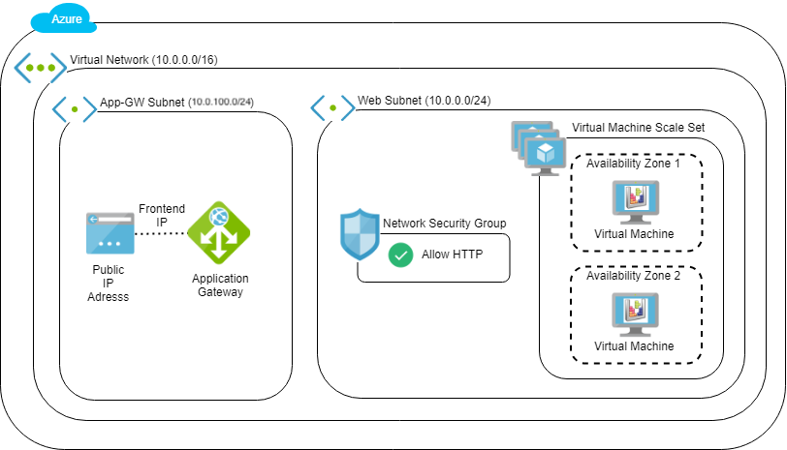

The instances are not accessible via the internet so you cannot access the application yet. In the next Lab Step, you will configure the VMSS to be in the backend pool of the Application Gateway. You will then be ablel to access the VMSS through the Application Gateway and have traffic load balanced across VMSS instances.