DIWALI SALES DATA ANALYSIS
Python Project Documentation
Python • Pandas • Exploratory Data Analysis • Data Visualization • Business Insight

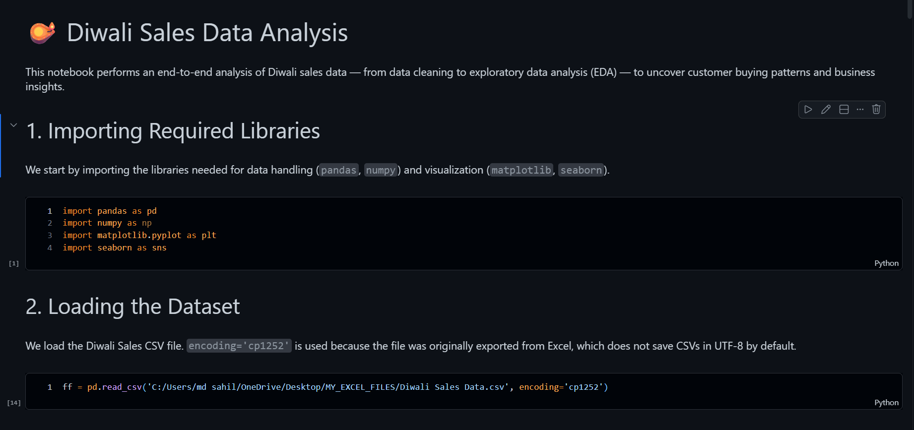

1.1 Introduction
This project is a Python-based Exploratory Data Analysis (EDA) project focused on analyzing Diwali sales data. Python and Pandas are used to inspect, prepare, analyze, and visualize the data in order to understand customer purchasing behavior, demographic patterns, product preferences, and sales patterns.

1.2 Project Objectives
- Analyze the overall Diwali sales dataset.
- Perform data cleaning and preprocessing.
- Identify important customer demographics.
- Analyze purchasing behavior by gender and age group.
- Analyze sales according to occupation and state.
- Identify popular product categories and products.
- Generate business-oriented insights from the analysis.

1.3 Scope of the Project
The project focuses on descriptive and diagnostic analytics. It is intended to understand patterns in the available historical sales data and does not present a predictive machine-learning system.

2. Dataset Information

2.1 Dataset Description
The project uses a Diwali Sales dataset containing customer, demographic, product, category, and purchasing-related information. The dataset is explored through Python and Pandas.

2.2 Main Analytical Areas
- Customer purchasing behavior
- Gender-wise analysis
- Age-group analysis
- Occupation-wise analysis
- State-wise analysis
- Marital-status analysis
- Product-category analysis
- Product-level analysis
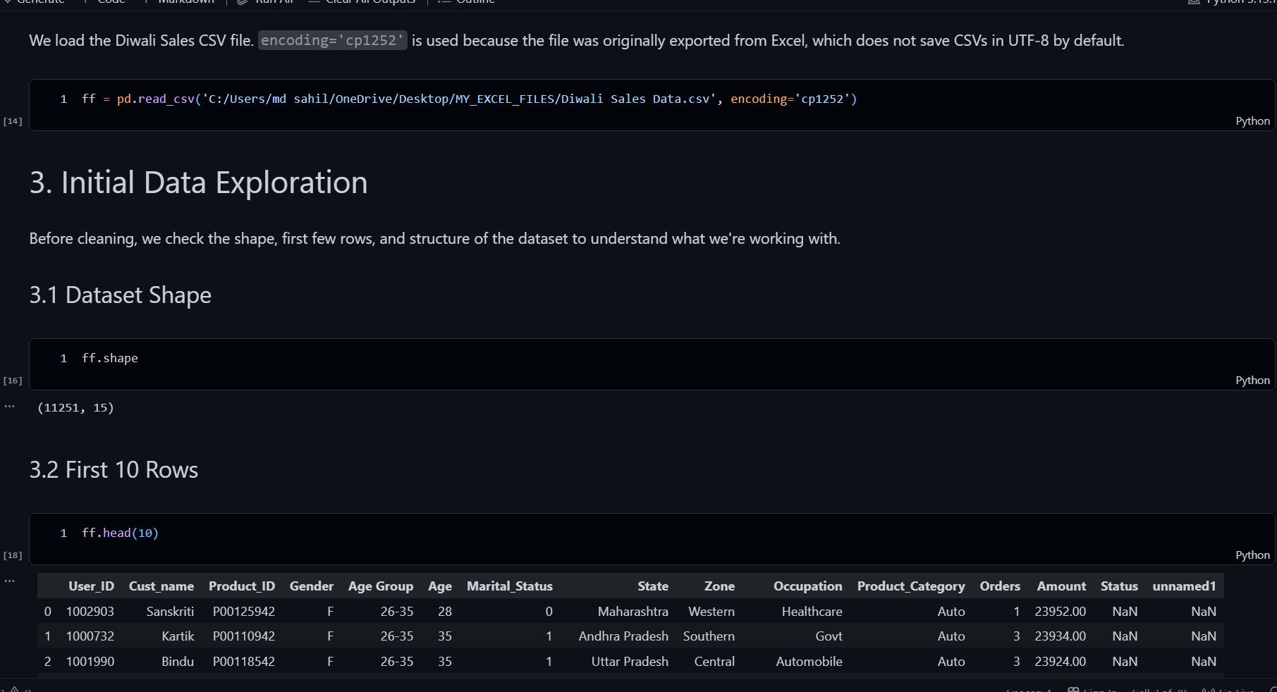

3. Data Cleaning & Preparation

3.1 Data Inspection
- Dataset structure and columns were inspected before analysis.
- Data types and available fields were reviewed.
- Missing/blank values were checked.
- Duplicate records were checked.
- Unique/distinct values were reviewed where relevant.
- Data was prepared for grouping, filtering, aggregation, and visualization.
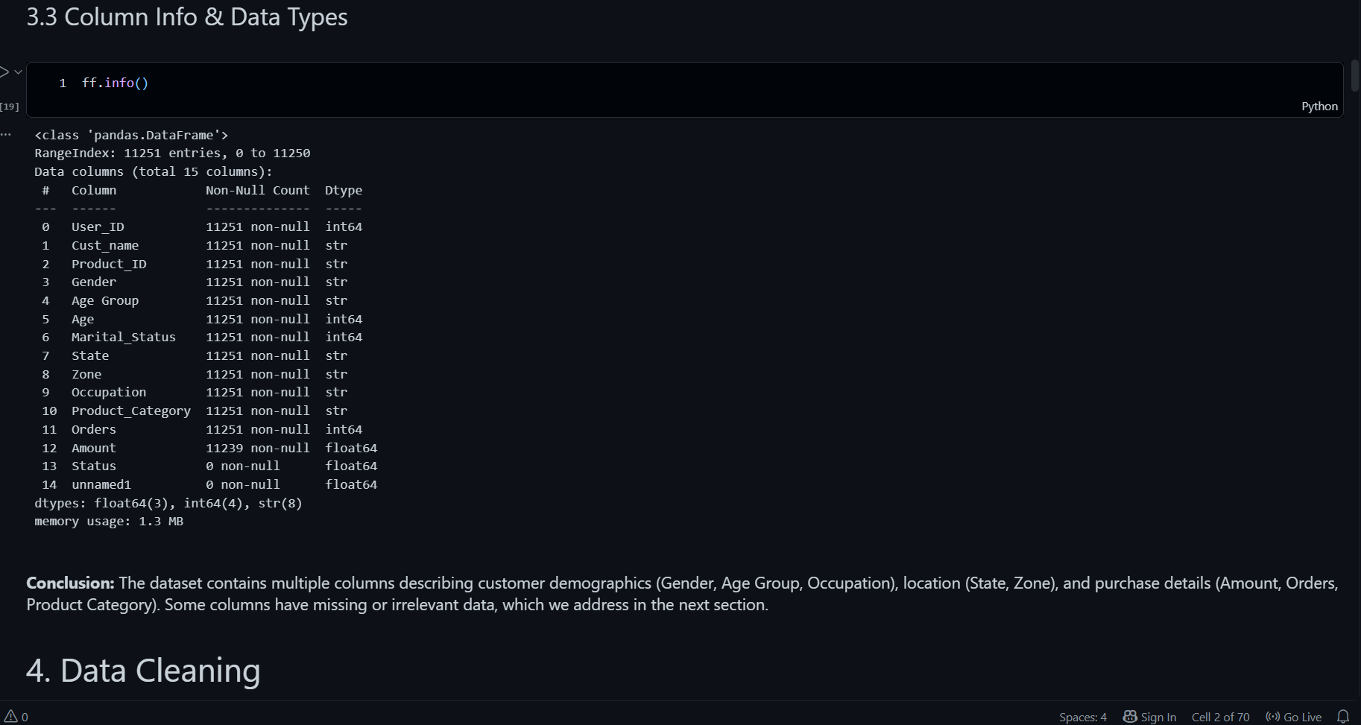

4. Exploratory Data Analysis

4.1 Gender-wise Analysis
Gender-based analysis is used to understand differences in purchasing activity between customer groups.

4.2 Age Group Analysis
Age-group analysis is used to understand purchasing activity across different customer age segments.

4.3 State-wise Analysis
State-level analysis is used to identify geographic differences in customer purchasing behavior.

4.4 Occupation Analysis
Occupation-wise analysis is used to understand purchasing patterns across professional groups.
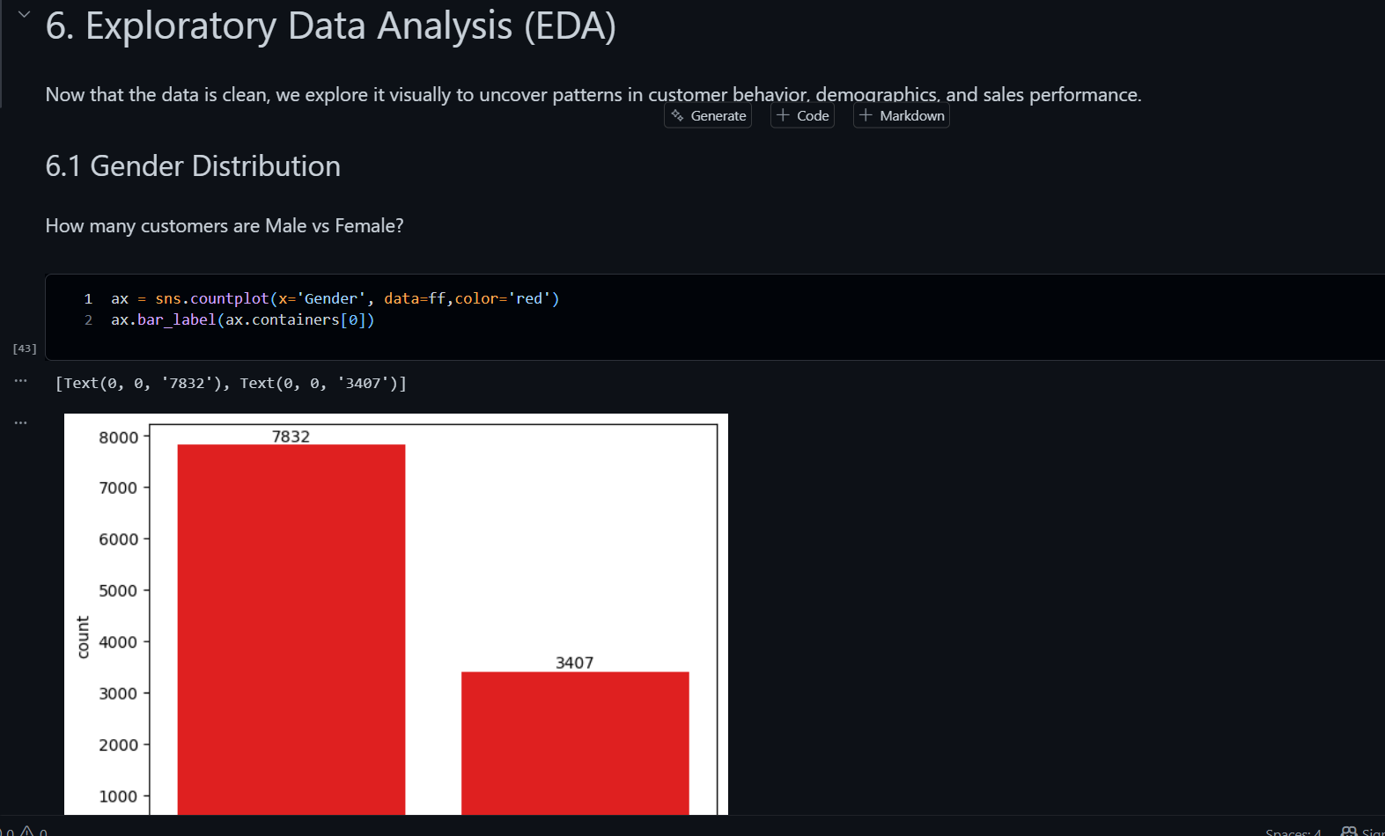5. Product & Category Analysis

5.1 Product Category Analysis
Product-category analysis is used to identify categories with stronger purchasing activity and understand customer product preferences.

5.2 Product-level Analysis
Product-level analysis is used to identify products with higher purchasing activity and useful demand patterns.
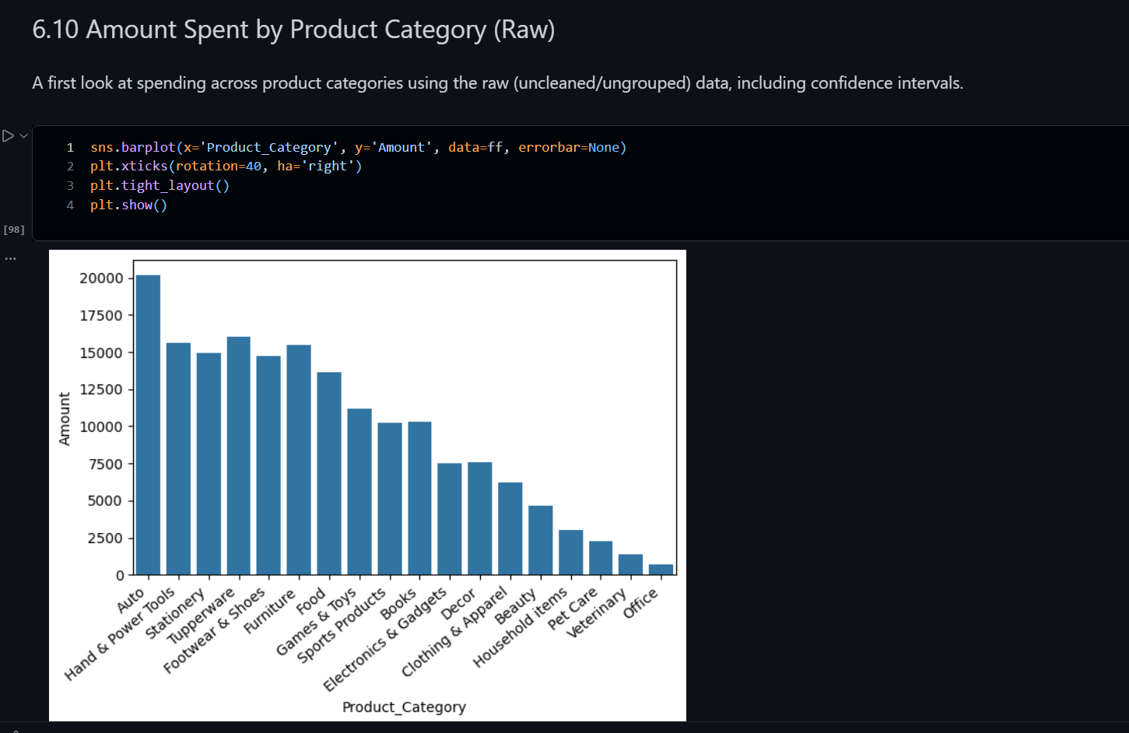6. Customer Segmentation
Customers are analyzed using multiple dimensions including gender, age, occupation, marital status, and state. This segmentation helps identify groups with different purchasing patterns.
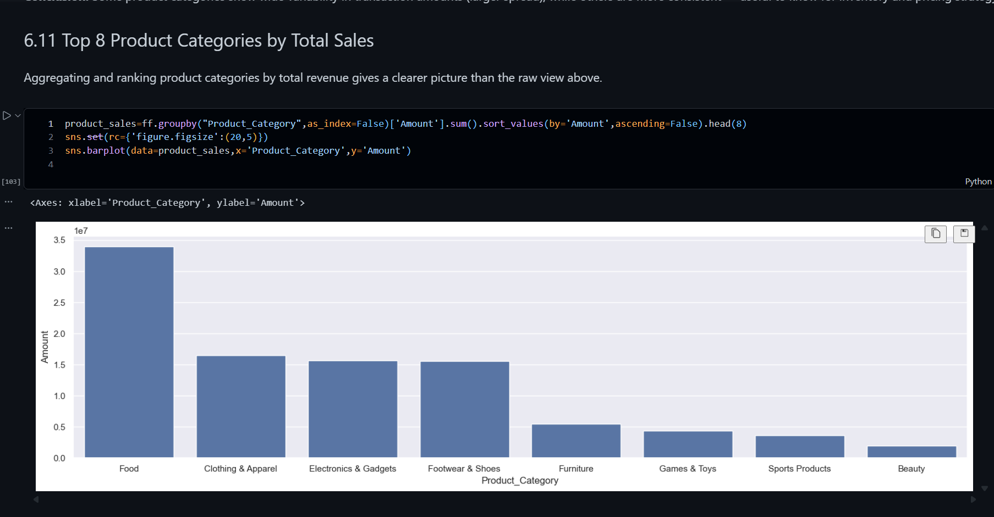7. Business Questions
- Which customer groups show stronger purchasing activity?
- How does purchasing behavior differ by gender and age?
- Which occupations and marital-status groups contribute more to purchasing activity?
- Which states show higher customer purchasing activity?
- Which product categories and products are more popular?
- How can these patterns support targeted promotions and inventory planning?

8. Business Insights
- Customer insights — understand important customer segments and their purchasing behavior.
- Geographic insights — identify locations with comparatively stronger customer activity.
- Product insights — understand product and category demand patterns.
- Marketing insights — support demographic and customer-based targeting.
- Inventory insights — support product and category planning using observed demand patterns.

9. Python / Pandas Implementation
The project demonstrates a practical Python and Pandas workflow for business analysis, including data loading, inspection, cleaning, filtering, grouping, aggregation, visualization, and business interpretation.
[ 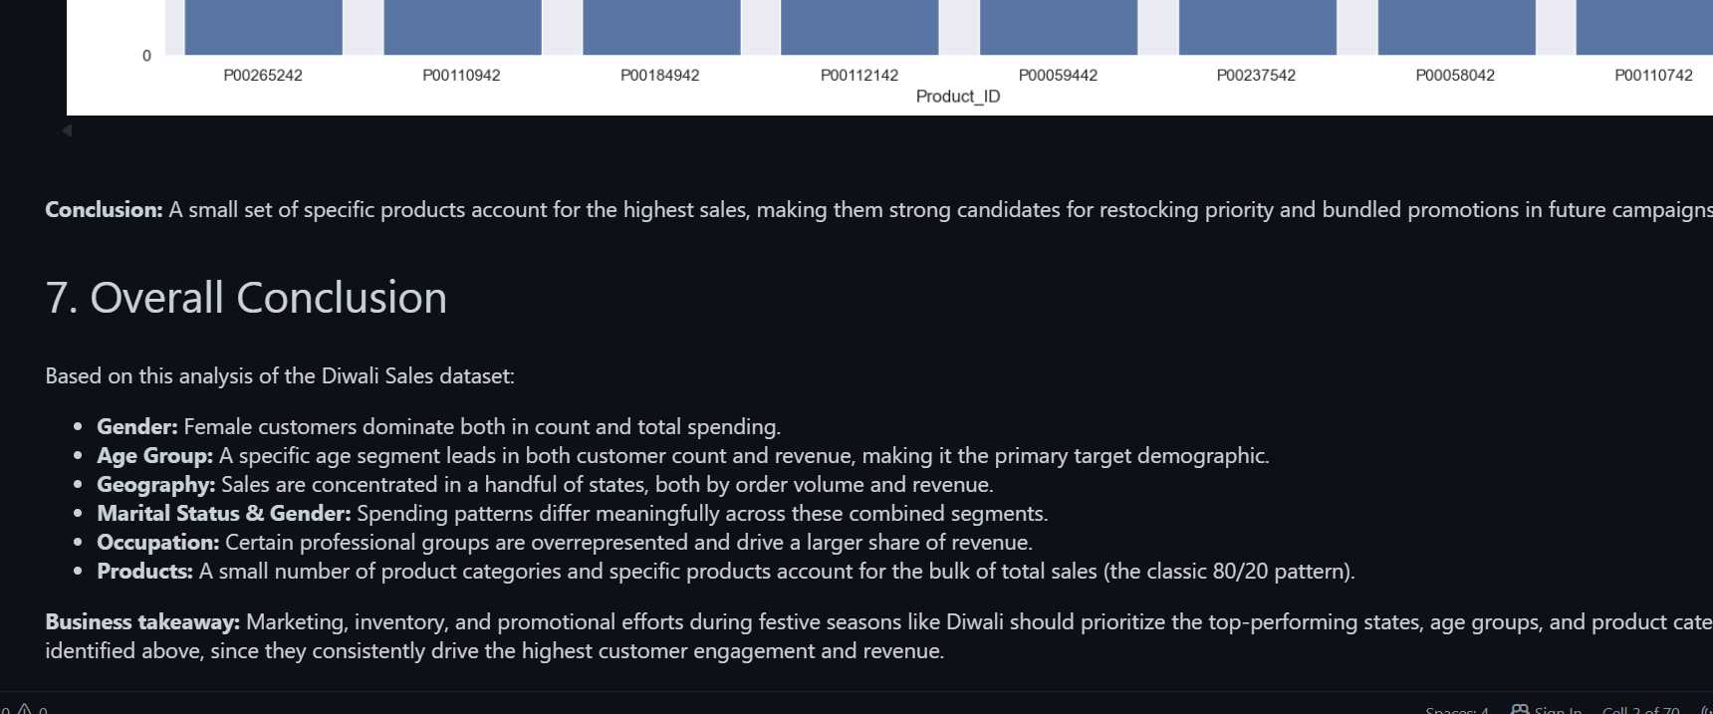10. Visualization Gallery
The notebook visualizations provide a visual summary of customer, product, geographic, and purchasing patterns.
Recommended: reuse the strongest chart from the notebook if a separate gallery is required. No additional screenshot space is required here.

11. Project Structure
- DIWALI_SALES_ENHANCED.ipynb — complete Python analysis notebook
- README.md — GitHub project overview
- Diwali_Sales_Python_Project_Documentation.docx — project documentation
- Dataset file — source data used by the notebook

12. How to Run the Project
- Open the notebook in Jupyter Notebook, JupyterLab, or Google Colab.
- Keep the dataset available at the location expected by the notebook.
- Run the notebook cells sequentially.
- Review the generated outputs and visualizations.

13. Skills Demonstrated
- Python
- Pandas
- Data Cleaning
- Exploratory Data Analysis
- Data Visualization
- Filtering & Aggregation
- GroupBy Analysis
- Customer Segmentation
- Business Insight Generation

14. Conclusion
The Diwali Sales Data Analysis project demonstrates how Python and Pandas can transform raw sales data into structured business information. The project covers data preparation, customer segmentation, demographic and geographic analysis, product/category analysis, and visualization, providing a practical data-analyst portfolio example.

15. Author
MD Sahil
Data Analyst
SQL | Power BI | Excel | Python | Pandas

