TOYS BUSINESS ANALYTICS
Power BI Project Documentation
Business Intelligence • DAX • Data Modeling • Time Intelligence • Website Analytics
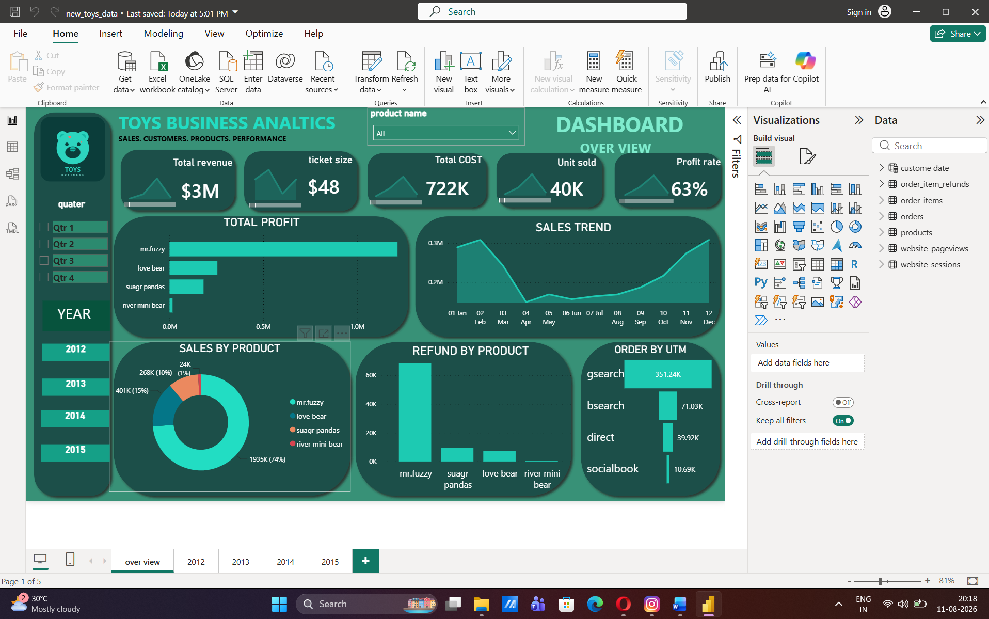
Figure 1 — Power BI Dashboard: Home / Overview Page

1. Project Overview

1.1 Introduction
This project is a Power BI-based business analytics solution developed for a toy business. The report brings together order, order-item, refund, product, website-session, and website-pageview data to provide a consolidated view of business performance.
The project focuses on transforming raw business data into useful analytical information through data preparation, calculated columns, DAX measures, time-intelligence calculations, and interactive dashboard reporting. The analysis covers sales, orders, products, profitability, refunds, website traffic, sessions, and marketing-source information.

1.2 Project Objectives
- Analyze overall toy business performance using Power BI.
- Measure total sales, orders, items purchased, and toys sold.
- Analyze profitability using COGS, profit, and profit margin calculations.
- Analyze refund amount and average refund performance.
- Understand website sessions and pageview activity.
- Analyze traffic sources, UTM information, device type, and referral sources.
- Create a dedicated custom Date table for time-based analysis.
- Use MTD and YTD calculations for time-intelligence reporting.
- Identify distinct/different values in important categorical fields before analysis.
- Check and understand NULL/blank values as part of data-quality analysis.
- Build an interactive Power BI report with navigation between report sections.
- Convert raw data into business-focused KPIs and insights.

1.3 Scope of the Project
The scope of this project covers descriptive and diagnostic business analytics. It focuses on understanding what happened in the business and identifying patterns across sales, products, profitability, refunds, and website activity. The project is not presented as a predictive machine-learning system.

2. Dataset Information

2.1 Dataset / Table Description
Table | Purpose in Analysis
orders | Order-level sales, cost, profit, customer/user and website-session information.
order_items | Item-level product/order information and COGS-related data.
order_item_refunds | Refund transactions and refund amount analysis.
products | Product master information such as product ID and product name.
website_sessions | Website session, device, referral, UTM and user/session information.
website_pageviews | Website pageview activity and session/pageview metrics.
custom_date | Dedicated date dimension for month, quarter, week, year, MTD and YTD analysis.

2.2 Main Fields Visible in the Power BI Model
Table | Fields / Measures Visible in Report
custom_date | Date; month; month_num; MTD; quarter; week of year; years; YTD
order_item_refunds | average refund; created_at; order_id; order_item_id; order_item_ref...; refund_am...; Time; total refund; total refund a...
order_items | cogs_usd; created_at; is_primary_item; order_id; order_item_id
orders | average order...; cogs_usd; created_at; items_purchas...; new_product...; order_id; price_usd; primary_prod...; profit margin; profits; Time; tota item puc...; total orders; total sales; total toys sold...; user_id; website_sessi...; year
products | created_at; product_id; product_name; Time
website_pageviews | created_at; pageview_url; Pageviews per...; Total Pageviews; Unique Sessio...; website_page...; website_sessi...
website_sessions | created_at; device_type; http_referer; is_repeat_sessi...; new_utm_cont...; new_utm_sour...; Time; total session; Total Sessions; user_id; utm_campaign; website_sessi...
Note: Some field names are truncated in the Power BI Fields pane screenshots. The documentation above keeps the visible naming where the full name cannot be confirmed from the screenshot.

2.3 Data Model / Schema
The report uses multiple related business tables. The model connects order transactions with order items, products, refunds, and website activity, while the custom Date table supports time-based reporting.
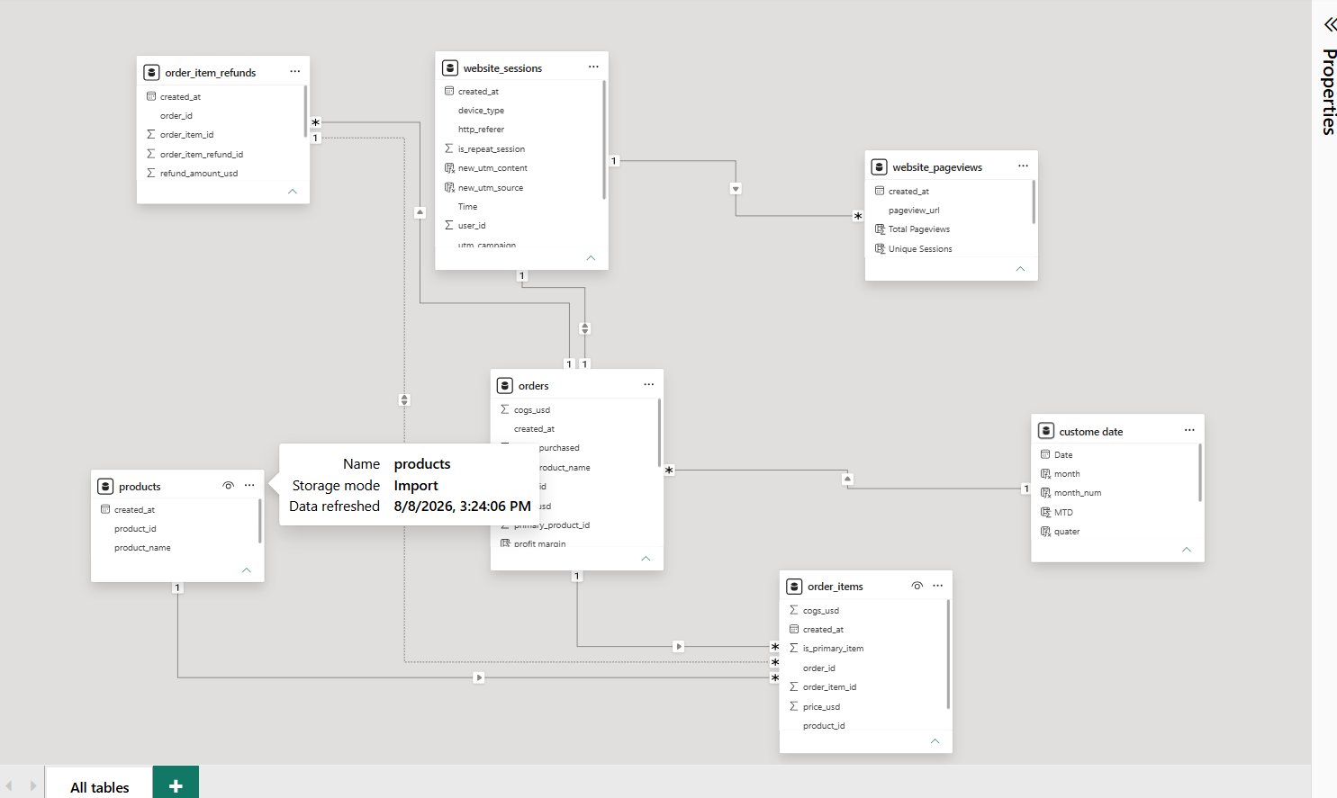
Figure 2 — Power BI Model View: Table Relationships and Schema

2.4 Initial Data Assessment
- The Power BI model was reviewed at table and field level before dashboard development.
- Important fields were reviewed for their data type and analytical role.
- NULL/blank values were considered during data-quality checking.
- Different/distinct values were reviewed in categorical fields to understand the available categories.
- Calculated columns and measures were separated conceptually so that row-level transformations and aggregated KPIs could be used appropriately.

2.5 Data Quality Analysis

NULL / Blank Value Analysis
NULL and blank values were checked as part of the data-quality process. The purpose was to identify missing information that could affect grouping, filtering, calculations, or business interpretation.
- Identify columns containing blank or NULL values.
- Review whether missing values are expected or problematic.
- Avoid incorrect conclusions caused by incomplete fields.
- Validate important KPI fields before using them in the dashboard.

Distinct / Different Value Analysis
Distinct values were reviewed to understand the categories present in the dataset before building business analysis. This is particularly useful for fields such as device type, referral source, UTM source, UTM campaign, pageview URL, and other categorical fields.
- Understand the actual categories available in the data.
- Detect inconsistent labels or unexpected categories.
- Prepare reliable grouping and filtering logic.
- Support marketing, website, and behavioral analysis.
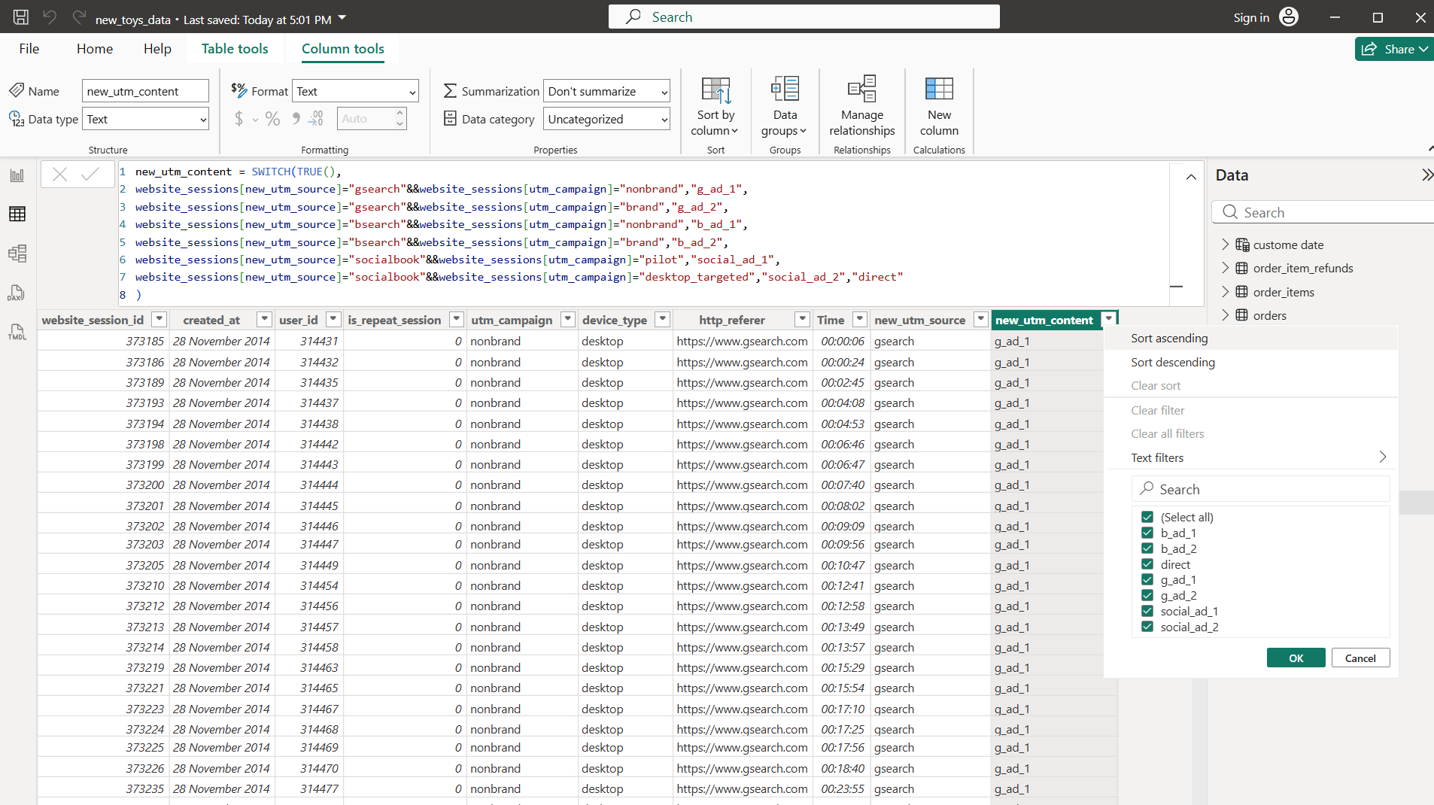
Figure 3 — Column Tools View: Checking Distinct / Different Values in new_utm_content (also used to validate the field for blank/NULL entries)

3. Data Preparation & Analytical Calculations

3.1 Custom Date Table
A dedicated custom Date table was created to support consistent time-based analysis across the report. The Date table contains calendar attributes and time-intelligence fields.
Field | Analytical Purpose
Date | Base date field used for time-based filtering and relationships.
month | Month-level reporting and trend analysis.
month_num | Numeric month ordering for correct chronological sorting.
quarter | Quarterly business analysis.
week of year | Weekly trend analysis.
years | Year-level analysis.
MTD | Month-to-Date performance.
YTD | Year-to-Date performance.
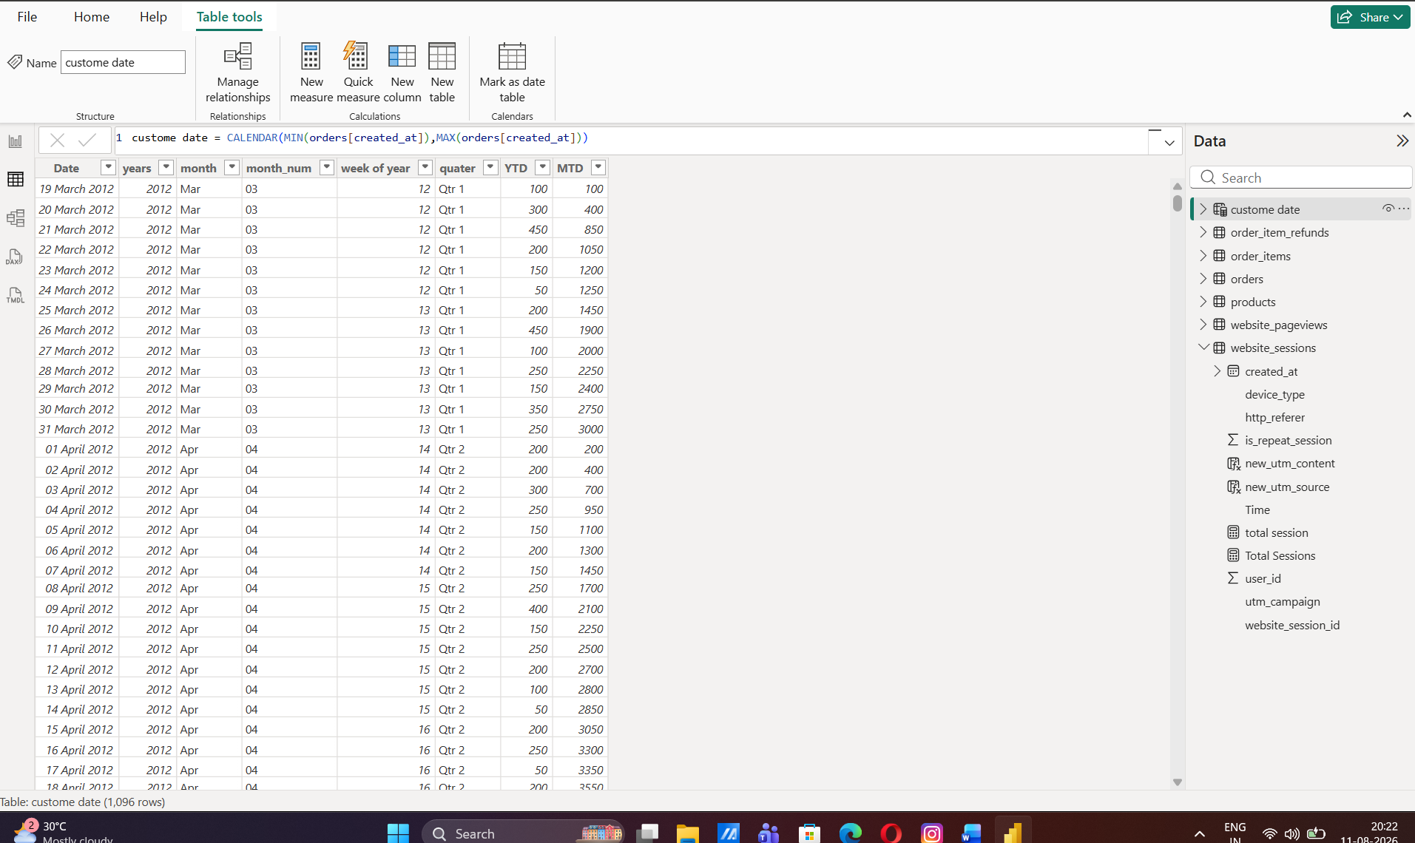
Figure 4 — Custom Date Table: Date, Years, Month, Month_num, Week of Year, Quarter, YTD and MTD Fields

3.2 DAX Measures & Calculated Fields
DAX measures and calculated fields were created to convert transactional data into reusable business KPIs. These calculations support aggregation, profitability analysis, website analytics, refunds, and time-based reporting.
Area | Measures / Fields Identified
Sales & Orders | total sales; total orders; average order...; items purchas...; tota item puc...; total toys sold...
Profitability | cogs_usd; profits; profit margin
Refunds | total refund; average refund; total refund a...
Website Sessions | total session; Total Sessions; Unique/Session-related fields
Website Pageviews | Total Pageviews; Pageviews per...; Unique Sessio...
Marketing | new_utm_source; new_utm_content; utm_campaign; http_referer
Product / Order Logic | new_product...; primary_prod...; is_primary_item
Time | year; Time; MTD; YTD; month; quarter; week of year

3.3 Sales & Order Metrics
- Total Sales — measures the overall sales value represented in the order data.
- Total Orders — counts the order-level business volume.
- Average Order — provides an order-value KPI for evaluating average transaction size.
- Items Purchased — measures the quantity of items associated with orders.
- Total Items Purchased — summarizes item purchasing volume.
- Total Toys Sold — measures the overall toy units sold.

3.4 Profitability Metrics
- COGS (cogs_usd) — represents cost of goods sold used in profitability analysis.
- Profits — measures business profit based on the available sales and cost fields.
- Profit Margin — evaluates profit relative to sales and is useful for comparing profitability.

3.5 Refund Metrics
- Total Refund — measures the total refund amount.
- Average Refund — measures the average refund value.
- Refund-related amount field — retained as visible in the Power BI model where the screenshot truncates the full name.

3.6 Website Analytics Metrics
- Total Sessions — measures website session volume.
- Total Pageviews — measures total pageview activity.
- Unique Sessions — supports session-level behavioral analysis.
- Pageviews per Session — supports understanding of engagement depth.

3.7 Marketing / Traffic Source Fields
- http_referer — identifies the referring source available in the session data.
- new_utm_source — transformed UTM source classification.
- new_utm_content — transformed UTM content classification.
- utm_campaign — campaign-level marketing information.
- device_type — device-based session segmentation.
- is_repeat_session — supports repeat-session analysis.

4. Business Analysis & Insights
The Power BI report is designed to answer practical business questions using the measures and fields created during the project. The following areas represent the main analytical themes of the Toys Business report.

4.1 Sales Performance
- Overall sales performance.
- Order volume and transaction activity.
- Average order value.
- Toy units sold.
- Sales performance over time.

4.2 Product Performance
- Product-level sales and order performance.
- Product contribution to business sales.
- Primary-product and item-level analysis.
- Identification of stronger and weaker product performance.

4.3 Profitability
- Profit generated from sales.
- COGS impact on business performance.
- Profit margin analysis.
- Comparison of revenue and profitability.

4.4 Refund Performance
- Total refund amount.
- Average refund value.
- Refund activity in relation to order performance.

4.5 Website Sessions & Pageviews
- Website session volume.
- Total pageview activity.
- Unique session behavior.
- Pageviews per session / engagement.
- Relationship between website activity and orders.

4.6 Marketing & Traffic Analysis
- UTM source performance.
- UTM campaign analysis.
- UTM content analysis.
- Referral-source analysis.
- Device-type segmentation.

4.7 Time-Based Analysis
- Monthly performance.
- Quarterly performance.
- Yearly performance.
- Weekly performance.
- MTD performance.
- YTD performance.

5. Power BI Dashboard & Report Structure
The final Power BI report uses multiple report pages and navigation to make the analysis easier to explore. The dashboard combines KPI cards, analytical visuals, filters, and page navigation.

5.1 Overview / Home Page
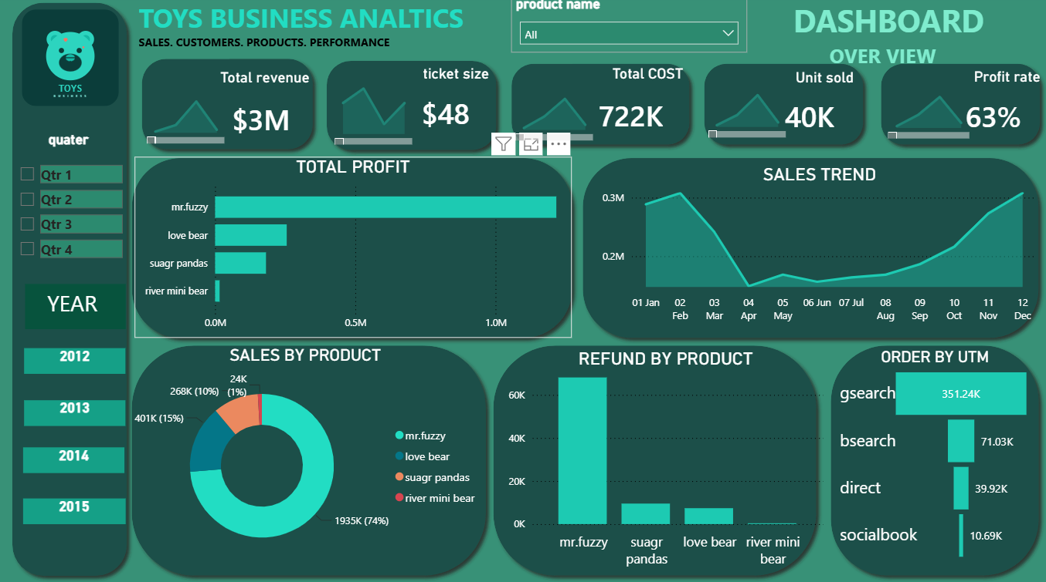
Figure 5 — Overview / Home Page: Total Revenue, Ticket Size, Total Cost, Unit Sold, Profit Rate, Total Profit by Product, Sales Trend, Sales by Product, Refund by Product and Order by UTM

5.2 Report Navigation
Navigation is used to move between the major analytical sections of the report. The navigation panel provides quarter (Qtr 1–Qtr 4) filtering and year buttons (2012–2015) that allow users to move from the overall business view into more detailed yearly analysis.
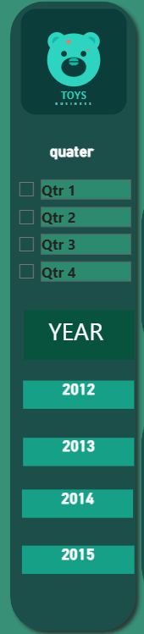
Figure 6 — Navigation Panel: Quarter Filters and Year Selection Buttons

5.3 Dashboard Pages
Page / Section | Purpose
Overview / Home | High-level business KPIs and overall performance.
2012 | Yearly sales, profit, refund and UTM performance for 2012.
2013 | Yearly sales, profit, refund and UTM performance for 2013.
2014 | Yearly sales, profit, refund and UTM performance for 2014.
2015 | Yearly sales, profit, refund and UTM performance for 2015.

5.4 Dashboard Evidence
Screenshots of each completed report page are provided below as evidence of the final Power BI implementation.

Year 2012
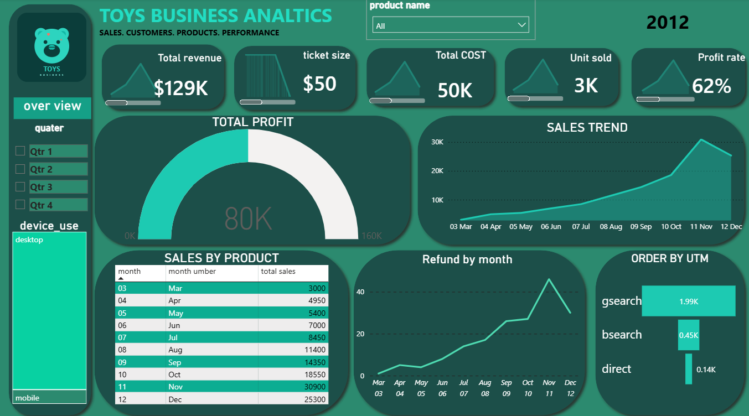
Figure 7 — Dashboard Page: Year 2012

Year 2013
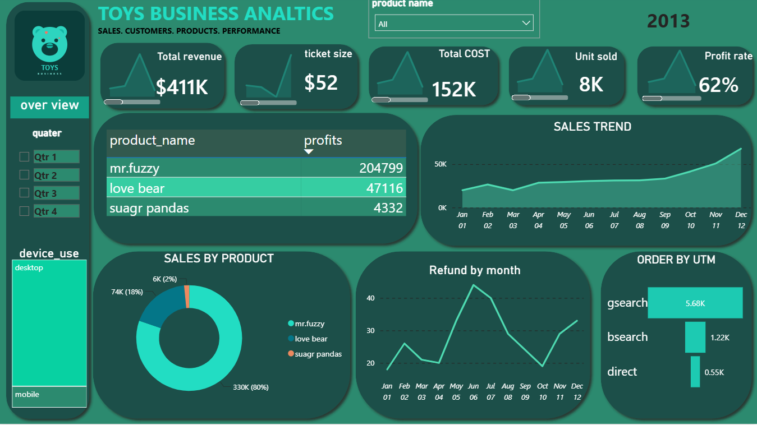
Figure 8 — Dashboard Page: Year 2013

Year 2014
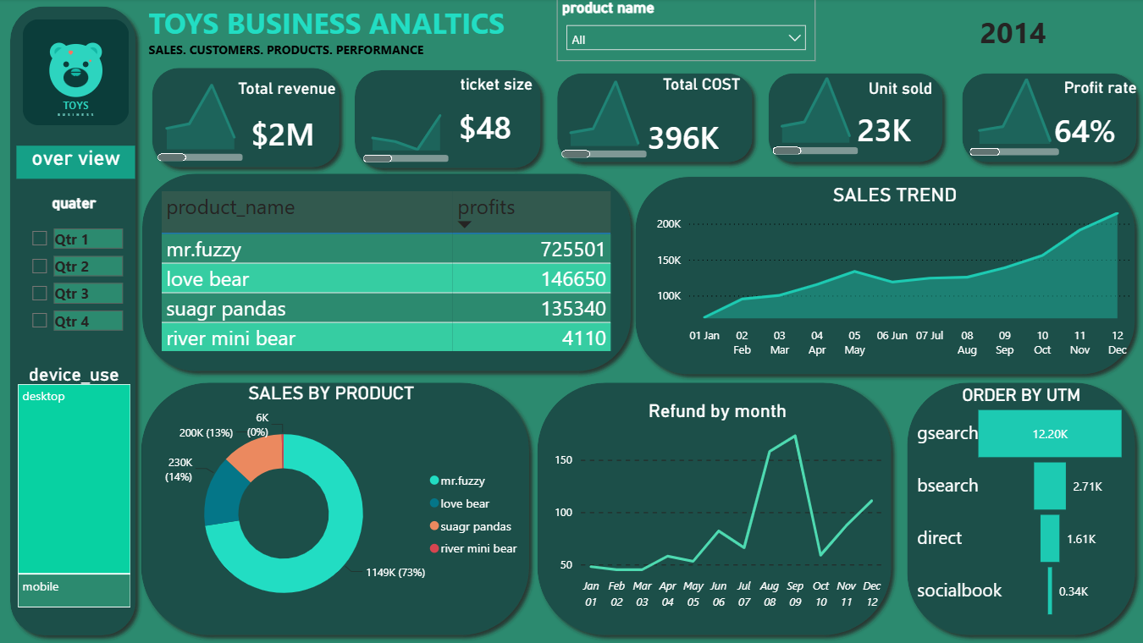
Figure 9 — Dashboard Page: Year 2014

Year 2015
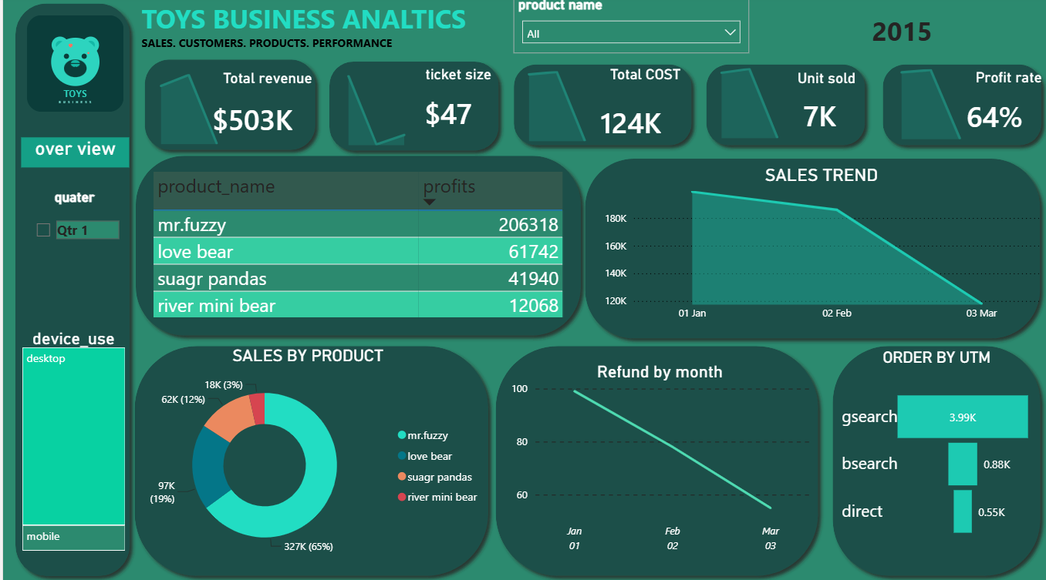
Figure 10 — Dashboard Page: Year 2015

6. Key Performance Indicators (KPIs)
KPI | Purpose
Total Sales | Measures overall sales value.
Total Orders | Measures total order volume.
Average Order | Measures average transaction/order value.
Total Items Purchased | Measures item purchasing volume.
Total Toys Sold | Measures toy unit volume.
COGS | Measures cost of goods sold.
Profit | Measures profit generated.
Profit Margin | Measures profitability relative to sales.
Total Refund | Measures total refunded amount.
Average Refund | Measures average refund value.
Total Sessions | Measures website session volume.
Total Pageviews | Measures website pageview volume.
Unique Sessions | Supports unique-session analysis.

7. Conclusion
This Toys Business Analytics project demonstrates the use of Microsoft Power BI to transform business data into an interactive analytical reporting solution. The project combines order, item, product, refund, website session, and pageview information to provide a broader view of business performance.
The creation of DAX measures, calculated fields, a custom Date table, MTD and YTD calculations, data-quality checks, and distinct-value analysis strengthens the analytical foundation of the report. The resulting dashboard is designed to help users understand sales, profitability, products, refunds, website activity, and marketing traffic from a single business intelligence environment.

