Contents

Information Workspace 1

USE CASE #1 (Entity Resolution, 3rd party data validation, geo location mapping, descriptive and predictive statistics, entity link analysis…maybe some textual analysis) 2

Business Case: Veteran’s Administration Travel Reimbursement Benefit Fraud 2

End User: Travel Benefits Office at the VAMC 2

Back End Process Map (MITRE and some possible vendor enablement): 2

Front End Process Map (Cross-vendor exchange model usage of analytic functions): 2

Example: U.S. Attorney's Office Files Federal Charges Against 16 Individuals For Fraudulent Receipt Of Travel Reimbursement Benefits From U.S. Department Of Veterans Affairs 3

USE CASE #2 (Entity Resolution, 3rd party data validation, geo location mapping, descriptive and predictive statistics, text analysis, entity link analysis, executive dashboard) 6

Business Case: VA beneficiary health care claims fraud across government health care programs. 6

End User: VA health Foreign Medical Program (VA-FMP) claims processing center and Foreign Service Benefit Plan (FSBP) claims processing center. 6

Back End Process Map (MITRE and some possible vendor enablement): 6

Front End Process Map (Cross-vendor exchange model usage of analytic functions): 6

Example: Former Defense Department Employee Sentenced To 40 Months In Prison For $2.5 Million Health Care Fraud-Veteran Admits Submitting Fraudulent Claims For Medical Expenses- 7

# Information Workspace

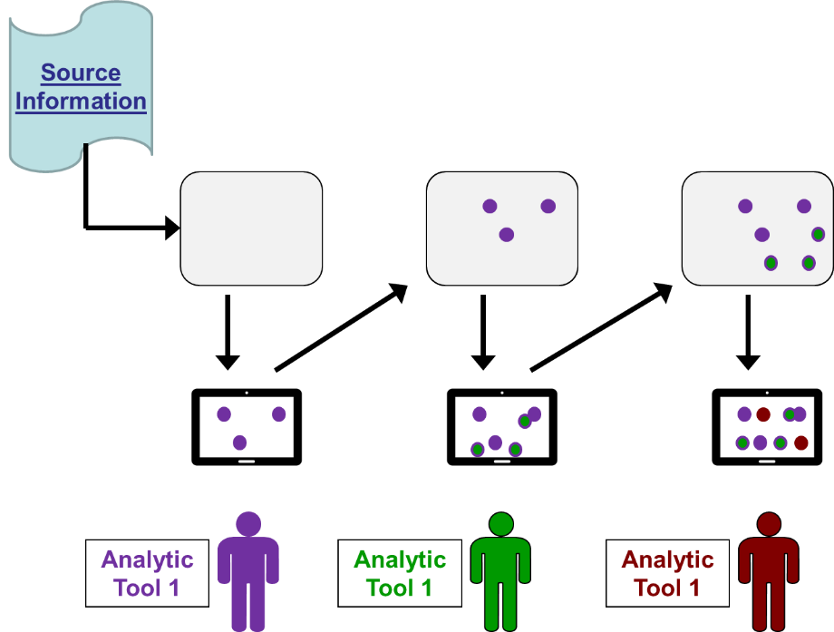

# USE CASE #1 (Entity Resolution, 3rd party data validation, geo location mapping, descriptive and predictive statistics, entity link analysis…maybe some textual analysis)

## Business Case: Veteran’s Administration Travel Reimbursement Benefit Fraud

Thursday, June 30, 2016

<https://www.justice.gov/usao-wdnc/pr/us-attorneys-office-files-federal-charges-against-16-individuals-fraudulent-receipt> (see below for text)

End User: Travel Benefits Office at the VAMC (*In order to claim mileage reimbursement, eligible veterans must go to the Travel Benefits Office at the VAMC and provide information about the distance traveled.  The veterans then obtain a voucher which they submit to the Agent Cashier to receive reimbursement for their travel.*)

### Back End Process Map (MITRE and some possible vendor enablement):

VA Data Management and entity resolution of Veteran’s current residence and VA service centers:

* ***Information Technology***: Centralized (or decentralized) management of multiple data repositories needs to allow a data scientist or analyst to access historical data on a beneficiary and resolve historical data and external 3rd party data to create a standardized version of the true beneficiary name, address and status.
* ***Data Scientist/Analyst***: Needs to have access to multiple data repositories and perform entity resolution and external 3rd party validation data to create a standardized version of the true beneficiary name, address and status that supports the front end analytic/reporting requirements.

We can expand this to express the data needs, analytic needs, and model needs. There are multiple data sources:

Openly available (e.g., geos of VA locations)

Data provider offered data sets if needed

Analytic results, if relevant

Naturally, entity resolution is an issue that must be addressed here. Some information should be fairly unambiguous (such as where VA sites are located and distinguishing them, as these are likely more-or-less fixed within the timeframe to be examined) and the vouchers provided they have some unique identifier. But the challenge will be resolving the people who submit the vouchers as names and addresses are not necessarily unique IDs. It is an important point to know if there is an ID that uniquely identifies them with respect to voucher information (for instance, SSN or something else). This is a clear place where some up front analytic work will need to be applied to get the desired downstream capability.

The sources listed above suggest some basic entities and relationships in the exchange model, most obviously:

Persons (beneficiaries in this use case)

Locations (residences, VA sites)

Voucher instances

Relationships

Person to voucher

Voucher to VA site

Person to residence

Residence to most proximal VA site(s)

Data properties

Names

Geo coordinates of locations

Addresses of locations

Status (what subcategories belong here?)

These different sources will need to be adapted into the exchange model being developed for the analytic exchange. Having an established exchange model that expands on the sketch above will allow these adapters to be developed.

### Front End Process Map (Cross-vendor exchange model usage of analytic functions):

* ***Data Scientist/Analyst:*** Needs to create probabilistic maps of VA beneficiary residence and VA service center locations so as to:
  + Create a ***proximity metric*** for which VA service center is likely to be used (score high if residence and VA service center that is being used is unlikely given other VA center options)
  + Create a ***mileage indicator*** for residence and VA service center that is accessible during processing of travel voucher. If requested mileage is out of bounds of the expected distance then the voucher is flagged for further review.
  + Create an ***external provider*** metric to identify travel vouchers that are used for external providers that are significantly further away than VA service centers
  + Create ***hotspot activity*** metrics that identify zip codes or service centers (VA or external) with high numbers of fraudulent claims
  + If the Travel Benefits Office captures information when a beneficiary comes in to submit a claim for mileage reimbursement, ***contextual textual analysis*** could be used to enhance a risk score (beneficiary describes reason for traveling to a service center far from residence).
* ***Geo Location Application Developer:*** Develop end user interface to consume standardized version of the true beneficiary record from the back end processes and VA service centers and map to the appropriate geo location map.
  + Show residence
  + Show likely VA service centers
  + ***Consume proximity metric*** from the Data Scientist/Analyst that displays links and color codes (red, yellow, green) links to likelihood of appropriate VA service center usage.
  + ***Consume mileage indicator*** to map to mileage voucher history and color code (red, yellow, green) the beneficiary node when mileage discrepancy is detected.
* ***Link Analysis and Visualization***: display source information and derived metrics in entity / link diagram, enabling analysts to explore the data topology and identify broader patterns and sources / influencers of the travel voucher fraud
  + Transform key indicators (like names, phone numbers, social security numbers, source address / zip code) into entities with links back to the travel voucher and provide information sources
  + Execute CPP (common point of presence) analytics against the travel voucher marked fraudulent to highlight common identifiers .. perhaps for example they share common EFT information (ACH Telephone Number)
  + Explore timeline analysis .. look for initial fraudulent claims that are followed by a cluster of similar fraudulent claims. Could this indicate communication pattern that cold be disrupted or monitored?
  + Explore all data using network analytics looking for individuals or locations that are related or can influence a large number of fraud claims? For example, does using a specific non-VA provider for a legitimate travel voucher often lead to a higher occurrence of fraudulent travel vouchers?

### Example: U.S. Attorney's Office Files Federal Charges Against 16 Individuals For Fraudulent Receipt Of Travel Reimbursement Benefits From U.S. Department Of Veterans Affairs

One Defendant Was Allegedly Reimbursed over $18,000 in Fraudulent Travel Vouchers

ASHEVILLE, N.C. – U.S. Attorney Jill Westmoreland Rose announced today that in the month of June the U.S. Attorney’s Office in Asheville has filed federal charges against 16 individuals that defrauded the U.S. Department of Veterans Affairs (the VA) by submitting fraudulent travel vouchers for reimbursement.

Kim Lampkins, Special Agent in Charge of the Mid-Atlantic Field Office, Washington, D.C., of the U.S. Department of Veterans Affairs, Office of Inspector General (VA-OIG), joins U.S. Attorney Rose in making today’s announcement.

According to allegations contained in filed court documents, the Charles George Veterans Affairs Medical Center (VAMC), located in Asheville, is operated by the VA and provides services for veterans of the United States military.  Under certain circumstances, veterans with service-connected disabilities are reimbursed for travel expenses on mileage they incur when traveling to and from their residence and the VAMC.  In order to claim mileage reimbursement, eligible veterans must go to the Travel Benefits Office at the VAMC and provide information about the distance traveled.  The veterans then obtain a voucher which they submit to the Agent Cashier to receive reimbursement for their travel.

The charging documents allege that the defendants submitted fraudulent travel vouchers that overstated the distance they traveled for medical appointments or to receive medical treatment.  The VA reimbursed the defendants for their travel expenses based on mileage information on the fraudulent vouchers.  A total of 16 individuals have been charged separately in connection with travel voucher fraud.

A federal grand jury returned federal indictments on June 7, 2016, against three individuals, charging each defendant separately with one count of making a false claim for travel benefits from the VA, for allegedly submitting multiple fraudulent travel vouchers over a period of months or years.  The charge levies a maximum penalty of five years in prison and a $250,000 fine.  The three indicted are:

* Arlan M. Land, 53, of Nolanville, TX, was indicted for allegedly obtaining from the VA approximately $18,839.10 in fraudulent claims.*(Docket no. 1:16-cr-72)*
* David B. Wright, 56, of Asheville, is facing federal charges for allegedly obtaining approximately $15,391.52 from the VA. *(Docket no. 1:16-cr-73)*
* Pamela L. Smith, 55, of Asheville, has been indicted for allegedly defrauding the VA of approximately $5,318.96. *(Docket no. 1:16-cr-71)*

Criminal bills of information have also been filed against 13 defendants.  They are each charged with one count of stealing money from the VA, a charge that levies a potential maximum prison term of one year and a $100,000 fine.  The loss amount associated with each case is less than $5,000.  Those charged are:

* Harris Hamilton, 60, of Chesnee, S.C., is charged for allegedly obtaining from the VA approximately $2,662 in fraudulent claims.  *(Docket no. 1:16-mj-72)*
* Marcus McEachin, 45, of Asheville, is charged for allegedly obtaining from the VA approximately $4,029 in fraudulent claims.  *(Docket no. 1:16-mj-73)*
* Michael Tate, 55, of Asheville, is charged for allegedly obtaining from the VA approximately $2,919 in fraudulent claims.  *(Docket no. 1:16-mj-74)*
* Christopher Miller, 52, of Spartanburg, S.C., is charged for allegedly obtaining from the VA approximately $3,411 in fraudulent claims.  *(Docket no. 1:16-mj-75)*
* Tommie Borders, 62, of Asheville, is charged for allegedly obtaining from the VA approximately $1,426 in fraudulent claims.  *(Docket no. 1:16-mj-76)*
* Ruben Dixon, 59, of Lenoir, N.C., is charged for allegedly obtaining from the VA approximately $1,234 in fraudulent claims.  *(Docket no. 1:16-mj-77)*
* Jeffrey Franklin, 58, of Asheville, is charged for allegedly obtaining from the VA approximately $3,486 in fraudulent claims.  *(Docket no. 1:16-mj-78)*
* Violet McKinney, 53, of Asheville, is charged for allegedly obtaining from the VA approximately $4,737 in fraudulent claims.  *(Docket no. 1:16-mj-79)*
* Guy Stivender, 57, of Asheville, is charged for allegedly obtaining from the VA approximately $1,534 in fraudulent claims.  *(Docket no. 1:16-mj-80)*
* TC Littlejohn, 56, of Asheville, is charged for allegedly obtaining from the VA approximately $1,514 in fraudulent claims.  *(Docket no. 1:16-mj-83)*
* Kevin Simms of Asheville, is charged for allegedly obtaining from the VA approximately $ 4,348 in fraudulent claims.  *(Docket no. 1:16-mj-84)*
* Marshall Dukes, 61, of Asheville, is charged for allegedly obtaining from the VA approximately $3,780 in fraudulent claims.  *(Docket no. 1:16-mj-85)*
* Kenneth Pickens, 47, of Asheville, is charged for allegedly obtaining from the VA approximately $2,480 in fraudulent claims.  *(Docket no. 1:16-mj-86)*

“The travel reimbursement program exists to ease the financial burden on military veterans seeking medical treatment and access to good medical care.  The system relies upon veterans to submit honest and accurate forms, reflecting actual travel expenses. Unfortunately, these 16 individuals allegedly decided to lie and make some extra cash by padding their travel vouchers.  We simply cannot allow this type of fraud, waste and abuse to go on and we will prosecute anyone who steals money from a program put in place to provide much-needed assistance to our country’s veterans,” said U.S. Attorney Rose.

The charges contained in the charging documents are allegations.  The defendants are presumed innocent unless and until proven guilty beyond a reasonable doubt in a court of law.

In making today’s announcement U.S. Attorney Rose thanked the VA-OIG and the Veterans Affairs Police Department for their investigation of the cases.  Assistant U.S. Attorney Richard Edwards of the U.S. Attorney’s Office in Asheville is in charge of the prosecution.

# USE CASE #2 (Entity Resolution, 3rd party data validation, geo location mapping, descriptive and predictive statistics, text analysis, entity link analysis, executive dashboard)

Thursday, December 18, 2014

<https://www.justice.gov/usao-dc/pr/former-defense-department-employee-sentenced-40-months-prison-25-million-health-care> (see below for text)

## Business Case: VA beneficiary health care claims fraud across government health care programs.

End User: VA health Foreign Medical Program (VA-FMP) claims processing center and Foreign Service Benefit Plan (FSBP) claims processing center. (*more than $2.5 million in false claims to the two government health care programs, for items and services never received and never paid for.* )

### Back End Process Map (MITRE and some possible vendor enablement):

VA Data Management and entity resolution of Veteran’s current residence and locations of medical service:

* ***Information Technology***: Centralized (or decentralized) management of multiple data repositories from both VA-FMP and FSBP needs to allow a data scientist or analyst to access historical data on a beneficiary and resolve historical data and external 3rd party data to create a standardized version of the true beneficiary name, address and status.
* ***Data Scientist/Analyst***: Needs to have access to multiple data repositories and perform entity resolution and external 3rd party validation data to create a standardized version of the true beneficiary name, address and status.
* ***Data Scientist/Analyst***: Needs to map locations of care and service provider entity level information (suppliers of durable medical equipment, pharmacies,

### Front End Process Map (Cross-vendor exchange model usage of analytic functions):

* ***Data Scientist/Analyst:*** Needs to create descriptive and probabilistic benchmarks for items and services claims:
  + Create ***peer group profile metrics*** for a beneficiary’s items and services (prescription medications, pharmaceutical items, provider rendering of services) to detect outliers/anomalies that can be flagged as high risk.
  + Create ***rules based*** indicators of risk that identify inconsistent item and service billing behavior (billing duplicate items and services to both VA-FMP and FSBP, textual indicators from unstructured claim level entries, diagnostic/procedure code incompatibility with medication/pharmacy or services, claim count anomalies that might indicate falsifying invoices).
  + Create ***predictive risk indicators*** of improper billing behavior when the historical data is available to support predictive modeling techniques (likelihood of receiving medication or services given diagnostic/procedure code claims information).
* ***Geo Location Application Developer:*** Develop end user interface to consume standardized version of the true beneficiary record from VA-FMP and FSBP data.
  + Show residence
  + Show likely VA service centers
  + ***Consume proximity metric*** from the Data Scientist/Analyst that displays links and color codes (red, yellow, green) links to likelihood of appropriate VA service center usage.
* ***Executive Dashboard:*** Support reporting of indicators of risk and case management of suspicious fraud.
  + ***Consume and quantify*** summarized data of suspicious beneficiary’s by location, type and levels of service.

### Example: Former Defense Department Employee Sentenced To 40 Months In Prison For $2.5 Million Health Care Fraud-Veteran Admits Submitting Fraudulent Claims For Medical Expenses-

According to a statement of offense submitted to the Court at the time of the guilty plea, Hargett worked from 1996 through 2012 in various positions as a civilian employee for the Department of Defense in Germany. From January 2011 through May 2012, he was an intelligence analyst stationed in Heidelberg. Previously, he had served in the U.S. Army from 1992 to 1996.

     As a federal employee stationed overseas, Hargett was enrolled since 2002 in the Foreign Service Benefit Plan (FSBP), a health care benefit program. Because of his service in the Army, he also was eligible for health care coverage from the U.S. Department of Veterans Affairs. For veterans working or residing abroad, the VA provides this coverage through its Foreign Medical Program (VA-FMP).

     From January 2007 through April 2012, according to the statement of offense, Hargett carried out a scheme to submit fraudulent claims and invoices to the FSBP and the VA-FMP. The claims falsely represented that Hargett bought prescription medications and other pharmaceutical items from a pharmacy in Germany. They also falsely represented that he had received and paid for various health care items and services from a doctor in Germany. Hargett also created and submitted forged invoices and other fraudulent paperwork, and admitted creating many of the false invoices on his government computer at the U.S. Army base in Heidelberg, Germany.

     All told, Hargett submitted more than $2.5 million in false claims to the two government health care programs, for items and services Hargett never received and never paid for.  As a result, Hargett wrongfully obtained more than $2.2 million, including about $943,519 from the FSBP and $1,261,512 from the VA-FMP.