Spacecraft Reentry Heating Plugin

Written by: Nate McBee – Aerospace Systems Engineer
Analytical Graphics Inc. 2012

The Spacecraft Reentry Heating Plugin was written by taking advantage of the STK AGI UiPlugin interface to create a customized User Interface Plugin. Some of the options for UiPlugins can be found in the STK Help materials.

This plugin was created to allow users the ability to supply design parameters for capsule styled reentry vehicles similar to NASA’s Apollo program (http://en.wikipedia.org/wiki/Space_capsule). The Plugin will create stagnation point heating data for the designed capsule as well as deceleration (G-Load) data which can be reported or graphed natively inside of STK.

The plugin is accessed by right clicking the Scenario Object in the Object Browser and selecting the Plugins option.

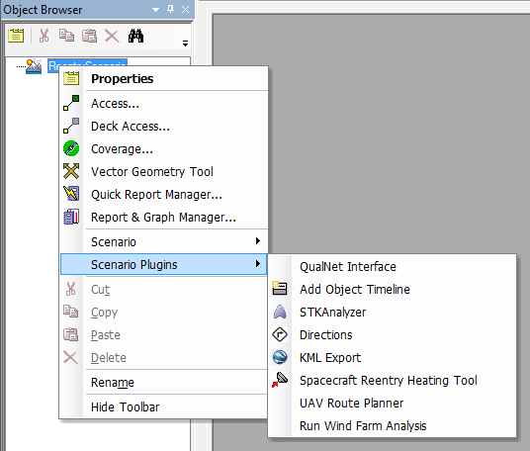

Alternatively, this plugin can be turned on via the Toolbar options for STK and be made available as a separate Toolbar by right-clicking in the Toolbar area and selecting the Reentry Heating Toolbar.

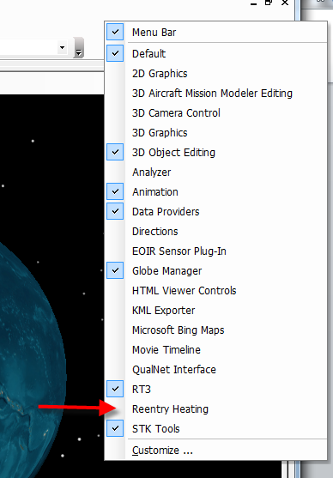

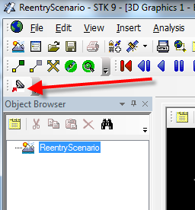

The Spacecraft Reentry Heating Plugin will allow users to define specific reentry parameters including dimensions of the reentry capsule.

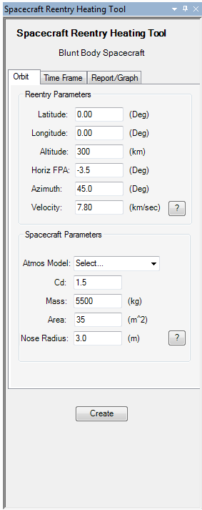

Once the parameters have been defined (including the desired Atmosphere Model), the Create button can be used to create the spacecraft’s reentry trajectory. The reentry assumes a zero-lifting entry.

The stagnation point heating and deceleration data is computed based on the supplied parameters and reentry profile and are made available to the user through reports and graphs. It is of interest to note that this data is stored for the Satellite Object in the Data Providers under ‘User Supplied Data’ in the event that it is necessary to use it for other reporting/graphing functions.

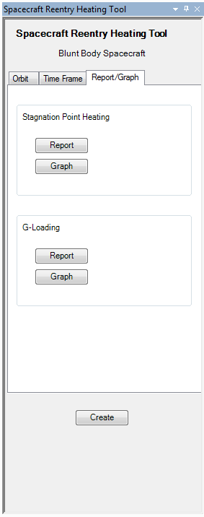

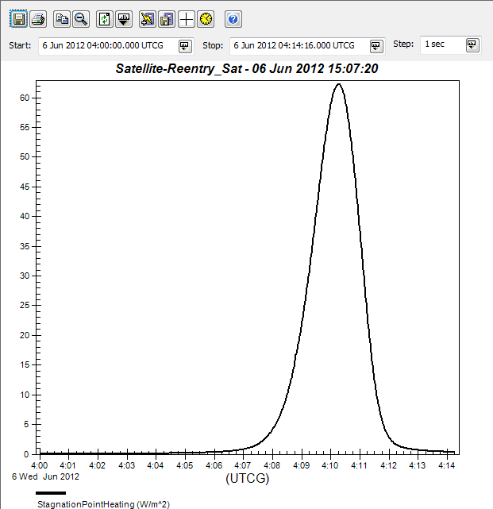

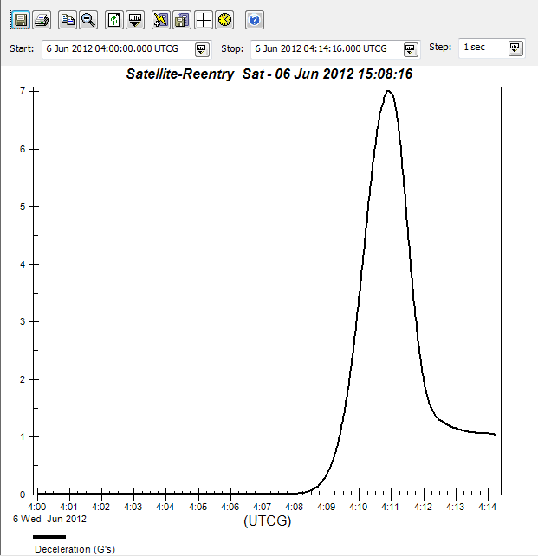

Examples of the Heating/Deceleration Graphs

Time Period - There is a tab for changing the Analysis Start/Stop time of the STK Scenario if necessary. This can easily be done through the standard methods inside of STK, but is provided with this plugin simply for ease of use.

Reentry Heating Plugin Configuration

The configuration page for any UiPlugin can be found by going to the Edit->Preferences menu.

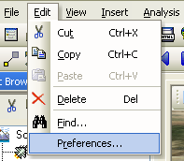

Here you can access the Configuration page for the Reentry Heating Plugin.

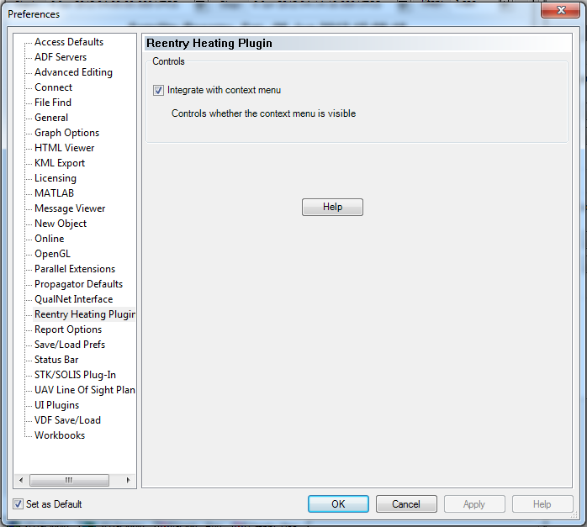
This allows a user to determine if the plugin should be made available in a ‘context’ mode, meaning that it can be accessed by right clicking STK Objects in the Object Browser and selecting the Plugins sub-menu.

There is also a Help button which will simply open this documentation file.

Reentry Heating Plugin Math Specification

The following methodology was used in determining the heating and deceleration values.

Parameters:

ρ = Atmospheric Density (kg/m³)
γ_{i} = Gas Transport Parameter
a = Vehicle Acceleration (m/s²)
A = Vehicle Cross-Sectional Area (m²)
c_{i} = Mass Fraction
C_{D} = Drag Coefficient (unitless)
F_{drag =} Drag Force (N)
K = Sutton-Graves Coefficient (unitless)
m = Vehicle Mass (kg)
M_{i} = Molecular Weight
q = Vehicle Heating Rate (W/m²)
R_{n} = Vehicle Nose Radius (m)
V = Vehicle Velocity (m/s)

Deceleration: Assuming a zero-lifting reentry profile

a = F_{drag}/m (1)

F_{drag} = (1/2)ρV²C_{D}A (2)

Therefore, combining equations 1 and 2 yields,

a = (1/2)ρV²C_{D}A/m (3)

Deceleration in terms of G-Loading,

G’s = a / 9.798 (m/s²) (4)

Stagnation Point Heating Rate:

Utilizing the studies of Sutton-Graves [1], the equation used for stagnation point heating rate given in (W/m²) is as follows:

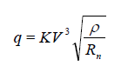 (5)

The constant K is derived from a gas mixture correlation as a function of mass fractions, gas transport parameters, and molecular weights.

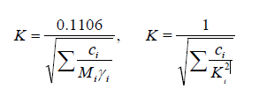 (6)

The following table can be used as a reference.

Table 1. Constant K
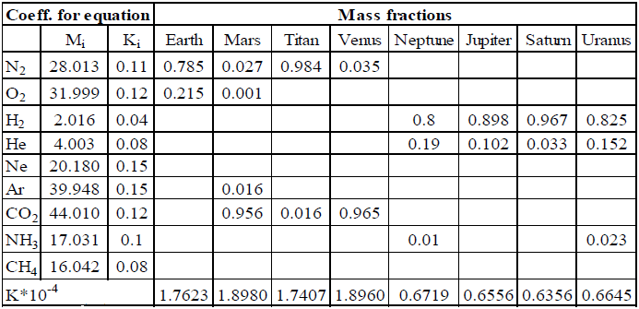

References:

- K. Sutton and R. A. Graves, “A general stagnation point convective heating equation for arbitrary gas mixtures,” Tech. Rep. NASA TR-376, NASA,Washington, DC, USA, 1971.

- Tauber, Michael E. Atmospheric Trajectories. Chapter for AA213 Atmospheric Entry. NASA/Ames Research Center, Stanford University, 1990.

- Samareh, Jamshid A. “A Multidisciplinary Tool for Systems Analysis of Planetary Entry, Descent, and Landing (SAPE)” Tech. Rep. NASA TM-2009-215950, NASA/Langley Research Center, Hampton, VA, USA, 2009

