PROJECT – 3
Objective: Data types in SQL and usage of various Data Definition Language commands

DDL statement for creating a table-
CREATE TABLE students (
student_id VARCHAR(10),
name VARCHAR(50),
age INT,
course VARCHAR(15)
);
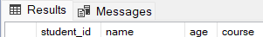
Creating a table from a table-
CREATE TABLE students2(
student_id VARCHAR(10),
name VARCHAR(50),
age INT,
course VARCHAR(15),
) as select name, age from students;
Insertion of data into tables-
insert into students values (‘100’,’Rahul Sharma’,18,’CSE’);
insert into students values ('102','Aditya',19,'CSE-DS');
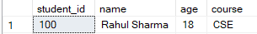

Insertion of selected data into a table from another table:
insert into students2 select student_id, name, age, course from students;
Retrieving data from the tables-
select * from students;
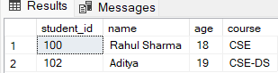
The retrieving of specific columns from table:
select name, age from students;
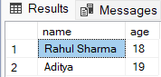
Select a data set from table data:
select * from students where age = 18;
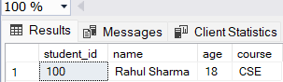

PROJECT – 4
Objective: To implement constraints on database and table.
NULL concept:
CREATE TABLE example (
student_id VARCHAR(10) NOT NULL,
name VARCHAR(50),
age INT,
course VARCHAR(15)
);
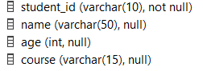
Primary key as a column constraint:
CREATE TABLE example1 (
student_id VARCHAR(10) primary key,
name VARCHAR(50),
age INT,
course VARCHAR(15)
);
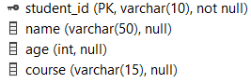
Primary key as a table constraint:
CREATE TABLE example2 (
student_id VARCHAR(10),
name VARCHAR(50),
age INT,
course VARCHAR(15),
primary key(student_id),
);
Default Value Concept:
CREATE TABLE example3 (
student_id VARCHAR(10),
name VARCHAR(50),
age INT default 18,
course VARCHAR(15),
);
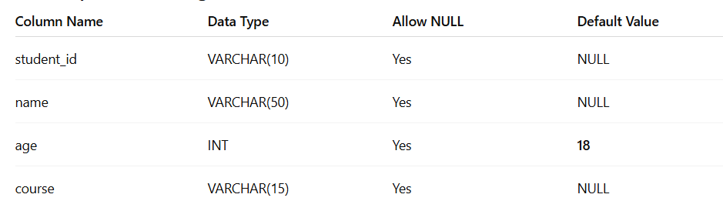
Foreign key as a column constraint:
CREATE TABLE example3 (
student_id VARCHAR(10),
name VARCHAR(50),
age INT,
course VARCHAR(15) references example3,
);
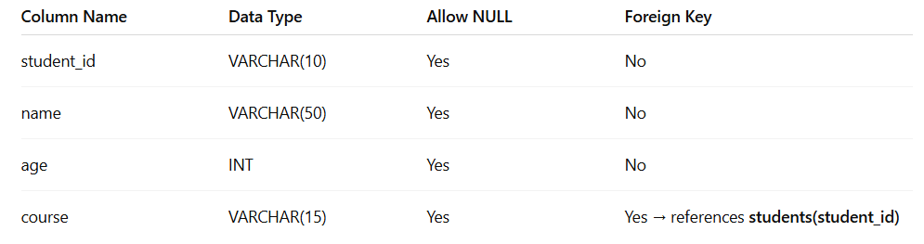
Foreign key as a tsble constraint:
CREATE TABLE example3 (
student_id VARCHAR(10),
name VARCHAR(50),
age INT,
course VARCHAR(15),
foreign key(student_id) references example3,
);
Check Integrity Constraints:
CREATE TABLE example4 (
student_id VARCHAR(10) primary key,
name VARCHAR(50),
age INT constraint check(age > 18),
course VARCHAR(15),
);
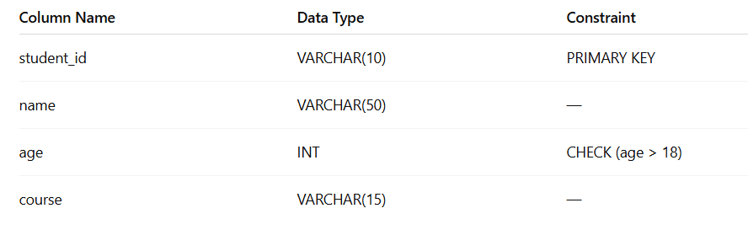

PROJECT – 4
Objective:- To Manipulate the Operations on the table.
Update the Table:
update students
set age = 19
where age = 18;
select * from students;
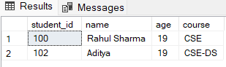
Deletion of all rows:
delete from students;
Deletion of specified row:
delete from students
where age = 19;
Renaming columns used with Expression Lists:
select name student_name, course student_course
from students;
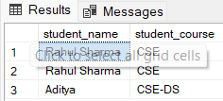
Range Searching:
select * from students
where name like'R%';
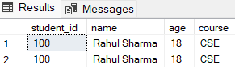
Sorting of data in table:
select * from students
order by name;
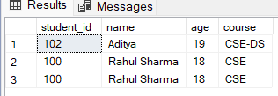
Aggregate Functions:
Avg:
select avg(age) from students;
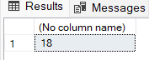
MIN:
select avg(age) from students;

PRACTICAL-6
Objective: To implement the concept of Joins and Grouping of data
Cartesian product:
select s1.*,s2.*
from students s1, students2 s2;
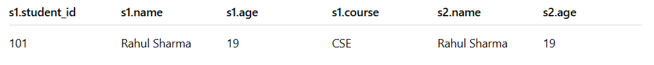
Inner Join:
select s1.*, s2.*
from students s1, students2 s2
where s1.course = s2.course;
Left Outer Join:
select s1.*, s2.*
from students s1
left join students2 s2
on s1.age = s2.age;
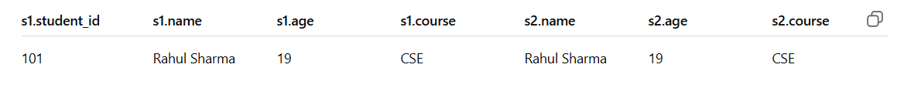
Right Outer Join:
select s1.*, s2.*
from students s1
right join students2 s2
on s1.age = s2.age;
FULL OUTER JOIN:
select s1.*, s2.*
from students s1
cross join students2 s2
on s1.age = s2.age;
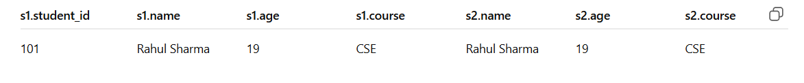
Grouping Data from Tables:
select course from students
group by course;
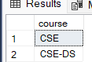

PROJECT-7
Objective: To implement the concept of Subqueries
Union Clause:
select * from students
union
select * rom students2;
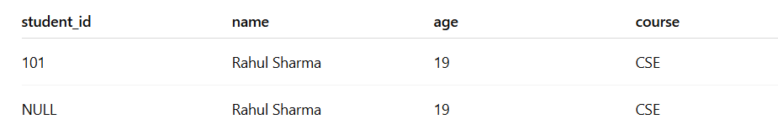
Intersect Clause:
select * from students
intersect
select * from students2;
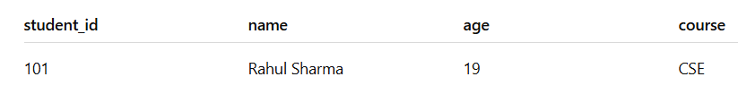
Minus Clause:
select * from students
minus
select * from students2;
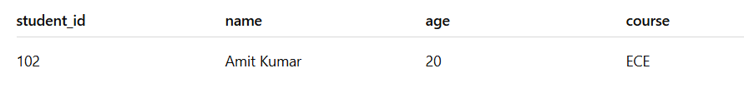

PROJECT-8
Objective: To implement the concept of indexes and views
Creating an index for table:
CREATE INDEX idx_city
ON oldclient_master(city);
SELECT * FROM oldclient_master WHERE city = ‘Delhi’;
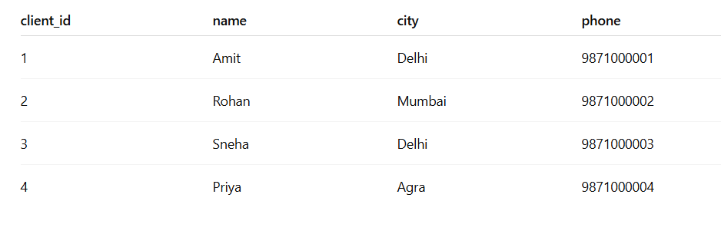
Composite Index:
CREATE INDEX idx_name_city
On oldclient_master(city_name, city);
SELECT FROM oldclient_master WHERE client_name = ‘Priyaa Sharma’ AND
City = ‘Mumbai’
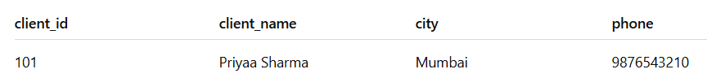
Unique Index:
CREATE UNIQUE INDEX idx_unique_clientname
On oldclient_master(client_name);
INSERT INTO oldclient_master VALUES(7, ‘Rahul Mehata, ‘Delhi’,16000.0);
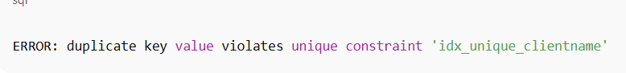
Dropping Index:
ALTER TABLE oldclient_master DROP INDEX idx_city;
SHOW INDEX FROM oldclient_master;
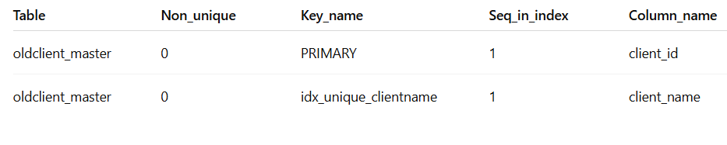
Creation of Views:
CREATE VIEW view_name AS
SELECT coloumnname, coloumnname
FROM tablename
WHERE coloumnname = expression_list;
SELECT * FROM delhi_clients;
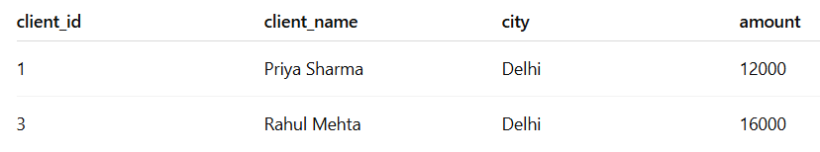
Renaming the coloumn of view:
CREATE VIEW city_balance_view AS
SELECT client_name AS CustomerName,
City AS Location,
Balance AS AccountBalance
FROM oldclient_master
WHERE balance > 15000;
SELECT * FROM city_balance_view;
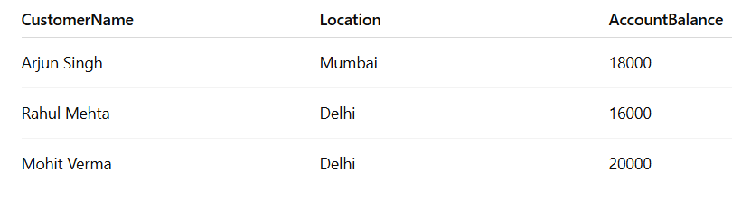
Destroying a View:
DROP VIEW city_balance_view;
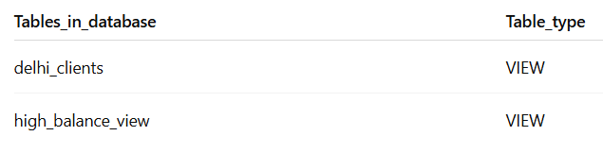

PROJECT – 9
Objective: To implement the basics of PL/SQL
Setting the server output on:
SET SERVEROUTPUT ON;

DECLARE
v_client_id oldclient_master.client_id%TYPE;
v_client_name oldclient_master.client_name%TYPE;
v_city oldclient_master.city%TYPE;
v_balance oldclient_master.balance%TYPE;
BEGIN
-- Fetch record into variables
SELECT client_id, client_name, city, balance
INTO v_client_id, v_client_name, v_city, v_balance
FROM oldclient_master
WHERE client_id = 3; -- you can change client_id here

-- Display output
DBMS_OUTPUT.PUT_LINE('Client ID: ' || v_client_id);
DBMS_OUTPUT.PUT_LINE('Client Name: ' || v_client_name);
DBMS_OUTPUT.PUT_LINE('City: ' || v_city);
DBMS_OUTPUT.PUT_LINE('Balance: ' || v_balance);

EXCEPTION
WHEN NO_DATA_FOUND THEN
DBMS_OUTPUT.PUT_LINE('No client found with this ID!');
WHEN OTHERS THEN
DBMS_OUTPUT.PUT_LINE('Error: ' || SQLERRM);
END;
/
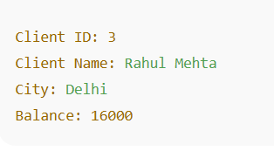
Conditional Control in PL/SQL:
SET SERVEROUTPUT ON;

DECLARE
v_balance NUMBER := 18000;
BEGIN
IF v_balance > 20000 THEN
DBMS_OUTPUT.PUT_LINE('Platinum Client');
ELSIF v_balance > 15000 THEN
DBMS_OUTPUT.PUT_LINE('Gold Client');
ELSIF v_balance > 10000 THEN
DBMS_OUTPUT.PUT_LINE('Silver Client');
ELSE
DBMS_OUTPUT.PUT_LINE('Basic Client');
END IF;
END;
/
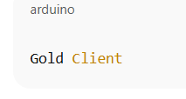

PROJECT-10
OBJECTIVE: To implement the concept of cursor and trigger
Example of CURSOR:
SET SERVEROUTPUT ON;

DECLARE
-- Step 1: Declare variables
v_id oldclient_master.client_id%TYPE;
v_name oldclient_master.client_name%TYPE;
v_city oldclient_master.city%TYPE;
v_balance oldclient_master.balance%TYPE;

-- Step 2: Declare cursor
CURSOR cur_client IS
SELECT client_id, client_name, city, balance
FROM oldclient_master
WHERE balance > 15000; -- you can change condition

BEGIN
-- Step 3: Open cursor
OPEN cur_client;

LOOP
-- Step 4: Fetch data into variables
FETCH cur_client INTO v_id, v_name, v_city, v_balance;

-- Step 5: Exit when no more rows
EXIT WHEN cur_client%NOTFOUND;

-- Step 6: Display output
DBMS_OUTPUT.PUT_LINE('ID: ' || v_id ||
', Name: ' || v_name ||
', City: ' || v_city ||
', Balance: ' || v_balance);
END LOOP;

-- Step 7: Close cursor
CLOSE cur_client;
END;
/
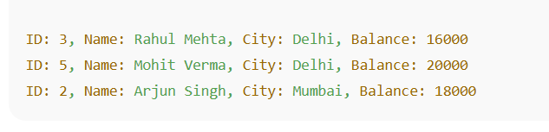
Example of Trigger:
CREATE OR REPLACE TRIGGER trg_client_insert_log
AFTER INSERT ON oldclient_master
FOR EACH ROW
BEGIN
INSERT INTO client_audit(client_id, client_name, action_date)
VALUES(:NEW.client_id, :NEW.client_name, SYSDATE);
END;
/
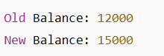

PROJECT
TITLE- NEWS WEBSITE
- HOME PAGE


- LOG-IN PAGE
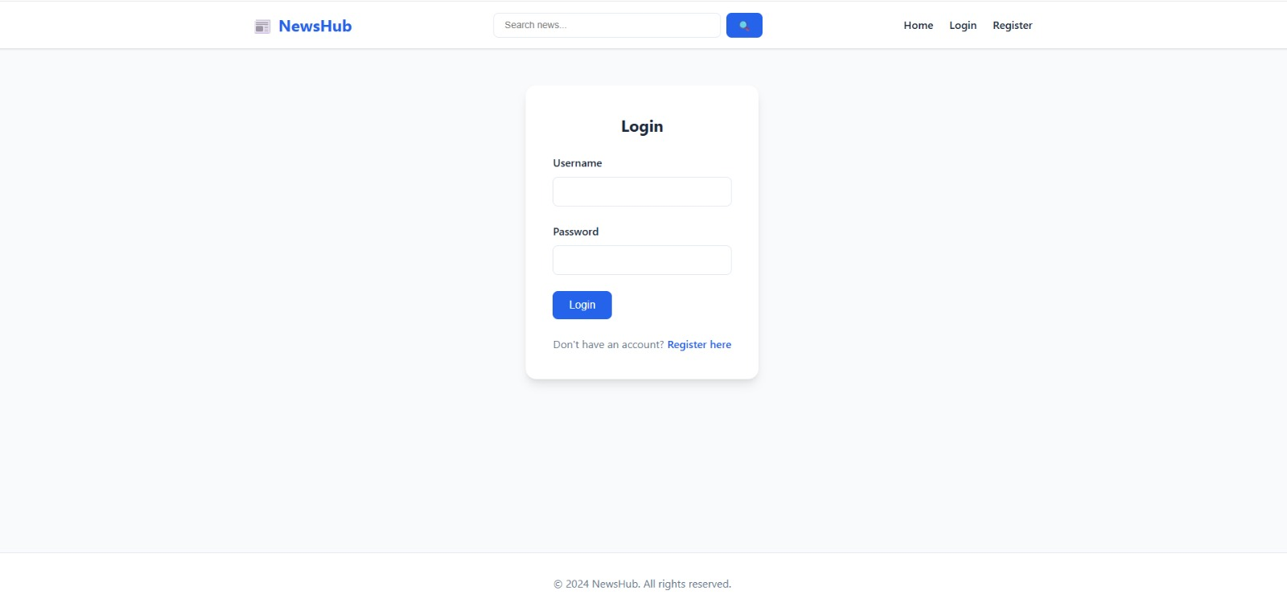

- NEWS PAGE WHERE USER CAN LIKE, SAVE and COMMENT


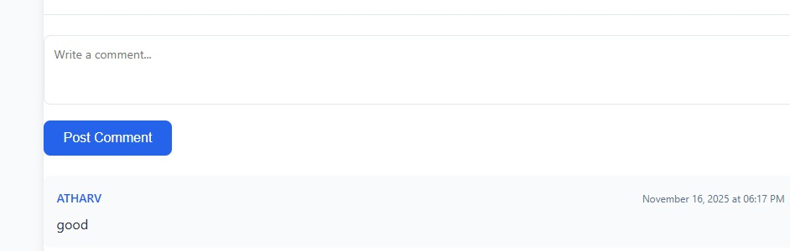

- SAVED ARTICLES AT ONE PLACE:
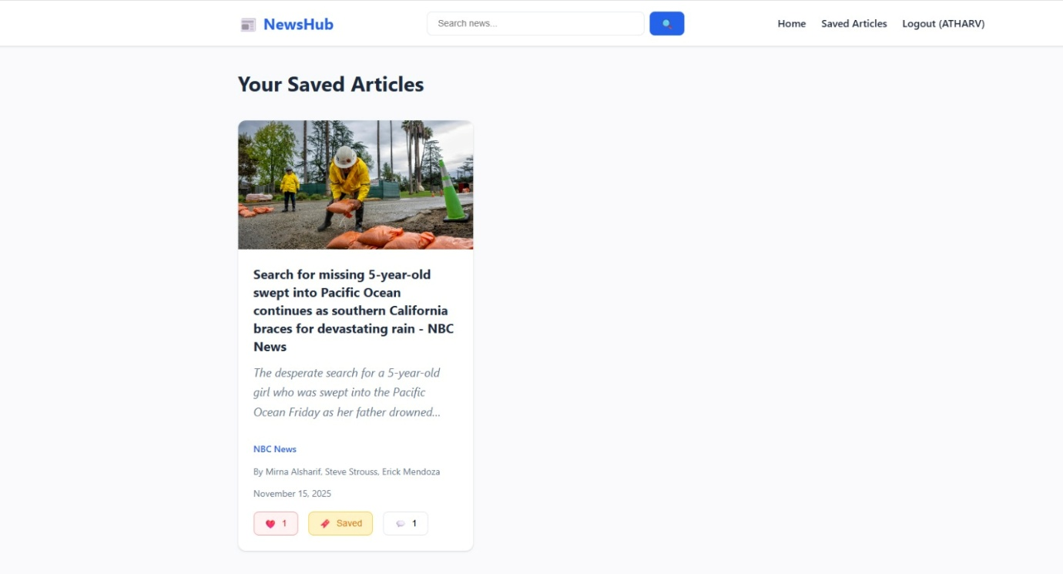

- ADMIN CAN EDIT AND DELETETHE NEWS AND MANAGE THE USERS

