System Testing, Maintenance Planning, and Reporting for an RPM Transmission-Gap Detection System

Anam Kazani
Department of Information Technology, University of the People
MSIT 5910-01: MSIT Capstone Project
Dr. Sirisha
October 21, 2026

System Testing, Maintenance Planning, and Reporting for an RPM Transmission-Gap Detection System
I am presenting my capstone system, in which remote patient monitoring (RPM) devices are flagged when they become inactive compared to the usual pattern of their activity, and patients who need nursing outreach are identified. Unit 6 merged its four modules into one application, version 0.3.0. This unit carries out tests of the whole system, addresses errors identified by the tests in version 0.4.0, and creates the strategy for system support after deployment. It is important to stress that all the data is synthetic.

Part A: System Testing and Documentation

System Testing
The 21 unit tests from Unit 5 still check each module under test. A further testing source file, test_system.py, was built for system-level testing, where another 25 test cases at four additional levels, plus regression tests, were created by me. In the integration tests, I tested the modules and database based on their ability to exchange data. The system tests checked the application as a black box by sending it real requests through HTTP to evaluate its functional and non-functional capabilities, which is how Hrupa (2024) and GeeksforGeeks (2025b) describe system testing. Acceptance tests directly assessed the Unit 3 functional requirements from the perspective of the nurse. Regression tests confirmed that the Unit 6 accuracy and detection times did not change, and performance tests checked speed and stability in an environment that resembles production, as BrowserStack (2025) advises.
The first run against version 0.3.0 passed 41 tests and failed four (Figures 1 and 2). One test, for the FR-8 cohort report, is marked as an expected failure because that report has not been built yet.
Figure 1
First Test Run Against Version 0.3.0
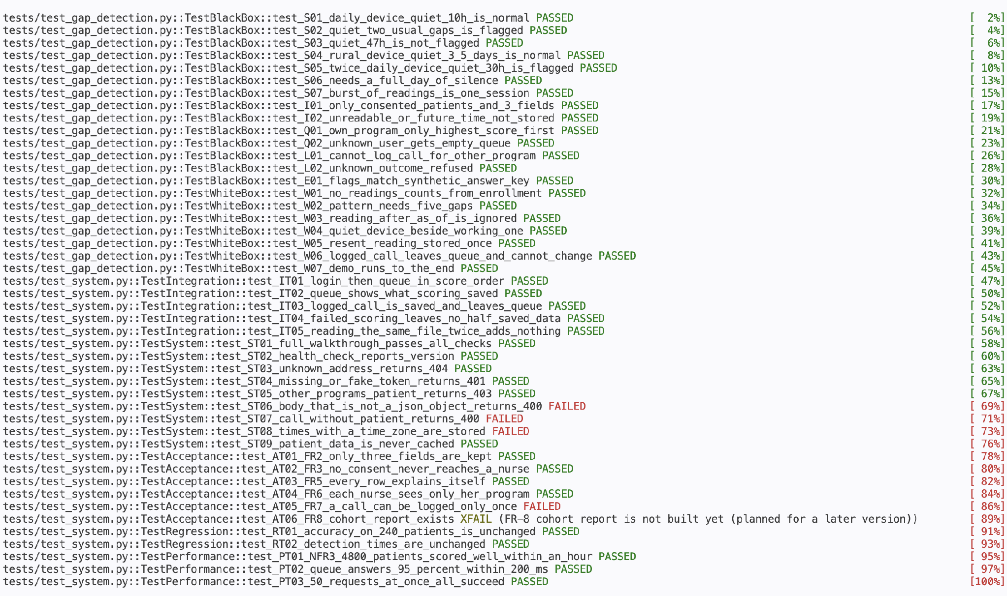
Figure 2
Why the Four Tests Failed
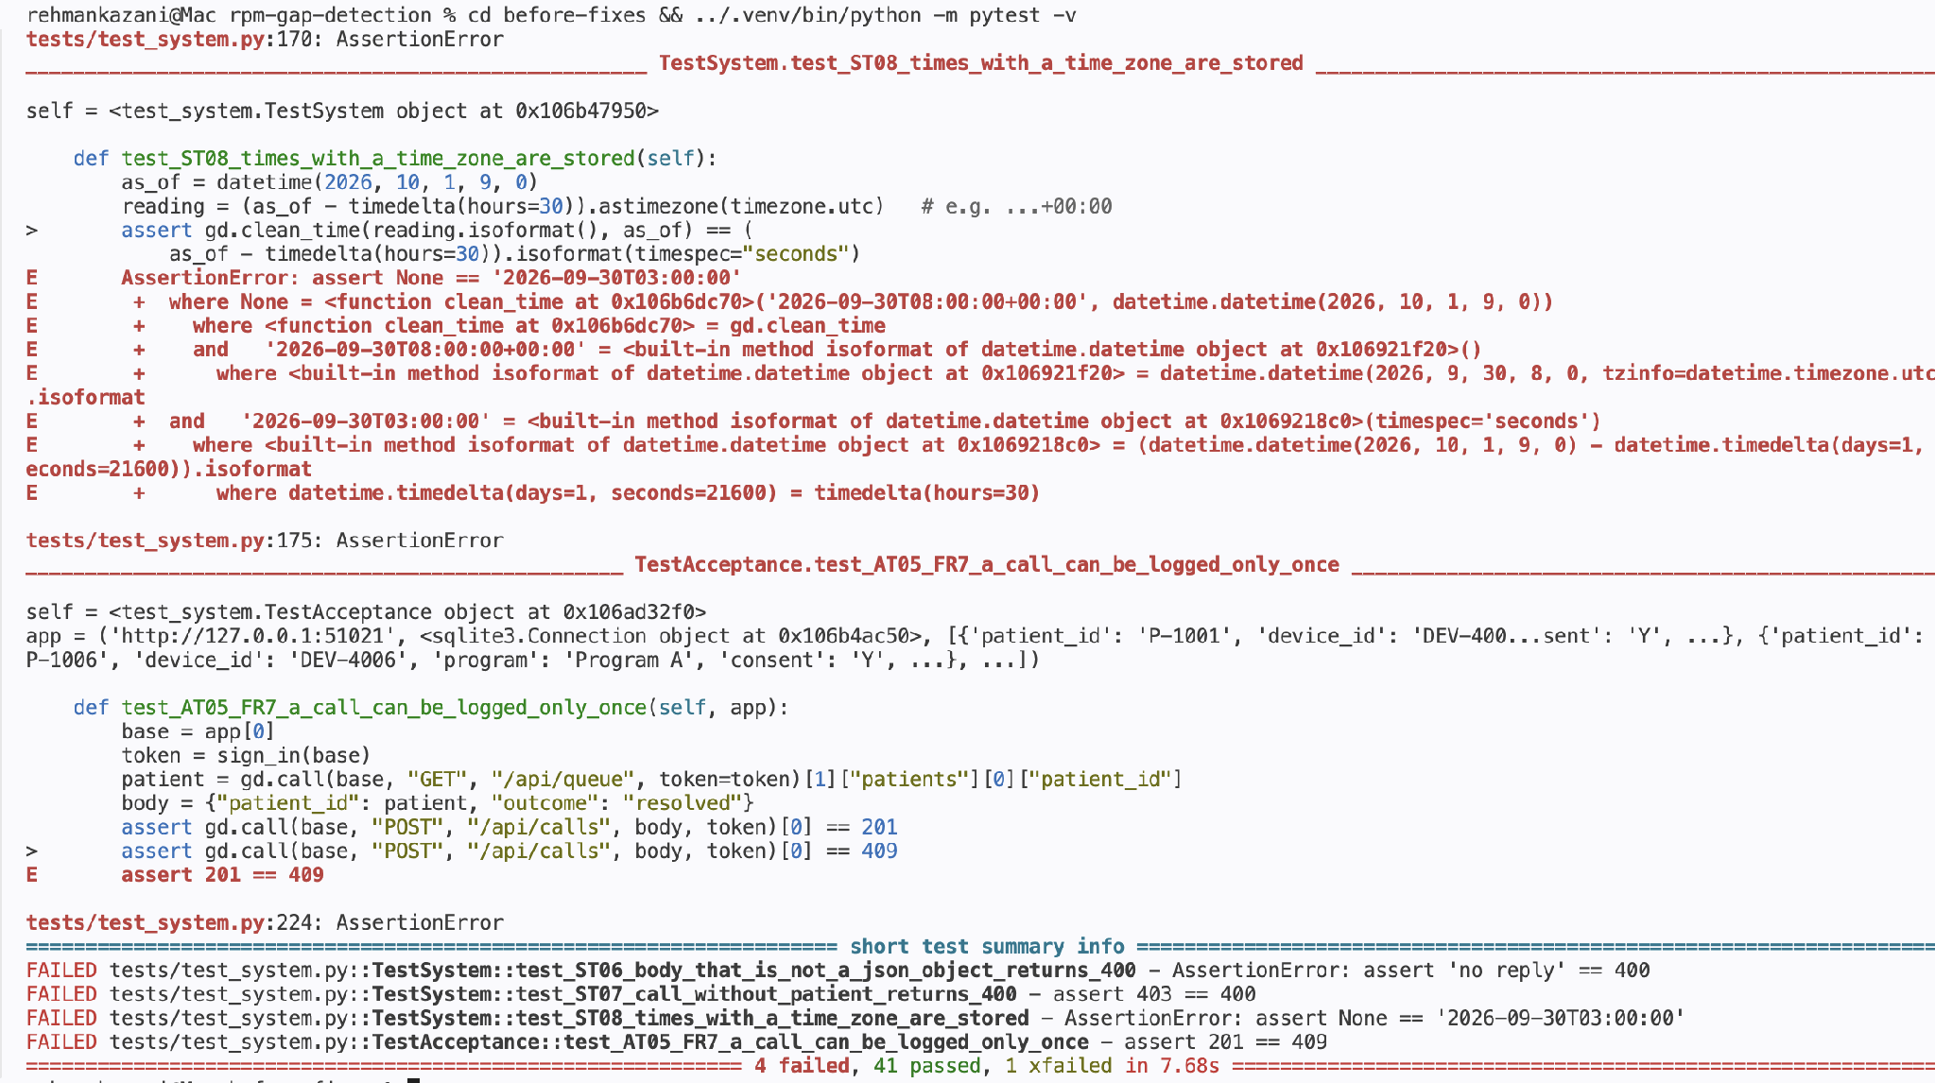
I fixed each defect in version 0.4.0 (Figure 3) and ran every test again. All 45 tests now pass, with the one expected failure (Figure 4). The performance tests ingested and scored 4,800 patients in 0.79 seconds, and the queue API answered 95% of 100 requests within 1.0 millisecond (Figure 5).
Figure 3
Fix for Defects D2 and D4 in log_outcome()
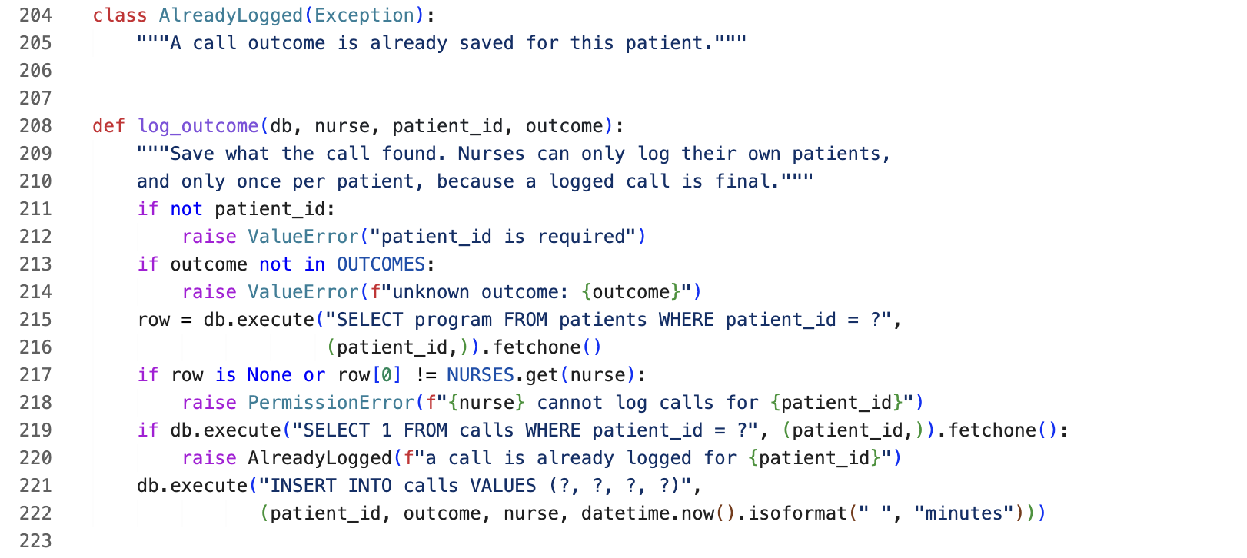
Figure 4
Second Test Run After the Fixes (Version 0.4.0)
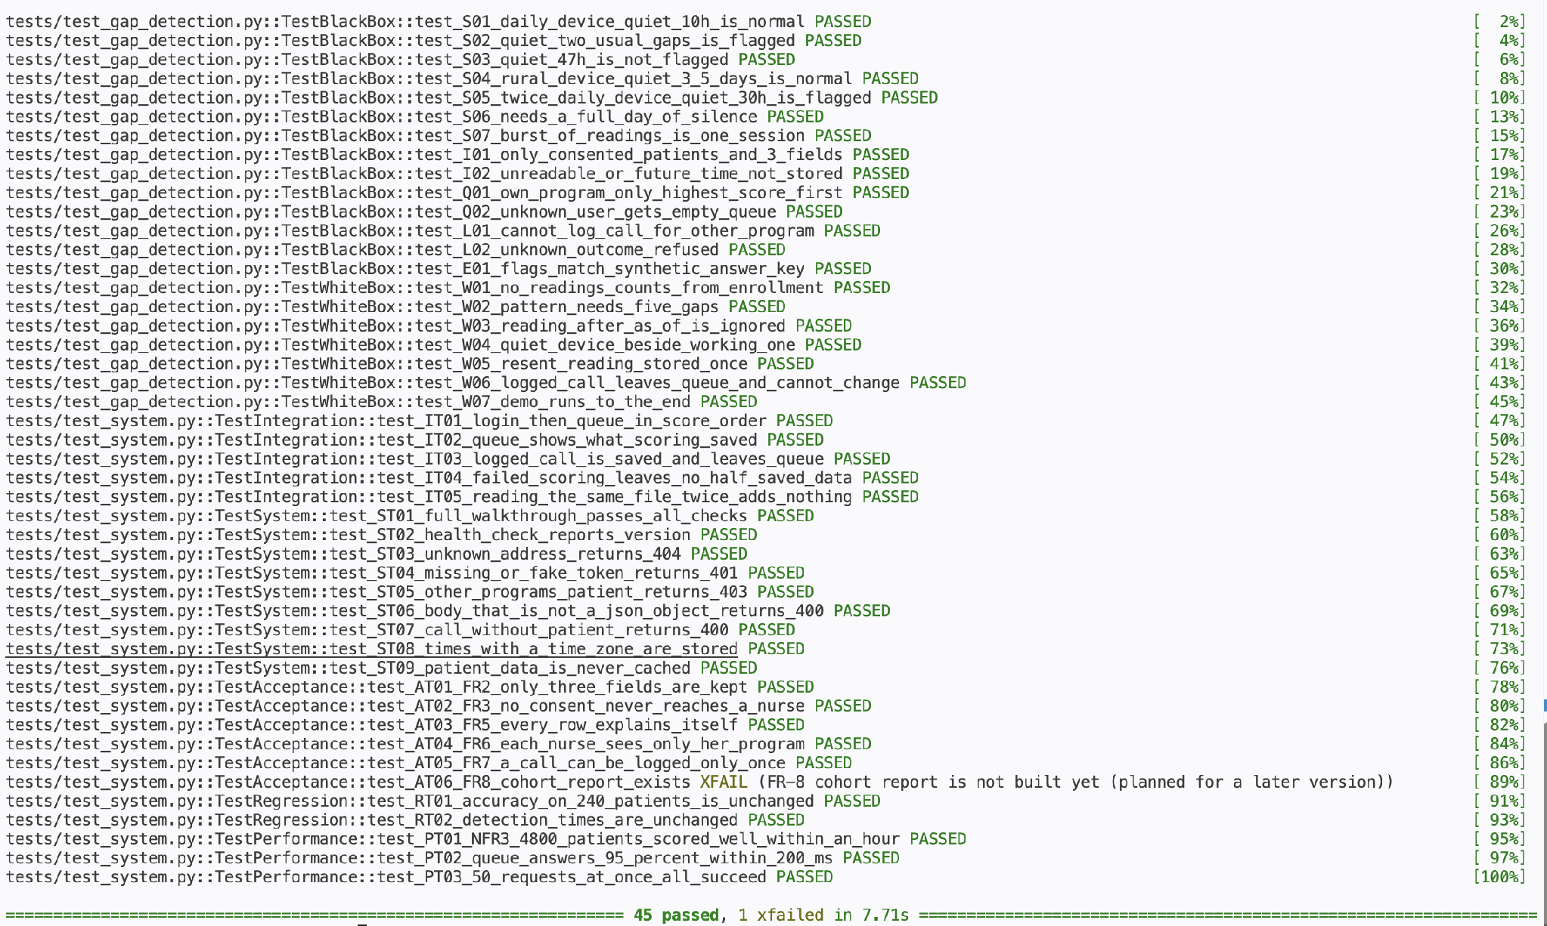
Figure 5
Performance Test Output
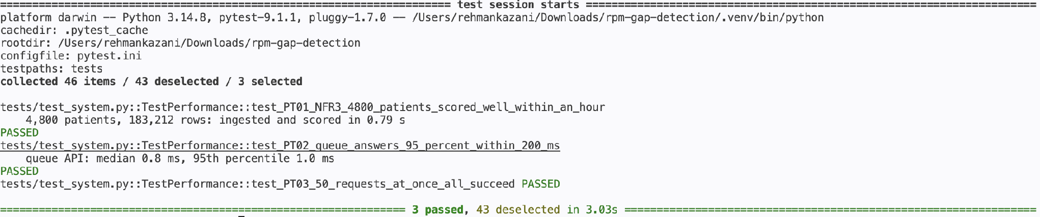

Test Documentation
Testing aimed at determining whether version 0.3.0 satisfies the Unit 3 specifications as a complete system before getting ready for deployment. It included testing of all four modules, the web API, and the database with synthetic data on Python 3.14 on a Mac. Following GeeksforGeeks (2025b), the process included the following steps: writing test cases from requirements, preparing test data, executing tests, recording defects, correcting them, and executing regression tests once again. Every test case is listed by its ID in Figures 1 and 4, and the results and defects are summarized in Tables 1 and 2, respectively.
Table 1
Test Summary Report
Level | Tests | What it checks | First run (v0.3.0) | After fixes (v0.4.0)
Unit | 21 | Each module alone | 21 passed | 21 passed
Integration | 5 | Modules and database together | 5 passed | 5 passed
System | 9 | Whole running application over HTTP | 6 passed, 3 failed | 9 passed
Acceptance | 6 | Functional requirements FR-2 to FR-8 | 4 passed, 1 failed, 1 expected failure | 5 passed, 1 expected failure
Regression | 2 | Unit 6 results unchanged | 2 passed | 2 passed
Performance | 3 | Speed and stability | 3 passed | 3 passed
Total | 46 |  | 41 passed, 4 failed, 1 expected failure | 45 passed, 1 expected failure
Table 2
Defects Found and Fixed
ID | Test | Problem in version 0.3.0 | Fix in version 0.4.0
D1 | ST06 | A request body that was not a JSON object, such as [], crashed the request, and the server closed the connection without replying | The API checks the body and answers 400
D2 | ST07 | Logging a call with no patient ID returned 403 instead of 400 | A patient ID is required
D3 | ST08 | Reading times with a time zone, such as +00:00, were rejected, so a vendor sending UTC times would lose every reading | Times with a zone are converted to local time
D4 | AT05 | The same call could be logged twice, giving one patient two outcomes | A second call returns 409
While fixing these, I also made the dashboard escape apostrophes in patient IDs. Some limitations remain documented rather than fixed. The FR-8 cohort report is missing, usability has not been tested with nurses, the database is kept in memory, and devices that normally send every three days still take a median of 142 hours to flag.

Evaluation
The unit tests were successful; however, system testing discovered four defects. The defects occurred on the boundaries where the system interacts with the vendor files and client requests, a situation where there is no single module accountable. Hrupa (2024) claims that system testing is the final structured check before users judge a product; D3 shows exactly that, as on the first day of using a new vendor it would have simply rejected every real reading. The testing carried out indeed confirmed that the changes had not affected the results, as both precision and recall remain at 1.00 and the times of detection stayed the same—25,49 and 142 hours accordingly. The fact that every case is written according to some requirement allows tracing back all results to the original design, meaning that the system would be accepted and supported more easily.

Part B: System Maintenance Plan

Maintenance Strategy
Thales (n.d.) describes four types of maintenance. Corrective maintenance fixes faults, such as D1 to D4, and is the most urgent here because a fault in scoring could hide a silent device. Adaptive maintenance adjusts the system to changes around it, such as a new vendor export format, a new Python version, or the organization's identity system. D3 was an adaptive problem found early. Perfective maintenance adds what users ask for, such as showing silences in days, a link to the patient's phone number, the FR-8 report, and a four-day cap for slow senders. Preventive maintenance deals with latent faults before they cause harm (GeeksforGeeks, 2025a), such as updating Python and rerunning the full test suite. Table 3 sets the schedule.
Table 3
Monitoring and Maintenance Schedule
When | Activity | Type
Every scoring pass | Check /api/health and record ingestion counts | Preventive
Daily | Review rejected and duplicate rows; a jump means the vendor file changed | Corrective, adaptive
Weekly | Review open bug reports and nurse requests | Corrective, perfective
Monthly | Update Python, run all 46 tests, check response times | Preventive
Quarterly | Review the threshold, flag rates, and false alarms with nurses | Perfective

Maintenance Documentation
Every change goes through the steps in Thales (n.d.), which are to identify, analyze, design, implement, test, accept, and deliver. Bug reports and enhancement requests are turned into GitHub issues with steps to reproduce the issue. For bugs, I start by creating a test that fails, as I did with D1 to D4, fix the bug on a feature branch created from development, and finally merge it when it passes all tests. Versions follow the structure major.minor.patch, where bug fixes change the last number and new features the middle number, and the changelog documents each release.
Version control and configuration management work side by side in this plan. Each tagged release on main is a restore point in case an update runs into issues, which Davies (2024) describes as the flexibility and accountability of version history. Controlled change is an aim of configuration management (Summers, 2020), so the flag threshold RPM_FLAG_AT can only be changed through a properly reviewed release, as this threshold determines which patients are called. A GitHub Actions workflow should run all tests for each pull request.

Risk Identification and Mitigation
Table 4 lists the main risks after deployment and how each will be handled.
Table 4
Post-Deployment Risks
Risk | Mitigation | Contingency
Security: sign-in tokens never expire in the prototype | Use the organization's identity system with expiring sessions and HTTPS | Clear all tokens and review the call log
Security: outdated Python with known vulnerabilities | Monthly updates, tested before release | Roll back to the previous release
Data inconsistency: the vendor changes its file or time format | Daily review of rejected rows and format tests like ST08 | Pause, fix, and reload the file, which adds no duplicates
Data loss: call outcomes kept only in memory | Database file on an encrypted disk with nightly backups | Restore the last backup
Usability: nurses stop trusting the queue | Keep false alarms low and review the queue with nurses quarterly, since repeated alerts cause alert fatigue (Ancker et al., 2017) | Fall back to the monthly report

References
Ancker, J. S., Edwards, A., Nosal, S., Hauser, D., Mauer, E., & Kaushal, R. (2017). Effects of workload, work complexity, and repeated alerts on alert fatigue in a clinical decision support system. BMC Medical Informatics and Decision Making, 17(1), Article 36. https://doi.org/10.1186/s12911-017-0430-8
BrowserStack. (2025, May 29). What is system testing? (Examples, use cases, types). https://www.browserstack.com/guide/what-is-system-testing
Davies, S. (2024). Blueprints: Creating, describing, and implementing designs for larger-scale software projects (Version 2.5). University of Mary Washington. https://open.umn.edu/opentextbooks/textbooks/blueprints-creating-describing-and-implementing-designs-for-larger-scale-software-projects-davis
GeeksforGeeks. (2025a, September 29). Software maintenance – Software engineering. https://www.geeksforgeeks.org/software-engineering/software-engineering-software-maintenance/
GeeksforGeeks. (2025b, July 22). System testing – Software testing. https://www.geeksforgeeks.org/software-testing/system-testing/
Hrupa, A. (2024, March 19). What is system testing in software testing. Testfort. https://testfort.com/blog/what-is-system-testing-in-software-testing
Summers, B. L. (2020). Effective methods for software engineering. Auerbach Publishers.
Thales. (n.d.). What is a software maintenance process? 4 types of software maintenance. https://cpl.thalesgroup.com/software-monetization/four-types-of-software-maintenance

