A Mini Project on

**University Network System**

Submitted to Manipal University, Jaipur

Towards the partial fulfillment for the Award of the Degree of

**BACHELORS OF TECHNOLOGY**

In Information Technology

2019-2020

By

Anamay Deshpande

(179302016)

Atharva Chourey

(179302036)



Under the guidance of

Dr. Narendra Singh Yadav

**Department of Information Technology**

**School of Computing and Information Technology**

**Manipal University Jaipur**

**CERTIFICATE**

Date: 21/05/2020

This is to certify that the project titled University Network Systemis a record of the Bonafede work done by **ANAMAY DESHPANDE** (179302016) & **ATHARVA CHOUREY**(179302036) submitted in partial fulfillment of the requirements for the award of the Degree of Bachelor of Technology B.Tech in Information Technologyof Manipal University Jaipur, during the academic year 2019-20.





**ABSTRACT**

In today’s fast-paced and evolving world where connectivity is the key and every person is dependent on electronic items, especially college students, it is very important for the universities and colleges to have a secure, fast and reliable network that connects each node of the college with the other. With that in the mind, we have implemented our version of a reliable network for a medium-sized university. A university can have different departments and each department can have a separate network.

There are various issues that a university network may face. The connection between a department should be secure and faculties should have access to all the resources in that department, whereas the students will have limited access to the network which will be solely for the study purpose. All the departments should be able to communicate with each other but can not access each other's resources. The network administrator will handle all the networks in the university and will keep the check on its efficiency.

We have used various networking devices such as routers, switches, servers, etc for our project and we tried our best to make this network efficient by using limited resources as per the requirements of the department.

Our aim in this project is to showcase an effective method to implement a university network design that can be implemented in many universities of similar size and structure. Our focus is on using cisco packet tracer and building a viable computer network

**CONTENTS**

|  |  |  |
| --- | --- | --- |
| **Sr. No.** | **Topic** | **Page No.** |
| 1 | *Chapter 1: Introduction*  1.1: Motivation  1.2: Objective | *5*  5  5 |
| 2 | *Chapter 2: Literature Review*  2.1: Hardware Devices  2.2 Networking Concepts | *6*  6  8 |
| 3 | *Chapter 3: Work Done*  3.1: Logical View of Network  3.2 Server Configuration  3.3 ISP Router Configuration  3.4 Border Router Configuration  3.5 College Router Configuration  3.6 Admin Building Switch VLAN Configuration  3.7 IT Dept Configuration  3.8 Accounts Dept Configuration  3.9 Registrar Dept Configuration  3.10 Faculty Dept Configuration  3.11 Student Dept Configuration | *12*  12  13  14  15  16  17  17  18  19  19  20 |
| 4 | *Chapter 4: Results and Discussions*  4.1 Ping Test  4.2 Packet Delivery Simulation | *21*  21  25 |
| 5 | *Chapter 5: Conclusions and Future Work*  5.1 Conclusions  5.2 Future Work | *28*  28  28 |
| 6 | *Chapter 6: References* | *29* |

**INTRODUCTION**

**1.1 Motivation:**

With the current developing world, the education system is also shifting to modern methods and technologies. The work which was earlier done on paper can now be done on a computer. All the files and documents can be stored on a single drive and it is easily accessible. With the introduction of the internet, it is much easier for teachers and students to teach and learn. The Internet has provided a lot of gifts to this modern world which is very helpful and to use these gifts we require a network. So it is necessary to establish a network especially in a university where faculty, students, and staff can manage their work properly. Providing a secure and efficient network we can easily save a lot of time, space, and other valuable resources.

**1.2 Objective of the project:**

With this project, we aim to showcase a standard, broad network that can be used for colleges and universities with similar infrastructure. This network contains 5 departments, which are present in most universities and can be used accordingly. The departments used are- IT, Accounts, Registrar, Faculty, and Students. Each department has a certain number of PCs as its end devices and in the network, we have represented the number of end devices in a department by using 2 PCs, one for the first one and one for the last PC in the department. It has been numbered accordingly.

The university has a private network with an IP address of 172.16.0.0/12 . There are 2 servers, to which the departments can connect through the ISP router, namely YouTube server and Google server. We have demonstrated the use of VLANs hereby representing each department as its own VLAN.

The end goal of this project is to implement a fully functional network for a university with similar requirements. By simulating it properly in the Cisco Packet Tracer tool, it can easily be implemented in the real world if needed.

**LITERATURE REVIEW**

**2.1 HARDWARE DEVICES:**

**2.1.1 Ethernet Cables:**

An [Ethernet](https://www.lifewire.com/what-is-ethernet-3426740) cable is a common type of network cable used with wired networks. [Ethernet cables](https://www.lifewire.com/best-ethernet-cables-4178848) connect devices such as PCs, [routers](https://www.lifewire.com/what-is-a-router-2618162), and [switches](https://www.lifewire.com/definition-of-network-switch-817588) within a [local area network](https://www.lifewire.com/what-is-lan-4684071). Ethernet cables plug into [Ethernet ports](https://www.lifewire.com/what-is-an-ethernet-port-817546), which are larger than phone cable ports. An Ethernet port on a computer is accessible through the [Ethernet card](https://www.lifewire.com/what-is-an-ethernet-card-817547) on the [motherboard](https://www.lifewire.com/motherboards-system-boards-and-mainboards-2618154). This port is usually on the back of a desktop computer, or on the side of a laptop. We have used two types of ethernet cables in our network: Ethernet straight-through cable and Ethernet crossover cable.   
Ethernet straight-through cable is a type of twisted pair cable that is used in local area networks to connect two different types of devices, such as a switch to a router or a PC to a switch. This type of cable is also sometimes called a patch cable and is an alternative to wireless connections where one or more computers access a router through a wireless signal. On a straight-through, the wired pins match.  
A crossover Ethernet cable is a type of Ethernet cable used to connect two devices of the same type: e.g. two computers or two switches to each other. Unlike straight-through cable, the RJ45 crossover cable uses two different wiring standards: one end uses the T568A wiring standard, and the other end uses the T568B wiring standard. The internal wiring of Ethernet crossover cables reverses the transmit and receive signals. [[1]](http://www.cables-solutions.com/difference-between-straight-through-and-crossover-cable.html)

**2.1.2 Switches:**

A switch is a data link layer networking device that connects devices in a network and uses packet switching to send and receive data over the network.

Like a hub, a switch also has many ports, to which computers are plugged in. However, when a data frame arrives at any port of a network switch, it examines the destination address and sends the frame to the corresponding device(s). Thus, it supports both unicast and multicast communications

There are many types of switches such as managed, unmanaged, smart, and PoE switches. All these switches are used in setting up a network. Thus it makes it an important tool for the connection.[[2]](https://www.cdw.com/content/cdw/en/articles/networking/2018/12/04/types-of-network-switches.html)

**2.1.3 Routers:**

A router is [a hardware](https://www.computerhope.com/jargon/h/hardware.htm) device designed to receive, analyze, and move incoming [packets](https://www.computerhope.com/jargon/p/packet.htm) to another [network](https://www.computerhope.com/jargon/n/network.htm). It may also be used to convert the packets to another network interface, [drop](https://www.computerhope.com/jargon/d/drop.htm) them, and perform other actions relating to a network.

A router has a lot more capabilities than other network devices, such as a [hub](https://www.computerhope.com/jargon/h/hub.htm) or a [switch](https://www.computerhope.com/jargon/s/switch.htm) that is only able to perform basic network functions. For example, a hub is often used to transfer data between computers or network devices but does not analyze or do anything with the data it is transferring. By contrast, routers can analyze the data being sent over a network, change how it is packaged, and send it to another network or over a different network. For example, routers are commonly used in home networks to share a single Internet connection between multiple computers.

Types of routers:

### Wireless (Wi-Fi) router

### Brouter

### Core router

### Edge router

### Virtual router

These routers play a very important role since the number of users is more and all the users use wireless means of communication whether it is a mobile or a laptop. So to provide them with an all-time connection we have to use routers while setting up the network.[[3]](https://www.computerhope.com/jargon/r/router.htm)

**2.2 NETWORKING CONCEPTS:**

**2.2.1 VLANs:**

A VLAN (virtual local area network) is a subnetwork that can group together collections of devices on separate physical local area networks (LANs). VLANs can spread across multiple switches, with each VLAN being treated as its own subnet or a broadcast domain. This means that frames broadcasted onto the network will be switched only between the ports within the same VLAN.  
A VLAN acts like a physical LAN, but it allows hosts to be grouped together in the same broadcast domain even if they are not connected to the same switch. In this project, we have created 5 separate VLANs for each department and have configured each VLAN to each switch used.  
Here are the main reasons why VLANs are used:

* VLANs increase the number of broadcast domains while decreasing their size.
* VLANs reduce security risks by reducing the number of hosts that receive copies of frames that the switches flood.
* you can keep hosts that hold sensitive data on a separate VLAN to improve security.
* you can create more flexible network designs that group users by department instead of by physical location.
* network changes are achieved with ease by just configuring a port into the appropriate VLAN. [[4]](https://study-ccna.com/what-is-a-vlan/)

**2.2.2 DHCP:**

Dynamic Host Configuration Protocol (DHCP) is a network management protocol used to automate the process of configuring devices on IP networks, thus allowing them to use network services such as DNS, NTP, and any communication protocol based on UDP or TCP. A DHCP server dynamically assigns an IP address and other network configuration parameters to each device on a network so they can communicate with other IP networks.   
DHCP remains an essential method to ensure that devices are able to join networks and are configured correctly. It greatly reduces the errors that are made when IP addresses are assigned manually and can stretch IP addresses by limiting how long a device can keep an individual IP address.  
In our network, we have assigned IP addresses to the faculty and student end devices because of the large number of users in those departments (250 in Faculty and 2000 in Students). It has reduced the chances of an error occurring while assigning IP addresses. We have also used DHCP for reduced network administration which provides benefits to an organization like this one. Some features DHCP offers to reduce network administration:

* Centralized and automated TCP/IP configuration
* The ability to define TCP/IP configuration from a central location
* The ability to assign a full range of additional TCP/IP configuration values by means of DHCP options. It comes in handy if you want more students to enroll in the university. [[5]](https://docs.microsoft.com/en-us/windows-server/networking/technologies/dhcp/dhcp-top)

**2.2.3 ISP:**

Internet service provider (ISP), a company that provides Internet connections and services to individuals and organizations. In addition to providing access to the Internet, ISPs may also provide software packages (such as browsers), email accounts, and a personal Web site or home page. ISPs can host Web sites for businesses and can also build the Web sites themselves. ISPs are all connected to each other through network access points, public network facilities on the Internet backbone. So to have a successful network in a university or any other place an ISP is the most important parameter. This is the only common link between the network of our university and the outer world. Comcast, Verizon, Level 3, Megapath, JIO, BSNL, Sify, and many others are the companies that are internet service providers in the current world.

Features of an ISP:

* An internet service provider (ISP) is a company that provides web access to both businesses and consumers.
* ISPs may also provide other services such as email services, domain registration, web hosting, and browser services.
* An ISP is considered to be an information service provider, storage service provider, internet network service provider (INSP), or a mix of all of them.
* Internet use has evolved from only those with university or government accounts having access to nearly everyone having access, whether it's paid or free.
* Access has gone from dial-up connections to high-speed broadband technology.[[6]](https://www.britannica.com/technology/Internet-service-provider)

**2.2.4 Private IP networks:**

Private internal addresses are not routed on the Internet and no traffic cannot be sent to them from the Internet, they are only supposed to work within the local network.

Private addresses include IP addresses from the following subnets:

* Range from 10.0.0.0 to 10.255.255.255 — a 10.0.0.0 network with a 255.0.0.0 or an /8 (8-bit) mask
* Range from 172.16.0.0 to 172.31.255.255 — a 172.16.0.0 network with a 255.240.0.0 (or a 12-bit) mask
* A 192.168.0.0 to 192.168.255.255 range, which is a 192.168.0.0 network masked by 255.255.0.0 or /16
* A special range 100.64.0.0 to 100.127.255.255 with a 255.192.0.0 or /10 network mask; this subnet is recommended according to rfc6598 for use as an address pool for CGN (Carrier-Grade NAT)

Those are reserved IP addresses. These addresses are intended for use in closed local area networks and the allocation of such addresses is not globally controlled by anyone.

Direct access to the Internet using a private IP address is not possible. In this case, the connection to the Internet is via NAT (network address translation replaces the private IP address with a public one). Private IP addresses within the same local network must be unique and cannot be repeated.

For a secure network in a department, we will be using these IP addresses. For example for the finance and administration department, this type of network is used since the chances of theft are less.[[7]](https://help.keenetic.com/hc/en-us/articles/213965789-What-is-the-difference-between-a-public-and-private-IP-address-)

**2.2.5 Gateways:**

A gateway is a network node used in telecommunications that connects two networks with different transmission protocols together. Gateways serve as an entry and exit point for a network as all data must pass through or communicate with the gateway prior to being routed. In most IP-based networks, the only traffic that does not go through at least one gateway is traffic flowing among nodes on the same local area network (LAN) segment. The term default gateway or network gateway may also be used to describe the same concept.

The primary advantage of using a gateway in personal or enterprise scenarios is simplifying internet connectivity into one device. In the enterprise, a gateway node can also act as a proxy server and a firewall. Thus it plays a vital role in our project, without a gateway it will not be possible to make a secure connection.[[8]](https://whatis.techtarget.com/definition/proxy-server)

**WORK DONE**

The entire network is made and configured on Cisco Packet Tracer. In this chapter, we will be showing the configurations of all major sub-networks and devices.

**3.1 LOGICAL VIEW OF NETWORK**

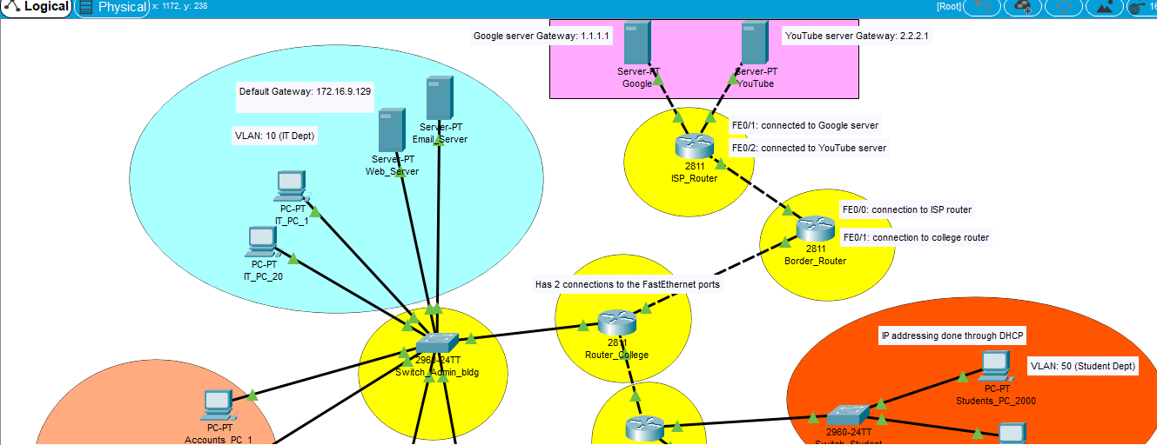

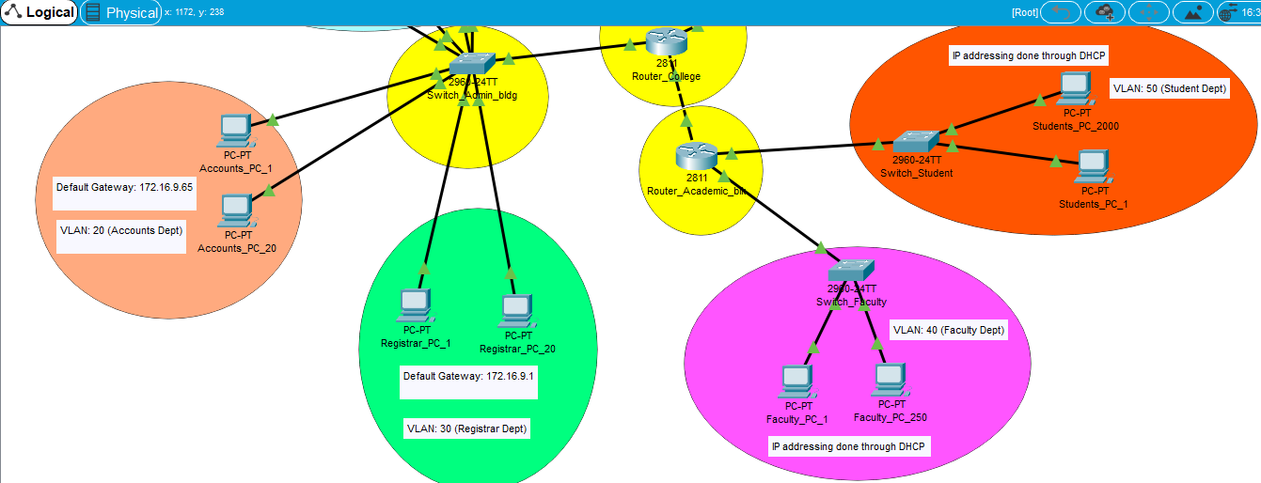

**3.2 SERVER CONFIGURATION:**

**3.2.1 GOOGLE SERVER CONFIG:**

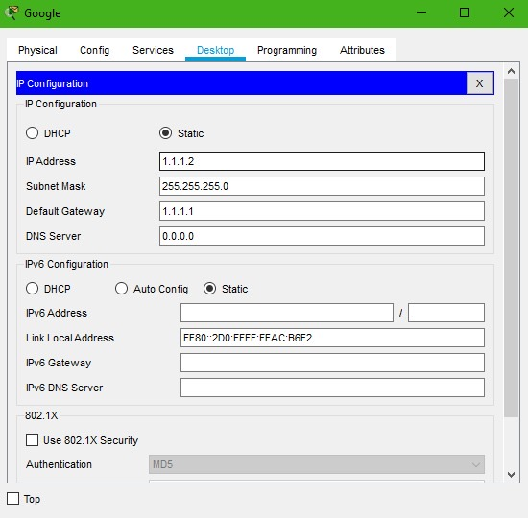

**3.2.2 YOUTUBE SERVER CONFIG:**

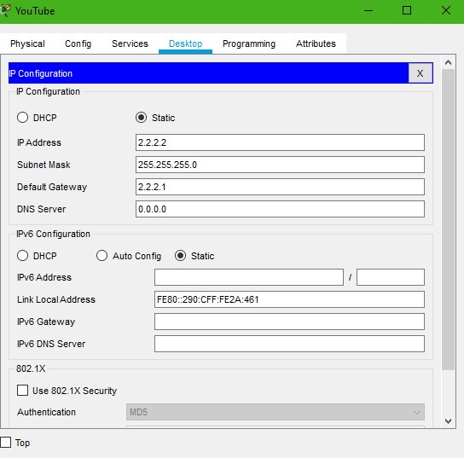

**3.3 ISP ROUTER CONFIGURATION:**

**3.3.1 ISP ROUTER CONFIG WITH INTERNET:**

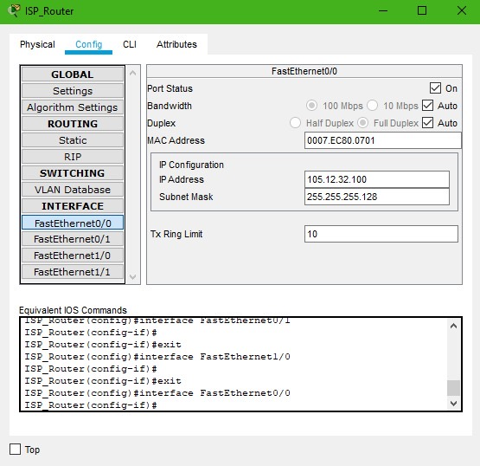

**3.3.2 ISP ROUTER CONFIG WITH SERVER (GOOGLE):**

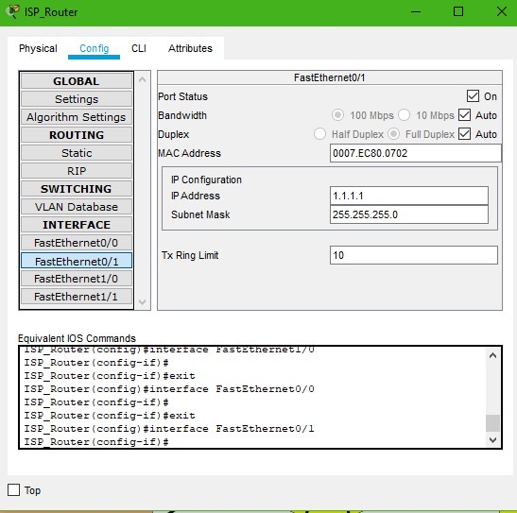

**3.4 BORDER ROUTER CONFIGURATION:**

**3.4.1 BORDER ROUTER CONFIG WITH ISP:**

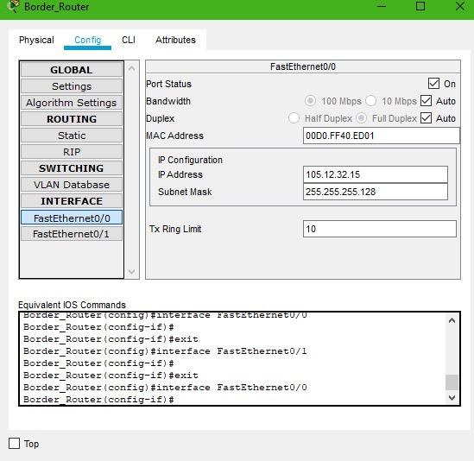

**3.4.2 BORDER ROUTER CONFIG WITH COLLEGE ROUTER:**

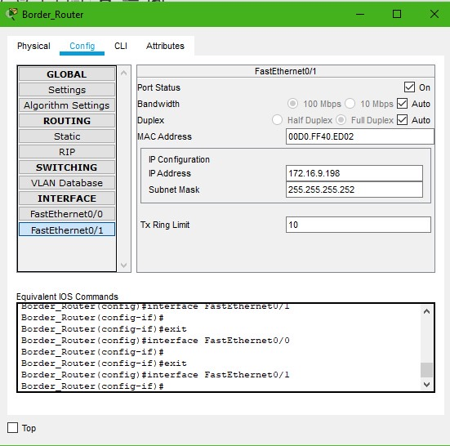

**3.5 COLLEGE ROUTER:**

**3.5.1 COLLEGE ROUTER CONFIG WITH ADMIN BLDG SWITCH:**

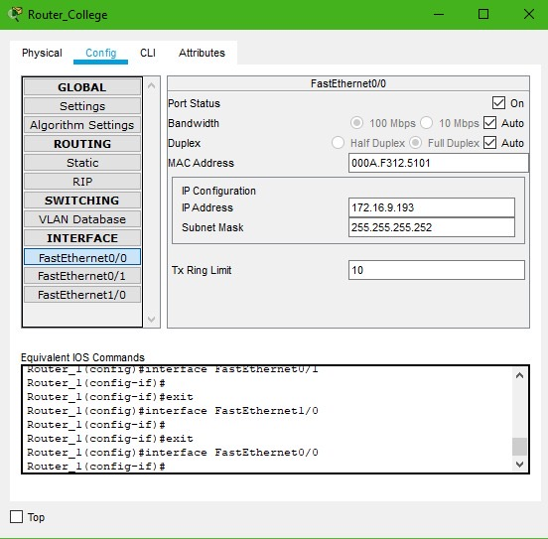

**3.5.2 COLLEGE ROUTER CONFIG WITH ACADEMIC BLK:**

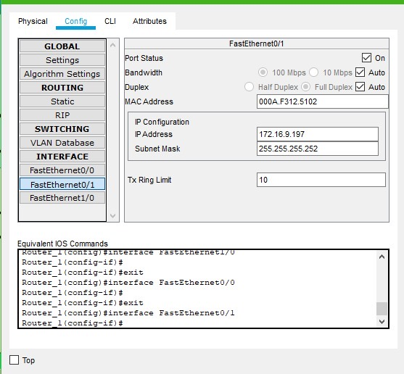

**3.6 ADMIN BUILDING SWITCH VLAN CONFIGURATION:**

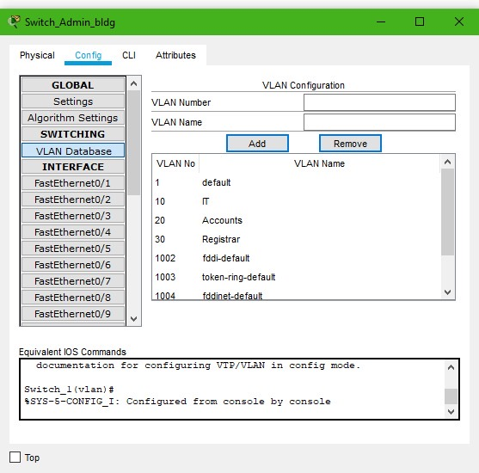

**3.7 IT DEPARTMENT CONFIGURATIONS:**

**3.7.1 EMAIL SERVER CONFIG:**

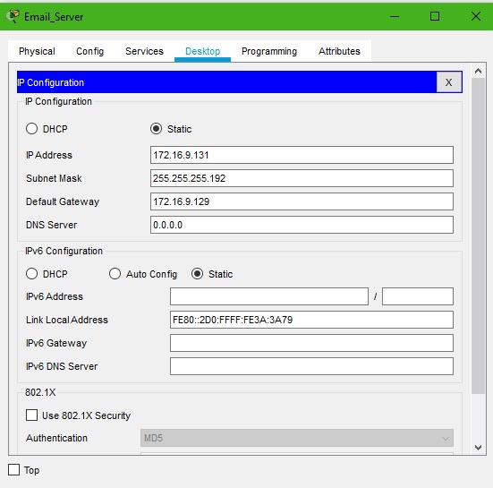

**3.7.2 IT PC CONFIG:**

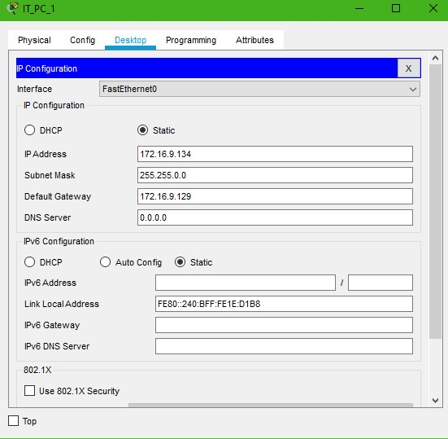

**3.8 ACCOUNTS DEPARTMENT PC CONFIGURATION:**

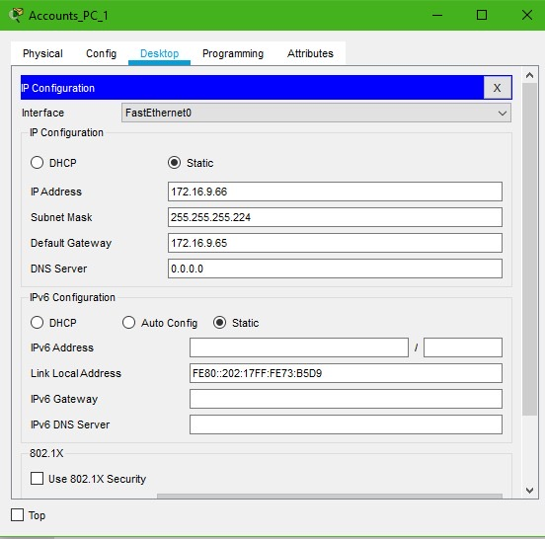

**3.9 REGISTRAR DEPARTMENT PC CONFIGURATION:**

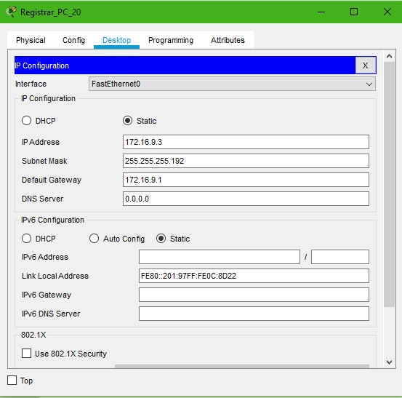

**3.10 FACULTY DEPARTMENT PC CONFIGURATION**

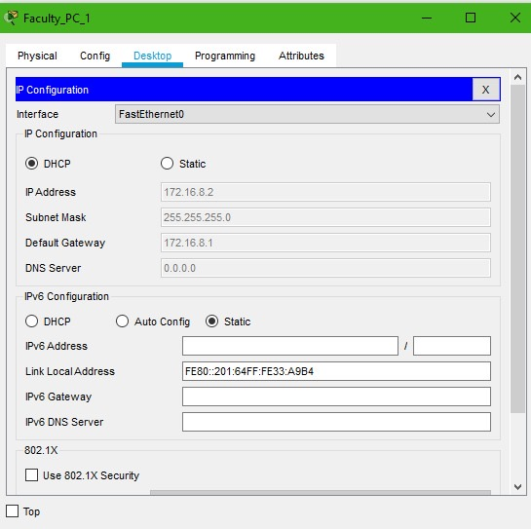

**3.11 STUDENT DEPARTMENT PC CONFIGURATION**

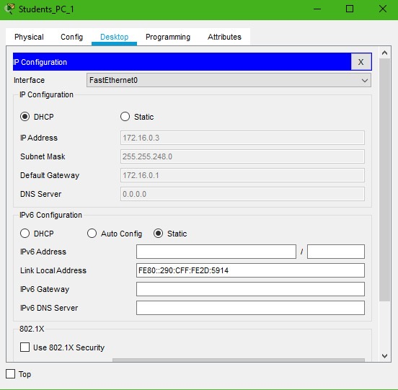

**RESULTS & DISCUSSIONS**

**4.1 PING TEST**

A ping test is a method of checking if the computer is connected to a network. It also determines the latency or delay between two computers. It is used to ensure that a host computer which your computer tries to access is operating. A ping test is run for troubleshooting to know connectivity as well as response time. Aside from checking if the computer is connected to a network, ping also gives indicators of the reliability and general speed of the connection.  
We will be showing the results of ping tests between PCs in different departments of our university to see if they are connected and can communicate with each other. [[9]](https://www.websitepulse.com/blog/what-is-ping-test)

**4.1.1 PING TEST B/W IT DEPT AND OTHER DEPTS IN ADMIN BLDG:**

First we see the results of the ping test between IT Dept PC and Accounts Dept PC.

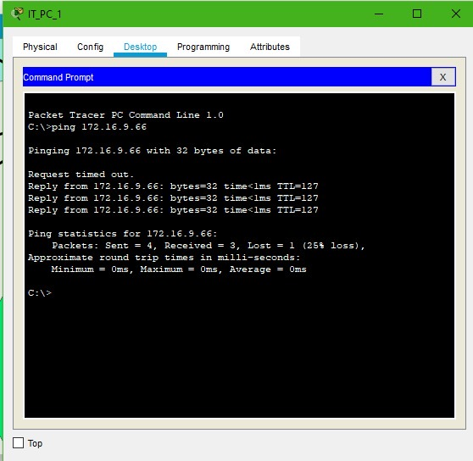

Now we see the result of a ping test between IT Dept PC and Registrar Dept PC.

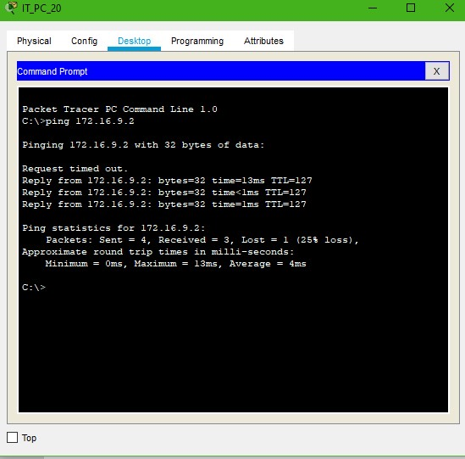

**4.1.2 PING TEST B/W ACC. DEPT AND DEPTS IN ACADEMIC BLK:**

Let us see the results of a ping test between an Accounts Dept PC and a Student PC.

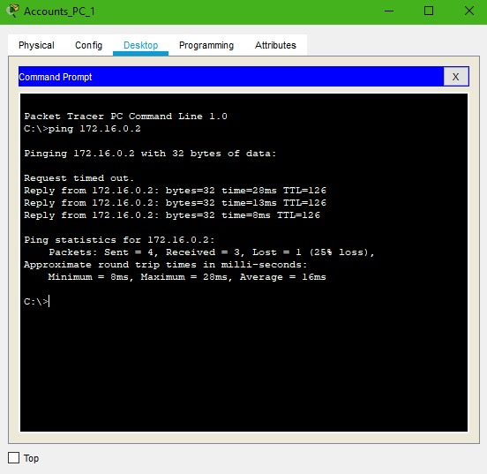

Now the results of a ping test between Accounts Dept PC and a Faculty PC.

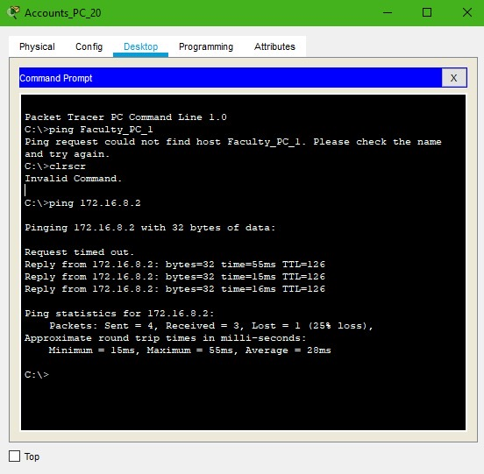

**4.1.3 PING TEST B/W SERVER AND PCs IN BOTH BUILDINGS:**

Let us see the results of a ping test between YouTube server and Accounts Dept PC.

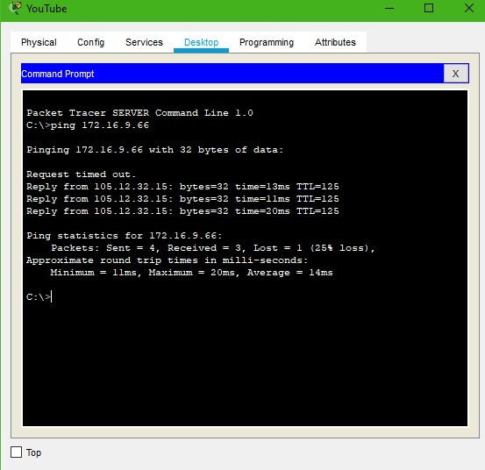

Next the results of a ping test between Google server and Student PC.

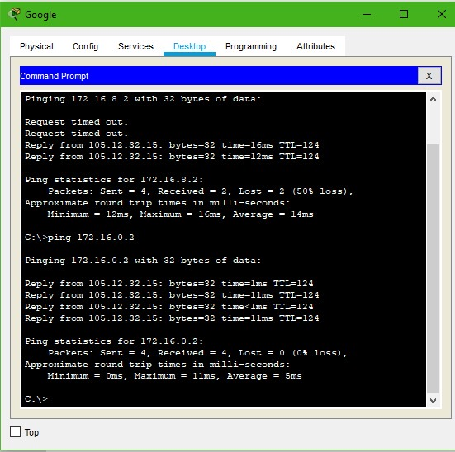

As we can see from the above ping tests, we are able to successfully communicate and connect 2 end devices from any subnetwork with each other. This achieves our primary goal. In most cases, 3 packets get delivered which shows that these are reliable cases and in no situation does 2 or more than 2 packets get lost.

**4.2 PACKET DELIVERY SIMULATION:**

To test the effectiveness of our network, we will use the simulation mode in Cisco Packet Tracer and send a simple Protocol Data Unit (PDU) from one PC to another.

**4.2.1 PDU SIMULATION B/W 2 PCs IN SAME NETWORK:**

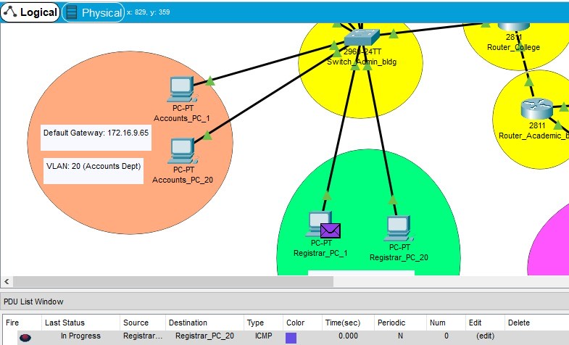

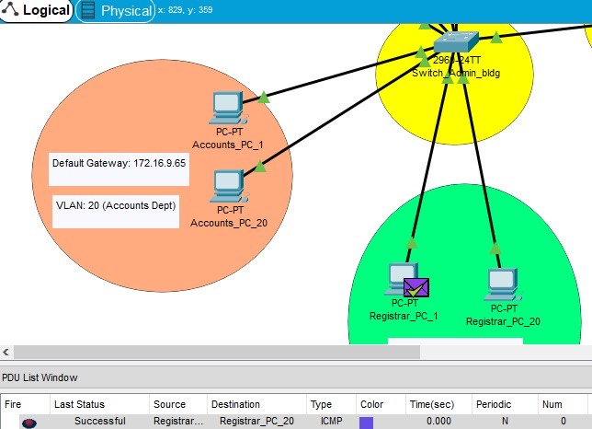

**4.2.2 PDU SIMULATION B/W 2 PCs IN DIFFERENT NETWORKS:**

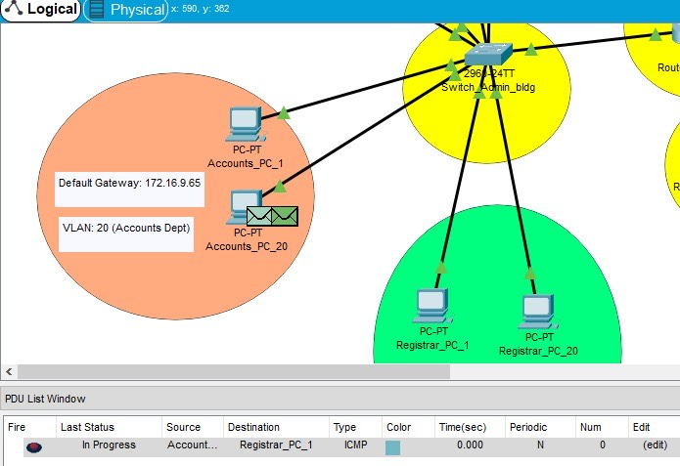

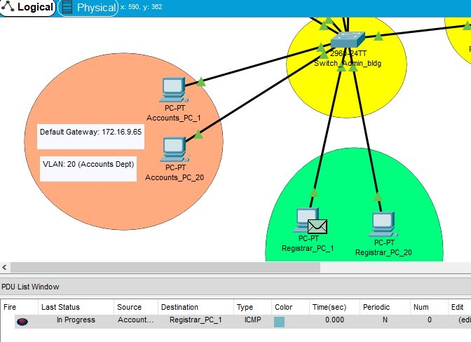

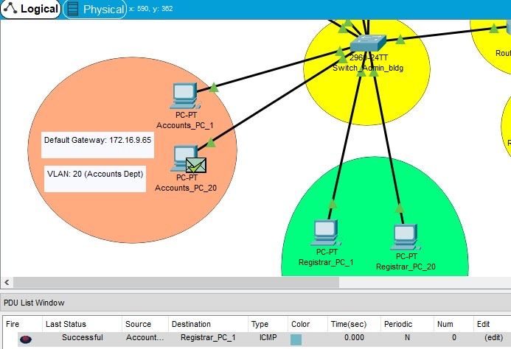

From the above experiments, we have gathered the following results:  
A PDU is successfully sent from one PC to another when the PCs are- a) in the same network and b) in different networks.  
Hence we can conclude from the above ping tests and simulations that two computers in the university can communicate and send & receive data between each other without any trouble.

**CONCLUSIONS AND FUTURE WORK**

**5.1 CONCLUSIONS:**

After conducting the following project, building a network for a university and by looking at the results, we can conclude that such an implementation of a communication network between internet-connected devices is feasible and can be used in the real world.

A reliable, secure and efficient network can be built along these lines, allowing students, faculty and an entire university to function smoothly and problem-free. Due to the limited use of routers and intermediate devices, this network implementation also saves the university money in cost of design and hardware pieces, thereby freeing up money for other valuable resources.

**5.2 FUTURE WORK:**

Any future work on this project and network would entail expansion of the university network. Depending on the requirements, a lot of expansion work can be done.

First and foremost, an expansion can be done with regards to the number of departments. There are possibly many sub-departments that are existing within current departments but are too small to convert into standalone departments. With expansion of the college, due to logistical requirements, these sub-departments would have to be converted into their own departments and to support these departments, they would have to be added to the existing network. New switches and routers would have to be connected depending on the location of these new departments.

Another expansion that will most like happen is the addition of new student and faculty departments due to the increase in admissions. To support these new additions of students and faculty, we would have to add a DHCP Server to support so many new DHCP allocated IP addresses.

In such a methodical manner, we can plan for any future scenarios and prepare for any expansion the university plans to conduct.

**REFERENCES**

[1] Ehternet Cables- <http://www.cables-solutions.com/difference-between-straight-through-and-crossover-cable.html>

[2] Switches- <https://www.cdw.com/content/cdw/en/articles/networking/2018/12/04/types-of-network-switches.html>

[3] Routers- <https://www.computerhope.com/jargon/r/router.htm>

[4] VLANs- <https://study-ccna.com/what-is-a-vlan/>

[5] DHCP- <https://docs.microsoft.com/en-us/windows-server/networking/technologies/dhcp/dhcp-top>

[6] ISP- <https://www.britannica.com/technology/Internet-service-provider>

[7] Private IP Networks- <https://help.keenetic.com/hc/en-us/articles/213965789-What-is-the-difference-between-a-public-and-private-IP-address->

[8] Gateways- <https://whatis.techtarget.com/definition/proxy-server>

[9] Ping Test- <https://www.websitepulse.com/blog/what-is-ping-test>