SKYLINE WEATHER
An End-to-End DevOps Delivery Pipeline for a Cross-Platform Desktop Application
Detailed Project Report
Submitted by
Anamay Narkar -16010123040
Annya Dhiman -16010123041
Anoushka Nelson -16010123049
B.Tech Computer Engineering, Final Year
K.J. Somaiya School of Engineering, Mumbai
DevOps Mini Project
October 2026
Repository: github.com/AnamayNarkar/devops_lab_ca

Abstract
Delivering desktop software is often a manual and error-prone task. A developer builds on one machine, copies the file to wherever it is needed, and users have no reliable way to tell which version is current or whether it was tested. The problem grows when the software must run on more than one operating system and CPU architecture, because each combination has to be built and checked on matching hardware.
This report presents Skyline Weather, a Python desktop weather application built with CustomTkinter, and the delivery pipeline around it. Two GitHub Actions workflows automate the path from commit to download. On every push and pull request, the first workflow runs eight unit tests and a GUI smoke test on both operating systems: Linux inside a Docker container and Windows natively. It also builds the Linux executable inside Docker as a check. When a version tag is pushed, the second workflow tests the code again, builds native executables for Windows and Linux on both x64 and ARM64 with PyInstaller, and publishes them with SHA-256 checksums to GitHub Releases.
A static website on GitHub Pages reads the latest release through the GitHub API, detects the visitor's operating system and CPU, and links directly to the matching download. Publishing a new tag therefore updates the download page without any manual deployment. A complete release run, with four parallel builds, takes about two to three minutes.
Keywords: DevOps, CI/CD, GitHub Actions, Docker, PyInstaller, GitHub Releases, GitHub Pages, ARM64, Python, CustomTkinter.

Table of contents
1. Introduction 6
1.1 Background 6
1.2 Problem statement 6
1.3 Objectives 6
1.4 Scope 6
2. Background and related concepts 7
2.1 CI/CD and release automation 7
2.2 Automated testing 7
2.3 Containerisation with Docker 7
2.4 Cross-platform packaging 7
2.5 Artifact distribution 7
3. Technology stack 8
3.1 Components 8
3.2 Python dependencies 9
4. System architecture 10
4.1 Pipeline architecture 10
4.2 Job dependencies 11
4.3 Trigger conditions 11
4.4 Repository structure 11
5. Application design 12
5.1 Features 12
5.2 Modules and functions 12
5.3 Data model 13
5.4 Search lifecycle 14
6. CI/CD pipeline 15
6.1 Workflow 1: continuous integration 15
6.2 Workflow 2: release build 15
6.3 Publishing the release 16
6.4 Gate behaviour 16
7. Containerisation and release distribution 17
7.1 Dockerfile 17
7.2 Release targets and distribution 17
7.3 Running a release 18
8. Configuration and permissions 19
9. End-to-end workflow 20
10. Conclusion and future work 21
10.1 Conclusion 21
10.2 Future work 21
References 22

List of figures
Figure 1: Technology stack by layer
Figure 2: High-level CI/CD pipeline architecture
Figure 3: Release workflow job dependency graph
Figure 4: Module map and data flow
Figure 5: Data model
Figure 6: Search lifecycle from input to display
Figure 7: Release to website data flow
Figure 8: Configuration and permission sources
Figure 9: End-to-end delivery sequence

List of tables
Table 1: Technology components and roles
Table 2: Dependency matrix
Table 3: Pipeline triggers
Table 4: Function summary
Table 5: CI test job steps
Table 6: Release build steps
Table 7: Quality gate summary
Table 8: Dockerfile instructions
Table 9: Docker build stages
Table 10: Release targets
Table 11: Configuration reference

1. Introduction

1.1 Background
Continuous integration and delivery have shortened the time between writing code and putting it in the hands of users. For desktop applications the deliverable is an executable file, and the pipeline must produce one for every platform the audience uses.
Two difficulties remain even when a pipeline exists. The first is hardware diversity: Windows and Linux machines now run on both x64 and ARM64 processors, and a PyInstaller executable only works on the platform it was built on. The second is discoverability: a release that nobody can find, or that is published without testing, gives users little confidence.

1.2 Problem statement
Small projects often deliver software by hand. Builds are made on a developer's laptop, tests are run when someone remembers, and the download link is shared in a message. This leads to three problems:
- Testing is optional, so a broken build can reach users.
- Builds exist only for the developer's own platform, which excludes ARM machines and other operating systems.
- There is no single, trusted place from which to download the latest version.

1.3 Objectives
- Build a clean, working desktop application that serves as a realistic delivery target.
- Run automated tests on every change and block the release when they fail.
- Provide a Docker image definition so that tests and the Linux build run in a reproducible environment.
- Build native executables for Windows and Linux on x64 and ARM64 and publish them to GitHub Releases with checksums.
- Provide a public download page that always links to the latest release without manual updates.

1.4 Scope
The application is deliberately small. It reads public weather data and stores nothing. The executables are not code-signed, and there are no macOS builds or installers. The project demonstrates delivery rather than forecasting, so data accuracy depends on Open-Meteo.

2. Background and related concepts

2.1 CI/CD and release automation
Continuous integration merges and tests every change automatically. Continuous delivery extends this so that a tested build is always ready to release. In this project a pushed version tag is the release trigger, and no person builds or uploads a file. Automating the path removes steps that people forget and makes every release repeatable [1][4].

2.2 Automated testing
Unit tests run the code in small pieces and report failures in seconds. Skyline Weather keeps all network and parsing logic in a module that does not import the GUI, and tests it with a fake HTTP session. The tests therefore run on any machine, including a headless CI runner, without calling the real weather service.

2.3 Containerisation with Docker
A container packages an application with its runtime and libraries, so it behaves the same on every machine. A multi-stage Dockerfile defines several named stages from one base. Here one stage runs the tests and a GUI smoke test, another builds the Linux executable, and a final stage exports just that file. Building a single stage with --target gives a fast, isolated run [2].

2.4 Cross-platform packaging
PyInstaller bundles a Python program, the interpreter and its dependencies into one executable. It does not cross-compile, so each target must be built on a matching operating system and CPU. GitHub-hosted runners now exist for Windows and Linux on ARM64, which makes native builds for all four targets possible without emulation [3].

2.5 Artifact distribution
GitHub Releases attaches files to a git tag and gives each file a permanent download URL. GitHub Pages serves static pages from the repository. Together they act as an artifact repository and a front end: the page asks the Releases API for the newest tag and renders the download links, so the website never needs editing when a new version ships [5][6].

3. Technology stack
The stack is grouped into five layers (Figure 1): the application, testing and packaging, the container, the CI/CD orchestration, and distribution. GitHub Releases is the final destination for every executable.
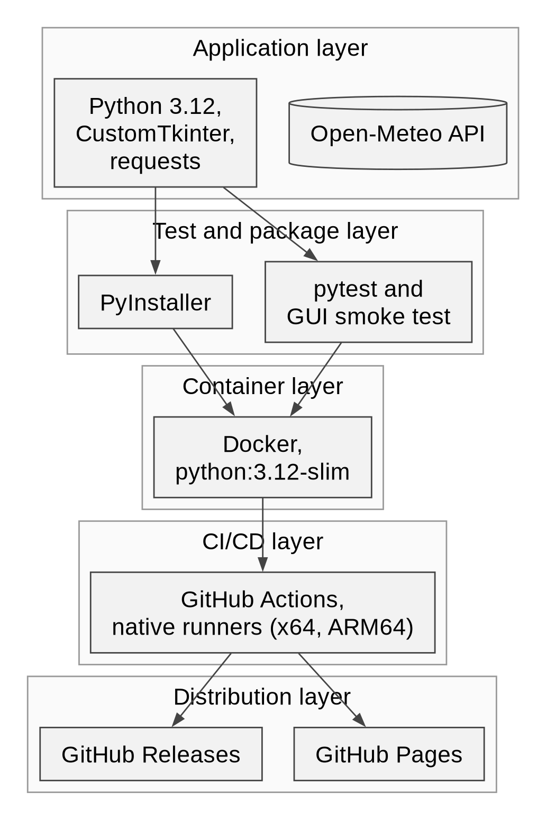
Figure 1: Technology stack by layer

3.1 Components
Table 1: Technology components and roles
Component | Role in the project
Python 3.12 | Runtime for the application, tests and build tools
CustomTkinter | Themed GUI toolkit built on Tkinter
Open-Meteo API | Free weather and geocoding data, no API key needed
pytest | Unit test runner
PyInstaller | Builds single-file executables
Docker, python:3.12-slim | Reproducible test and Linux build environment
GitHub Actions | Workflow automation and native ARM64 runners
GitHub Releases | Hosts executables and checksum files
GitHub Pages | Hosts the download website from the docs folder

3.2 Python dependencies
Table 2: Dependency matrix
Package | Version | Purpose
Python | 3.12 | Language runtime used in CI and Docker
customtkinter | >=5.2.2 | GUI widgets and dark theme
requests | >=2.32 | HTTP client for the weather API
pytest | >=8 | Automated test runner
pyinstaller | >=6.10 | Executable packaging

4. System architecture

4.1 Pipeline architecture
Figure 2 shows the complete flow. A push to the main branch or a pull request starts the CI workflow, which tests Linux inside Docker, tests Windows natively and checks the Linux build in Docker. Pushing a version tag starts the release workflow: it tests again, builds four executables in parallel and publishes a GitHub Release. The download website then reads that release.
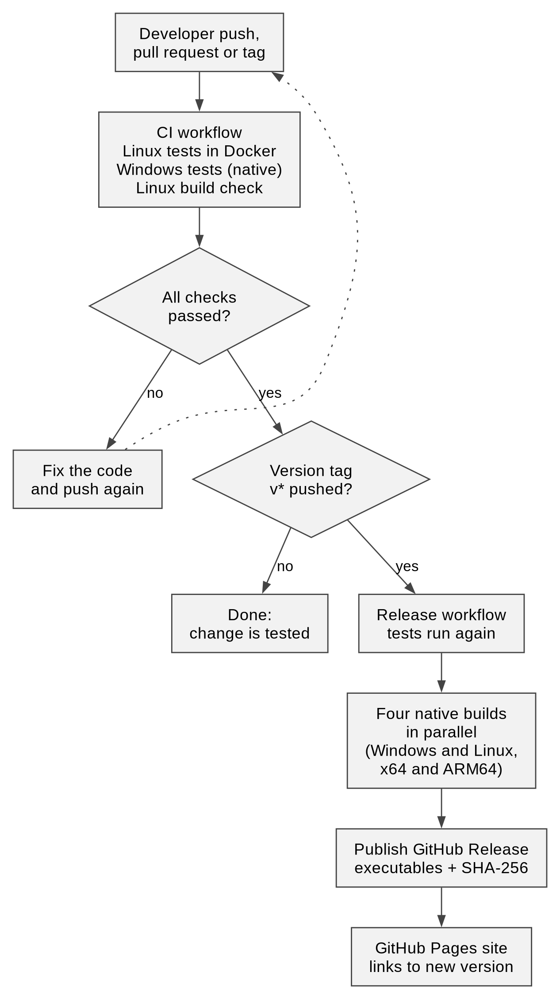
Figure 2: High-level CI/CD pipeline architecture

4.2 Job dependencies
The release workflow has three kinds of job (Figure 3). The four build jobs need both test jobs, and the release job needs all four builds, so nothing is published unless the tests pass on both systems and every target builds.
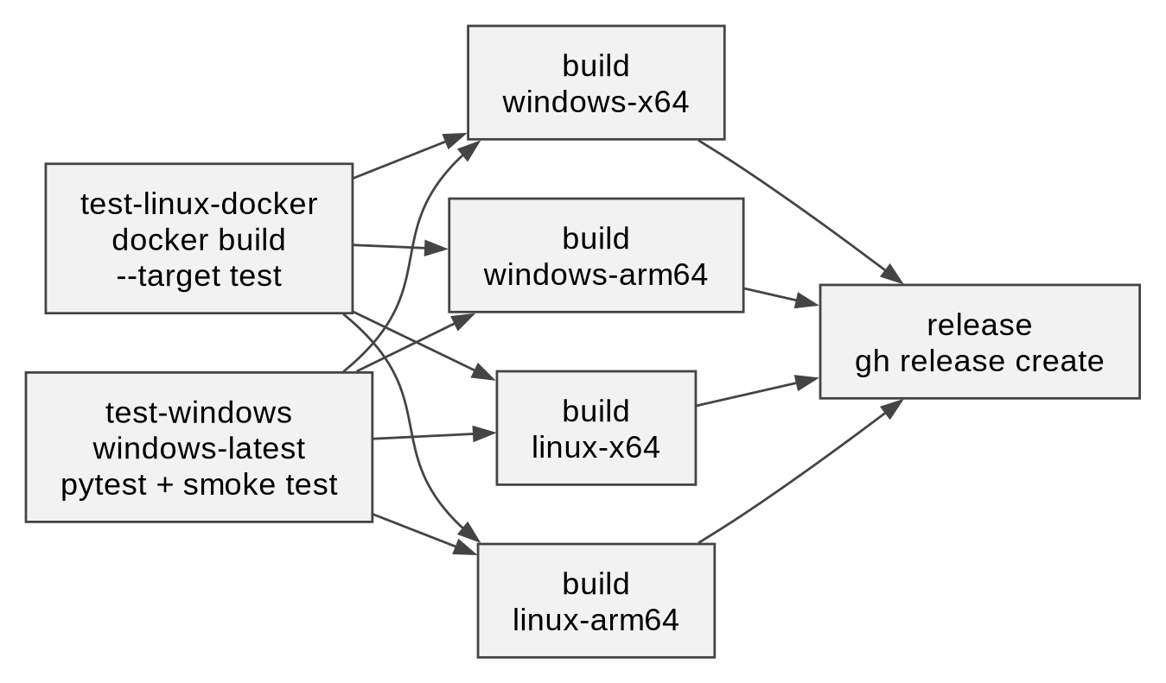
Figure 3: Release workflow job dependency graph

4.3 Trigger conditions
Table 3: Pipeline triggers
Trigger | Description
Push to main | ci.yml: Linux tests in Docker, Windows tests, Docker build check
Pull request | ci.yml runs the same checks on proposed changes
Tag v* | release.yml: test, build four executables, publish a release

4.4 Repository structure
The repository separates application code, tests, pipeline definitions and the website:
devops_lab_ca/
main.py PyInstaller entry point
Dockerfile test, build and artifact stages
requirements.txt runtime dependencies
requirements-dev.txt test and build dependencies
pytest.ini pytest configuration
.dockerignore, .gitignore ignore rules
.github/workflows/ci.yml tests and Docker build check
.github/workflows/release.yml test, 4-way build, release
skyline/api.py weather data layer (no GUI)
skyline/ui.py CustomTkinter interface
skyline/__main__.py python -m skyline entry
tests/test_api.py 8 pytest cases
tests/smoke_gui.py headless GUI smoke test
docs/index.html GitHub Pages download site
README.md usage and pipeline summary
report/ project report

5. Application design

5.1 Features
- City search: the user types a city and presses Enter or Go; the first geocoding match is used.
- Current conditions: temperature, feels-like temperature, humidity, wind speed, and an icon with a description.
- Five-day forecast: a daily high and low with an icon for each day.
- Unit toggle: switches between °C and °F without a new network request.
- Responsive window: the network call runs on a background thread, so the interface never freezes.
- Error handling: empty input, unknown cities and network failures show a readable message in the status line.

5.2 Modules and functions
The application is split into a data layer and a user interface (Figure 4). The function get_weather chains geocoding and forecasting, and all HTTP access goes through a session argument that the tests replace with a fake.
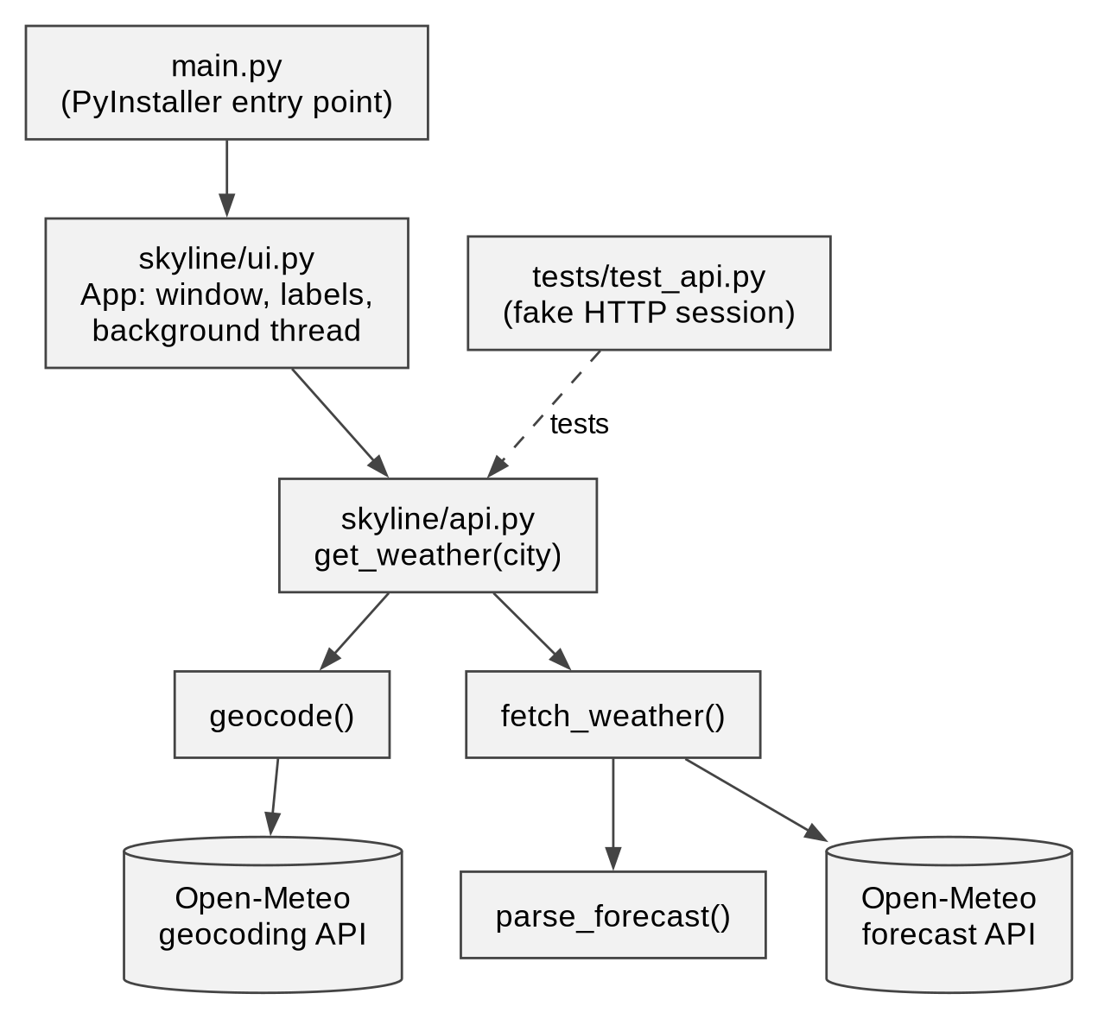
Figure 4: Module map and data flow
Table 4: Function summary
Function | Module | Behaviour
geocode(query) | skyline/api.py | Validates the text, calls the geocoding API and returns a Place
fetch_weather(place) | skyline/api.py | Requests current and daily data and returns a Weather object
parse_forecast(place, data) | skyline/api.py | Converts the API JSON into Weather and Day objects
describe(code, is_day) | skyline/api.py | Maps a WMO weather code to a text and an icon
format_temp(value, unit) | skyline/api.py | Rounds a temperature and converts °C to °F
App | skyline/ui.py | Builds the window and renders the results

5.3 Data model
Three dataclasses carry the data (Figure 5). A Place holds the name, country and coordinates returned by geocoding. A Weather object holds the current readings, its Place and a list of Day objects, each with a date, a weather code, and high and low temperatures. Every failure is raised as a single WeatherError type, which the interface shows to the user.
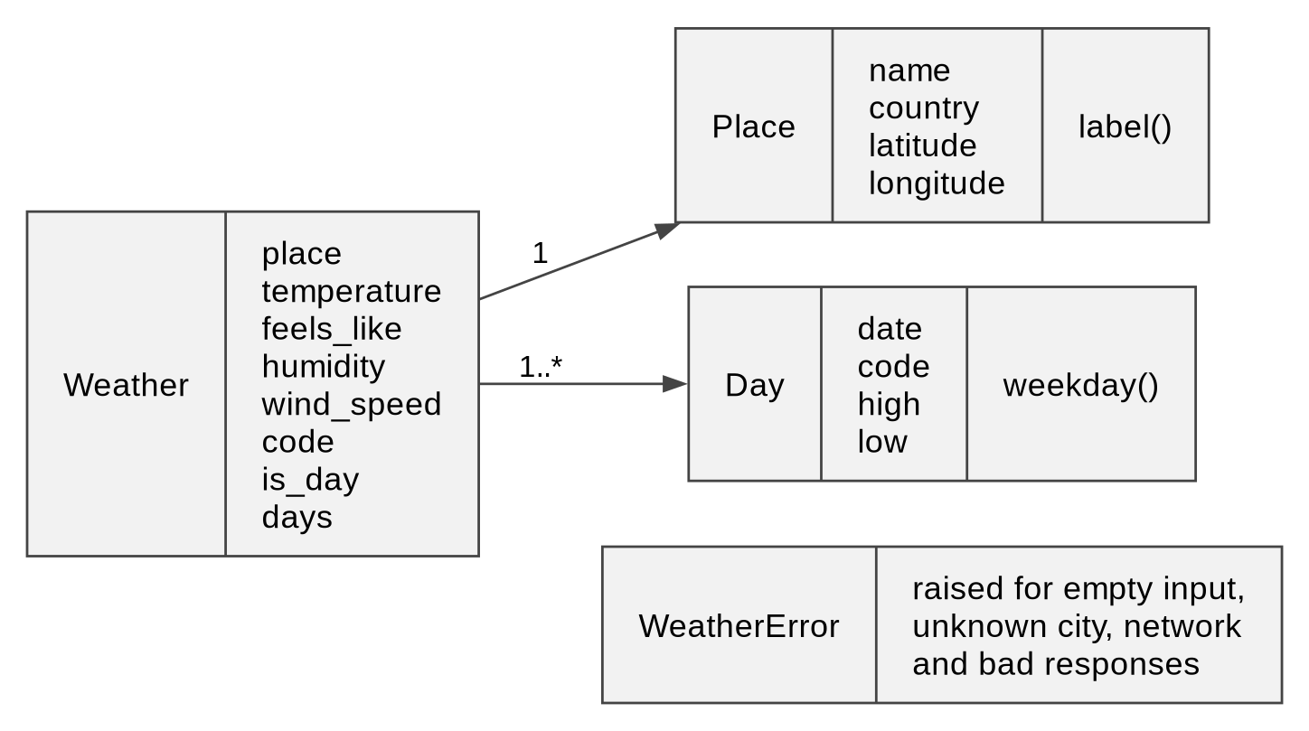
Figure 5: Data model

5.4 Search lifecycle
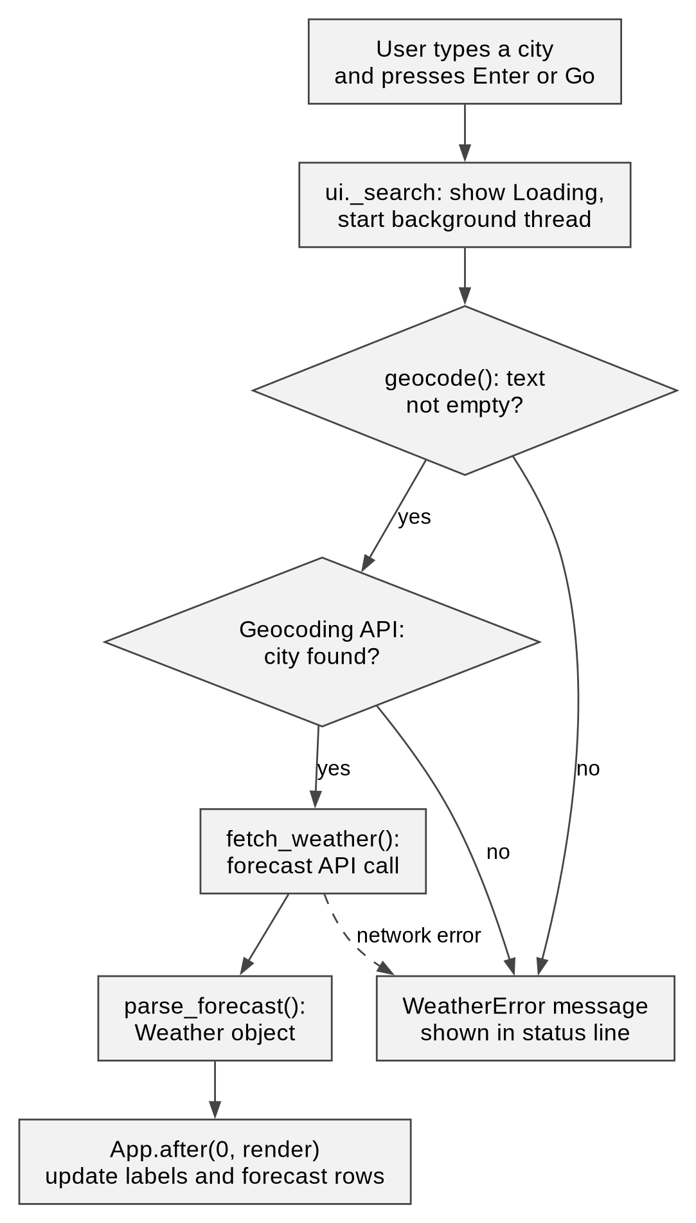
Figure 6: Search lifecycle from input to display

6. CI/CD pipeline

6.1 Workflow 1: continuous integration
The ci.yml workflow runs on every push to main and on pull requests. It runs two test jobs in parallel. Linux is tested inside a Docker container, using the test stage of the Dockerfile. Windows is tested natively on windows-latest with Python 3.12, because GitHub's Windows runners cannot run Linux containers. A third job builds the Linux executable in Docker.
Table 5: CI test job steps
No. | Action | Purpose
1 | actions/checkout@v4 | Fetch the source (both test jobs)
2 | docker build --target test (Linux job) | Run pytest, then the GUI smoke test, inside a clean container
3 | actions/setup-python@v5, Python 3.12 (Windows job) | Runtime with dependency caching
4 | pip install -r requirements-dev.txt | Install application and test dependencies
5 | pytest -q and python tests/smoke_gui.py | Run the 8 unit tests, then open the real window briefly
6 | docker build --target artifact (separate job) | Build the Linux executable and check the recipe works

The smoke test creates the application window and closes it after 1.5 seconds: under a virtual display (Xvfb) inside Docker on Linux, and on the real desktop of the Windows runner. It catches import errors and layout crashes that tests of the data layer cannot see.

6.2 Workflow 2: release build
The release.yml workflow runs when a tag starting with v is pushed. The two test jobs run first. Four build jobs then need both and run in parallel on native runners: ubuntu-24.04, ubuntu-24.04-arm, windows-latest and windows-11-arm. Each installs the dependencies, builds a single-file executable with PyInstaller, writes a SHA-256 checksum and uploads both as an artifact.
Table 6: Release build steps
No. | Action | Purpose
1 | actions/checkout@v4, actions/setup-python@v5 | Source and Python 3.12 on the target runner
2 | pip install -r requirements-dev.txt | Install dependencies
3 | pyinstaller --onefile --windowed --collect-all customtkinter main.py | Build one executable named for its target
4 | sha256sum or shasum -a 256 | Write a checksum file next to the executable
5 | actions/upload-artifact@v4 | Hand the files to the release job
6 | gh release create (release job) | Publish a GitHub Release with generated notes

6.3 Publishing the release
The release job needs all four build jobs. It downloads every artifact into one folder and runs gh release create with the tag name, a title of the form Skyline Weather vX.Y.Z and automatically generated release notes. The job uses the built-in GITHUB_TOKEN with contents: write permission, so no personal credentials are stored in the repository.

6.4 Gate behaviour
The pipeline follows one rule: nothing is published unless it has been tested and built on every target. Table 7 summarises the layers.
Table 7: Quality gate summary
Layer | Tool | Detects | On failure
Unit tests | pytest, Docker (Linux), native (Windows) | Logic errors in parsing, formatting and error handling | CI turns red; the release job never starts
GUI smoke test | Xvfb (Linux), desktop (Windows) | Crashes while the window is created | CI turns red
Container | Docker stages | Missing system libraries and dependencies | CI turns red
Release gate | needs: both test jobs, then all builds | Partial or untested releases | No release is created

Build jobs run with fail-fast disabled, so a failure on one target does not hide the result of the others, but the release job still waits for all four.

7. Containerisation and release distribution

7.1 Dockerfile
Table 8: Dockerfile instructions
Instruction | Effect
FROM python:3.12-slim AS base | Minimal Debian base shared by all stages
RUN apt-get install binutils libtk8.6 xvfb xauth | Tk runtime, virtual screen and PyInstaller needs
COPY requirements*.txt; RUN pip install | Installs dependencies without a pip cache
COPY . . | Copies the source, filtered by .dockerignore
FROM base AS test; RUN pytest -q; RUN xvfb-run ... | Fails the image build if a test or the smoke test fails
FROM base AS build; RUN pyinstaller ... | Checks that tkinter imports, then builds the Linux executable
FROM scratch AS artifact | Exports only the executable file

Table 9: Docker build stages
Stage | Base | Purpose | Used by
test | base | Run the unit tests and GUI smoke test | ci.yml, release.yml
build | base | Build the Linux executable | artifact stage
artifact | scratch | Export the executable only | docker build --output

The commands for building the stages locally are:
docker build --target test -t skyline-weather:test .
docker build --target artifact --output dist .
ls -l dist

7.2 Release targets and distribution
Each tag produces four executables, one per supported platform (Table 10). The release job attaches them with their checksum files, and the website reads the release through the GitHub API (Figure 7).
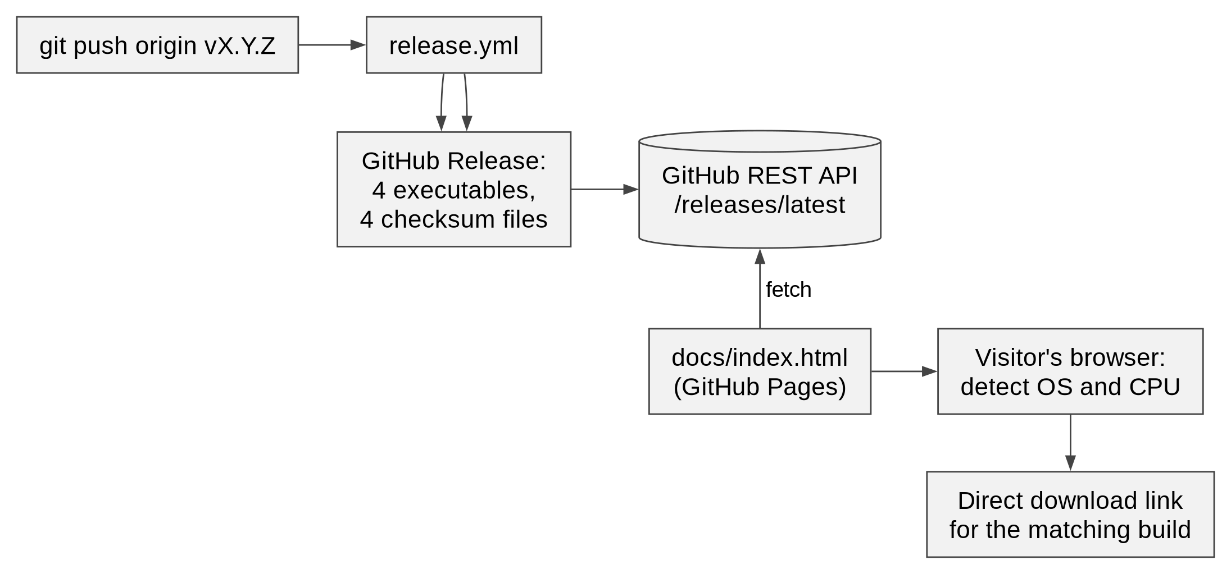
Figure 7: Release to website data flow
Table 10: Release targets
Target | Runner | Architecture | Output file | Size
linux-x64 | ubuntu-24.04 | x86-64 | skyline-weather-linux-x64 | 29.5 MB
linux-arm64 | ubuntu-24.04-arm | ARM64 | skyline-weather-linux-arm64 | 28.6 MB
windows-x64 | windows-latest | x86-64 | skyline-weather-windows-x64.exe | 15.3 MB
windows-arm64 | windows-11-arm | ARM64 | skyline-weather-windows-arm64.exe | 14.9 MB

7.3 Running a release
A release needs only a version tag. The commands below publish version 0.1.1 and then download and verify a build from the terminal. The same steps are used in the live demonstration:
# Publish a new version
git commit -am "Bump version"
git tag v0.1.1
git push && git push origin v0.1.1

# Download and verify from the terminal
gh release download -R AnamayNarkar/devops_lab_ca \
-p 'skyline-weather-linux-x64*'
sha256sum -c skyline-weather-linux-x64.sha256
chmod +x skyline-weather-linux-x64 # downloads lose the executable flag
./skyline-weather-linux-x64

8. Configuration and permissions
The pipeline needs no stored secrets. Everything it uses is either a file in the repository or a setting that GitHub provides (Figure 8). The release job authenticates with the built-in GITHUB_TOKEN, and Pages serves the docs folder from the main branch.
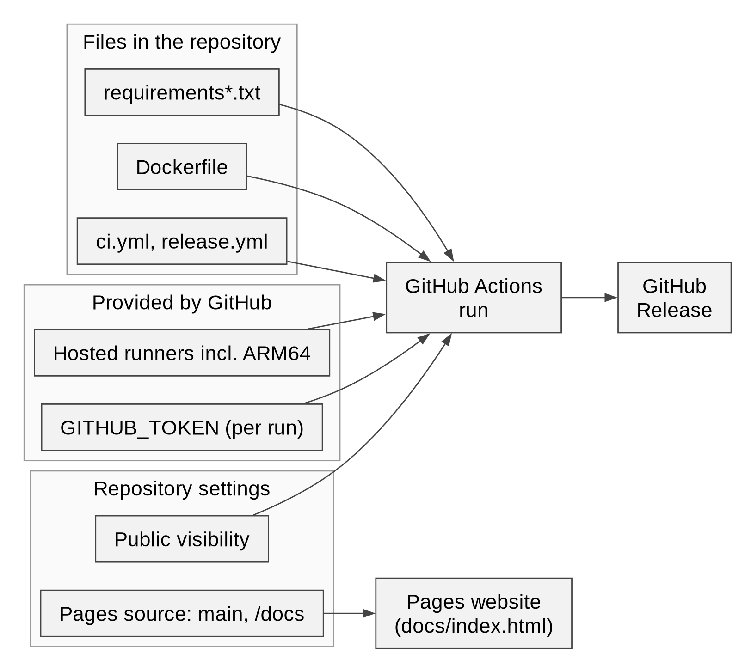
Figure 8: Configuration and permission sources
Table 11: Configuration reference
Setting | Required | Default | Purpose
GITHUB_TOKEN | Automatic | Created for each run | Lets the release job create the GitHub Release
permissions: contents | Yes | Repository default | Set to write in release.yml so it can publish
Repository visibility | Yes | Public | Needed for free ARM64 runners and GitHub Pages
Pages source | Yes | main branch, /docs | Serves the download website
Tag pattern | Yes | v* | Starts the release workflow
Python version | Yes | 3.12 | Used by CI, the release workflow and Docker
Runner labels | Yes | See Table 10 | Select the operating system and CPU of each build
REPO in docs/index.html | Yes | AnamayNarkar/devops_lab_ca | Repository whose releases the website reads

9. End-to-end workflow
Figure 9 follows one change through every participant. The developer pushes a commit and CI checks it. A pushed tag then starts the release workflow, which runs the tests, builds four executables in parallel and publishes them. The website shows the new version to the next visitor.
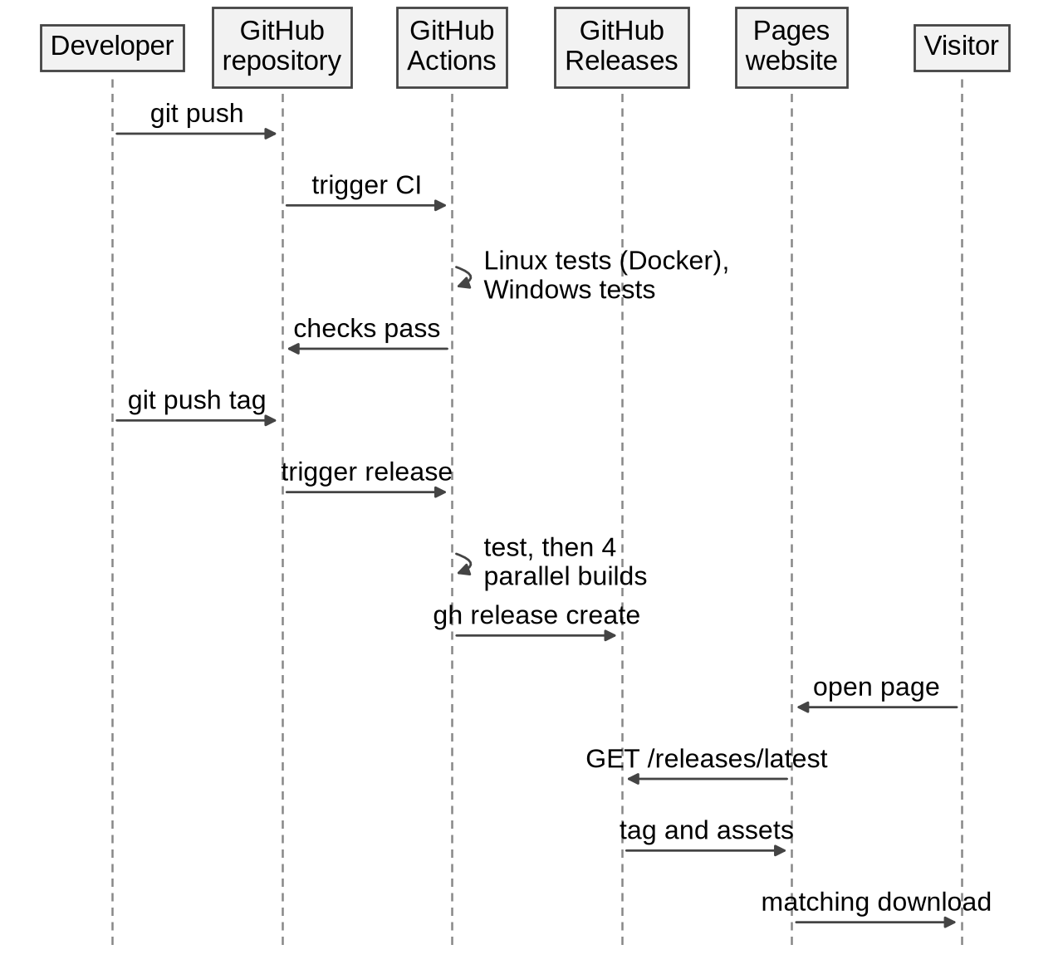
Figure 9: End-to-end delivery sequence

10. Conclusion and future work

10.1 Conclusion
Skyline Weather combines a small Python desktop application, two GitHub Actions workflows, a multi-stage Dockerfile and a static download site. Linux is tested inside a Docker container and Windows is tested natively, since GitHub's Windows runners cannot run Linux containers. A pushed tag now produces tested, checksummed executables for Windows and Linux on x64 and ARM64, and the download page offers them without manual deployment.

10.2 Future work
- Code-sign the Windows builds so that SmartScreen does not warn users, and add macOS builds.
- Wrap the executables in installers such as MSI and AppImage.
- Pin third-party actions to release tags or commit hashes.
- Add a UI test layer, for example screenshot comparison under a virtual display.
- Run the ARM64 builds on real ARM hardware as an acceptance check; so far they are built but not executed.
- Test the finished executables automatically, for example by launching each one in CI.

References
[1] J. Humble and D. Farley, "Continuous Delivery: Reliable Software Releases through Build, Test, and Deployment Automation," Addison-Wesley, 2010.
[2] Docker, Inc., "Multi-stage builds," https://docs.docker.com/build/building/multi-stage/.
[3] PyInstaller Team, "PyInstaller manual," https://pyinstaller.org/.
[4] GitHub, "GitHub Actions documentation," https://docs.github.com/actions.
[5] GitHub, "About releases," https://docs.github.com/repositories/releasing-projects-on-github/about-releases.
[6] GitHub, "GitHub Pages documentation," https://docs.github.com/pages.
[7] Open-Meteo, "Weather Forecast API," https://open-meteo.com/en/docs.
[8] T. Schimansky, "CustomTkinter," https://github.com/TomSchimansky/CustomTkinter.

