Here are several real-world case studies where Design Thinking has been successfully applied in software development. These examples demonstrate how understanding user needs, iterative prototyping, and continuous feedback resulted in successful software products.
Airbnb – Improving the User Experience
Problem
Airbnb was struggling to attract customers, and bookings were very low.
Design Thinking Process
Empathize
- Found that hosts uploaded poor-quality photos.
- Interviewed hosts and travelers to understand their experiences.
Define
- Users lacked confidence because property photos were unclear.
Ideate
- Improve property listings using professional photography.
- Simplify the booking experience.
Prototype
- Offered free professional photography for selected listings.
- Redesigned listing pages.
Test
- Users trusted listings more.
- Bookings increased significantly.

Outcome
- Increased customer trust.
- Higher booking rates.
- Airbnb became one of the world's largest accommodation platforms.

Design Thinking Lesson
Understanding users' emotions is often more valuable than adding new features.

2. IBM Design Thinking

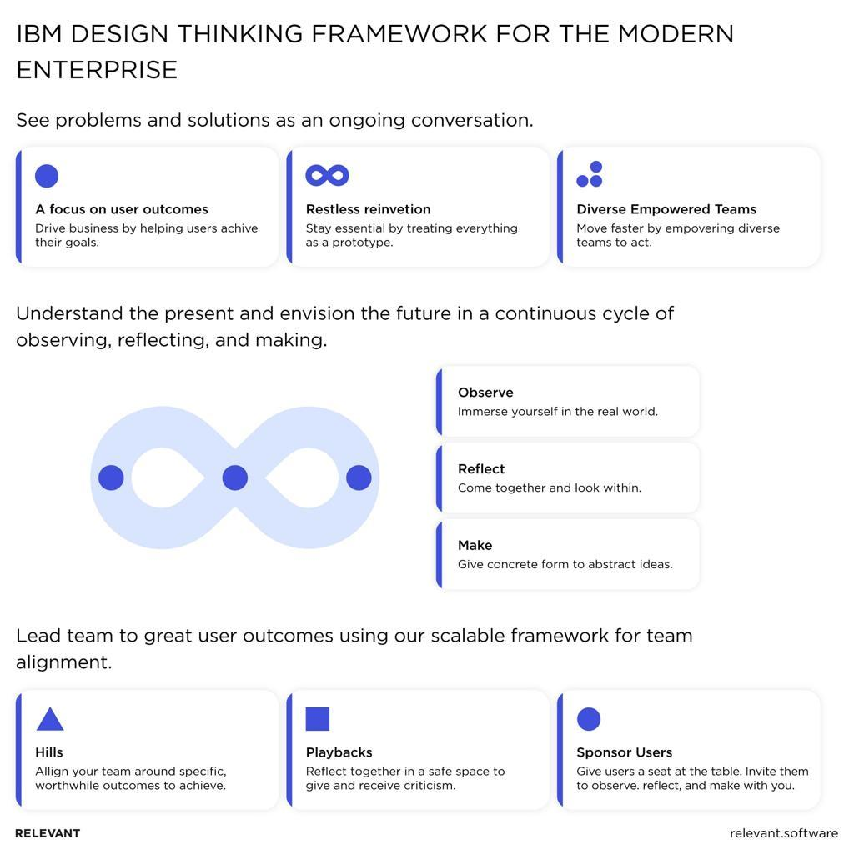
6

Problem
IBM software products were technically strong but often difficult to use.

Design Thinking Process
Empathize
- Observed how customers actually used enterprise software.
Define
- Interfaces were complex.
- Users required extensive training.
Ideate
- Simplify workflows.
- Reduce unnecessary screens.
Prototype
- Created interactive prototypes.
- Gathered customer feedback.
Test
- Improved products based on user feedback before development.

Outcome
- Faster software development.
- Improved usability.
- Better customer satisfaction.

Lesson
Design should focus on user outcomes rather than system features.

3. Microsoft Office 365
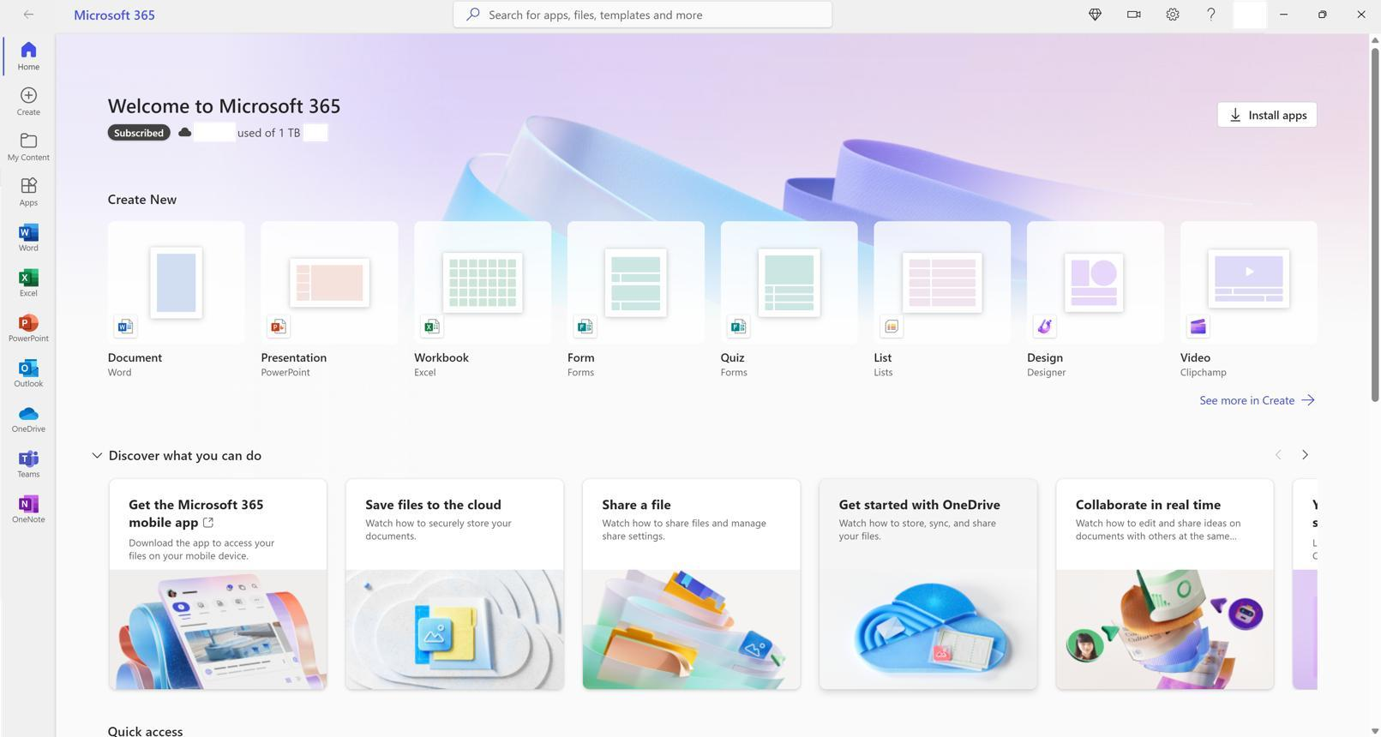
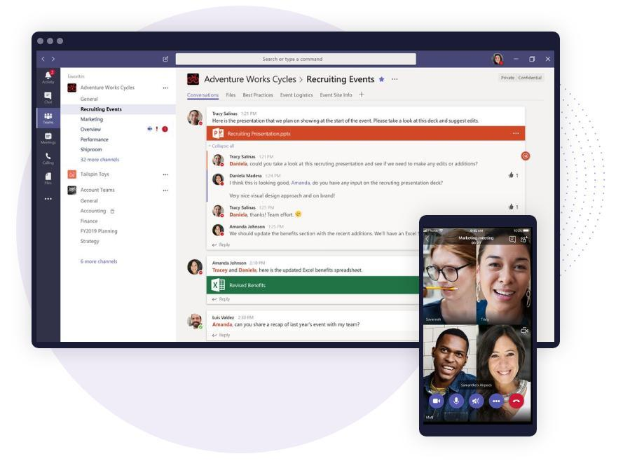
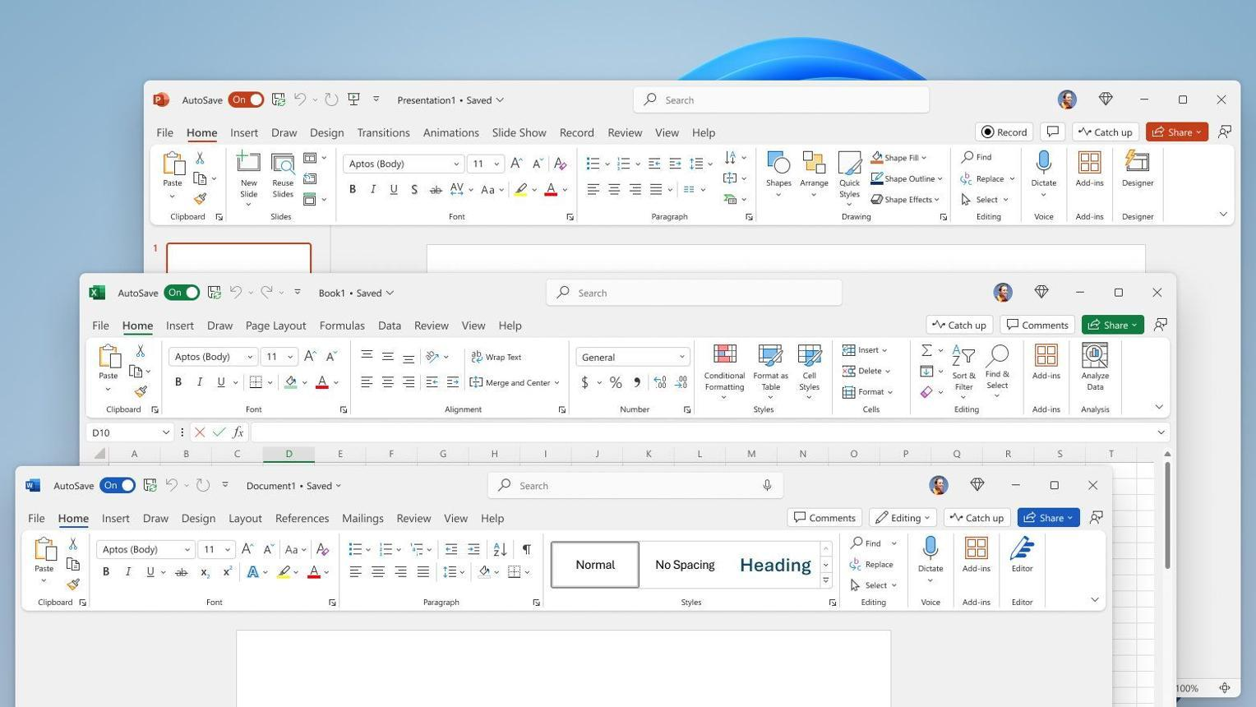
6

Problem
Many Office features were difficult for users to discover.

Design Thinking Process
Empathize
- Collected user feedback.
- Analyzed usage data.
Define
- Users wanted simpler collaboration and document sharing.
Ideate
- Introduce cloud collaboration.
- Simplify interface elements.
Prototype
- Tested new collaboration features with selected users.
Test
- Refined features based on user behavior.
Outcome
- Real-time collaboration.
- Improved productivity.
- Better user satisfaction.
Lesson
Continuous user feedback leads to better software evolution.

UBER
Problem
Booking traditional taxis was inconvenient.
Design Thinking Process
Empathize
- Interviewed passengers and drivers.
Define
- Difficulty finding taxis.
- Uncertain waiting time.
- No fare transparency.
Ideate
- One-tap booking.
- Live GPS tracking.
- Digital payment.
Prototype
- Released an MVP in one city.
Test
- Improved the app through customer feedback.
Outcome
- Easier ride booking.
- Increased trust.
- Global adoption.
Lesson
Solve one major user pain point before expanding functionality.

