
University of Asia Pacific
DEPARTMENT OF CSE
Fall-2025

COURSE CODE: CSE-312
COURSE TITLE: Data Communication and Computer Networks Lab
SEMESTER: 3rd Year, 2nd Semester

SUBMITTED BY,
NAME: Arnob Saha Bosu Jit
STUDENT ID: 23101222
SECTION: D₂

Lab Report: WDM System – 4, 8, 32 Channels

1. Introduction
Wavelength Division Multiplexing (WDM) is a sophisticated optical networking technique that enables the simultaneous transmission of multiple data streams over a single fiber strand by assigning each signal a unique wavelength (frequency). By leveraging this method, network operators can dramatically expand bandwidth capacity without the prohibitive costs of laying new physical fiber infrastructure.
This study utilized OptiSystem to design and evaluate WDM architectures across three specific scales: 4-channel, 8-channel, and 32-channel configurations.
The primary goal of this experiment is to quantify the correlation between increased channel density and the resulting impact on signal integrity. Key performance indicators (KPIs) analyzed include:
- Signal Quality: Assessment of overall transmission reliability.
- Noise Profiles: Evaluation of cumulative noise floors as channels increase.
- Bit Error Rate (BER) & Q-Factor: Quantitative measures of data accuracy and signal-to-noise efficiency.
- Eye Diagram Characteristics: Visual and statistical analysis of timing jitter and pulse distortion.

2. Component List
The following components were used in the system design:
- Pseudo Random Bit Sequence Generator (PRBS)
- NRZ Pulse Generator
- Continuous Wave (CW) Laser
- Mach-Zehnder Modulator (MZM)
- WDM Multiplexer (Mux)
- Optical Fiber (Length = 50 km with loop control)
- Optical Amplifier (Gain = 20 dB, Noise Figure = 4 dB) (used in 8 and 32 channel systems)
- WDM Demultiplexer (Demux)
- PIN Photodetector
- Low Pass Bessel Filter
- 3R Regenerator
- BER Analyzer
- Oscilloscope Visualizer
- Optical Spectrum Analyzer (OSA)
- WDM Analyzer

3. Model Design
- 4 Channel WDM:

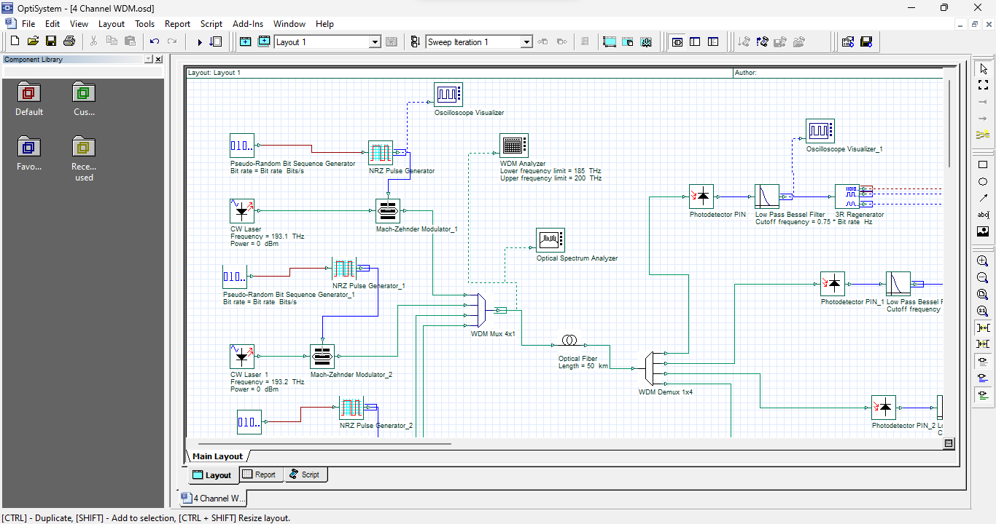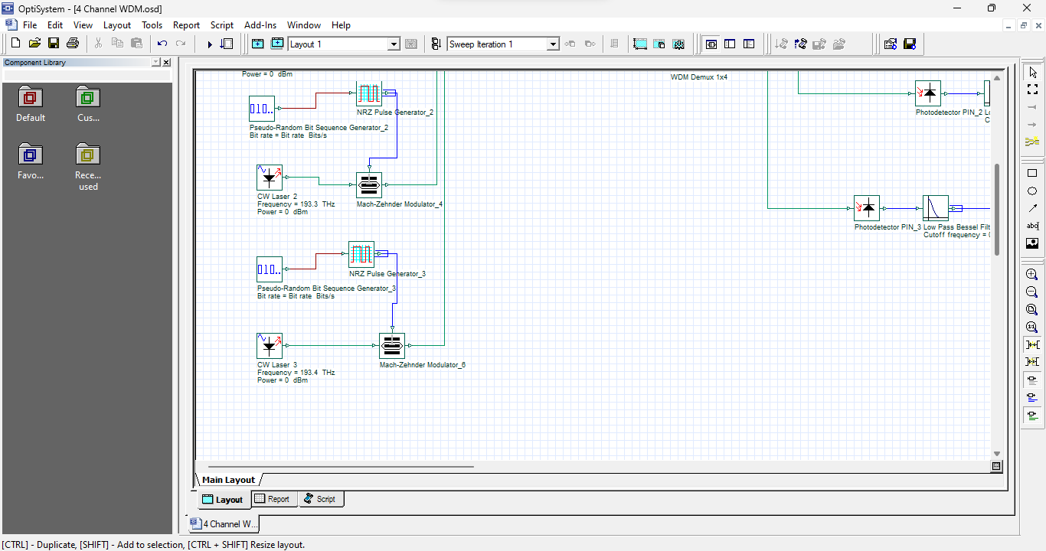
Figure-01: 4 Channel WDM.

- 8 Channel WDM:
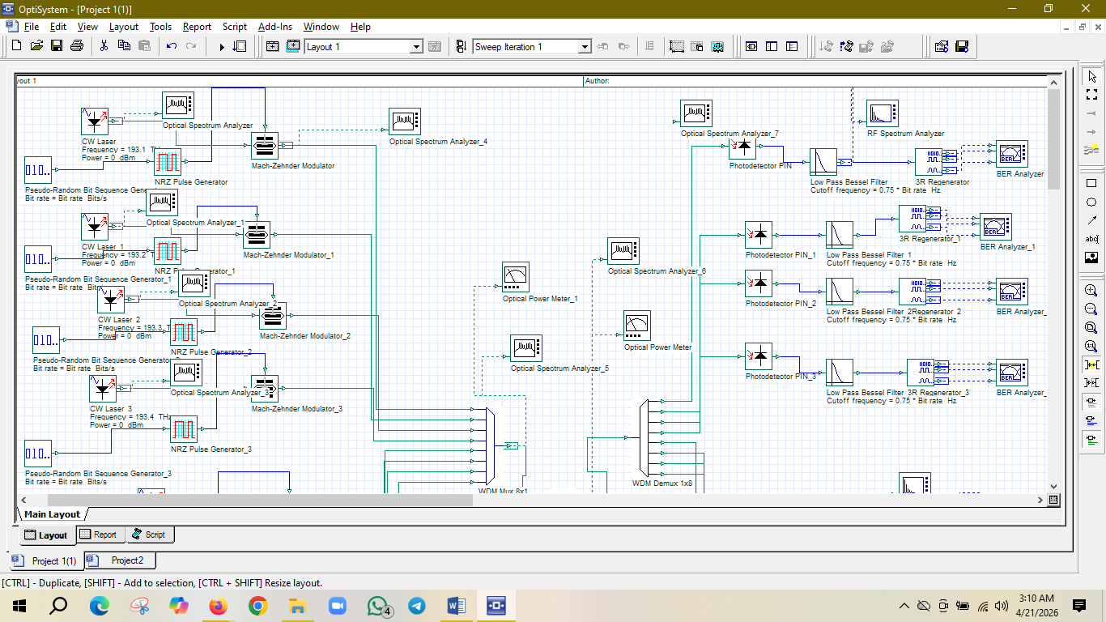
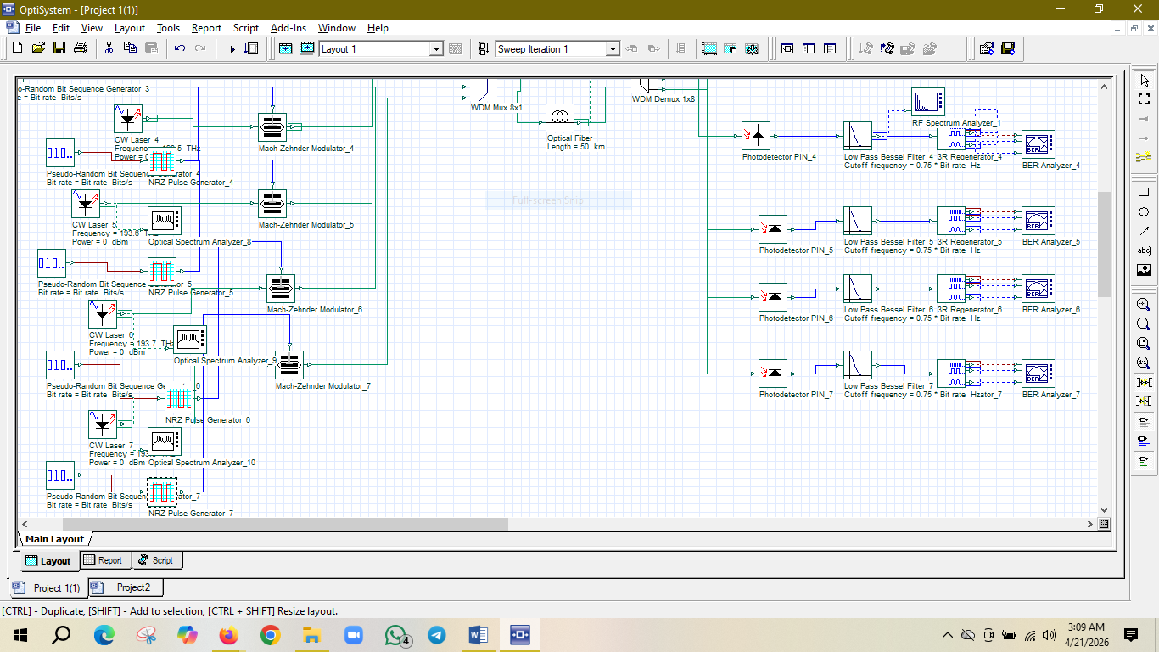

Figure-02: 8 Channel WDM.

- 32 Channel WDM:
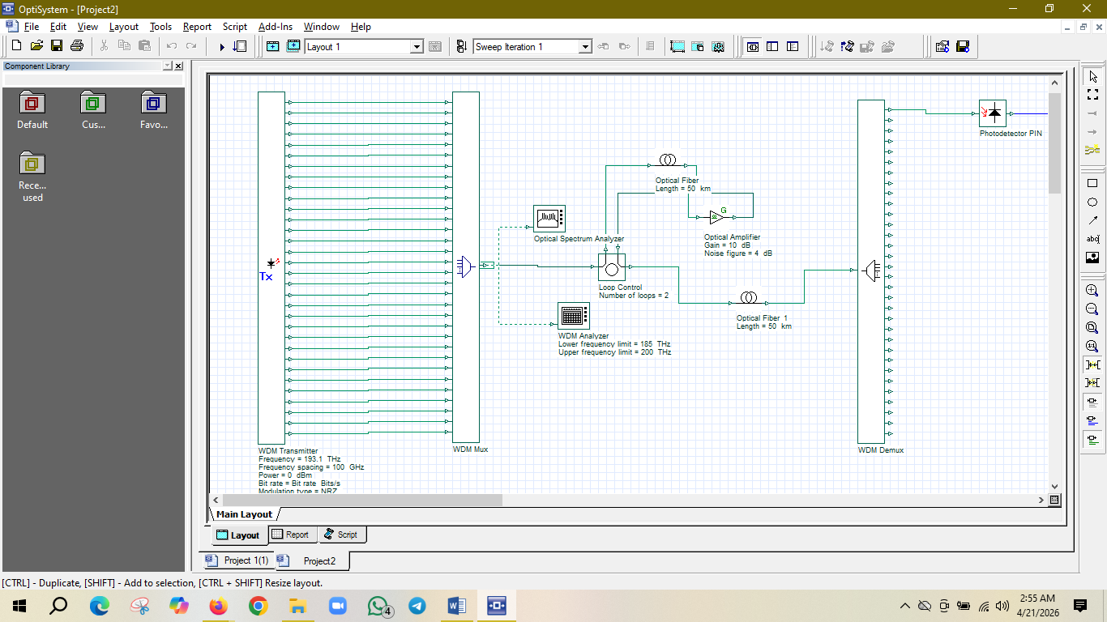
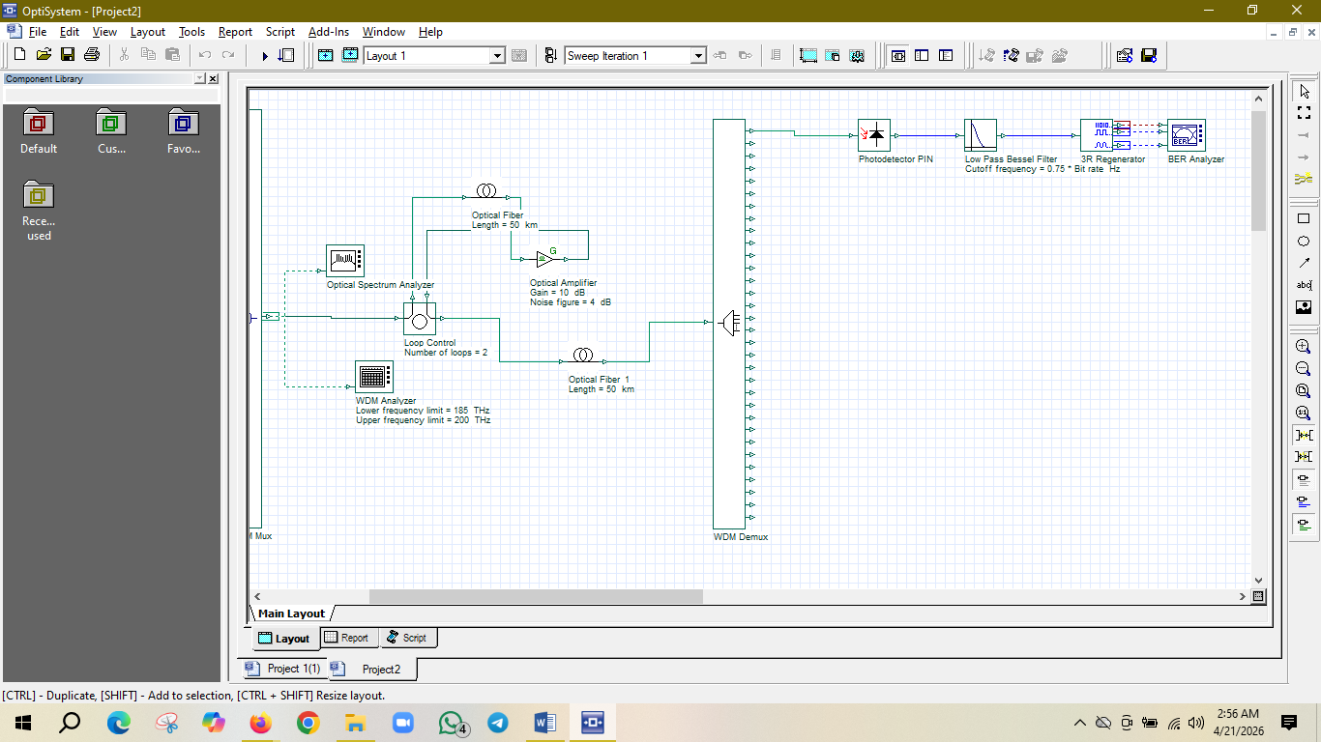
Figure-03: 32 Channel WDM.

4. Working Procedure
- Generate random binary data using PRBS.
- Convert the binary data into NRZ electrical signals.
- Modulate optical carriers using Mach-Zehnder Modulators.
- Combine all channels using WDM multiplexer.
- Transmit the signal through optical fiber.
- Use optical amplifier (for 8 and 32 channel systems).
- Demultiplex the signal into individual channels.
- Detect signals using PIN photodetectors.
- Filter and regenerate signals.
- Analyze outputs using:
- Oscilloscope (Tx and Rx)
- Optical Spectrum Analyzer
- WDM Analyzer
- BER Analyzer
- Eye Diagram

5. Results and Discussion
(a) Signal Analysis (Oscilloscope- Tx and Rx):
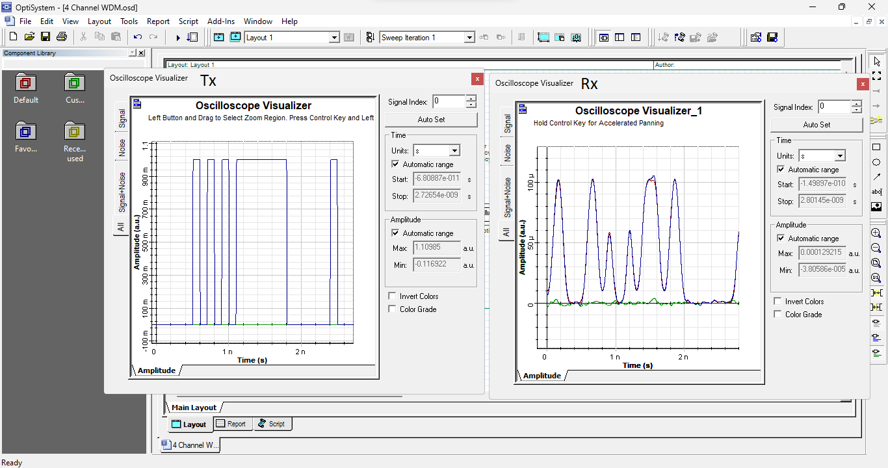
Figure-04: Oscilloscope Signal of Tx & Rx in 4 Channel WDM.
- The transmitter (Tx) signal shows clean and well-defined NRZ pulses with sharp transitions between logic levels.
- The receiver (Rx) signal shows distortion and amplitude variations due to:
  - Fiber transmission losses
  - Filtering effects
  - Noise accumulation
- The distortion becomes more significant as the number of channels increases.
(b) Optical Signal Analysis (OSA Output):
- 4-Channel System:
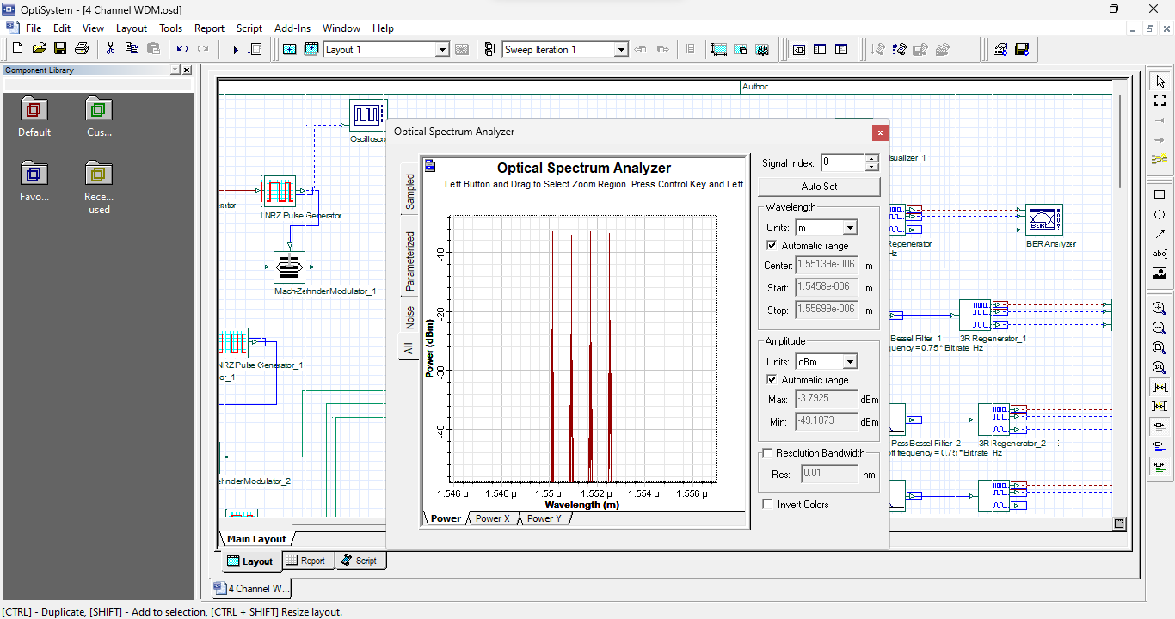
Figure-05: Optical Signal Analysis of a 4 Channel System.
- Four distinct peaks are observed.
- Channels are clearly separated with minimal noise.
- Indicates high signal quality and negligible interference.
- 8-Channel System:
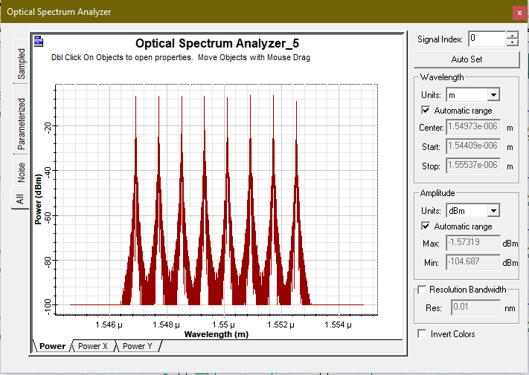
Figure-06: Optical Signal Analysis of an 8 Channel System.
- Eight distinct spectral peaks are observed, centered around 1.55μm, corresponding to the 8-channel WDM configuration.
- The channels exhibit visible noise floors between the peaks (reaching approximately -80 dBm), indicating the introduction of amplifier noise compared to lower-channel counts.
- Reduced channel spacing is evident as the spectral density increases, leading to a narrower guard band between individual signals.
- 32-Channel System:
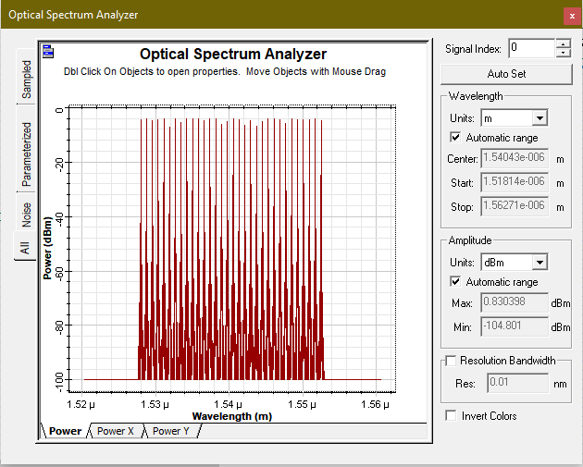
Figure-07: Optical Signal Analysis of a 32 Channel System.

- Thirty-two tightly packed spectral peaks are observed, spanning a much wider wavelength range from approximately 1.528μm to 1.553μm.
- Significant spectral congestion is evident, with extremely narrow spacing between channels that increases the risk of linear and non-linear crosstalk.
- Elevated noise levels and signal fluctuation are present across the spectrum, indicating a substantial decrease in the Optical Signal-to-Noise Ratio (OSNR) compared to the 4 and 8-channel systems.
(c) Eye Diagram Analysis:
- 4-Channel System:
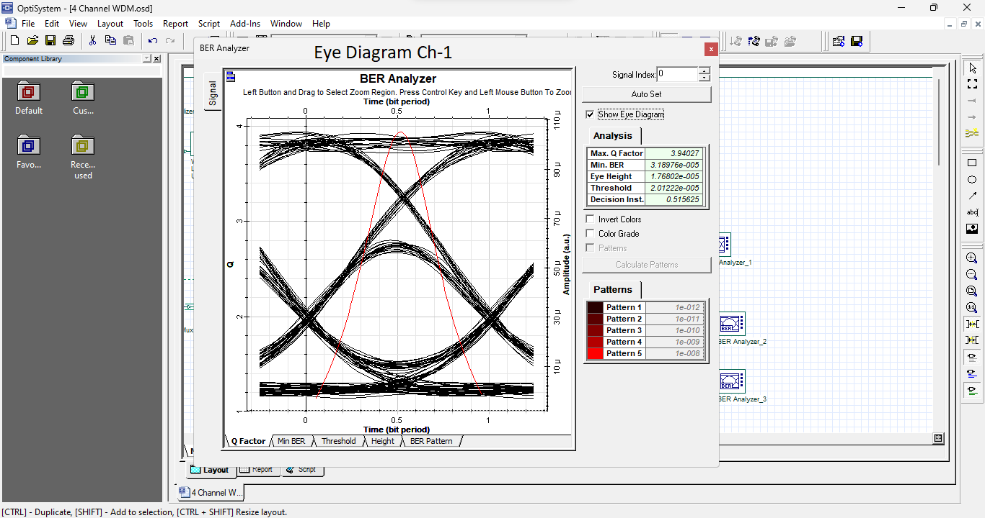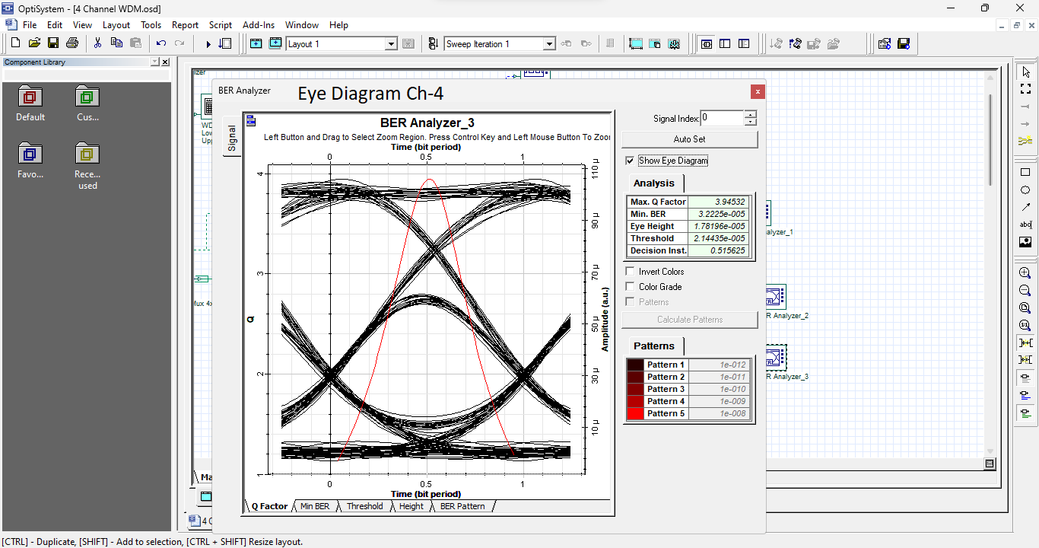
Figure-08: Eye Diagram of a 4 Channel System.
- Eye diagram is wide open with clear separation between logic levels.
- Low noise and minimal jitter are observed.
- Q-factor ≈ 3.94
- BER ≈ 3.18 × 10⁻⁵
- Indicates excellent signal quality.

- 8-Channel System
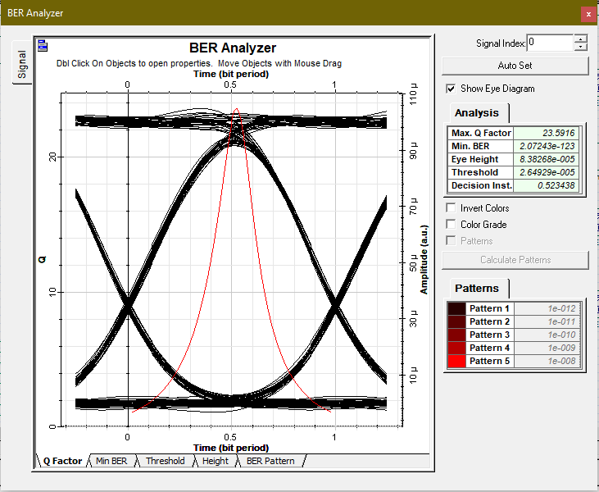
Figure-09: Eye Diagram of an 8 Channel System.
- Eye opening remains wide and clear, although it shows a slight reduction in vertical margin compared to a 4-channel system.
- Minimal noise and jitter are visible, evidenced by the relatively sharp and well-defined signal traces.
- Eye height is substantial (approximately 8.38×10−5), indicating a strong distinction between high and low logic levels.
- Max Q-Factor ≈ 23.59, which represents a high-quality signal well above the standard threshold for reliable transmission.
- Min BER ≈ 2.07×10⁻¹²³, indicating an exceptionally low error rate and near-perfect data integrity.
- Indicates excellent signal quality, despite the increase in channel count, with the system maintaining high performance and minimal interference.
- 32-Channel System:
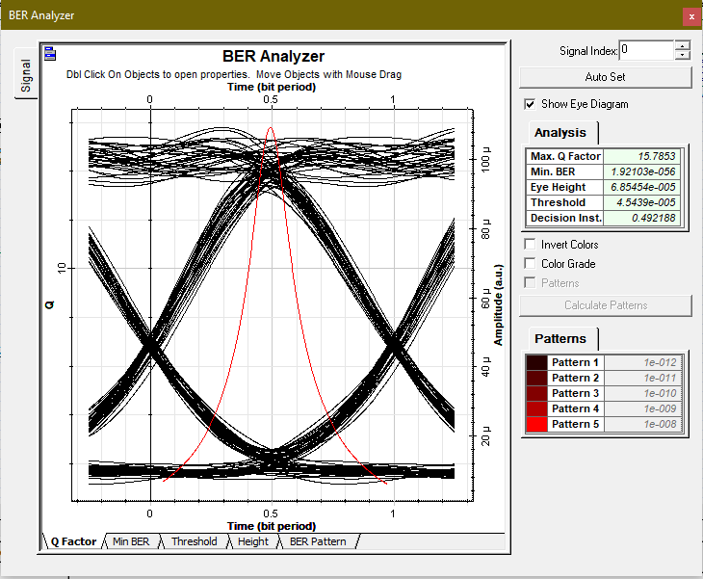
Figure-10: Eye Diagram of a 32 Channel System.
- Eye opening is noticeably reduced compared to the 8-channel system, showing a narrower vertical and horizontal margin.
- Increased noise and jitter are visible, resulting in thicker, less defined signal traces and a more "fuzzy" appearance.
- Eye height has decreased to approximately 6.85×10⁻⁵, indicating a reduction in signal clarity as channel density increases.
- Max Q-Factor ≈ 15.78, which is still robust but represents a significant drop from the 23.59 achieved in the 8-channel configuration.
- Min BER ≈ 1.92×10⁻⁵⁶, showing a higher probability of error compared to the lower channel counts, though still within a functional range for this specific simulation.
- Indicates moderate signal degradation due to increased spectral congestion and cumulative noise from a higher number of multiplexed channels.

(d) BER and Q-Factor Analysis
- 4-Channel System:
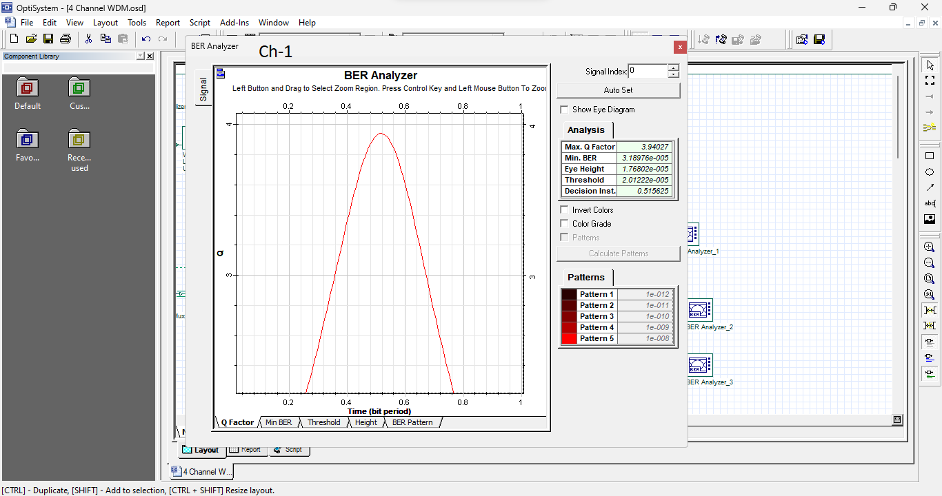
- Q-factor ≈ 3.94
- BER ≈ 10⁻⁵
- System performance is excellent.
- 8-Channel System:
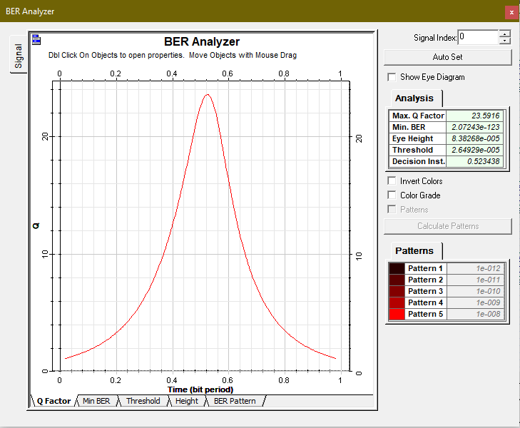
- Max Q-factor ≈ 23.59, indicating a very high signal-to-noise ratio and excellent pulse peak clarity.
- Min BER ≈ 2.07×10⁻¹²³, which represents a near-zero probability of bit errors, confirming superior data integrity.
- Performance remains highly robust, with the sharp peak of the Q-curve suggesting precise timing and minimal jitter.
- Negligible signal degradation is observed at this channel count, as the system successfully manages:
  - Controlled Optical Amplifier Noise: The noise floor remains low enough to avoid impacting the Q-factor significantly.
  - Minimal Channel Interference: Sufficient spacing prevents cross-talk, maintaining a high eye height of 8.38×10⁻⁵.
- 32-Channel System:
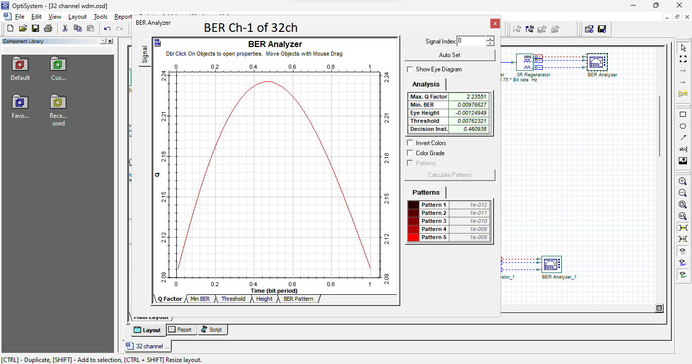
- Max Q-factor ≈ 15.78, showing a noticeable decrease from the 8-channel system, though it remains within a functional range for this simulation.
- Min BER ≈ 1.92×10⁻⁵⁶, indicating an increase in bit error probability as the system reaches higher spectral density.
- The Q-curve peak is broader, suggesting increased timing jitter and a reduction in the ideal sampling window for the receiver.
- Performance degrades significantly due to:
  - Cumulative Optical Amplifier Noise: A higher noise floor is visible, which lowers the overall signal-to-noise ratio.
  - High Spectral Congestion: The tight packing of 32 channels leads to increased inter-channel interference and potential crosstalk.
  - Intersymbol Interference (ISI): Pulse spreading and distortion become more pronounced, as evidenced by the reduced eye height of 6.85×10⁻⁵.

Overall Discussion:
- Increasing the number of channels increases system capacity.
- However, it also introduces:
  - Higher noise levels
  - Spectral congestion
  - Crosstalk between channels
  - Intersymbol interference
- The system transitions from:
  - Optimal performance at 4 channels with maximum signal clarity.
  - Measurable degradation at 8 channels due to increased noise floors.
  - Significant quality reduction at 32 channels due to spectral congestion and intersymbol interference (ISI), though the system remains functional within the simulation parameters.

6. Conclusion
This study evaluated the performance of Wavelength Division Multiplexing (WDM) systems across 4, 8, and 32-channel configurations. The results demonstrate a clear inverse relationship between channel density and signal integrity.
- 4-Channel System: Achieved optimal performance with the highest signal clarity. The wide channel spacing ensured distinct isolation and negligible interference, resulting in the most robust Q-factor and lowest BER.
- 8-Channel System: Exhibited measurable quality loss but remained highly reliable. The Max Q-factor of 23.59 and Min BER of 2.07×10⁻¹²³ indicate excellent performance, though visible noise floors and closer channel proximity began to emerge on the OSA.
- 32-Channel System: Showed significant quality reduction due to extreme spectral congestion. While the system remained functional with a Q-factor of 15.78 and BER of 1.92×10⁻⁵⁶, the performance was noticeably compromised by narrowed eye openings, increased jitter, and the onset of intersymbol interference (ISI).
The data confirms that while expanding channel counts successfully boosts overall system capacity, it involves a proportional cost to signal reliability. Ultimately, designing WDM systems requires a strategic trade-off between maximizing data throughput and maintaining superior transmission quality.

