IBM Customer Churn Analysis & Risk Insights Report

Anamika K S
anamikasureshk@gmail.com
Date: 10-04-2026
A data-driven analysis of customer behavior, churn drivers, and revenue risk using Power BI
Tools used: Power BI, DAX

EXECUTIVE SUMMARY

Customer churn is a critical challenge in the telecom industry, directly impacting revenue, customer lifetime value, and overall business sustainability. This report presents a comprehensive analysis of customer churn using the IBM Telecom dataset, with the objective of identifying key churn drivers, quantifying revenue impact, and enabling data-driven retention strategies through interactive Power BI dashboards.
The analysis reveals a churn rate of 26.54%, indicating that more than one in four customers discontinue their services. This has resulted in an estimated revenue loss of $3.68M, highlighting the significant financial implications of customer attrition. A deeper exploration of customer behaviour shows that churn is strongly influenced by contract type, tenure, and service engagement.
Customers on month-to-month contracts exhibit the highest churn rate (46%), making contract flexibility a major risk factor. Additionally, customers within their first 12 months show the highest likelihood of churn (47%), emphasizing the importance of early-stage customer experience and engagement.
Service-level insights further indicate that the absence of online security and technical support nearly doubles churn probability, establishing these features as critical retention drivers. Moreover, fibre optic users—despite being high-value customers—demonstrate elevated churn rates (41%), suggesting a gap between customer expectations and service delivery.
From a demographic perspective, customers who are unmarried or without dependents show higher churn tendencies, indicating lower service dependency and higher price sensitivity. Geographically, churn and revenue loss are concentrated in key cities, with San Diego and Los Angeles contributing the highest revenue leakage, pointing to potential regional challenges.
To proactively address churn, a risk segmentation model was developed, identifying 991 high-risk customers, representing approximately $1.05M in potential revenue exposure. These customers are primarily associated with short-term contracts, lack of support services, and high-usage patterns, making them ideal targets for retention initiatives.
Based on these findings, the report recommends strategic actions such as promoting long-term contracts, bundling essential support services, strengthening early customer engagement, and implementing targeted regional retention programs. These interventions are expected to reduce churn, protect high-value customers, and enhance overall profitability.
This analysis demonstrates how leveraging data analytics and visualization can transform raw customer data into actionable insights, enabling organizations to shift from reactive to proactive churn management and drive sustainable business growth.

INTRODUCTION AND BUSINESS CONTEXT

In the highly competitive telecom industry, customer retention plays a critical role in sustaining revenue and long-term profitability. With low switching barriers and increasing service options, customers can easily move between providers, making customer churn a key business concern. Churn not only reduces the active customer base but also leads to significant revenue loss and increased costs associated with acquiring new customers.
In this context, the business is experiencing a churn rate of 26.54%, meaning that more than one in four customers are discontinuing their services. This has resulted in an estimated revenue loss of $3.68M, highlighting the financial impact of customer attrition. Such a high churn rate indicates underlying issues related to customer satisfaction, service experience, and engagement.
However, without a clear understanding of why customers are churning and which segments are most at risk, it becomes difficult to implement effective retention strategies. A data-driven approach is therefore essential to uncover key churn drivers, identify high-risk customers, and prioritize actions that can reduce churn and protect revenue.
This project addresses these challenges by analyzing customer behavior across multiple dimensions—including demographics, service usage, contract types, tenure, and geographic distribution—using interactive Power BI dashboards. The goal is to transform raw data into actionable insights that enable proactive decision-making and improve customer retention outcomes.

OBJECTIVE OF THE ANALYSIS

The objective of this analysis is to leverage customer data to understand churn behavior and derive actionable insights that support effective retention strategies. The key goals of the analysis are:
- Identify the primary drivers of customer churn across contract type, tenure, services, and demographics
- Analyze churn patterns across different customer segments and lifecycle stages
- Quantify the revenue impact of customer attrition
- Identify high-risk customers based on behavioral and service-related factors
- Enable data-driven decision-making through interactive dashboards
- Recommend targeted strategies to reduce churn and improve customer retention

DATASET AND DATA MODEL OVERVIEW

This analysis is based on the IBM Telco Customer Churn dataset, which provides detailed information on customer demographics, service subscriptions, account details, and churn status. The dataset consists of 7,043 customers, out of which 1,869 customers have churned, resulting in a churn rate of 26.54%.

DATA SUMMARY

Customer-level data capturing demographics, services, and billing details
Key attributes include:
- Gender, Senior Citizen, Dependents, and Marital Status
- Internet Service Type (Fiber Optic, DSL, etc.)
- Online Security, Tech Support, Streaming Services
- Contract Type and Tenure
- Monthly Charges and Total Revenue
- Churn Status (Yes/No)

DATA MODEL

The data is structured using a star schema model to enable efficient analysis and scalability:
- The Services table acts as the central fact table, containing key customer-level transactional and service-related information
- Dimension tables such as Customer Demographics and Location are connected via one-to-many relationships
- A Population table is included but remains unconnected, allowing for potential future enhancements
This model ensures:
- Efficient filtering and aggregation across visuals
- Consistent calculation of churn-related metrics
- Flexibility to extend the model for deeper analysis

KEY METRICS AND MEASURES
To support the analysis, several calculated measures were created using DAX, including:
- Churn Rate
- Total Revenue and Revenue Loss
- Customer Lifetime Value (CLTV)
- Risk Score, based on contract type, tenure, and service usage
- High-Risk Customer Identification
These measures form the foundation for identifying churn patterns, evaluating revenue impact, and enabling risk-based customer segmentation.

DASHBOARD OVERVIEW

To effectively analyze customer churn and its business impact, a set of interactive dashboards were developed using Power BI. These dashboards provide a comprehensive view of customer behavior, churn patterns, and revenue exposure across multiple dimensions.
The report is structured into the following key dashboard sections:
- KPI & Overview Dashboard
Presents high-level metrics such as total customers, churn rate, total revenue, and revenue loss, along with trends across contract types, tenure, and service categories.
- Customer Demographics Analysis
Examines churn patterns across demographic factors such as gender, senior citizen status, marital status, and dependents.
- Service-Based Analysis
Analyzes the impact of service usage—including internet type, online security, tech support, and streaming services—on customer churn.
- Location-Based Analysis
Identifies geographic trends in customer distribution, churn count, and revenue loss across different cities.
- Risk & Revenue Exposure Analysis
Highlights high-risk customer segments and quantifies potential revenue at risk, enabling targeted retention strategies.
Each dashboard is designed to enable intuitive exploration through filters and slicers, allowing users to drill down into specific customer segments and uncover actionable insights.

ANALYSIS AND KEY INSIGHTS

KPI AND OVERALL CHURN INSIGHTS

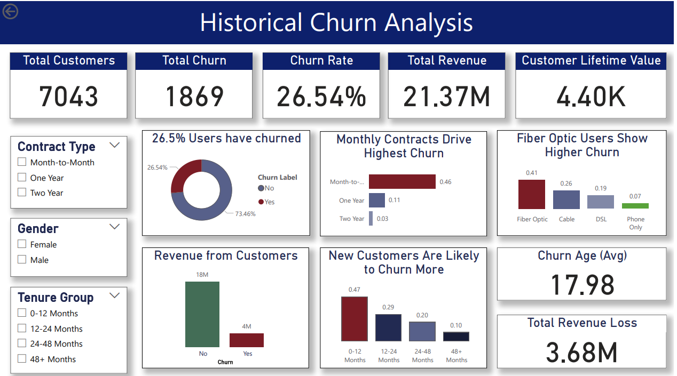

INSIGHTS
- The overall churn rate stands at 26.54%, indicating that more than one in four customers discontinue services.
- The business has incurred a total revenue loss of $3.68M, highlighting the direct financial impact of churn.
- The average customer lifetime value (CLTV) is $4.4K, suggesting significant value loss per churned customer.
- Customers on month-to-month contracts show the highest churn rate (46%), compared to one-year (11%) and two-year (3%) contracts.
- Customers within the first 12 months exhibit the highest churn rate (47%), which declines significantly with increasing tenure.

BISINESS INTERPRETATION
- The high churn rate signals systemic retention issues, not isolated cases.
- Revenue loss at this scale indicates an urgent need for proactive churn management strategies.
- Improving retention, even marginally, can result in substantial revenue recovery.
- Short-term contracts provide flexibility, making customers more likely to switch providers.
- The initial customer lifecycle phase is critical, indicating potential gaps in onboarding, service quality, or expectation management.
- Long-term contracts act as a strong retention mechanism.

CUSTOMER DEMOGRAPHICS ANALYSIS

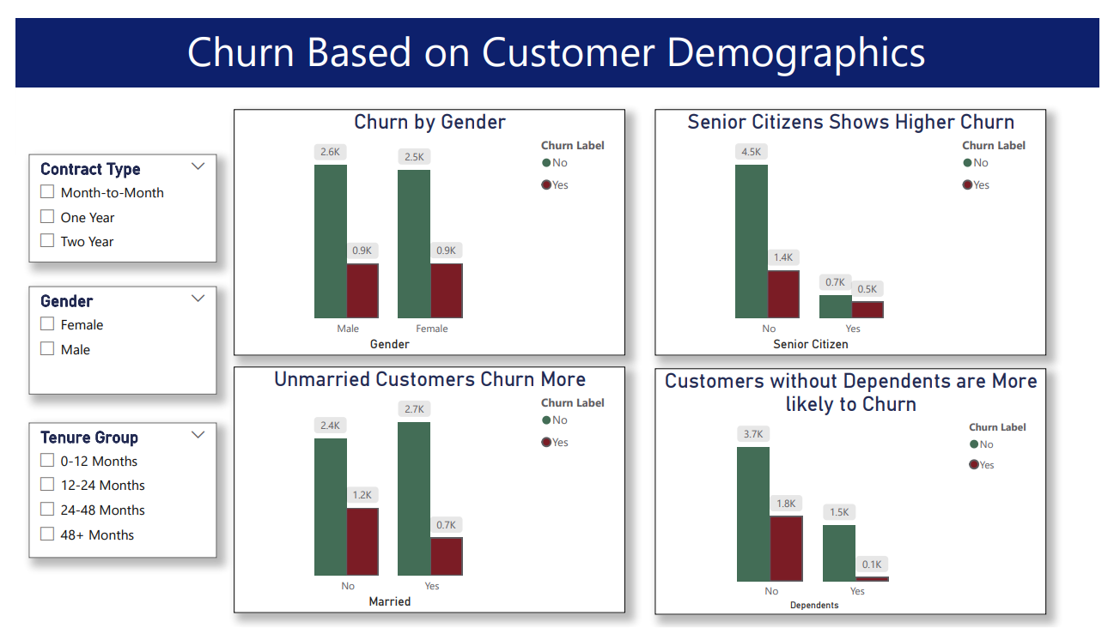

INSIGHTS
- Senior citizens show relatively higher churn compared to non-senior customers.
- Unmarried customers and those without dependents have higher churn rates.
- Gender does not significantly impact churn behavior, with similar patterns observed across male and female customers.

BUSINESS INTERPRETATION
- Customers with fewer personal or household dependencies are less likely to remain loyal and more price-sensitive.
- Senior citizens may require better support or simplified service experiences.
- Demographics alone are not primary churn drivers but influence customer stability and retention likelihood.

SERVICE BASED ANALYSIS

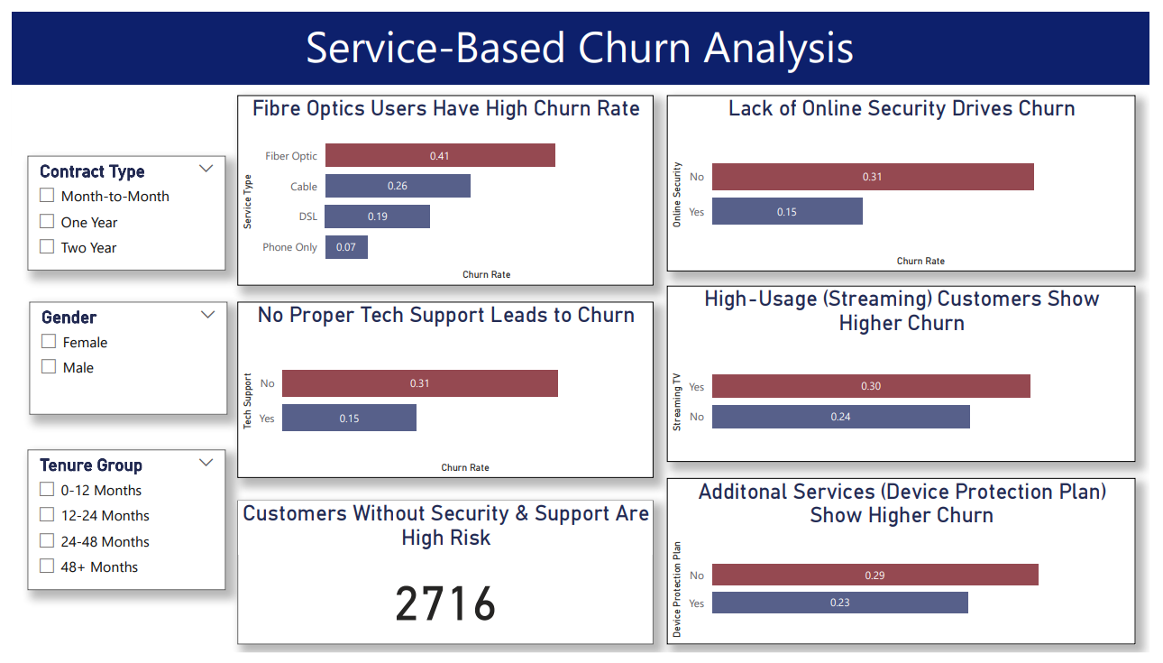INSIGHTS
- Customers without online security or tech support show nearly double the churn rate (31% vs 15%).
- Fiber optic users have the highest churn rate (41%) among service types.
- Customers using streaming services exhibit higher churn, indicating dissatisfaction despite higher engagement.
- A significant segment (~2700 customers) lacks both security and support services, making them highly vulnerable.

BUSINESS INTERPRETATION
- Add-on services such as security and support are critical retention drivers, not optional features.
- High-value customers (fiber optic users) may have higher expectations, and unmet expectations lead to churn.
- Service experience plays a more significant role than basic subscription in retention.

LOCATION BASED ANALYSIS

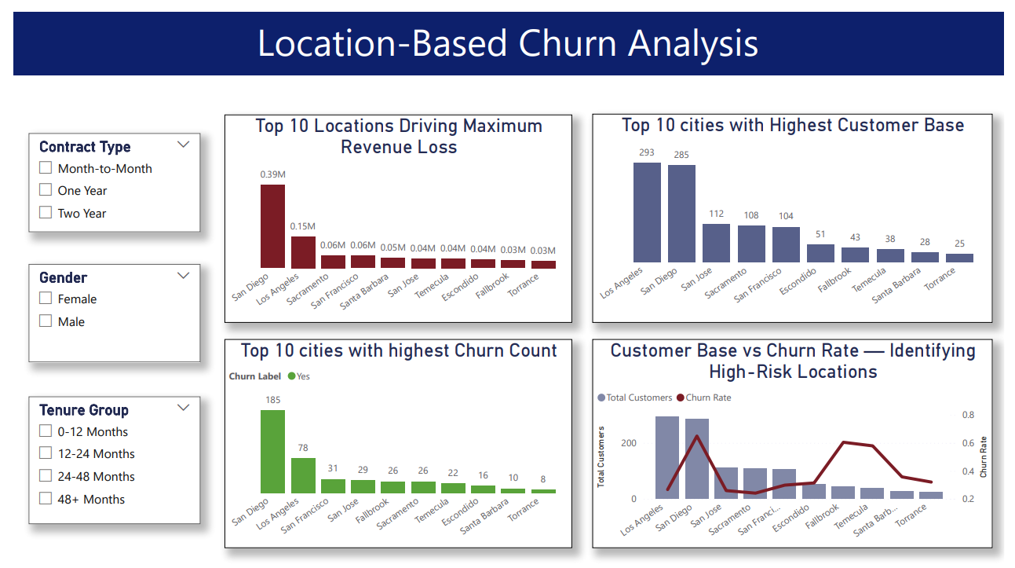INSIGHTS
- San Diego and Los Angeles contribute the highest to revenue loss due to churn.
- Cities with a high customer base also show high churn volumes, indicating concentrated risk areas.
- Certain locations exhibit both high churn rates and high customer counts, making them critical focus regions.

BUSINESS INTERPRETATION
- Churn is geographically concentrated, not evenly distributed.
- Regional factors such as pricing, competition, or service quality may influence churn.
- Targeting high-impact locations can yield maximum return on retention efforts.

RISK & REVENUE EXPOSURE ANALYSIS

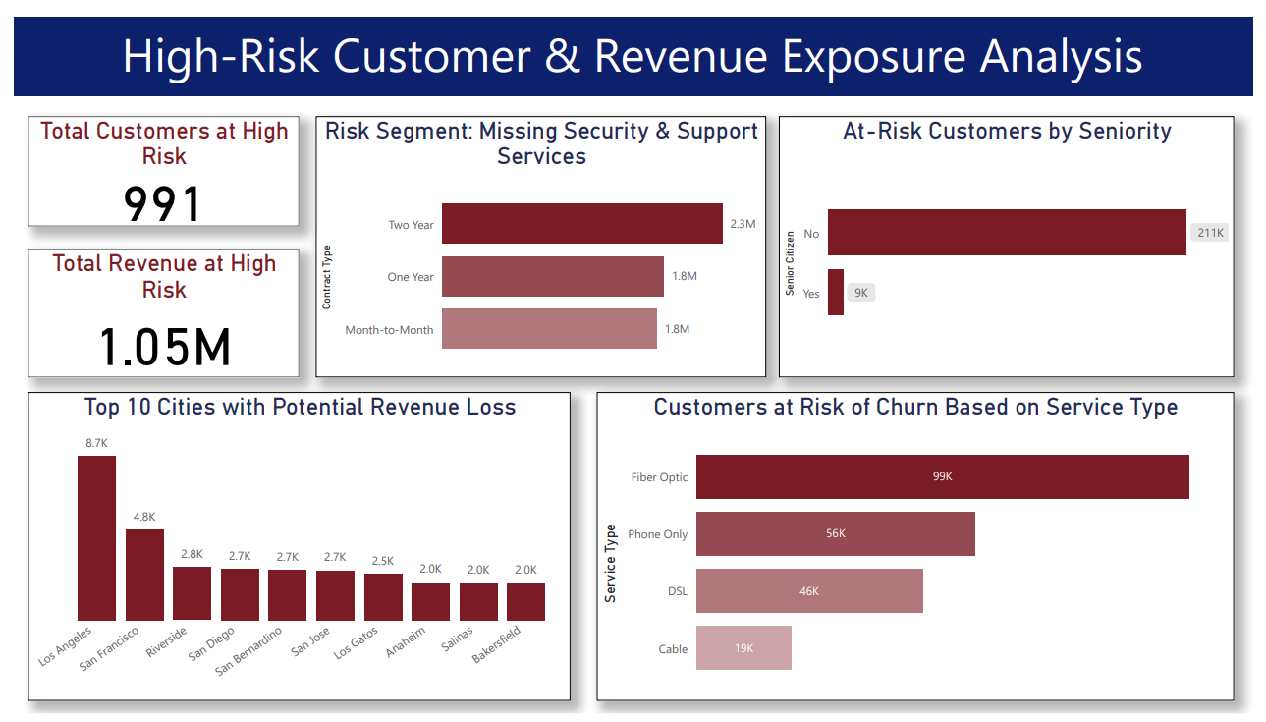INSIGHTS
- A total of 991 customers are identified as high-risk, representing $1.05M in potential revenue exposure.
- High-risk customers are predominantly:
  - On month-to-month contracts
  - Lacking security and support services
  - Using fiber optic services
- Revenue exposure is also concentrated in key cities such as Los Angeles and San Francisco.

BUSINESS INTERPRETATION
- The risk model enables a shift from reactive to proactive churn management.
- High-risk customers represent an immediate opportunity for targeted retention interventions.
- Addressing risk factors early can significantly reduce future revenue loss.

KEY FINDINGS
- Churn is significantly high at 26.54%, indicating a major risk to customer retention and long-term revenue stability.
- Month-to-month contracts are the primary churn driver, with nearly half of such customers discontinuing services.
- Customer churn is heavily concentrated in the early lifecycle, with customers in the first 12 months being the most vulnerable.
- Lack of value-added services (Online Security & Tech Support) is strongly correlated with higher churn, highlighting their importance in retention.
- Fiber optic customers exhibit the highest churn, suggesting a gap between service expectations and actual experience.
- Customers without dependents or long-term commitments are more likely to churn, indicating lower loyalty and higher price sensitivity.
- Churn impact is geographically concentrated, with major revenue loss originating from key cities like San Diego and Los Angeles.
- A total of 991 customers are identified as high-risk, contributing to a potential revenue exposure of $1.05M.
- Retention opportunities are highly actionable, as high-risk customers share common characteristics that can be targeted proactively.

ROCOMMENDATIONS

Strengthen Contract-Based Retention
- Introduce incentives for long-term contracts (discounts, bundled offers, loyalty benefits)
- Design targeted campaigns to convert month-to-month customers into annual plans
Impact: Reduces churn significantly by increasing customer commitment and stability

Improve Early Customer Experience (0–12 Months)
- Implement a structured customer onboarding program
- Provide proactive engagement (welcome offers, check-ins, usage guidance) during initial months
- Monitor new customers using early warning churn indicators
Impact: Addresses the most vulnerable phase where nearly half of churn occurs

Bundle Value-Added Services
- Promote Online Security and Tech Support as part of bundled packages
- Offer free trials or discounted add-ons to increase adoption
- Educate customers on the benefits of these services
Impact: Strengthens customer dependency and reduces churn risk

Enhance Fiber Optic Service Experience
- Investigate potential issues in pricing, service quality, or support responsiveness
- Conduct customer feedback analysis specifically for fiber optic users
- Provide premium support or differentiated service tiers
Impact: Retains high-value customers and reduces churn in a critical segment

Implement Risk-Based Retention Strategy
- Leverage the risk score model to identify and track high-risk customers
- Launch targeted retention campaigns (personalized offers, proactive outreach)
- Prioritize customers contributing to high revenue exposure
Impact: Enables proactive intervention and prevents future revenue loss

Focus on High-Impact Locations
- Develop region-specific retention strategies for cities with high churn
- Analyze local factors such as competition, pricing, and service quality
- Allocate marketing and support resources strategically
Impact: Maximizes ROI by targeting areas with the highest churn impact

Continuous Monitoring & Dashboard Utilization
- Use the Power BI dashboard as a decision-support tool for leadership
- Track churn trends, risk segments, and revenue impact in real time
- Regularly update and refine DAX-based risk models
Impact: Ensures sustained churn reduction through data-driven decision-making

CONCLUSION
The analysis highlights that customer churn is not random but driven by a combination of contract type, early customer experience, service adoption, and customer risk factors.
A significant portion of churn originates from:
- Customers on short-term contracts
- Users in their initial lifecycle (0–12 months)
- Customers lacking value-added services such as security and support
Additionally, the identification of high-risk customers contributing to substantial revenue exposure demonstrates the importance of shifting from reactive to proactive churn management.
By leveraging the insights and implementing targeted strategies, the business can:
- Reduce churn rates
- Improve customer lifetime value
- Protect high-value customer segments
- Drive sustainable revenue growth
This project demonstrates how data-driven decision-making using Power BI can transform raw data into actionable business insights and strategic recommendations.

