ASSIGNMENT 1
Ans1.Frontend- It is that part of development which can be seen by user that is the Outlet of our website or project. Generally, it focus on interactive part of code. Examples-HTML, CSS, React etc.
Backend- It is that part of code which is used for performance and scalability. It’s connect database with frontend and APIs. It’s handle authentication and security. Examples-Python, java, Node.js etc.
Full-Stack: It is the combination of both frontend and backend. It’s build end to end solutions. In this there is coordination between database, UI/UX and server.
Ans2.
Server(Website Host)
Internet(Network)
CClient(Web Browser)

- User requests URL.
- Browser sends HTTP req.
- Server send requested files
- Browser renders websites

Ans3. 1. Type URL
2. DNS Lookup
3. TCP/TLS Handshake
4. Send HTTP Request
5. Server Processes
6. HTTP Response
7. Parse HTML
8. Fetch CSS/JS/Images
9. Render Page
10. Display & Interact

Ans4. To set up a web development environment, several essential tools are required. A code editor or IDE (like VS Code or Sublime Text) is used to write and manage code efficiently. A web browser (such as Chrome or Firefox) helps test and debug web pages using built-in developer tools. A version control system like Git, along with platforms such as GitHub, manages code versions and enables collaboration. A local web server (like XAMPP or Node.js) allows developers to run and test websites locally before deployment. A database management system (such as MySQL or MongoDB) stores and organizes data for dynamic web applications. A package manager (like npm or Yarn) handles libraries and dependencies. Additionally, frameworks and libraries (such as React or Django) simplify and speed up development, while build tools (like Webpack or Sass) optimize code for better performance. Finally, testing tools (like Postman or Jest) are used to check the functionality and reliability of web applications.

Ans5. A web server is software or hardware that stores, processes, and delivers web pages to users over the internet when requested through a browser using the HTTP/HTTPS protocol. Common examples include Apache, Nginx, Microsoft IIS, LiteSpeed, and Node.js.
Ans6. A frontend developer designs and builds the user interface of a website using technologies like HTML, CSS, and JavaScript, ensuring it is responsive and visually appealing. A backend developer manages the server-side logic, handles data processing, and connects the frontend with the database using languages like Java, Python, or Node.js. A database administrator (DBA) is responsible for designing, maintaining, and securing databases, ensuring efficient data storage, retrieval, and backup for smooth application performance.
Ans7.
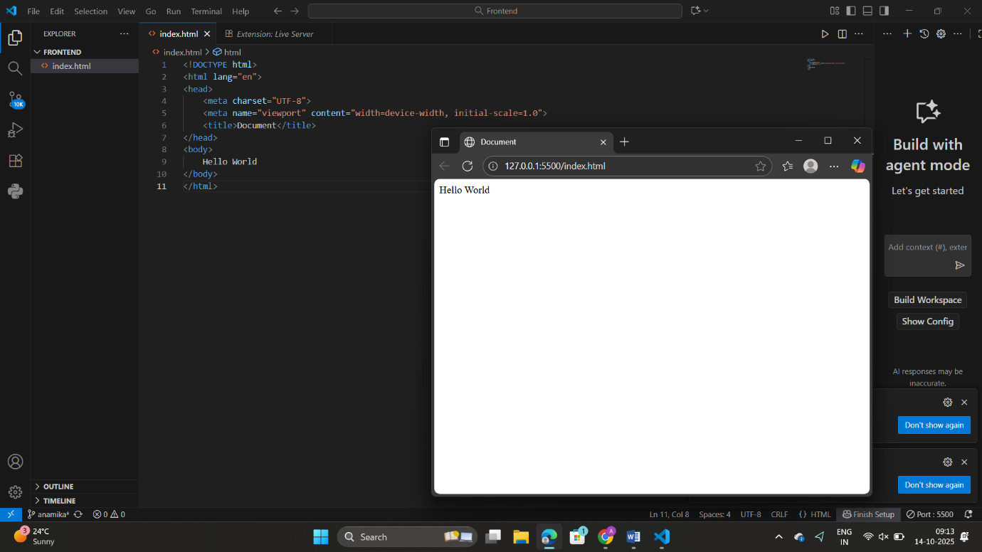

Ans8. A static website displays fixed content to every visitor; its pages are pre-built using HTML and CSS and do not change unless manually updated. Example: a personal portfolio or company landing page.
A dynamic website, on the other hand, displays content that changes based on user interaction or data from a database, often using server-side languages like PHP, Python, or Node.js. Example: Facebook or Amazon, where content updates dynamically for each user.

Ans9. Five Web Browsers and Their Rendering Engines:
- Google Chrome – uses the Blink rendering engine.
- Mozilla Firefox – uses the Gecko engine.
- Microsoft Edge – uses Blink (earlier used EdgeHTML).
- Apple Safari – uses the WebKit engine.
- Opera – uses Blink.
Difference in Rendering Engines:
Rendering engines determine how HTML, CSS, and JavaScript are interpreted and displayed on screen. Each engine has its own implementation methods, leading to slight differences in speed, performance, and visual rendering of websites across browsers.

Ans10.
Application Tier
(Server-side)
Node.js, Python,
Java
Business Logic
MySQL, MongoDB
Data Storage
Data Access
Presentation Tier
(Web Browser)
HTML, CSS, JS
UI / UX
Client-side scripting|

