Migration : Is used whenever we change something in class structure so that changes done in the class are sent to the database & database should be updated as per the changes done in the class

Steps for Migration

Step 1:

Enable-Migrations (Give this only once)

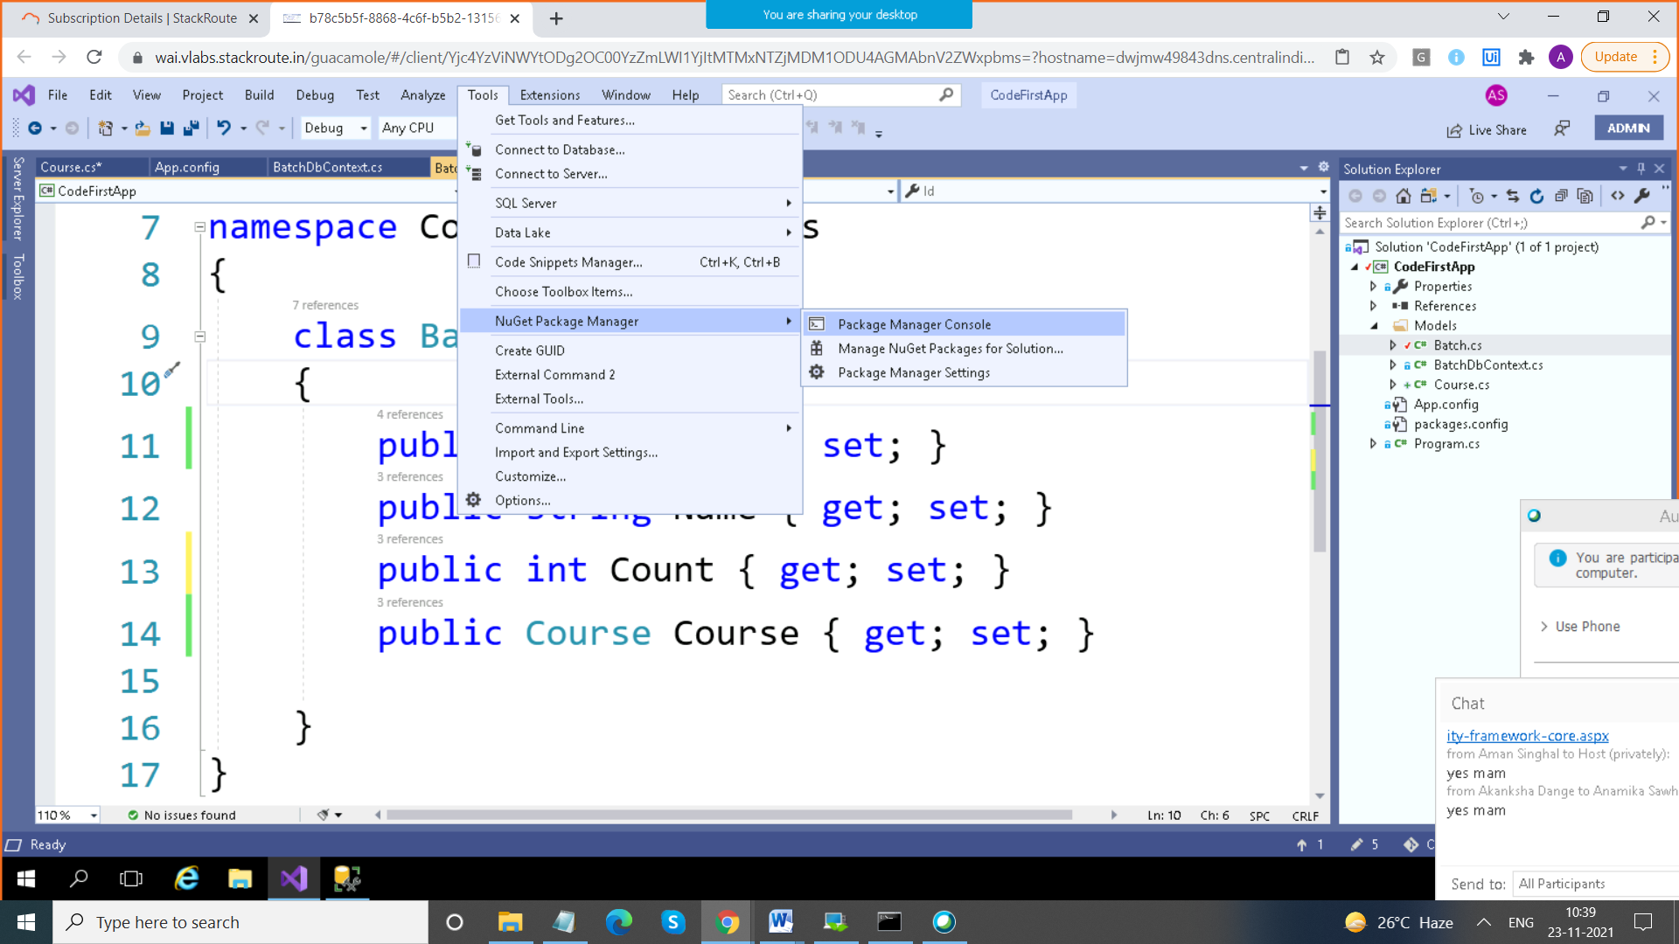

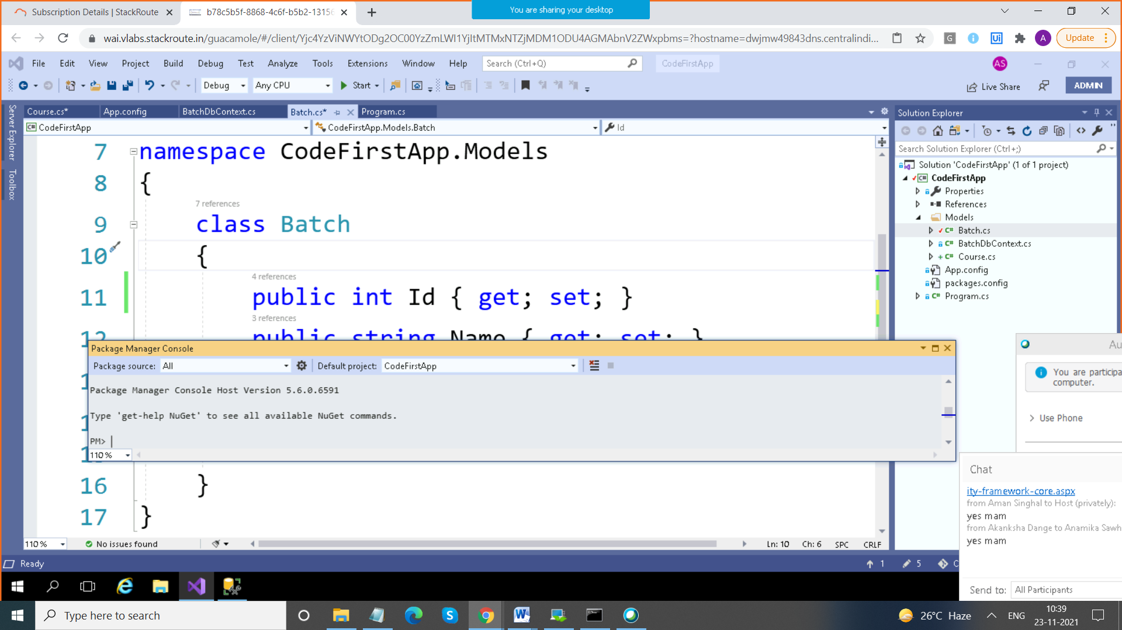

After this we get a folder Migrations

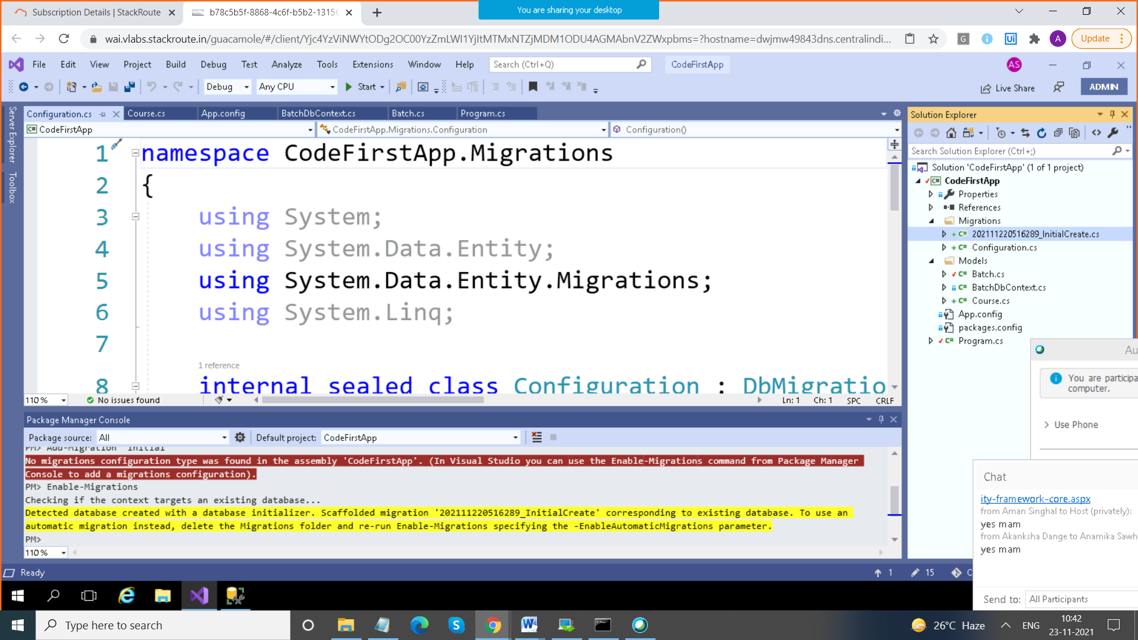

After this whenever you change anything in the class

Add-Migration "Added Course"

Step 3: update-database

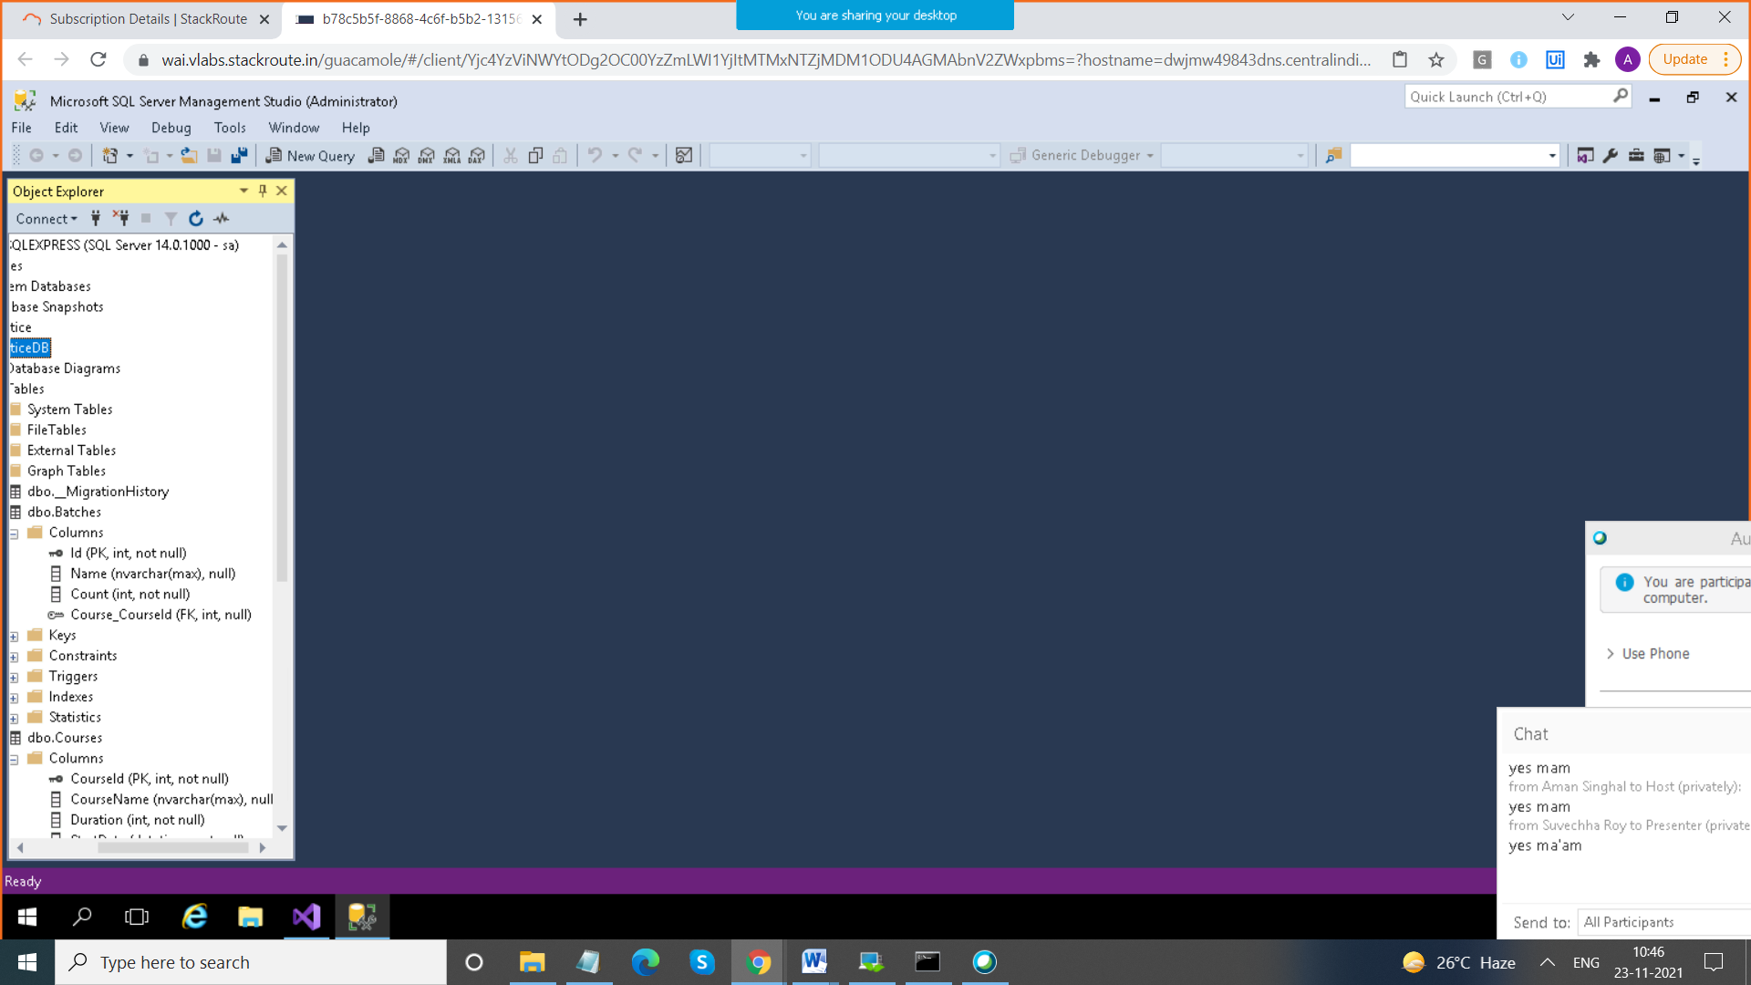

To go to some prev state of the database

update-database -TargetMigration "202111220516289_InitialCreate"

Override Conventions

2 ways

1. By using Data Annotations

2. By using Fluent API

<https://www.entityframeworktutorial.net/code-first/fluent-api-in-code-first.aspx>