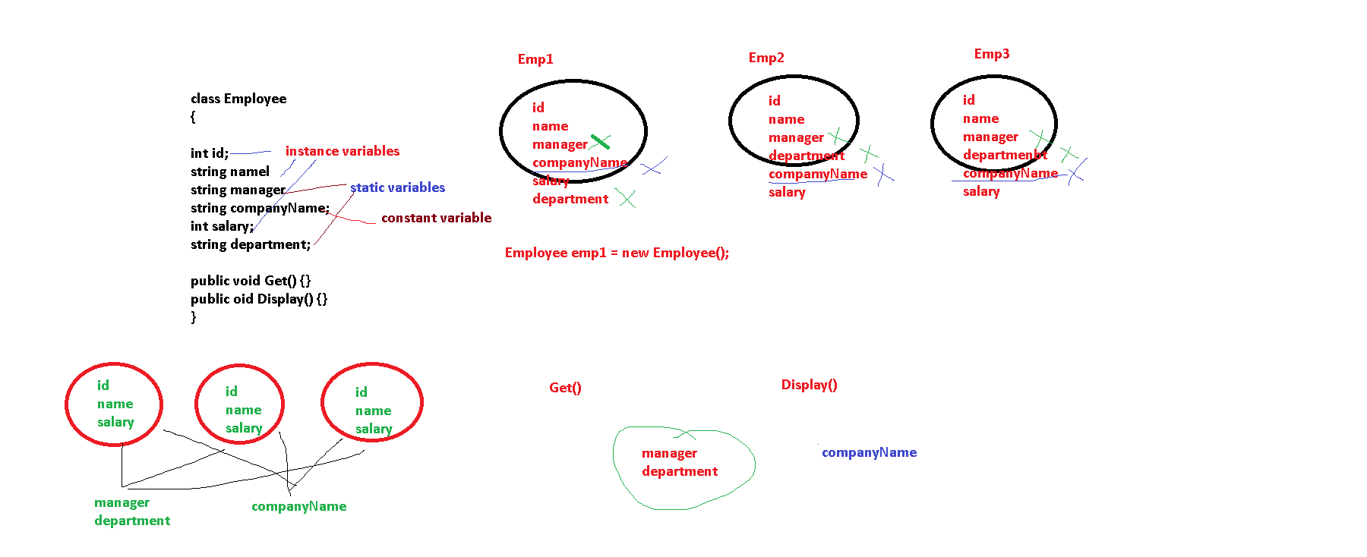

class Employee

{

   int id; > Instance Var

   string name; > Instance Var

  //  public static string Department;

   static string department; > Static Var

   int salary; > > Instance Var

   public const string companyName="CTS"; > Constant Var

By default, the variables of a class are instance variables. There is a separate copy of that variable for all the objects

Static variable is a variable which is shared by all the objects of a class. There is a single copy of that variable.

How to access it : We can access it by class Name

1. Make it public , then we can access it
2. Add a static method

Static Method is a method which can access only static variables

Variables could be

* Instance (Sep for every object , At object level)
* Static (At class level)
* Constant (At class level , cannot be modified)
* ReadOnly (Sep for every object , At object level , once set cannot be changed[1])

1.