CIDR :

Classless Inter-Domain Routing (**CIDR**) notation is a shorthand representation of a subnet mask.

When designing a system architecture in Azure, you will often need to connect Azure VMs (Virtual Network Peering if in the same region, or using VPN Gateway if not) to each other or to extend your on-prem network to the Azure cloud. Azure Virtual Networks are used to achieve this and provide a logical isolation of the Azure cloud, dedicated to your subscription. This isolation allows you to create separate Virtual Networks for development, test, and production. Each Virtual Network can be segmented into multiple subnets and the VMs can connect to each other by using Private IP addresses, even if they are in different subnets. Azure provides system routes between subnets, Virtual Networks, and on-prem networks.

When creating a Virtual Network, specifying the address space is the most critical configuration. This is the IP range for the entire network that will be divided into subnets. When considering the address space, there are some address ranges which cannot be used for Virtual Networks:

As you create your Virtual Network, Azure will help to ensure you do not have your address range overlap with other Virtual Networks. In the portal, you’ll have to create a default subnet when you create your Virtual Network, but you can [manage](https://docs.microsoft.com/en-us/azure/virtual-network/virtual-network-manage-subnet) subnets by changing the address range of a subnet as well as adding additional subnets. As you create subnets, it’s important to understand some specifics to ensure we have the correct number of IPs for a given subnet.

The first thing to understand is that Azure holds 5 IP addresses for every subnet. The first and last IP in each subnet is reserved for the network identification and for broadcast, respectively. Azure also holds 3 additional addresses for internal use starting from the first address in the subnet.

The second, and most important, is that subnets are created using classless internet domain routing (CIDR) blocks of the address space that was designed for the Virtual Network. As an example, the smallest range you can specify for a subnet is /29, which provides eight IP addresses. As mentioned earlier, the Azure portal makes it easy to create Virtual Networks and subnets, and even tells you how many IP addresses a given CIDR block is. Give it a try – in the Azure portal, type 10.1.0.0/29 in an address range box (either for the Virtual Network or the subnet). Notice at the bottom it gives you actual IP address range as well as the number of IP addresses.

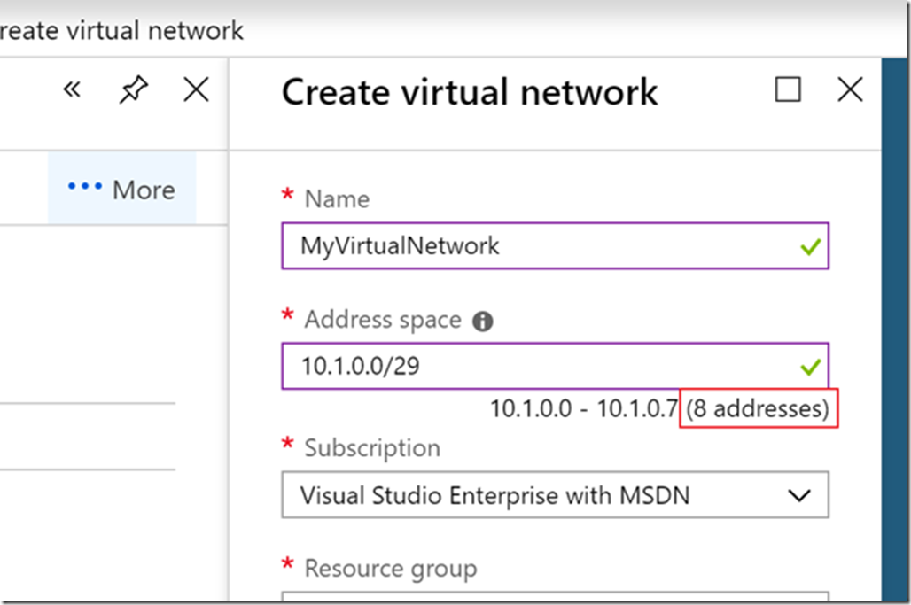

In this case, it shows 10.1.0.0 – 10.1.0.7, which is 8 addresses. However, remember that 5 are reserved so you effectively have 3 addresses in this range. But, how do you figure out what the /29 is doing so you can know exactly what you want rather than typing in a bunch of numbers to get to the address range and number of addresses that you need?

Let’s start our example with what we looked at earlier: 10.1.0.0/29. First, what is the number after the slash? It represents the bit mask for the network, telling us how many bits are the same for each IP on the subnet and which bits are variable. In this example, the first 29 bits are all the same. You can visualize this by writing the binary representation of the IP address in octets.

For a quick refresher on how each bit is represented in binary, the values of each bit from left to right is: 128 64 32 16 8 4 2 1

So, we can represent 10.1.0.0 as the following octet:

0000 1010 – 0000 0001 – 0000 0000 – 0000 0000

As mentioned earlier, the /29 means the first 29 bits of the octet are the same, which I’ve bolded for ease of reading: **0000 1010 – 0000 0001 – 0000 0000 – 0000 0**000

This means, the last three bits can be 0 or 1. If we make them all 1s, we get the maximum IP value in the range:

**0000 1010 – 0000 0001 – 0000 0000 – 0000 0**111

This equates to 10.1.0.7, so we have our range as 10.1.0.0 – 10.1.0.7, just as the screenshot above shows. This is an easy example to calculate by looking at the range, but for something a bit more complicated, you would just calculate the combination of bit options. So, if you have 3 bits which are variable as in this example, you have 2^3, or 8, IP addresses; if you have 10 variable bits, you have 2^10, or 1024, IP addresses.

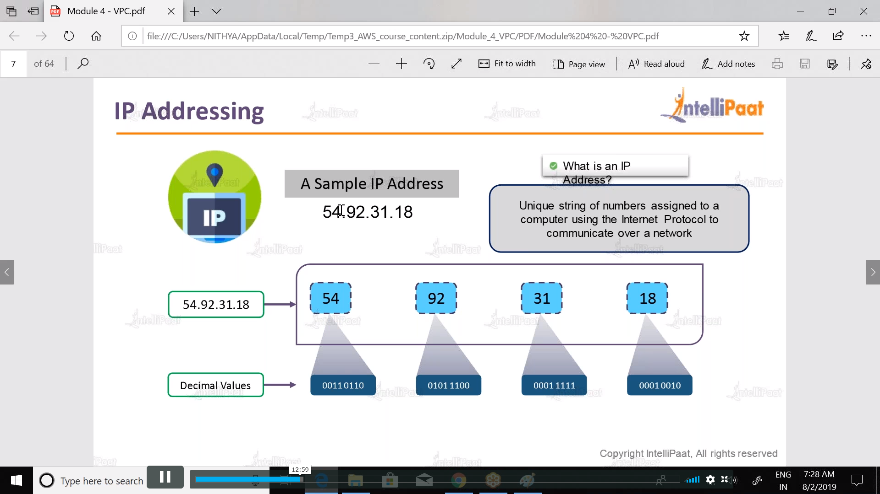

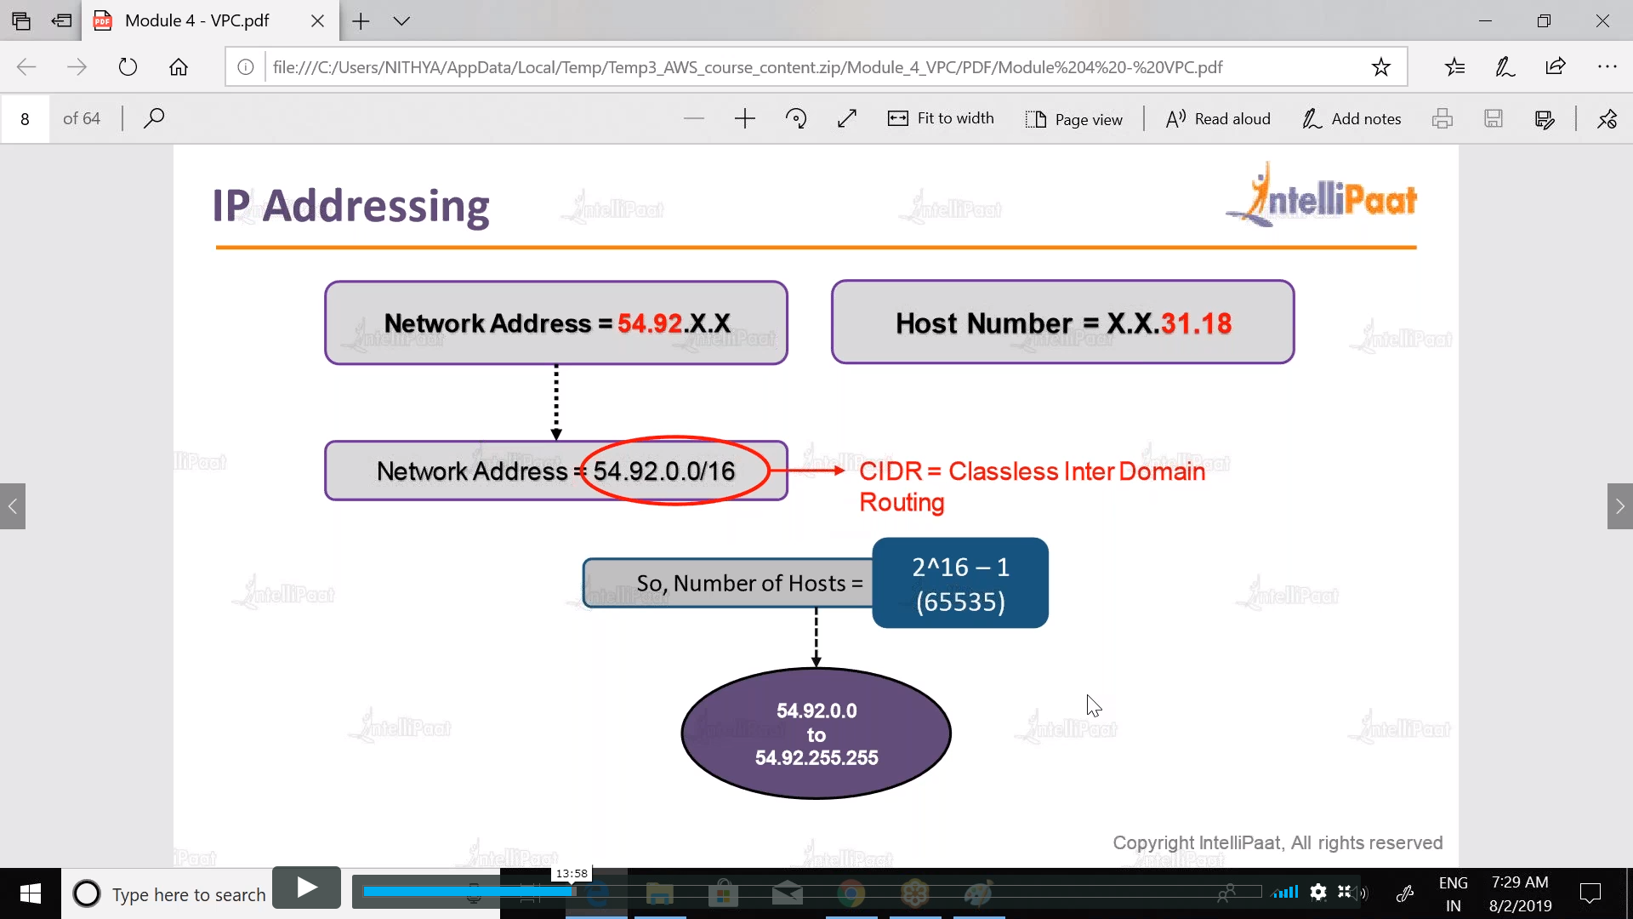 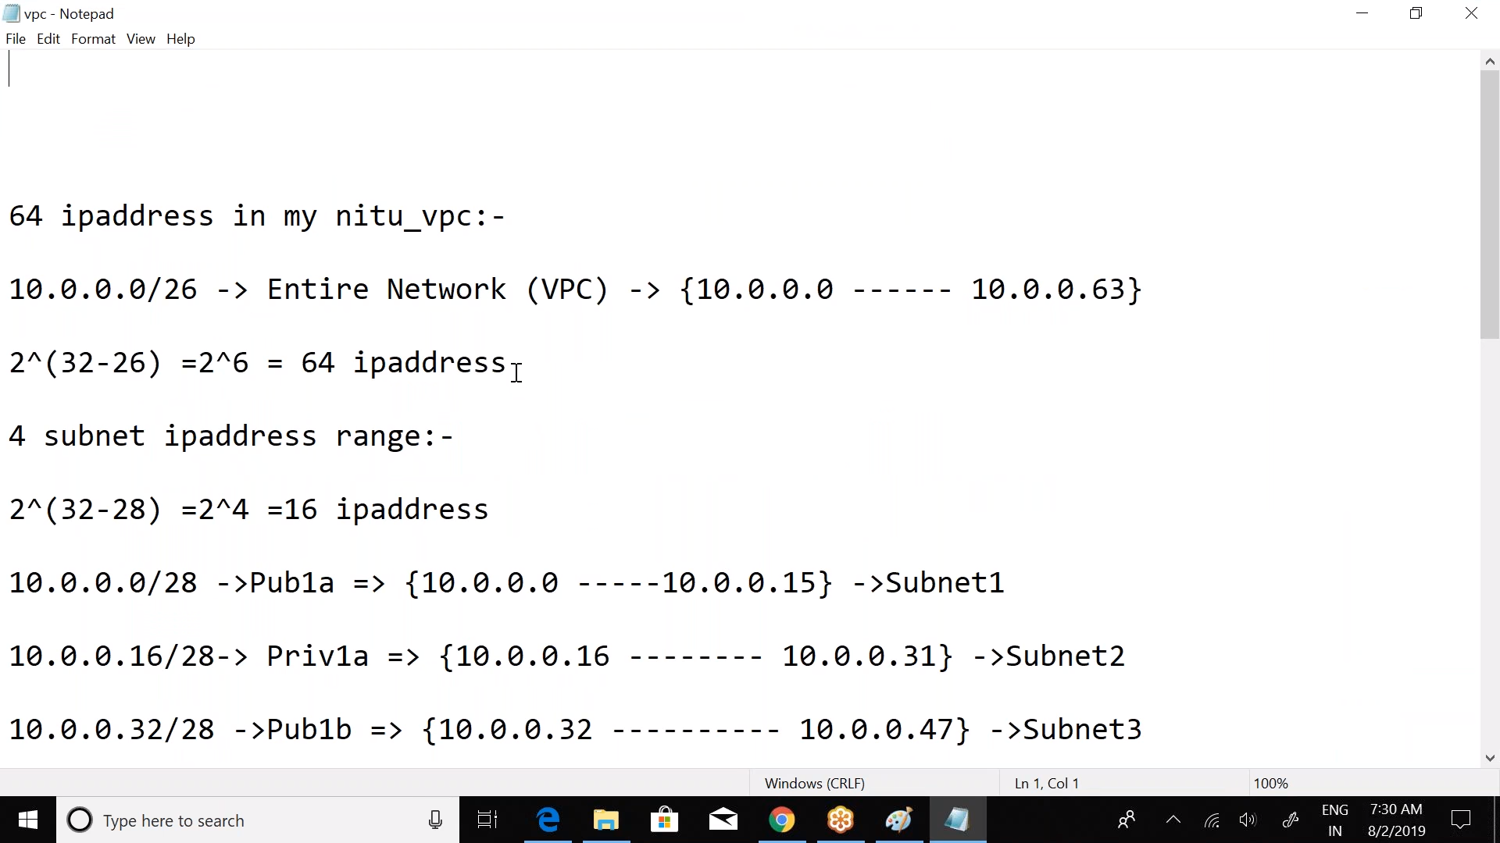

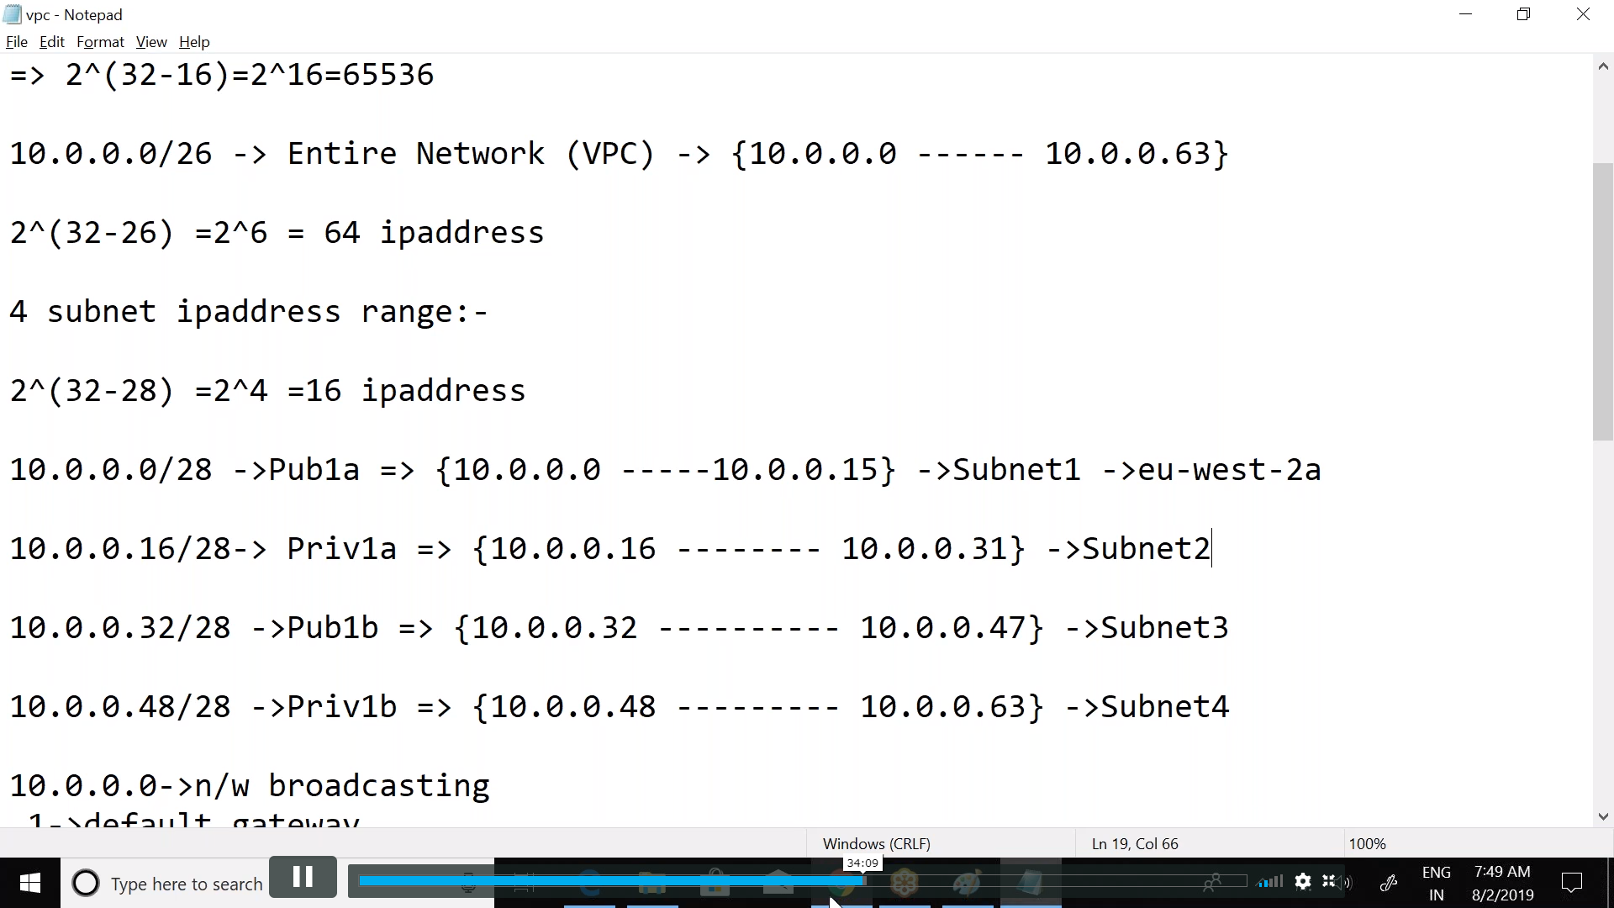

195.10.20.128/26 > Here 26 means no. of network bits, no. of continuors I’s

32-26 = 6

Out of 32, 26 asre for network, so only 6 are left for host

Cannot touch first three octets, why ? because 8

=8 + 8 + 8 = 24 , then 2 bits from 4th octet. From 4th octet, we can onnlt yake 6 bits

195.20.10.10000000

195.20.10.11 000000 these are 6 host bits

Total hosts availabl;e are 2^6 = 64 ,

Out of these 64,

195.20.10.10 0

00000

00001

00010

11111