<https://docs.microsoft.com/en-us/azure/azure-monitor/learn/quick-collect-activity-log-portal>

<https://www.youtube.com/watch?v=6yzPx983w9A> Log Analytics

Create and customize dashboards in Azure portal

Click on Dashboard

New Dashboard

Give it a name

Add the Categories

Add a clock : Do settings, size

Markdown

It’s a private Dashboard

Make it shared

Once you publish , Give access

----------------------------

Select Monitor

When We click on Logs in Monitor, we see workspace for log analytics

Create a Log analytics

Create Resource

Select Log Analytics

Create New

Name , Select subscription, Resource Group, Location, Pricing Tier ,

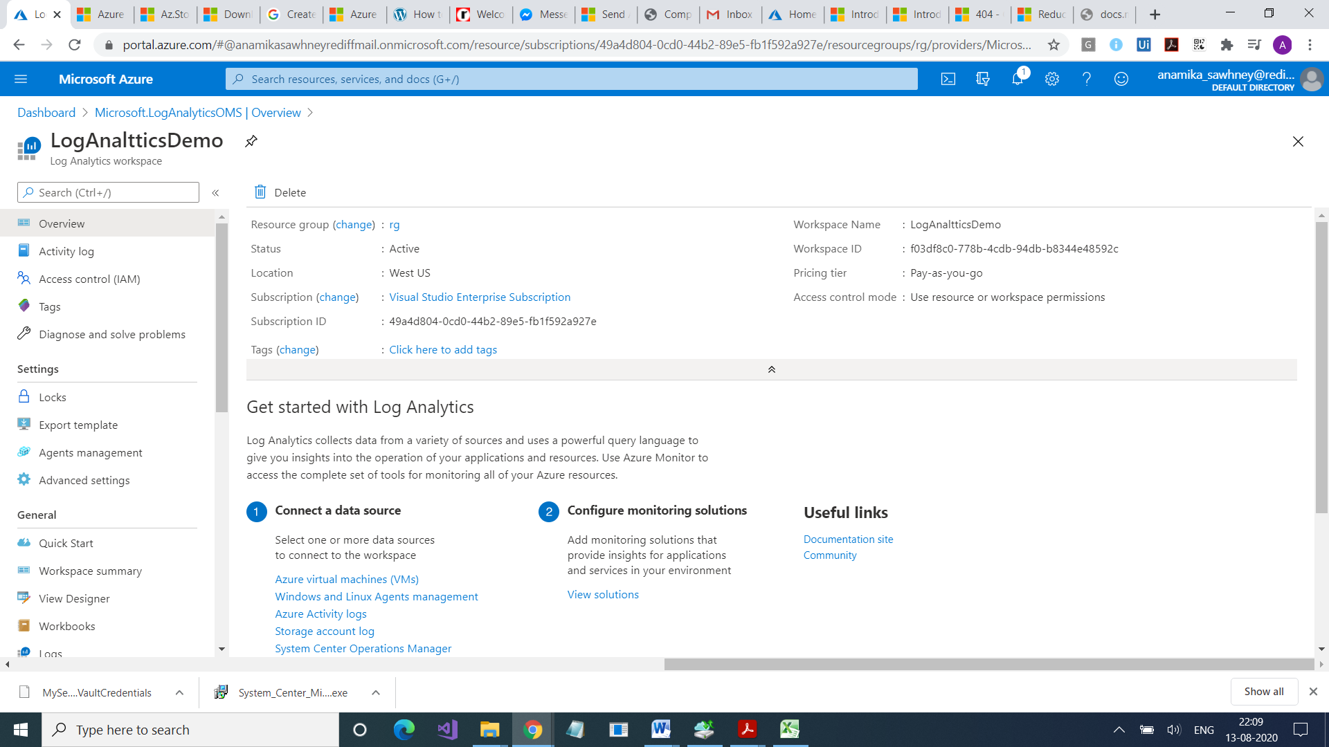

Right now, its an empty workspace. You have to connect to data to log analytics. There is no data fed into it.

**Select Workspace Data Sources**

Select Virtual Machine

Connect

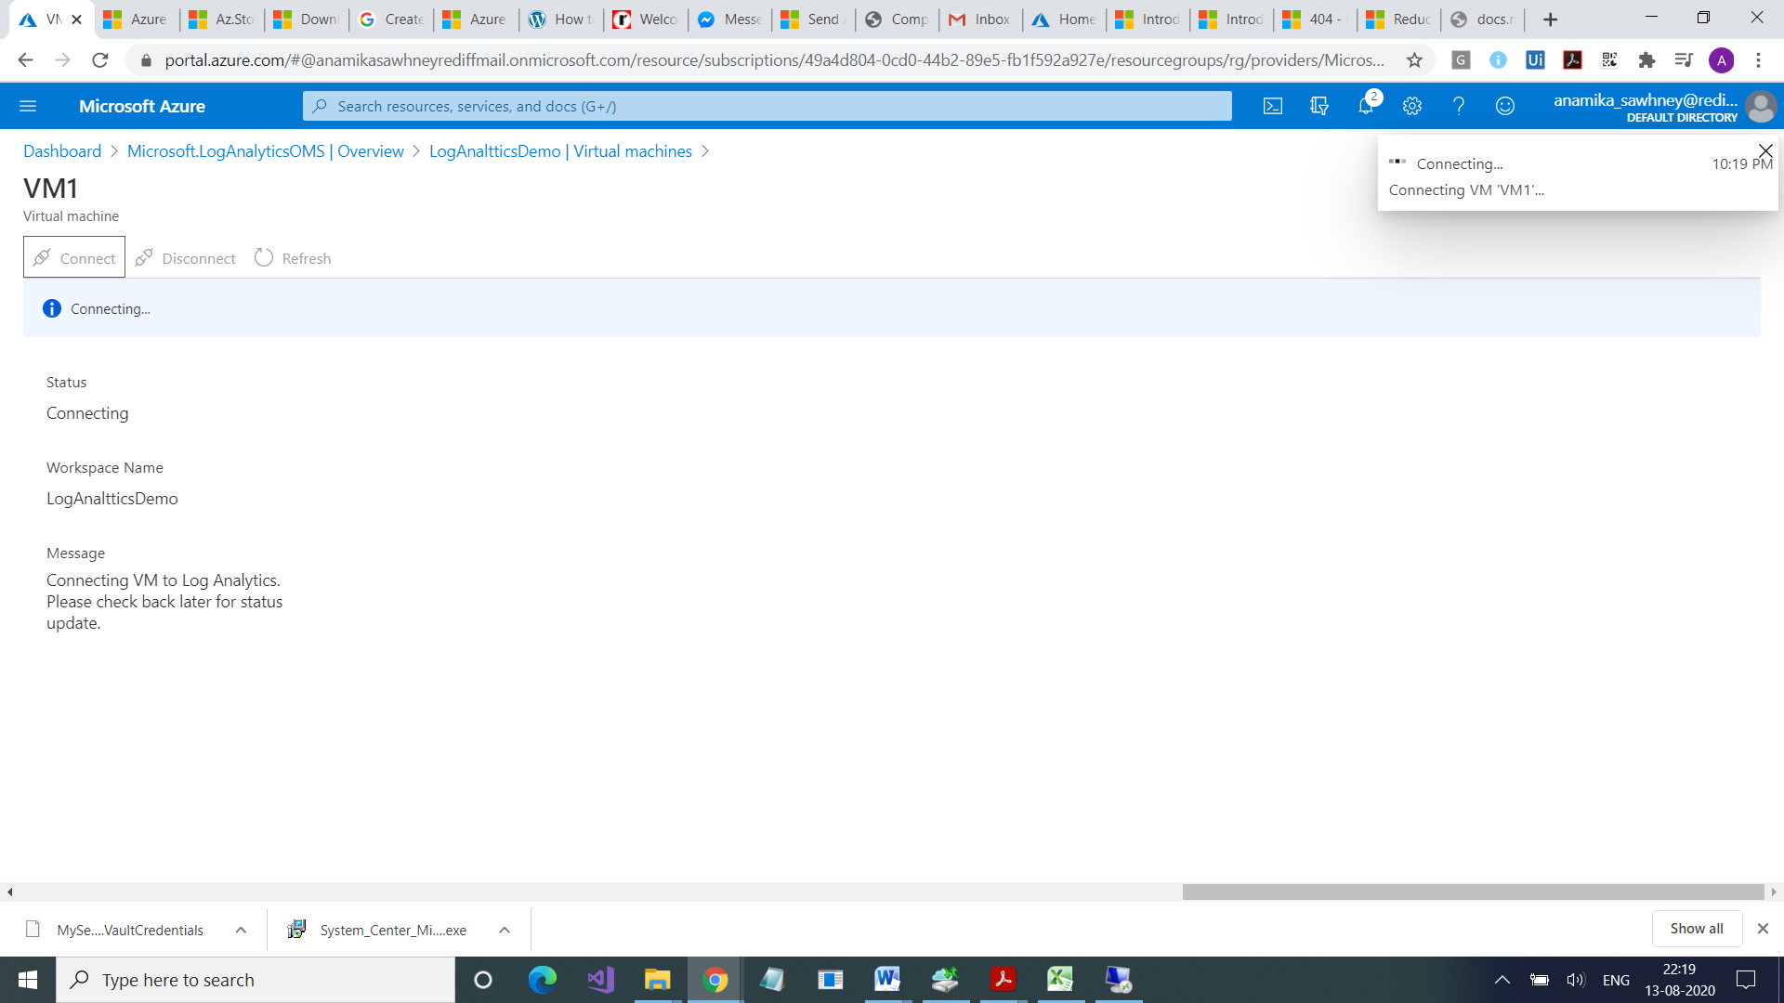

Message

Connecting VM to Log Analytics.

Please check back later for status update.

Open VM through RDP.

Open Control Panel

Turm Windows Features

You will see Service Azure Moniroring Service running there

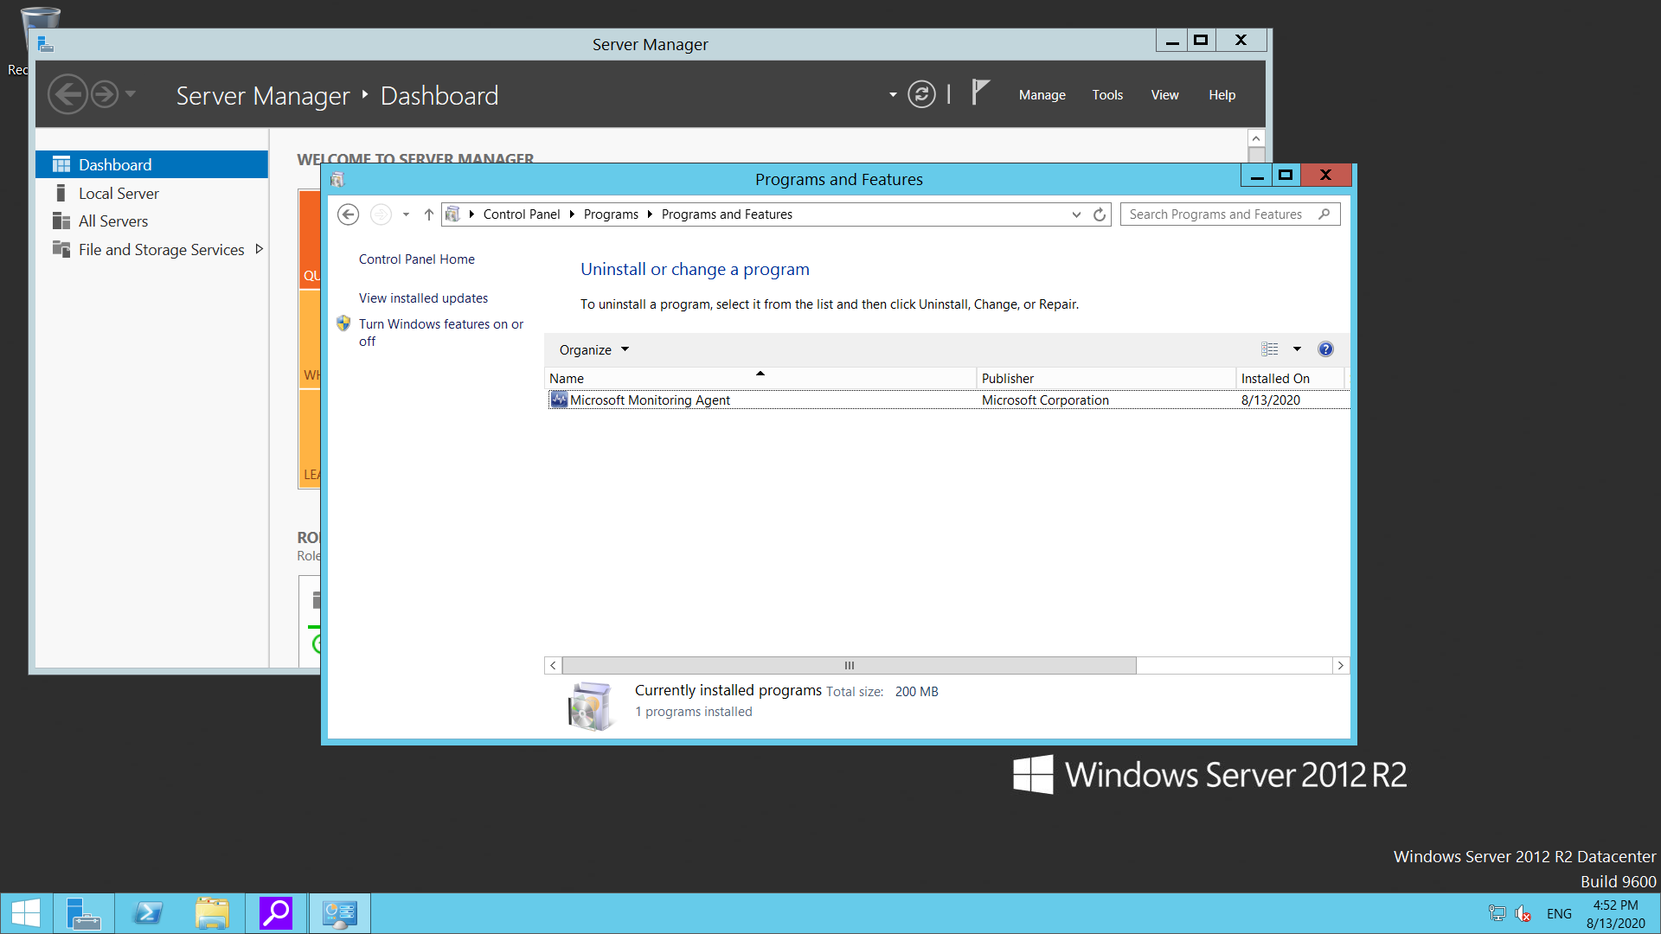

In Azure Portal you will see This workspace in front of VM name

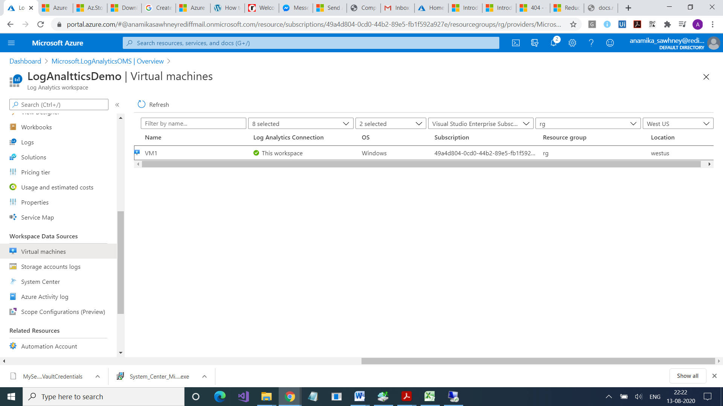

Click on Advanced Settings

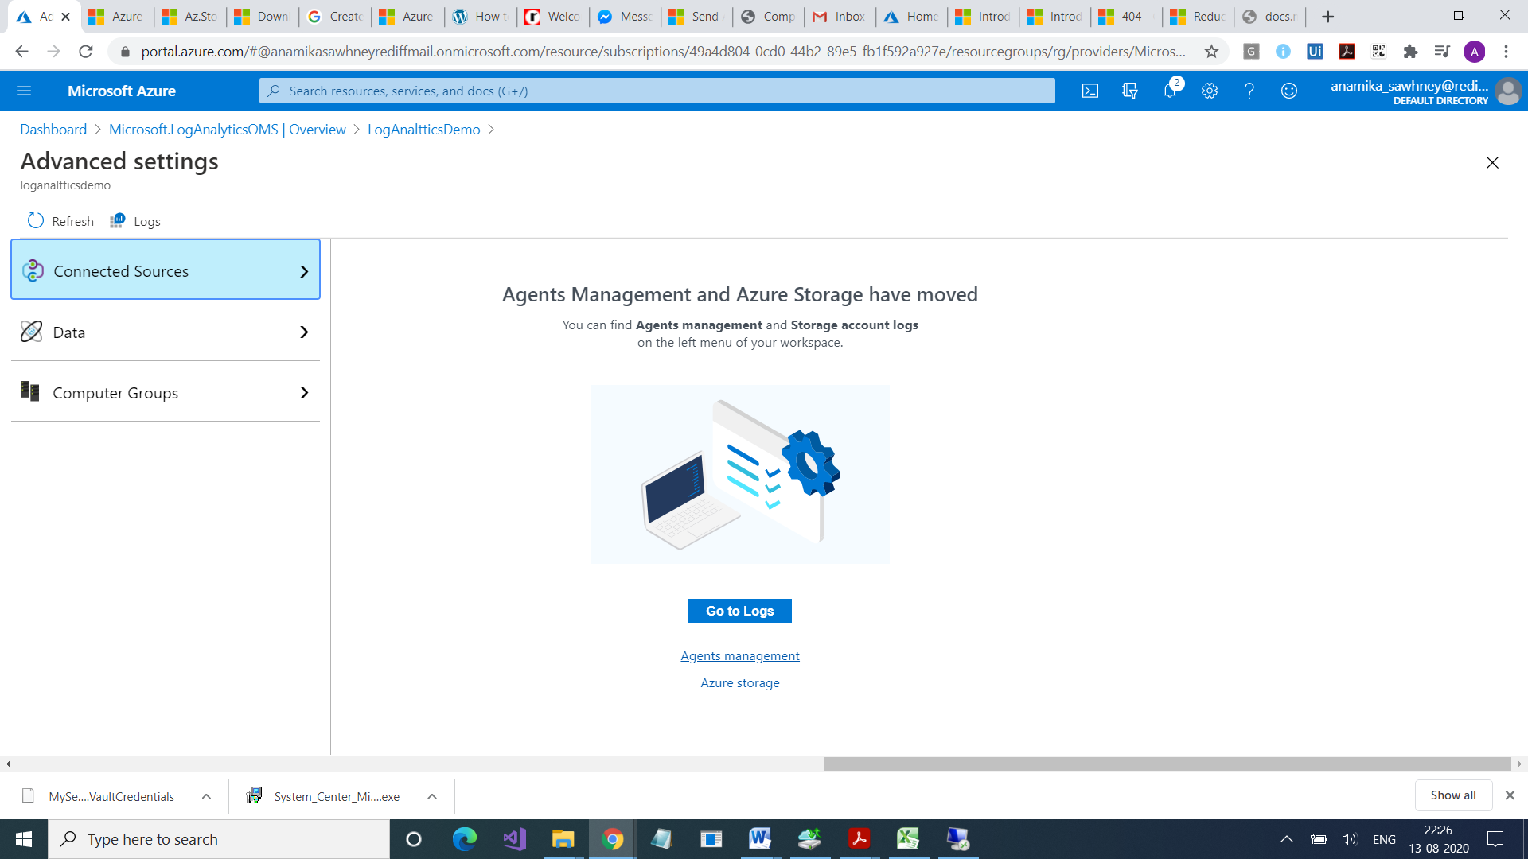

You will see Windows VM connected

Now click on Data

Select Windows Event Logs > Type System >

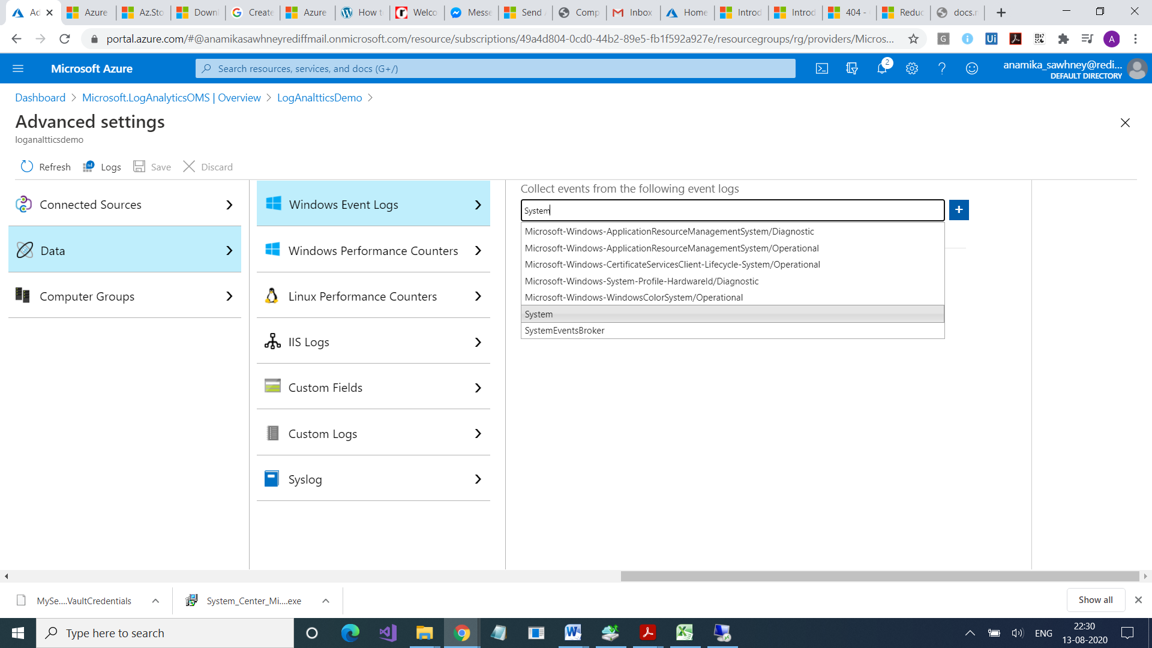

Click on +

Select Application

Select Windows Performance Counter

Click on Add

Add one for Custom Logs

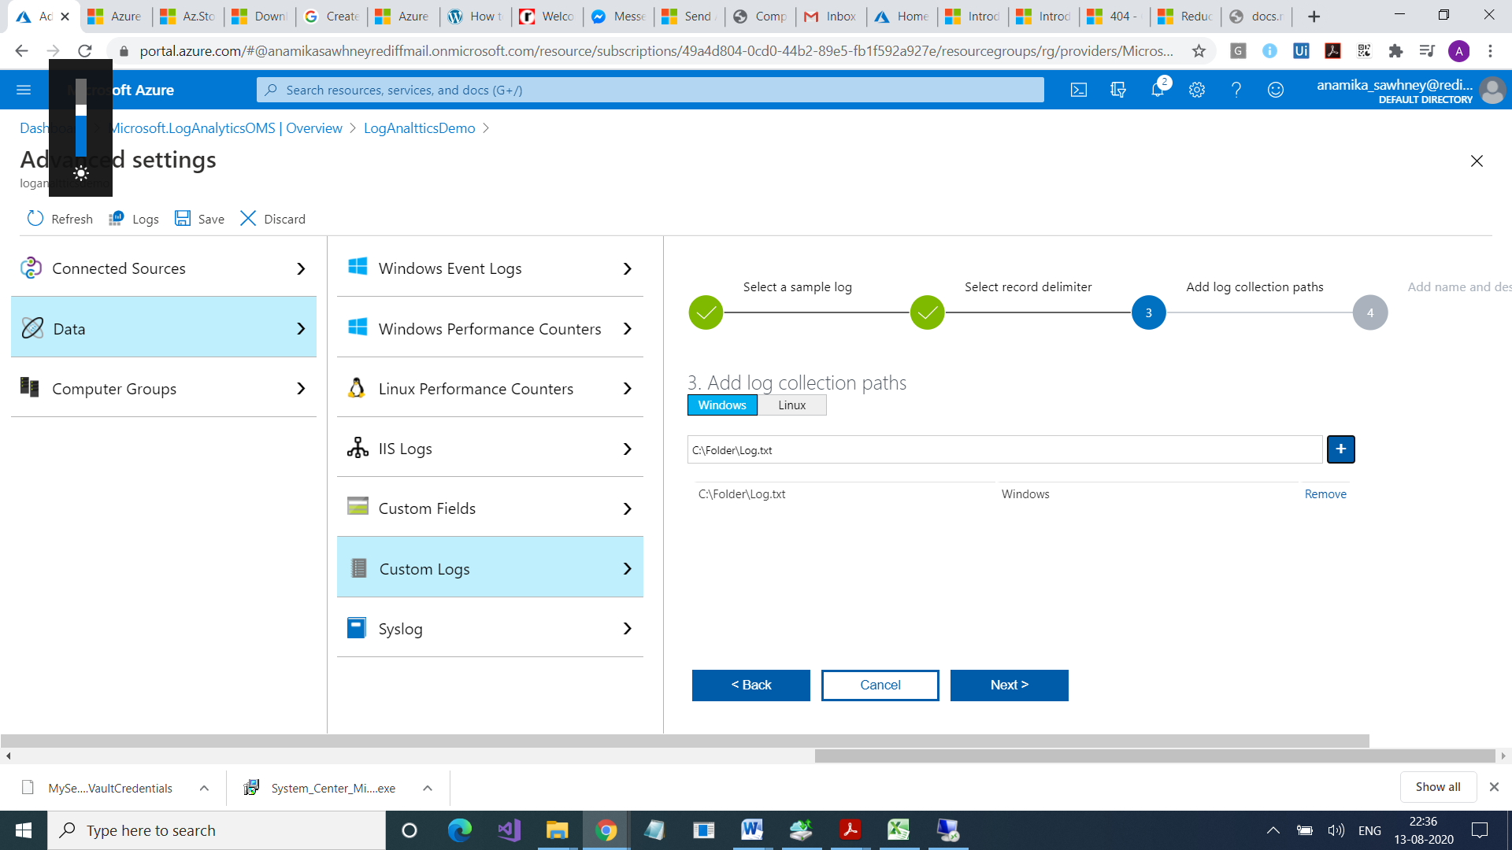

Save the configuration

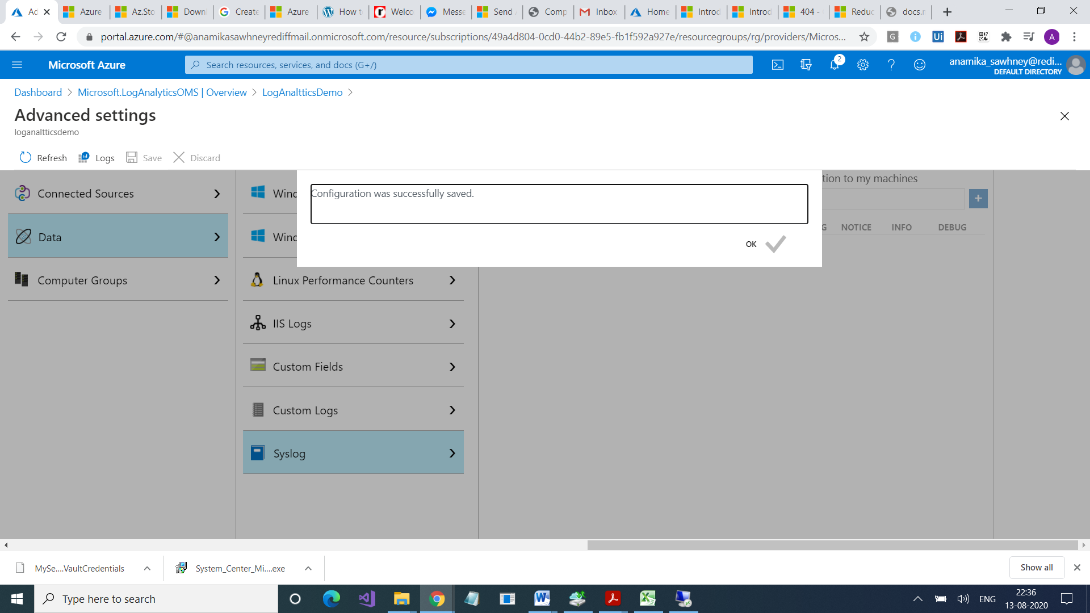

**Select Activity Log**

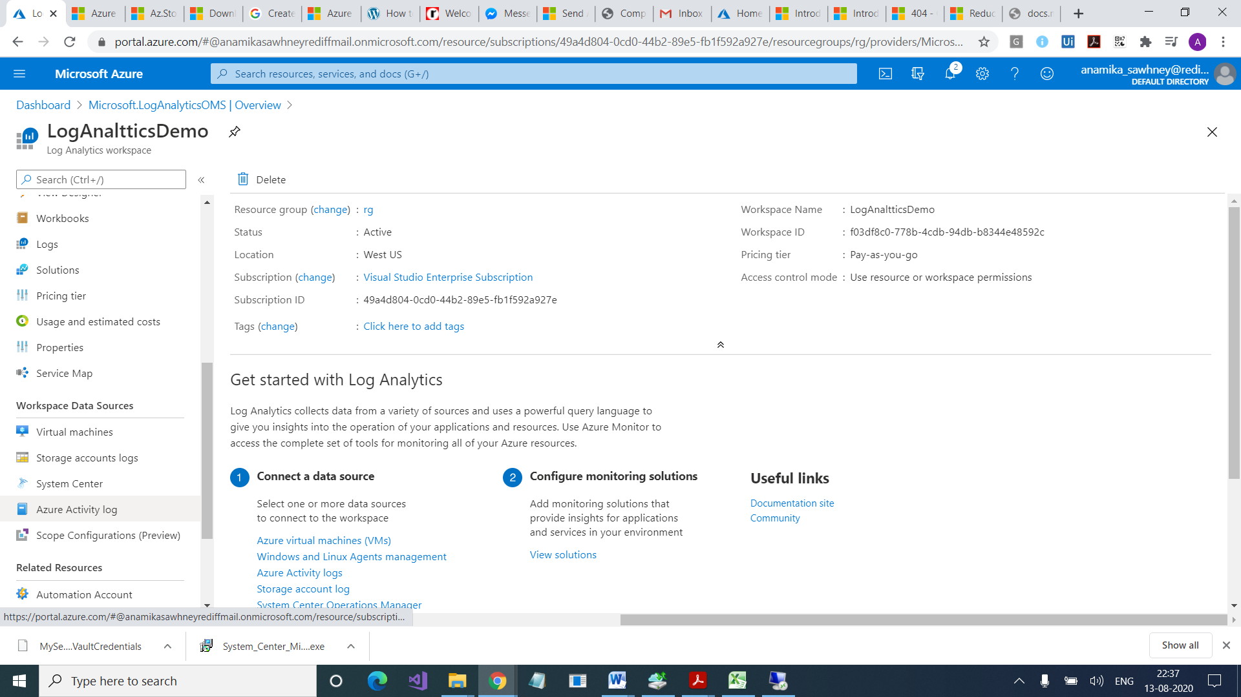

You will see your subscription

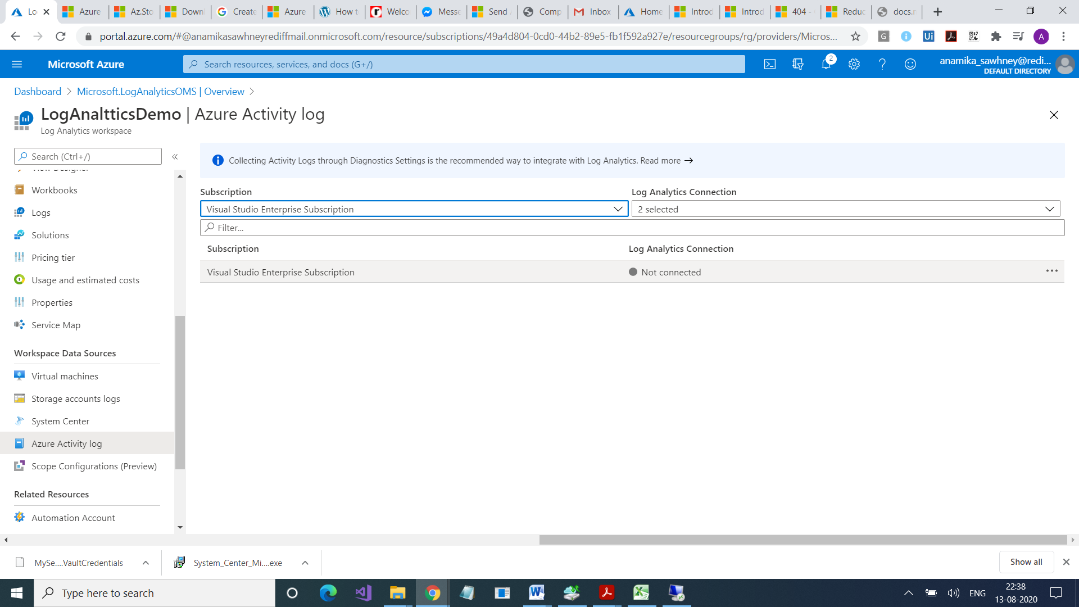

Connect it too

Now Go to Logs /We can also go from Monitor



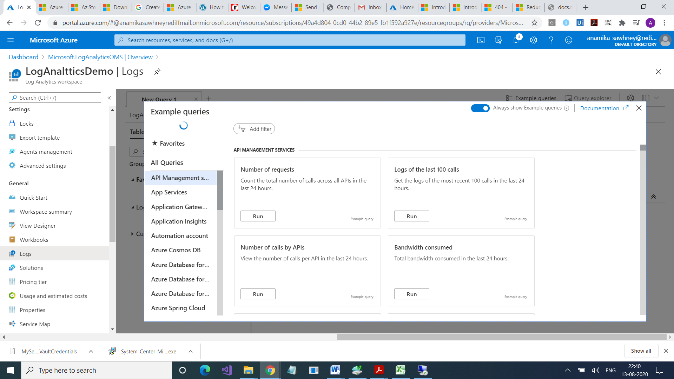

Write Perf

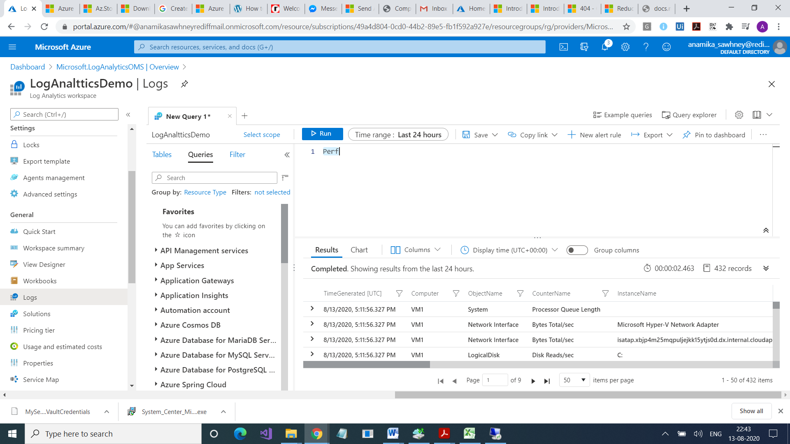

Heartbeat

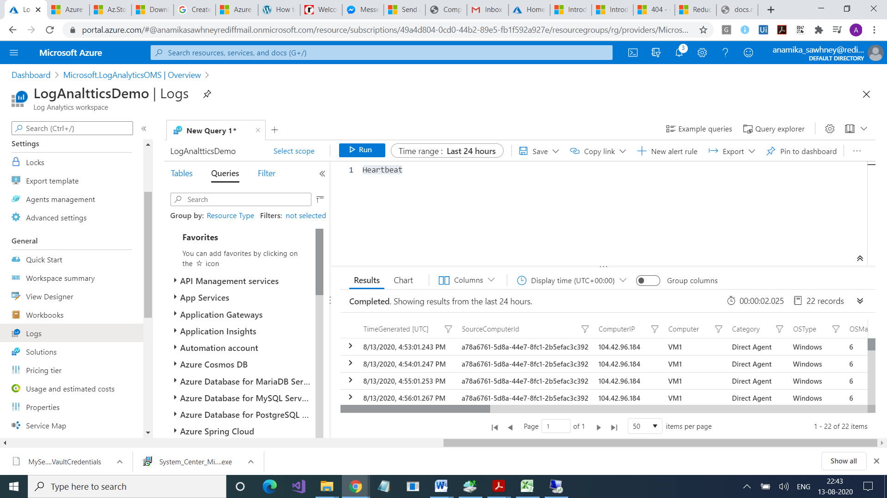

Heartbeat

| where Computer == "VM1"

Heartbeat

| where Computer == "VM1"

| where TimeGenerated > ago(1h)

Event

Perf

| where TimeGenerated > ago(1h) | where CounterName == @"%Processor Time" | summarize avg(CounterValue)

by Computer , (bin(TimeGenerated,15m)) |render timechart

CLicl on Create Alert Rule

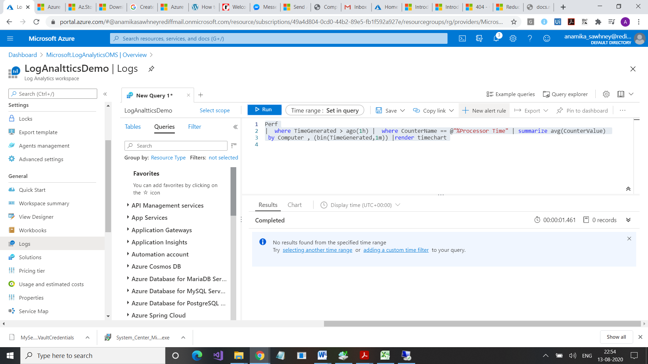

search *

| where TimeGenerated {TimeRange}

| summarize AggregatedValue = count() by Type | order by AggregatedValue desc

search *

| where TimeGenerated > ago(1d)

| summarize AggregatedValue = count() by Type

| order by AggregatedValue desc

Introduction to Azure Advisor - **https://docs.microsoft.com/en-us/azure/advisor/advisor-overview**

Advisor Cost recommendations - [**https://docs.microsoft.com/en-us/azure/advisor/advisor-cost-rec­ommendations**](https://docs.microsoft.com/en-us/azure/advisor/advisor-cost-recommendations)

The new alerts experience in Azure Monitor - [**https://docs.microsoft.com/en-us/azure/monitor­ing-and-diagnostics/monitoring-overview-unified-alerts**](https://docs.microsoft.com/en-us/azure/monitoring-and-diagnostics/monitoring-overview-unified-alerts)

Monitor Subscription Activity with the Azure Activity Log - **https://docs.microsoft.com/en-us/azure/ monitoring-and-diagnostics/monitoring-overview-activity-logs**

For more information, you can see: **Query the Activity Log in the Azure portal** - [**https://docs.micro­soft.com/en-us/azure/monitoring-and-diagnostics/monitoring-overview-activi­ty-logs#query-the-activity-log-in-the-azure-portal**9](https://docs.microsoft.com/en-us/azure/monitoring-and-diagnostics/monitoring-overview-activity-logs#query-the-activity-log-in-the-azure-portal9)

Data Sources in Log Analytics - [**https://docs.microsoft.com/en-us/azure/log-analytics/log-analyt­ics-data-sources**](https://docs.microsoft.com/en-us/azure/log-analytics/log-analytics-data-sources)

Azure Log Analytics – meet our new query language - **https://azure.microsoft.com/en-us/blog/ azure-log-analytics-meet-our-new-query-language-2/**

Azure Monitor log queries - **https://docs.microsoft.com/en-us/azure/azure-monitor/log-query/ query-language**

Writing a query - [**https://docs.microsoft.com/en-us/azure/log-analytics/log-analyt­ics-log-search#writing-a-query**21](https://docs.microsoft.com/en-us/azure/log-analytics/log-analytics-log-search#writing-a-query21)

Getting Started with the Analytics Portal - [**https://portal.loganalytics.io/demo#/discover/home**23](https://portal.loganalytics.io/demo#/discover/home23)

1