**Idle timeout : 4 mins**

In its default configuration, Azure Load Balancer has an ‘idle timeout’ setting of 4 minutes. This means that if you have a period of inactivity on your tcp or http sessions for more than the timeout value, there is no guarantee to have the connection maintained between the client and your service. When the connection is closed, your client application will get an error message like “The underlying connection was closed: A connection that was expected to be kept alive was closed by the server”. A common practice to keep the connection active for a longer period is to use TCP Keep-alive (You can find .NET examples [here](https://msdn.microsoft.com/en-us/library/system.net.servicepoint.settcpkeepalive.aspx)). Packets are sent when no activity is detected on the connection. By keeping on-going network activity, the idle timeout value is never hit and the connection is maintained for a long period. While TCP Keep-alive works well for scenarios where battery is not a constraint, it is generally not a valid option for mobile applications. Using TCP Keep-alive from a mobile application will likely drain the device battery faster. To support such scenarios, we have added support for a configurable idle timeout. You can now set it for a duration between 4 and 30 minutes. This setting works for inbound connections only. [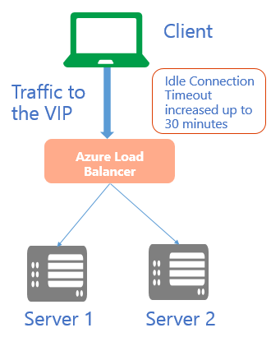](https://acom.azurecomcdn.net/80C57D/blogmedia/blogmedia/2014/08/Tcp-Idle-Timeout-.png)

Load Balancer Coverage **You cannot** attach Azure Load Balancer to Azure VMs in different regions; all VMs must be in the same Azure region. This is true for both Basic and Standard Load Balancer. For multi-region coverage, Microsoft has another offering called Azure Traffic Manager.

Difference between Classful Routing and Classless Routing

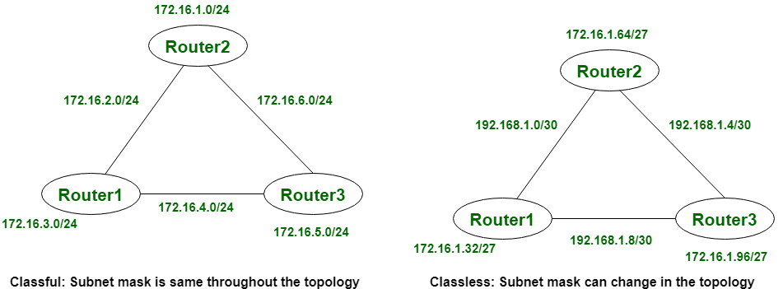

Let’s see that the difference between classful routing and classless routing:

| **S.NO** | **CLASSFUL ROUTING** | **CLASSLESS ROUTING** |
| --- | --- | --- |
| 1. | In classful routing, VLMS(Variable Length Subnet Mask) is not supported. | While in classless routing, VLMS(Variable Length Subnet Mask) is supported. |
| 2. | Classful routing requires more bandwidth. | While it requires less bandwidth. |
| 3. | In classful routing, hello messages are not used. | While in classless routing, hello messages are used. |
| 4. | Classful routing does not import subnet mask. | Whereas it imports subnet mask. |
| 5. | In classful routing, address is divided into three parts which are: Network, Subnet and Host. | While in classless routing, address is divided into two parts which are: Subnet and Host. |
| 6. | In classful routing, regular or periodic updates are used. | Whereas in this, triggered updates are used. |
| 7. | In classful routing, CIDR(Classless Inter-Domain Routing) is not supported. | While in classless routing, CIDR(Classless Inter-Domain Routing) is supported. |
| 8. | In classful routing, subnets are not displayed in other major subnet. | While in classless routing, subnets are displayed in other major subnet.. |
| 9. | In classful routing, fault can be detected easily. | While in classless routing, fault detection is little tough. |

<https://whatismyipaddress.com/cidr>