SSPR

Create a User

Login with that user

Click on Forgot password

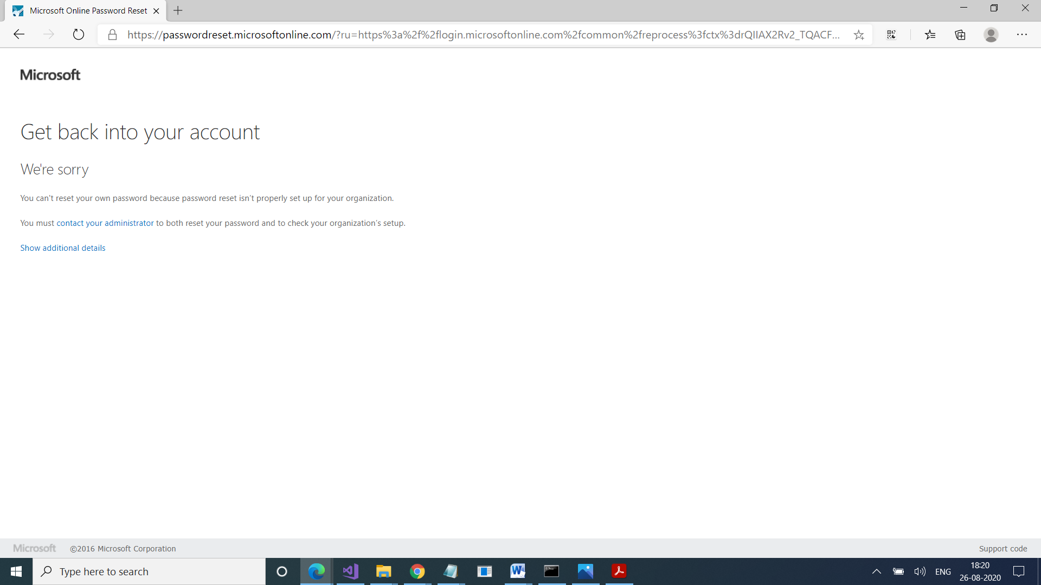

We need to enable SSPR for our users

As an IT Admin, we will go to Users

Click on Reset Password

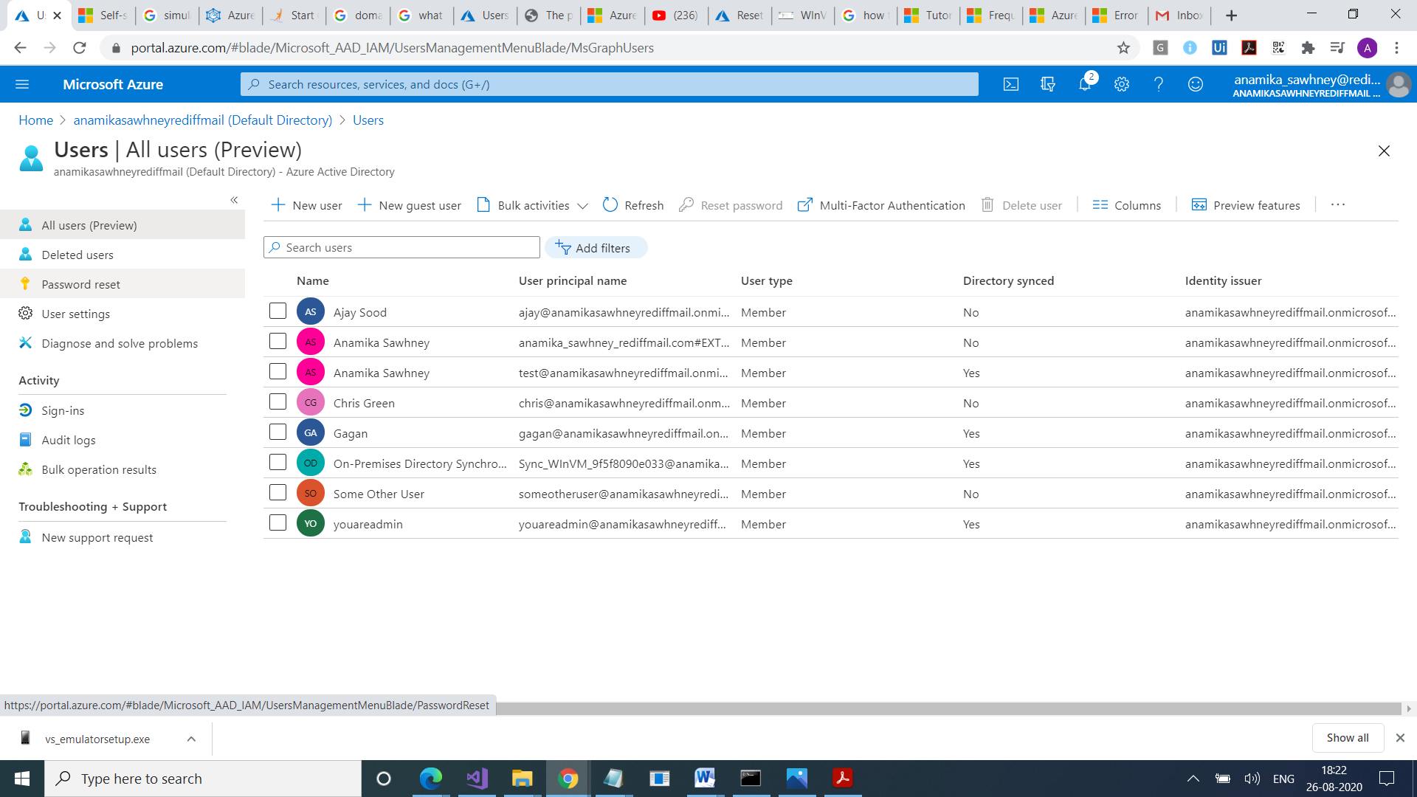

Select Authentication Methods