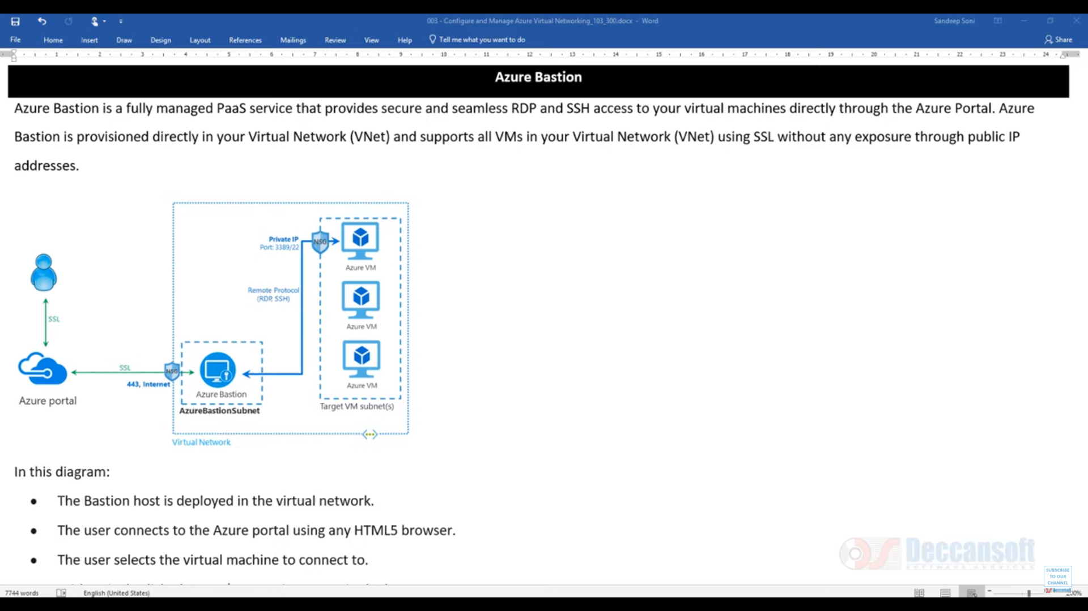

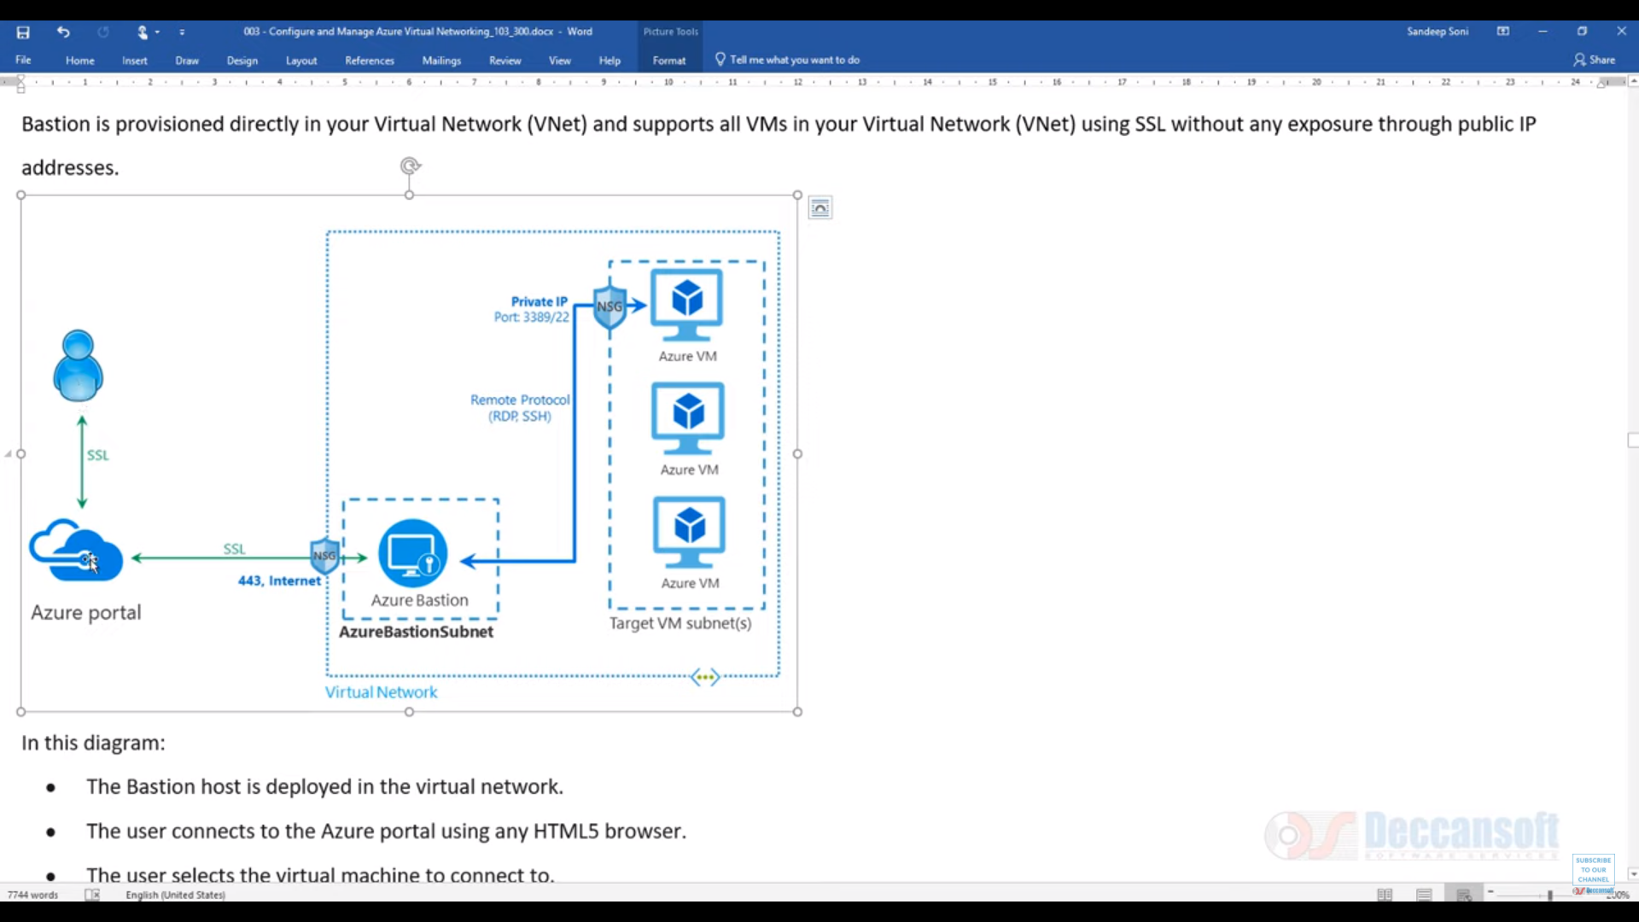

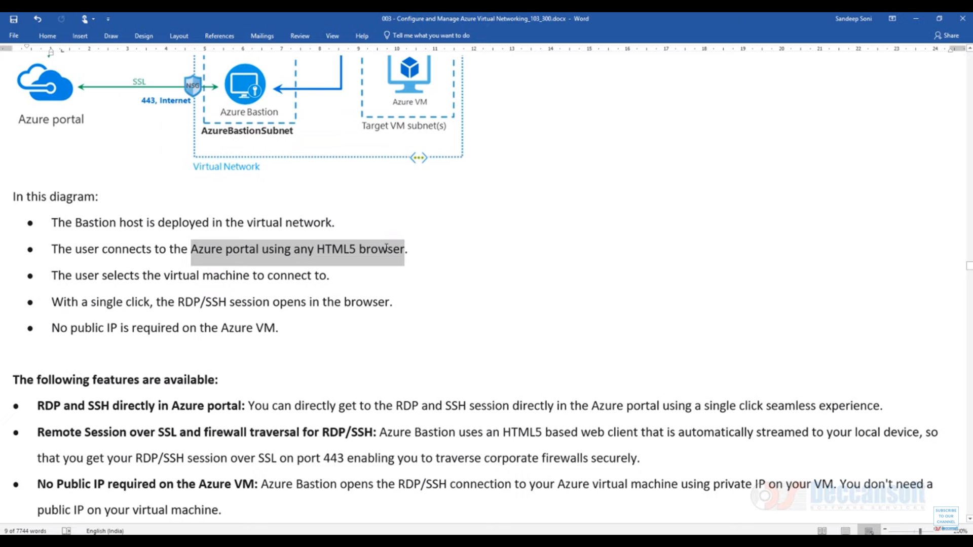

**Azure Bastion** is a new fully platform-managed PaaS service you provision inside your virtual network. It provides secure and seamless RDP/SSH connectivity to your VMs directly in the **Azure** portal over SSL. When you connect via **Azure Bastion**, your virtual machines do not need a public IP address.

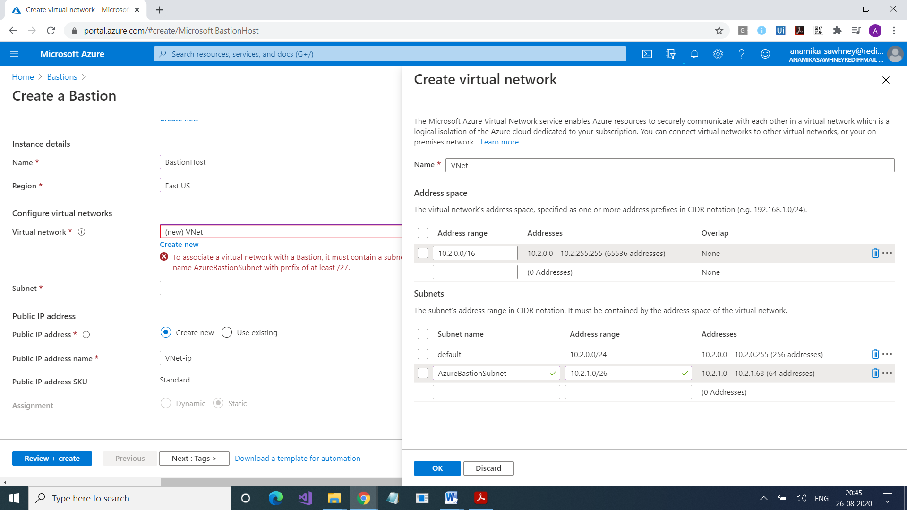

<https://azure.microsoft.com/en-in/services/azure-bastion/#get-started>