AzCopy :

Create two Storage Accounts, sourceacct, destinationaccount

In one storage account (sourceacct), add blob

we have to copy this container from this storage account to other (destinationaccount)

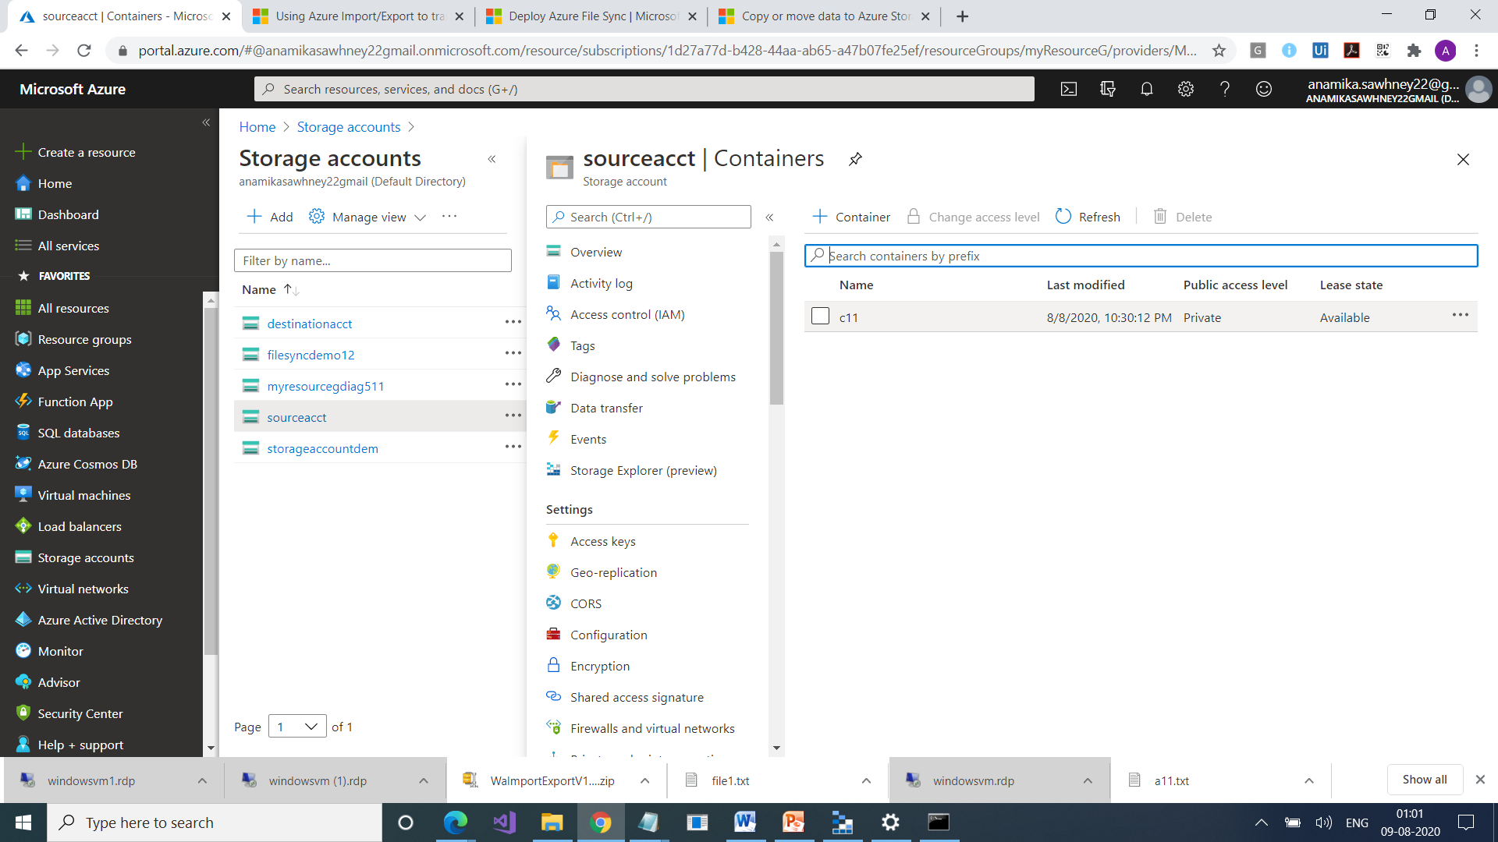

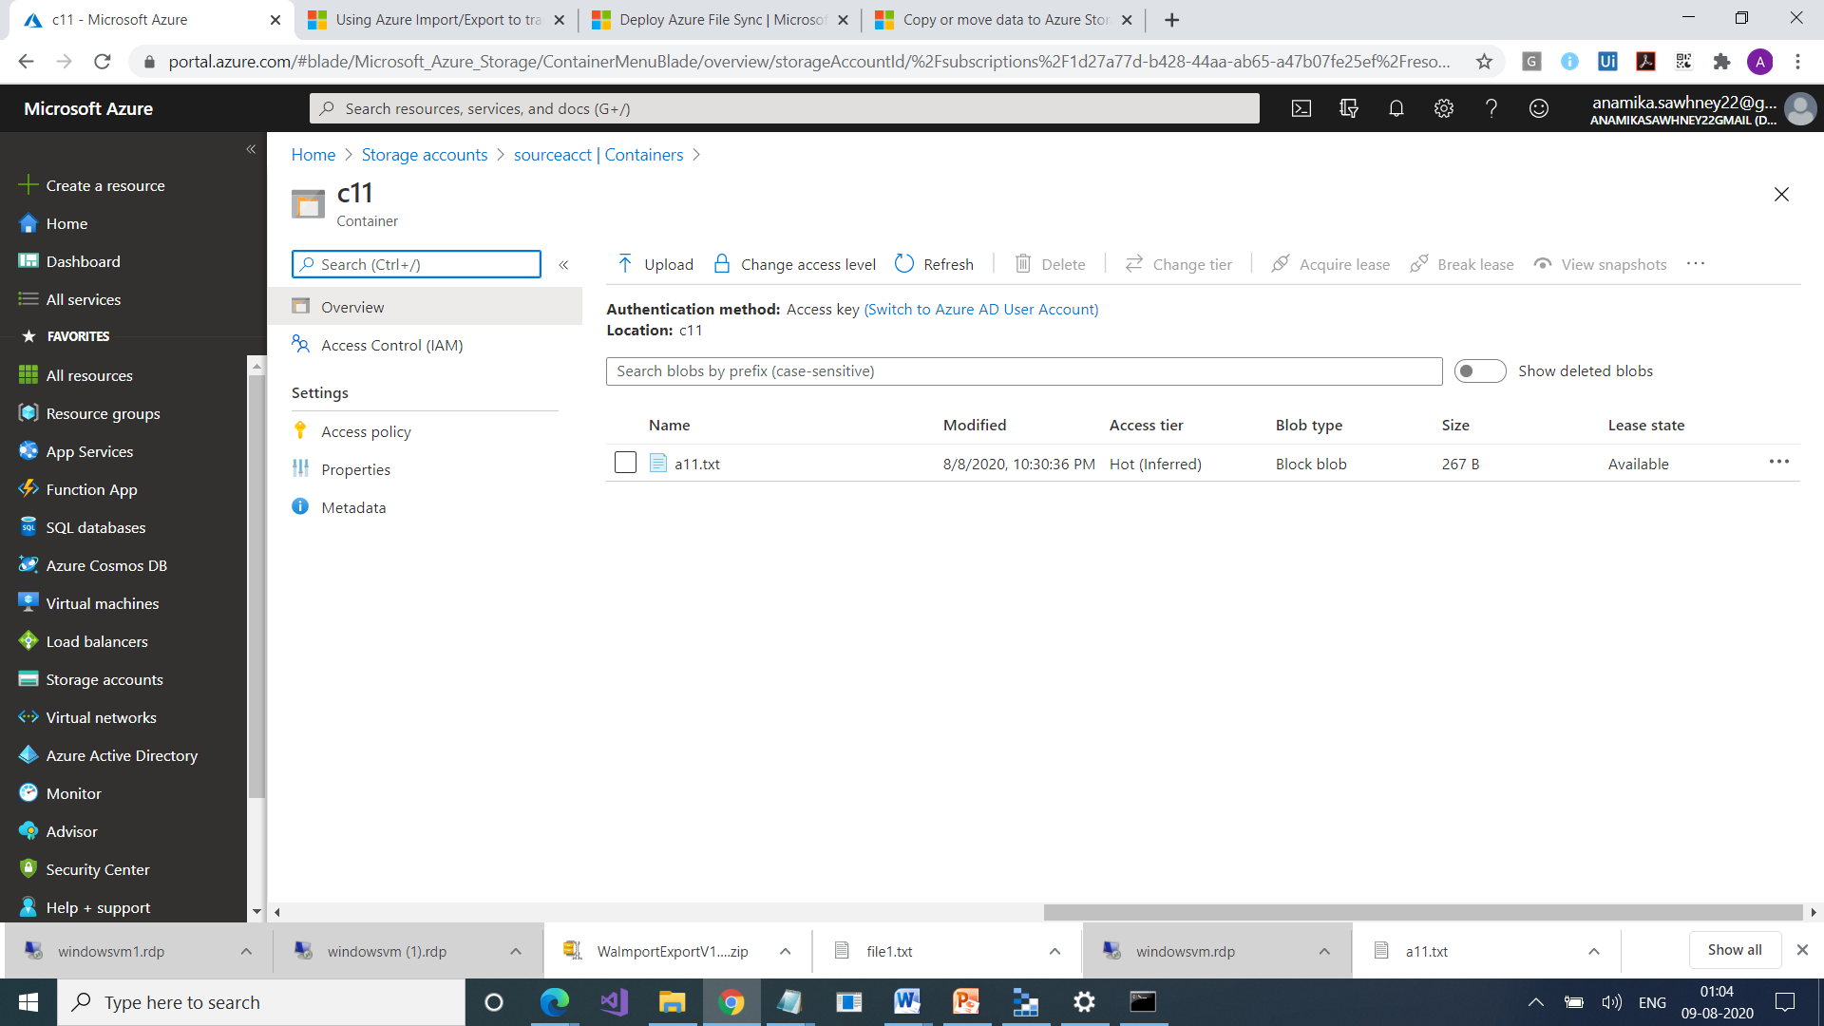

We have to use SAS (Shared Access Signature) for both storage accounts

Go to sourceacct > Shared Access Signature

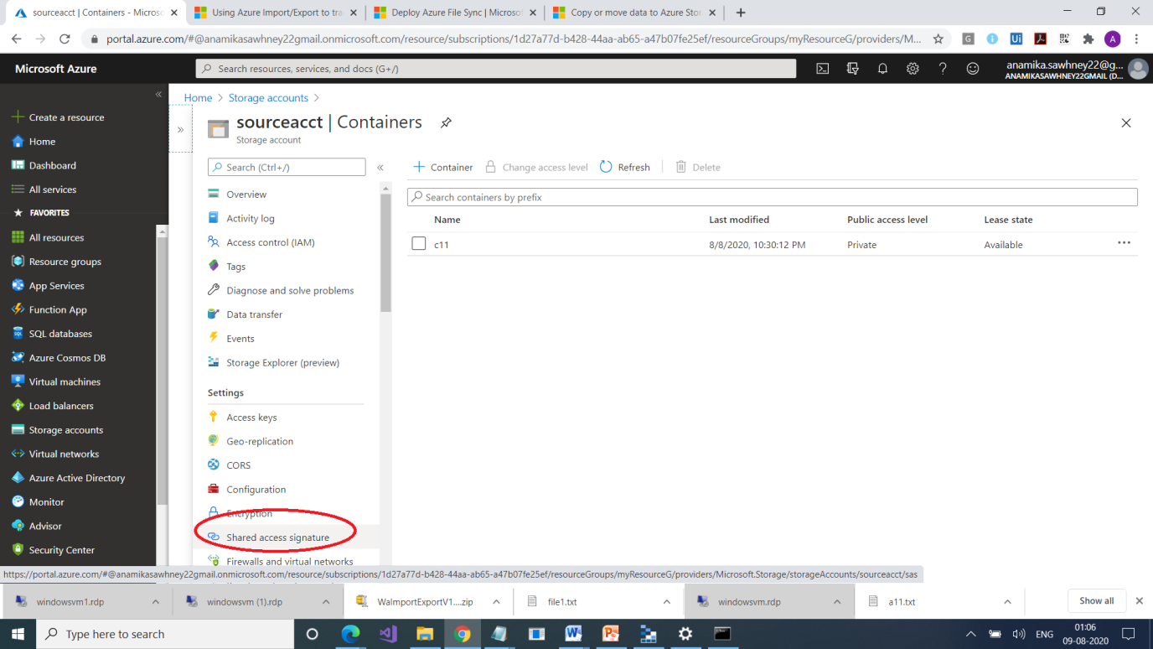

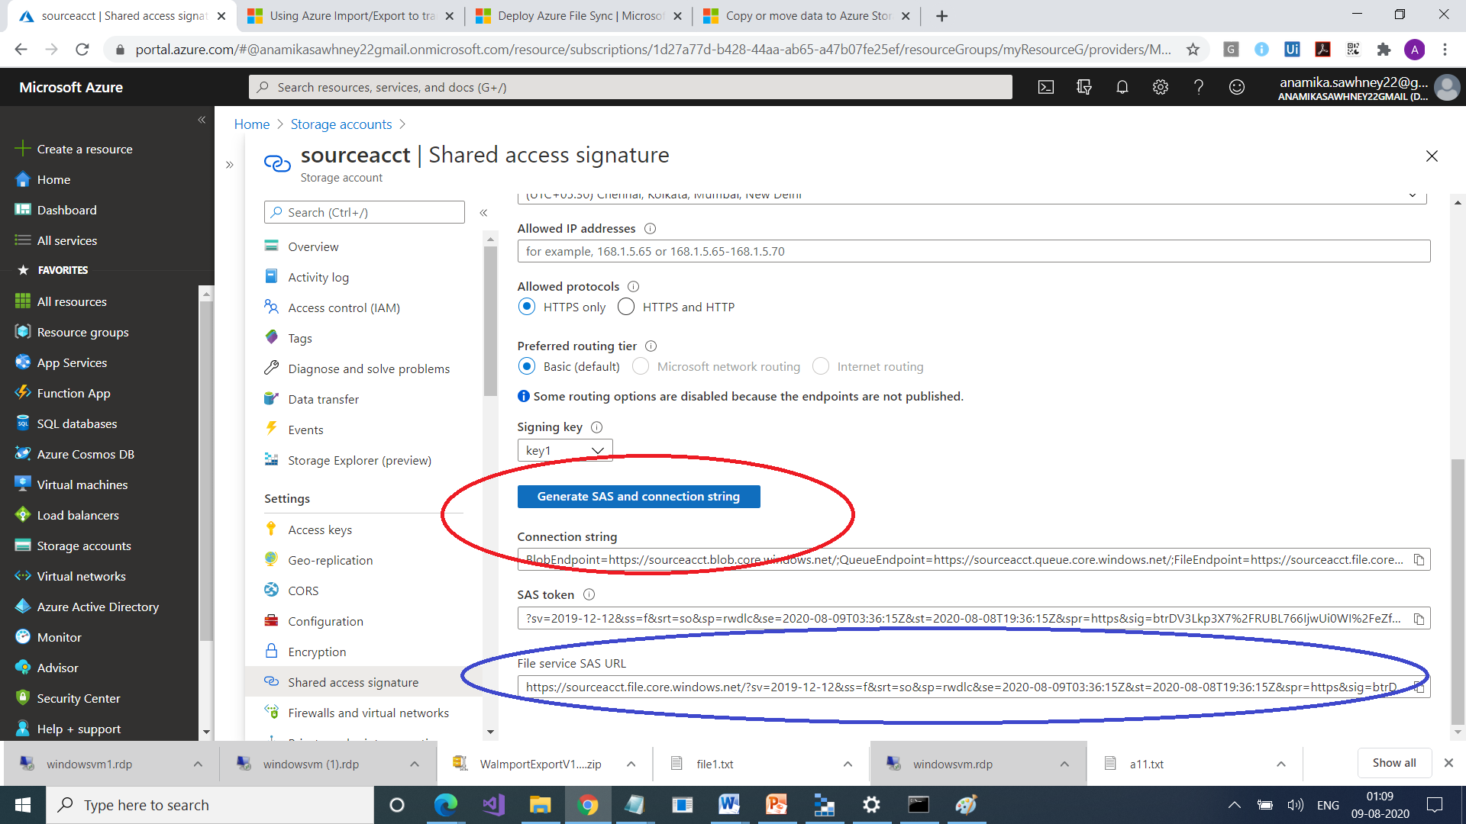

Similarly do for destinationaccount too ie. Generate SAS token

Keep both the SAL URL in notepad

Install AzCopy tool

<https://docs.microsoft.com/en-us/azure/storage/common/storage-use-azcopy-v10>

Once downloaded, unzip it

Go to its folder location (AzCopy)

Go to command prompt

Login to Azure portal

Azcopy login > We need tenant Id

For this go to portal , go to active Azure Directory

Copy the tenant id from there

azcopy login --tenant-id=<copy fromm there>

Now it gives you a link and a code

Go to that link and copy code

You are connected

Now you can give commands from command prompt

azcopy copy sourcesasurl destinationsasurl –recursive

Copy to local machine

local directory

azcopy copy "https://s1source.blob.core.windows.net/c111" "E:\IM" --recursive

FOLLOW THIS LINK

<https://docs.microsoft.com/en-us/azure/storage/common/storage-use-azcopy-blobs>