0`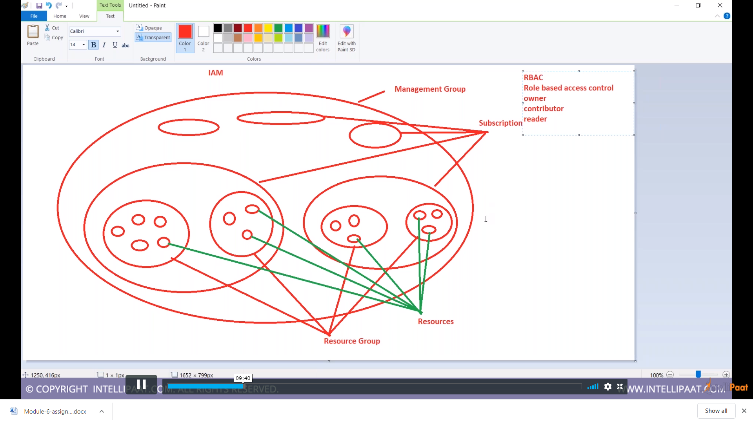

{

"Name": "customrolenodemo",

"Id": null,

"IsCustom": true,

"Description": "demo",

"Actions": [ "*/read",

"Microsoft.Support/*",

"Microsoft.Compute/virtualMachines/write"],

"AssignableScopes": ["/subscriptions/49a4d804-0cd0-44b2-89e5-fb1f592a927e"]

}Get-AzRoleDefinition | ? {$_.IsCustom -eq $true} | FT Name, IsCustom

New-AzRoleDefinition -InputFile "E:\role1.json"

Get-AzRoleDefinition | ? {$_.IsCustom -eq $true} | FT Name, IsCustom

Custom Roles are created at subscription level

To check them , go to subscription and then check