We’ll cover **Topic Azure Resource, Resource Group**,**how to create a Resource Group, Resource Manager(ARM)** & **ARM Template**on**Microsoft Azure cloud**.

While you can technically create a resource group when adding a resource, I suggest you always start by setting up the resource group first.

By creating the resource group first, you can put yourself into a frame of mind where you are considering how exactly you want to structure the application.

**What Is Resource?**

All the entities and services managed by Azure are called Resources. Resources may be virtual machines including Windows and Linux machines, storage, databases, active directories, or networks in Azure.

**What Is A Resource Group?**

In Azure, a Resource Group is a logical collection of all resources. The resource group stores metadata about the resources.

It is generally created on an environment basis such as development, production, or testing resource groups.

Basically, it provides a way to monitor, control access, provision, and manage to bill for collections of assets/resources that are being used by a client.

**How To Create A Resource Group?**

1. Sign in to your Microsoft Azure Account.

2. On the [**Azure portal**](https://portal.azure.com/#home), search for and select **Resource Groups**.

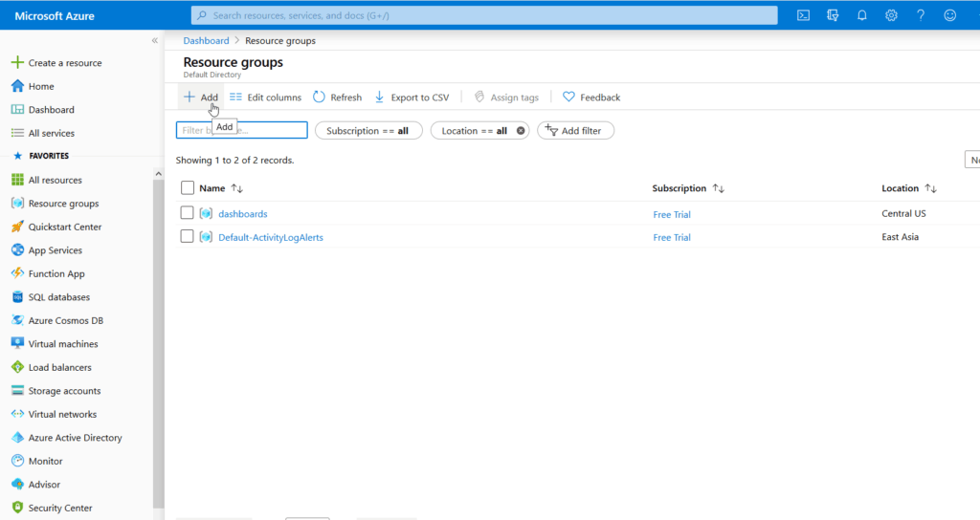

3. Select **Add**

4. Enter the following details:

* **Subscription**: Select your Azure subscription
* **Resource group**: Enter a new resource group name.
* **Region**: Select an Azure location, such as Western India, Central US, etc.

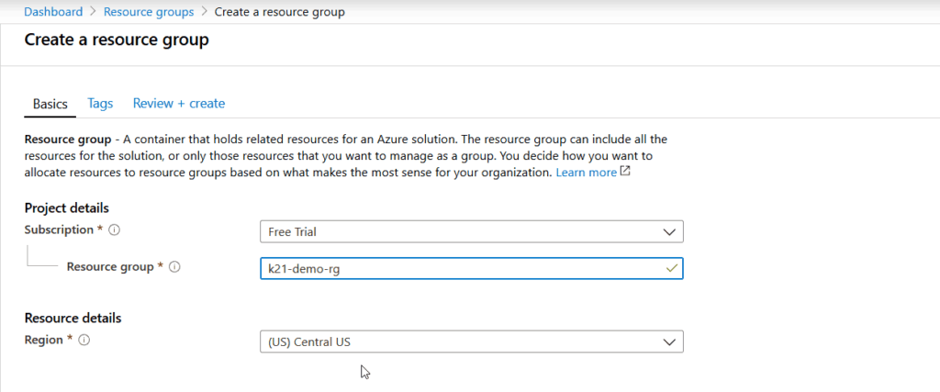

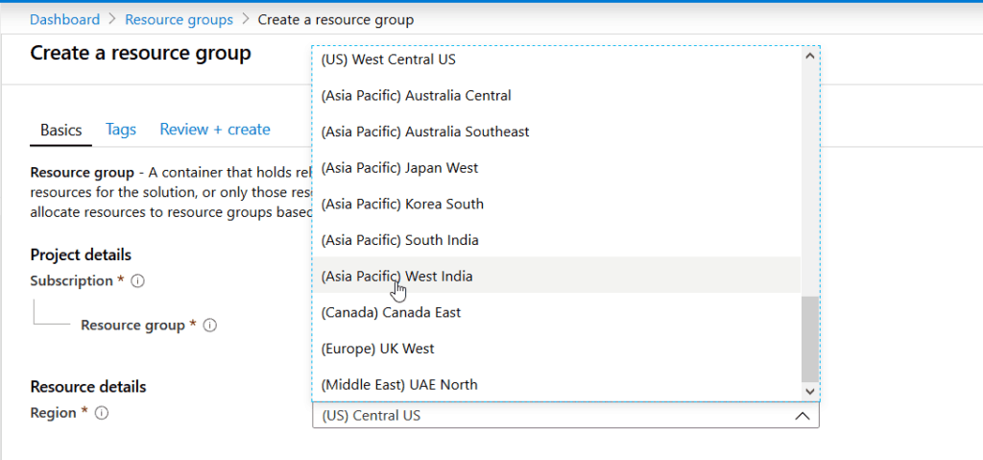

5. Select **Create**. It takes a few seconds to create a resource group.

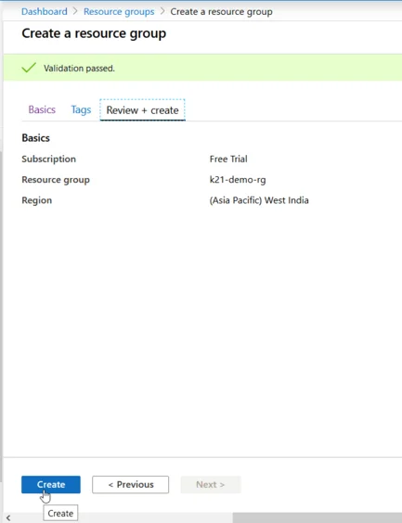

6. The resource group is now created. You can view and manage it under **Resource Groups**.

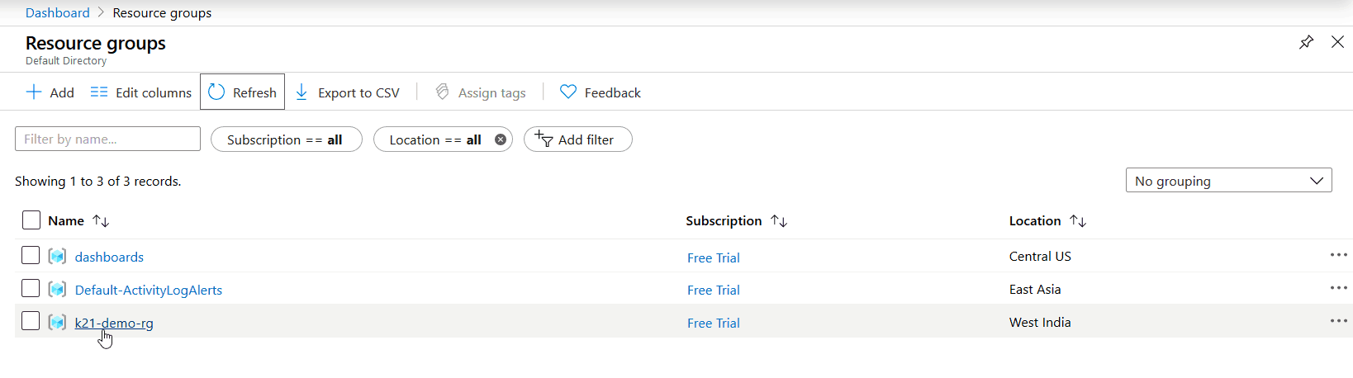

7. Now you can use this **Resource Group** to store your different Resources in your Azure Subscription.

**What Is Azure Resource Manager (ARM)?**

1. Azure Resource Manager is the deployment and management service for Azure.
2. It provides a management layer that enables you to create, update, and delete resources in your Azure subscription.
3. You use management features, like access control, locks, and tags, to secure and organize your resources after deployment.

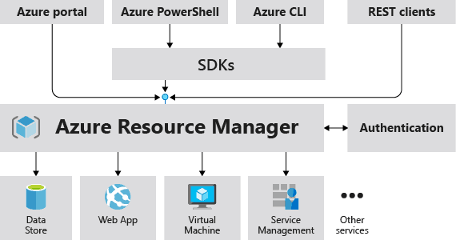

**What Is The ARM Template?**

1. To implement infrastructure as code for your Azure solutions, use Azure Resource Manager (ARM) templates.
2. The template is a JavaScript Object Notation (JSON) file that defines the infrastructure and configuration for your project.
3. The template uses declarative syntax, which lets you state what you intend to deploy without having to write the sequence of programming commands to create it.
4. In the template, you specify the resources to deploy and the properties for those resources.

**Sample Questions**

**Q1.**This question requires that you evaluate the text to determine if it is correct.

**“You plan to deploy 20 virtual machines to an Azure environment. To ensure that a virtual machine named VM1 cannot connect to the other virtual machines, VM1 must be deployed to a separate virtual network. “**

Instructions: Review the text. If it makes the statement correct, select “No change is needed”. If the statement is incorrect, select the answer choice that makes the statement correct.

1. No change is needed
2. run a different operating system than the other virtual machines
3. be deployed to a separate resource group
4. have two network interfaces

**Correct Answer:**A

**Explanation:**Any resource inside a virtual network(Vnet) can communicate with another resource inside the same virtual network.

**Q2.**This question requires that you evaluate the text to determine if it is correct.

**“When you need to delegate permissions to several Azure virtual machines simultaneously, you must deploy the Azure virtual machines to the same Azure region.”**

Instructions: Review the underlined text. If it makes the statement correct, select “No change is needed”. If the statement is incorrect, select the answer choice that makes the statement correct.

1. No change is needed
2. by using the same Azure Resource Manager template
3. to the same resource group
4. to the same availability zone

**Correct Answer:**C