An Application consist of

FE > Its part from where user interacts with the system

BE > Its part with which user can not interact

Depending upon how user interacts with the system , interface could be of 2 types

CUI > Character based , where user has to enter values

Enter Name : Ajay

GUI > Graphical based , where user get to work easily because of options provided

Applications could be of how many types depending upon UI

Console

Windows

Web

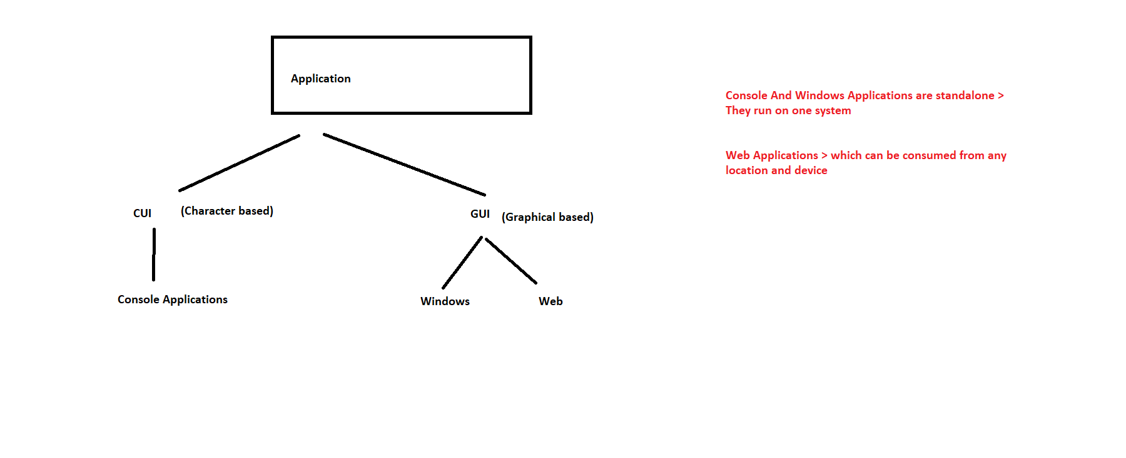

For Web Applications , we need server & client

Server is the machine on which that Web Application is stored

And we are the clients as we want to access that application

Browser is the client

Web Application

FE > To create your web pages , we can have

HTML > It is used to create static web pages

CSS > It is used to decorate that web page

Javascript > It is used to make that static web page interactive

JQuery

Bootstrap

HTML > Hyper Text Markup Language

Features >

1. It is a Markup Language
2. It is Case insensitive h1 H1
3. It consist of Tags

Tags

1. Container > which we start then we have to close it also <> CONTENTS </>
2. Empty > There is no need to close them <>

**HTML Page consist of 2 main sections (.html / .htm)**

head & body

<!doctype html> > It tells browser that we are using HTML 5

<html>

<head> Anything which tells about the page

Also some external links

<meta>

<link>

<script>

</head>

<body>

What you will want to display in page will come here

</body>

</html>

We use any editor

Notepad

Notepad++

Visual Studio Code

Visual Studio 2019

<https://www.w3schools.com/html/default.asp>