IDE >Integrated Development Environment

Solution > Container for projects

Project > Container for source code

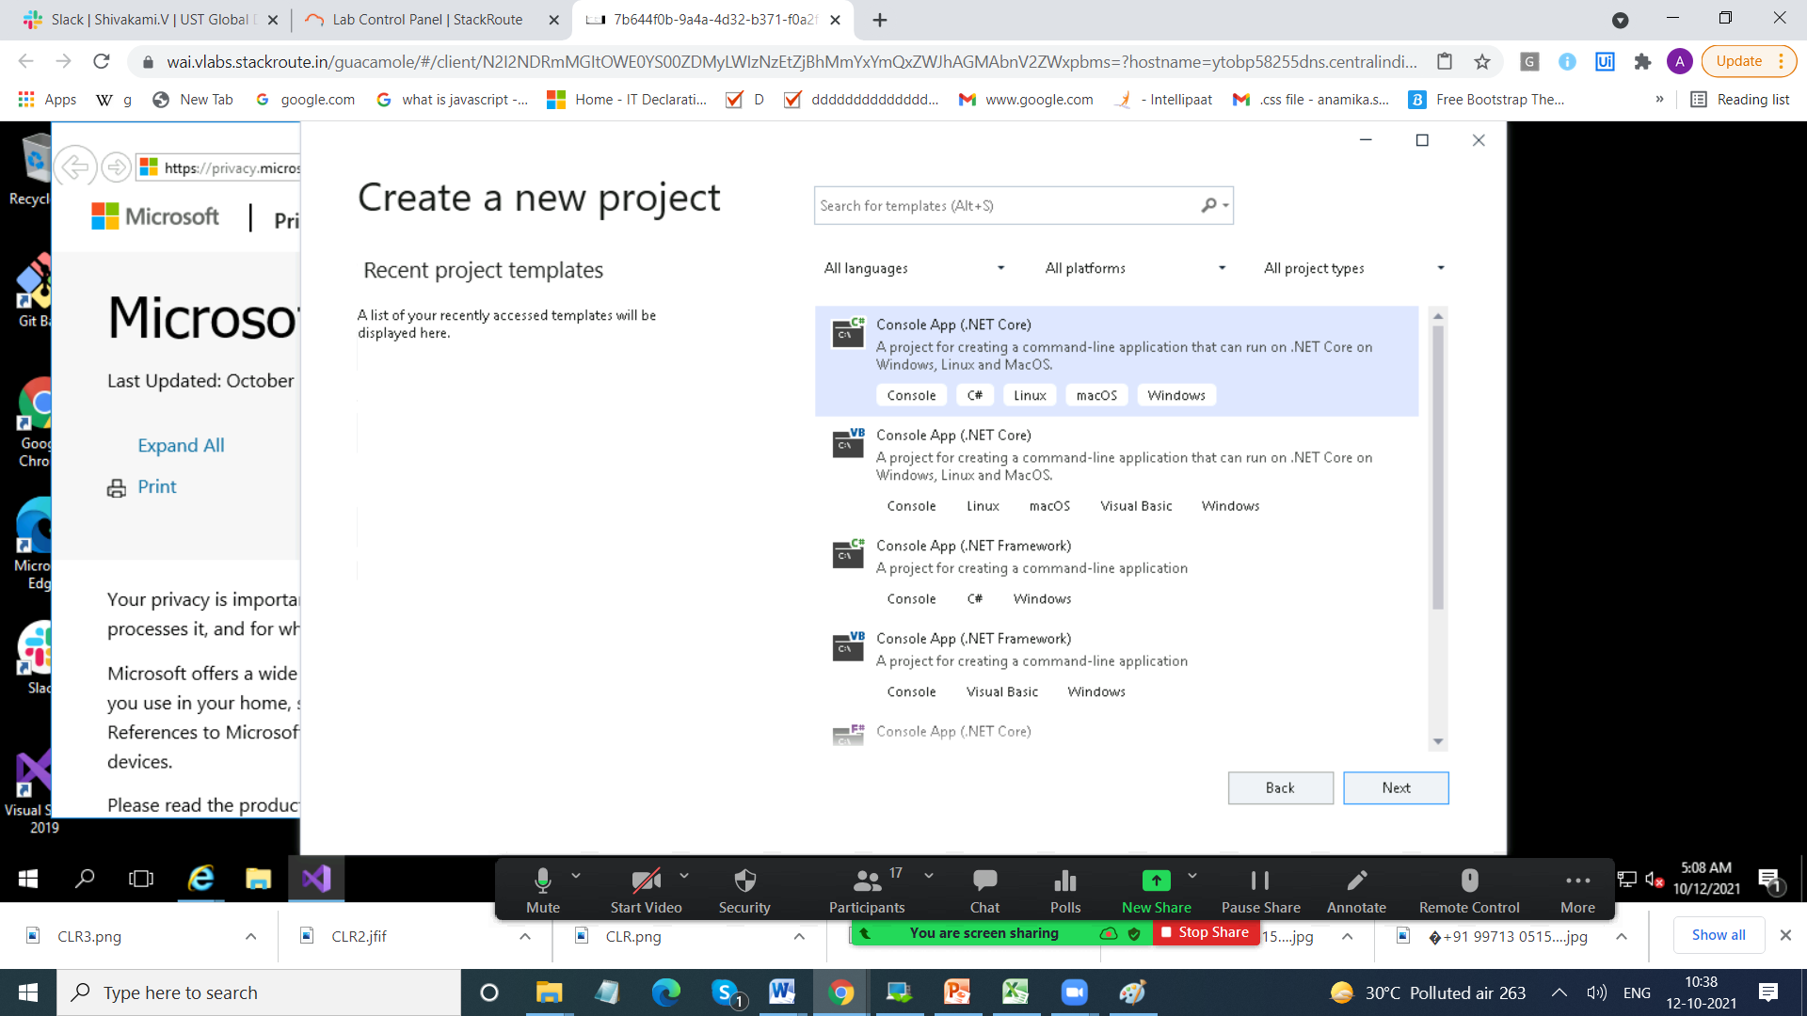

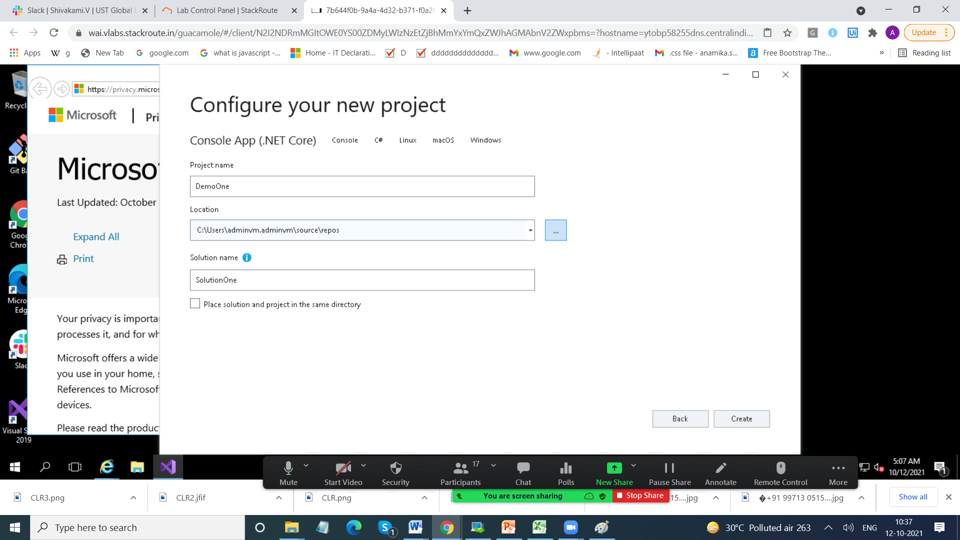

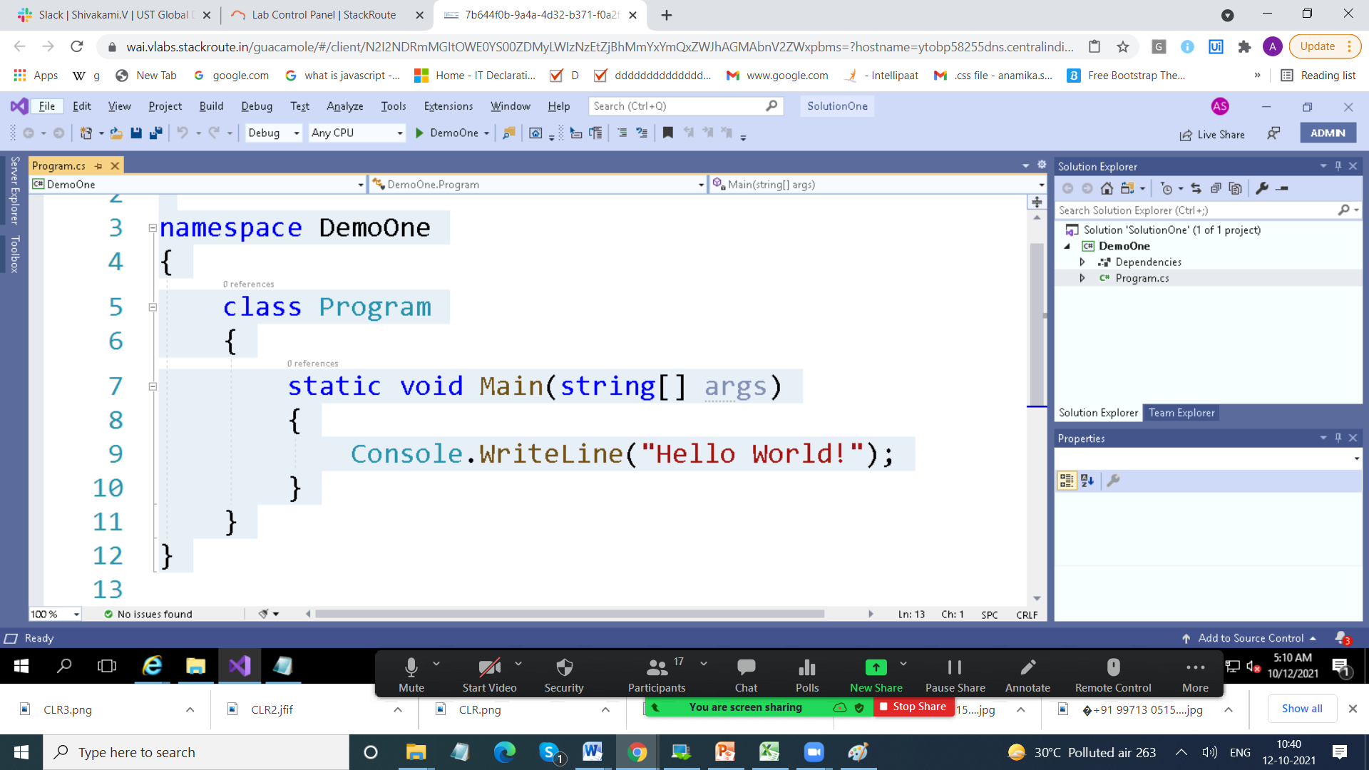

using System;

namespace DemoOne

{

class Program

{

static void Main(string[] args)

{

Console.WriteLine("Hello World!");

}

}

}

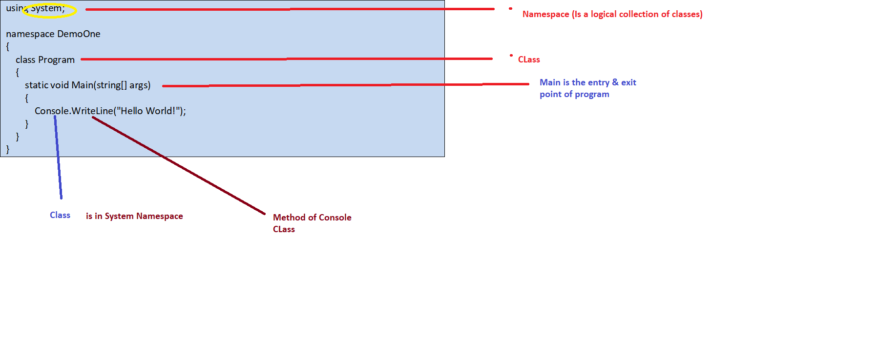

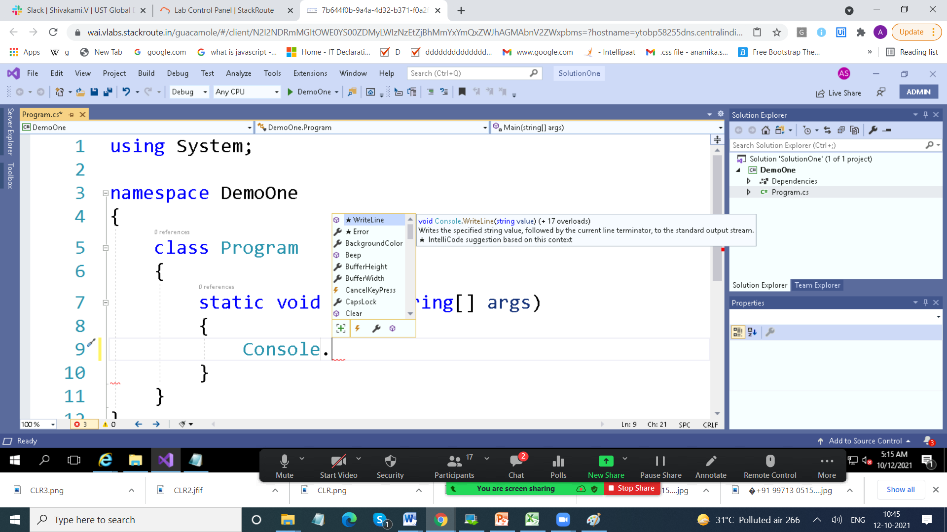

Intellisense > We get suggestions

Operators > Which acts upon operands

Arithmatical > + - \* / %

Logical > && || !

Relational / Comparison > == > < <> >= <=

Assignment = += -= \*= /= %=