Arrays > int n1, int n2

Int num[100];

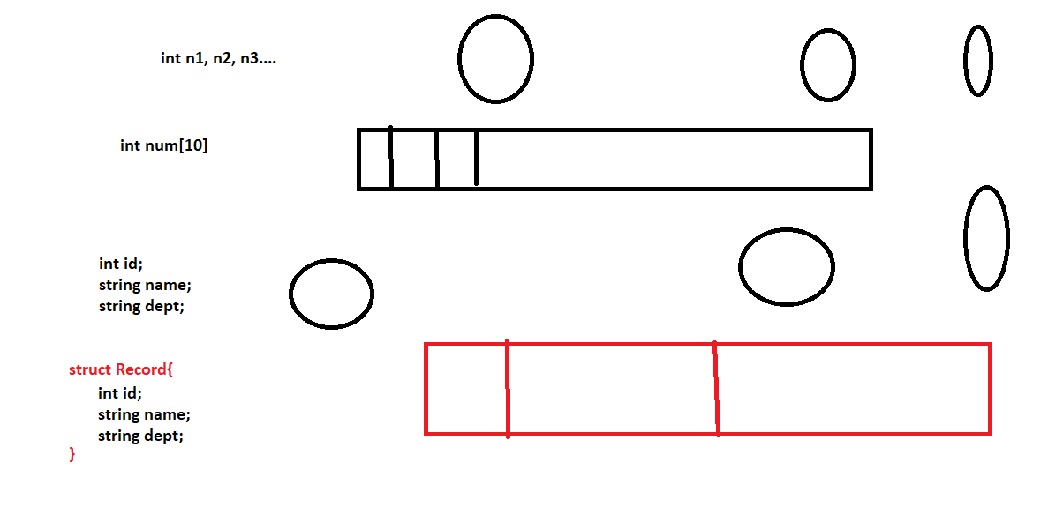

Classes & Structures

(UDT)

They both can have methods

They both constructor

**Class Struct**

Reference Type Value Type

Classes have all types of contructors Can have only fully parameterized

They have def constructor (but we can not

Explicitly add that in structure

Don’t have inherited

String & StringBuilder

String is immutable > It will not change

StringBuilder is mutable

StringBuilder > System.Text;

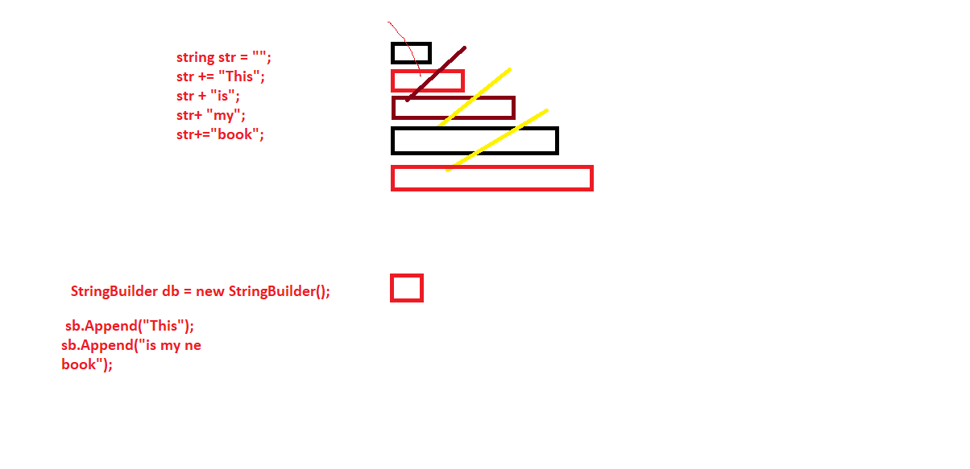

String Vs StringBuilder

StringReader & StringWriter

StreamWriter & StreamReader