HTML

CSS

Javascript

JQeury

C# : Console

Sql Server

ADO.Net

Why ADO.Net : Bridge between FE and BE

Limitations in ADO.Net

1. Queries are checked at run time
2. There is no intellisense
3. There is no mapping between tables & classes

Entity Framework : It is ORM

Object Relational Mapper

Entity Framework(Three Approaches to work in Entity Framework)

1. Database First Approach
2. Model First Approach
3. Code First Approach

using System;

using System.Collections.Generic;

using System.Configuration;

using System.Data;

using System.Data.SqlClient;

using System.Linq;

using System.Text;

using System.Threading.Tasks;

namespace ConsoleApp5

{

class Program

{

static SqlConnection GetConnection()

{

string connectionString = ConfigurationManager.ConnectionStrings["con"].ToString();

SqlConnection con = new SqlConnection(connectionString);

return con;

}

static void Main(string[] args)

{

using (SqlConnection con = GetConnection())

{

using (SqlCommand ada = new SqlCommand("Select \* from studet", con))

{

con.Open();

SqlDataReader read = ada.ExecuteReader();

}

}

}

}

}

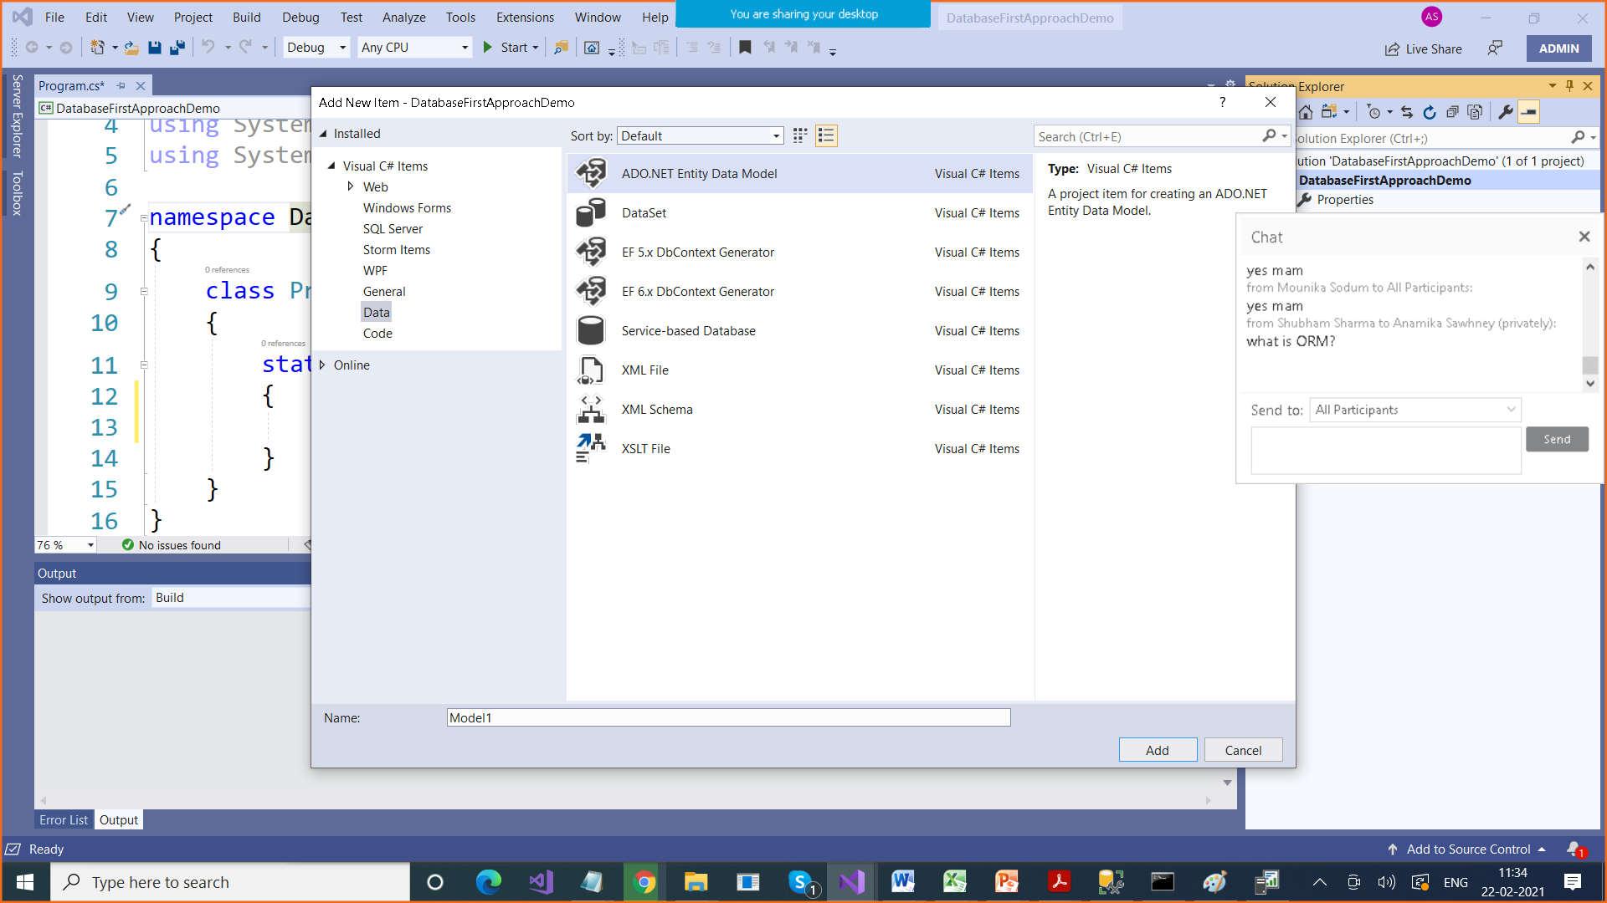

After Database First Appraoch,

1. We get edmx > table is converted to a class

And the columns of that table are converted to properties

2. An entry in app.config file , which contained our connectionString

3. we get a class with same name as in app.config connectionString , this class inherits from DbCOntext class

4. In this class , we get a collection of Employee type

using System;

using System.Collections.Generic;

using System.Linq;

using System.Text;

using System.Threading.Tasks;

namespace DatabaseFirstApproachDemo

{

class Program

{

static void Main(string[] args)

{

practiceEntities db = new practiceEntities();

var list = db.Employees.ToList();

foreach (Employee emp in list)

{

Console.WriteLine(emp.id + " " + emp.name + " " + emp.salary);

}

Console.WriteLine("Insertion of Record");

Employee emp1 = new Employee()

{

id = 24,

name = "New Name",

dept = "Accts",

salary = 90000,

address = "Delhi"

};

db.Employees.Add(emp1);

db.SaveChanges();

Console.WriteLine("Updating Record");

Console.WriteLine("Enter ID whose record to change");

int id = Convert.ToByte(Console.ReadLine());

Employee emp2 = db.Employees.Find(id);

if (emp2 != null)

{

Console.WriteLine(emp2.name);

foreach (Employee emp3 in list)

{

if (emp3.id == id)

{

emp3.dept = "Changed";

break;

}

}

}

db.SaveChanges();

Console.WriteLine("Deletion of Record");

Console.WriteLine("Enter ID whose record to delete");

id = Convert.ToByte(Console.ReadLine());

Employee emp4 = db.Employees.Find(id);

if (emp4 != null)

{

db.Employees.Remove(emp4);

db.SaveChanges();

}

}

}

}