using System;

using System.Collections.Generic;

using System.Data.Entity;

using System.Linq;

using System.Text;

using System.Threading.Tasks;

namespace CodeFirstApproachemo

{

class Item

{

public int Id { get; set; }

public string ItemName { get; set; }

public int Qty { get; set; }

public string Description { get; set; }

public Item() { }

public Item(string itemName , int qty , string des)

{

this.ItemName = itemName;

this.Qty = qty;

this.Description = des;

}

}

class ItDbContext : DbContext

{

//public ItemsDbContext()

//{

//}

public DbSet<Item> Items { get; set; }

}

}

<connectionStrings>

<add name="ItDbContext" connectionString="data source=LAPTOP-53S2KQS8\SQLEXPRESS;initial catalog=S100; integrated security=true" providerName="System.Data.SqlClient"/>

</connectionStrings>

using System;

using System.Collections.Generic;

using System.Linq;

using System.Text;

using System.Threading.Tasks;

namespace CodeFirstApproachemo

{

class Program

{

static void Main(string[] args)

{

ItDbContext db = new ItDbContext();

var itemList = db.Items.ToList();

foreach (Item temp in itemList)

{

Console.WriteLine(temp.Id + " " + temp.ItemName);

}

// Insert Records

//char ch = 'y';

//while (ch == 'y')

//{

// try

// {

// Console.WriteLine("Enter Name");

// string itemName = Console.ReadLine();

// Console.WriteLine("Snter Qty");

// int qty = Convert.ToByte(Console.ReadLine());

// Console.WriteLine("Enter Decsription");

// string des = Console.ReadLine();

// Item item = new Item(itemName, qty, des);

// db.Items.Add(item);

// db.SaveChanges();

// Console.WriteLine("Do you want to insert more record");

// ch = (char)Console.Read();

// }

// catch(Exception ex)

// {

// Console.WriteLine(ex.Message);

// }

// }

//Console.WriteLine("Enter ID for which to dlete record");

//int id ;

//id = Convert.ToByte(Console.ReadLine());

//Item item = db.Items.Find(id);

//if (item != null)

//{

// db.Items.Remove(item);

// db.SaveChanges();

// Console.WriteLine("Record is deleted");

//}

Console.WriteLine("Enter ID for which to edit record");

int id = Convert.ToByte(Console.ReadLine());

Item item = (from temp in db.Items

where temp.Id == id

select temp).FirstOrDefault();

if (item != null)

{

db.Items.Where(x => x.Id == id).ToList()

.ForEach(i => i.ItemName = "Name is changed");

db.SaveChanges();

Console.WriteLine("Record updated");

}

else

{

Console.WriteLine("Rceord Not found");

}

}

}

}

We want to add properties in class

Whenever we work with Code First Approach, to have coordination between classes and tables , we have to use Migration

Step 1: Enable-Migrations , it will enable migration for your DBContext , it will create a folder

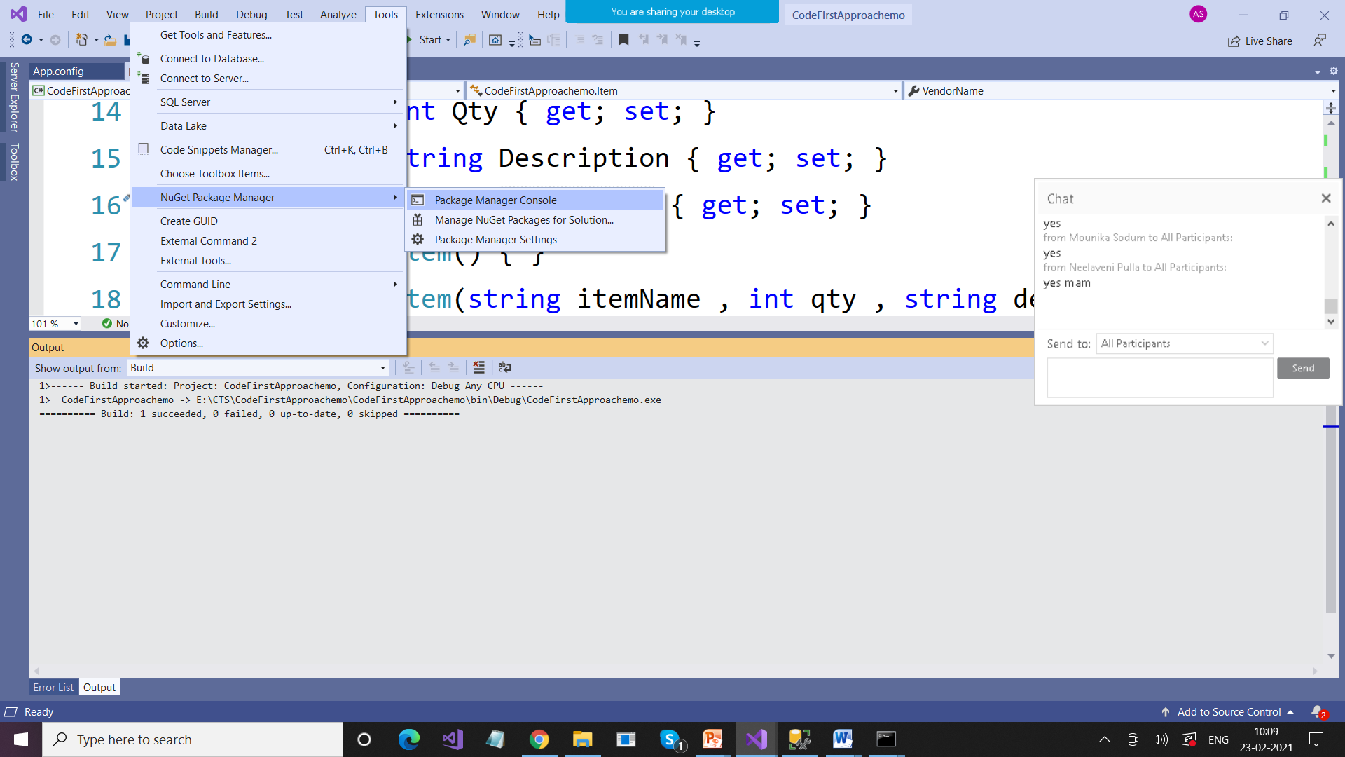

Step 2: Add-Migration AddedVendorName

Step 3: Update-Database