**Objectives**

* Identify the applications and benefits of HTML
  + Standard markup language for creating Web pages, Hyper Text Markup Language, building blocks of HTML pages, Role of Browser
* Demonstrate creating valid web page with title
  + Markup Language Syntax, .html, .htm, <doctype>, <html>, <head>, <title>
* Describe HTML document Structure
  + Tag name, start tag, end tag, attributes and tag content
* Demonstrate usage of Header, Footer and Section tags appropriately
  + Importance of semantics tags and purpose, List of Semantic Tags, <header>, <nav>, <footer>, <article>, <section>
* Demonstrate usage of Heading, Paragraphs and List tags to compile a document
  + <h1>, <p>, <li>, <ul>, <ol>

Hands on 1

**Basic HTML Tags**  
Create a web page with title "Hello World" and page content having "Hello World" using <doctype>, <html>, <head>, <title>, <body>. Refer screen shot below.   
  
**NOTE:**Code submission not required. To be implemented using Notepad++ and manually verified by the SME.   
  
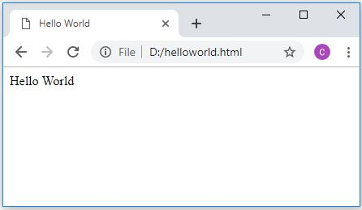

Hands on 2

**Header, navigation, section, article, footer.**

Create a page demonstrating HTML5 semantic tags. Name the file as semantics.html, which has header, navigation, section, article and footer sections with the details as shown in the screen shot.   
  
**NOTE:**Code submission not required. To be implemented using Notepad++ and manually verified by the SME.  
  
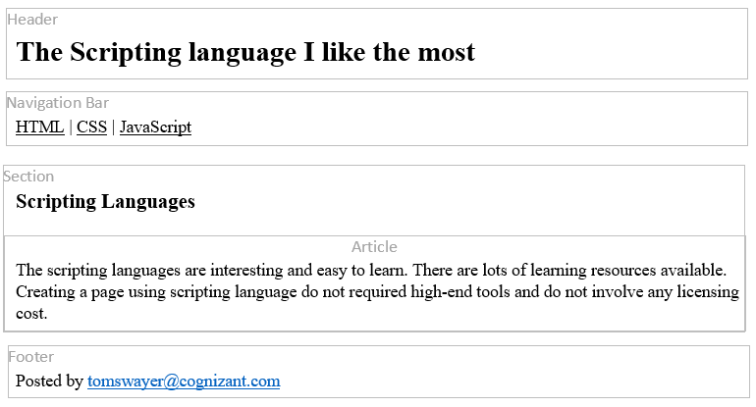 

Hands on 3

**Heading, Paragraph and List**

Instead of managing your favorite links using bookmarks option in browser, you are going to build a web page of favorite links. To initialize this web page development let us have a page with title, a description and favorite links as numbered item. Refer the screen below and come up with a HTML page for this.  
  
*Web Page Name:*favorites.html

**NOTE:** Code submission not required. To be implemented using Notepad++ and manually verified by the SME.

**Sample Layout**  
